TOPIC: ENCAPSULATION
1. Definition
Encapsulation is one of the fundamental pillars of Object-Oriented Programming. In simple terms, it is a mechanism that binds together code (methods) and the data (variables) it manipulates, keeping both safe from outside interference and misuse.
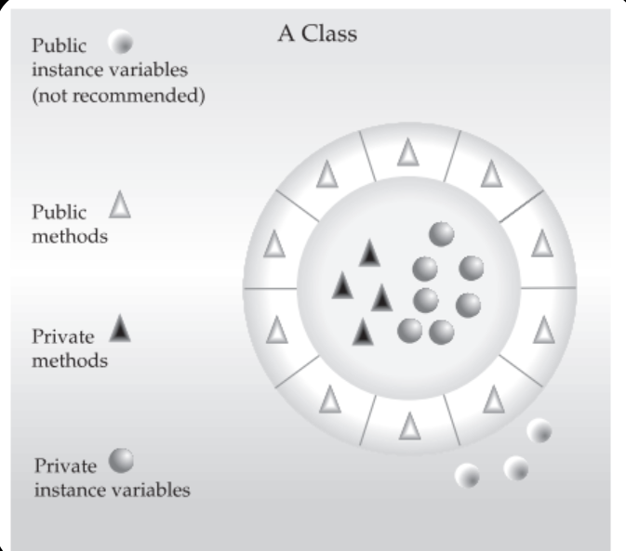
The Core (Grey/Black items): Inside the circle, we have our private methods and data. These are hidden. This is the 'secret sauce' of how our object works.
The Shell (White Triangles): Surrounding the core are the public methods. This is the 'Interface'. It is the only way the outside world can talk to the core.
The Danger Zone: Notice the 'Public instance variables' floating outside the wrapper? The diagram explicitly labels this 'Not Recommended'. If data is outside the wrapper, anyone can change it, breaking the safety of your program."
"Consider the automatic transmission in your car. It encapsulates hundreds of complex details: engine bits, acceleration data, road pitch, and fluid pressure."
- The Encapsulation: All that mechanical complexity is hidden inside the transmission box.
- The Interface: You, the driver, have a specific, well-defined interface: The Gear Shift Lever.

- Why is this good?
  - Simplicity: You don't need to be a mechanic to drive. You just move the lever.
  - Safety: You cannot affect the transmission by turning on the windshield wipers. The systems are separate.
  - Flexibility: Ford, Toyota, and Tesla build transmissions differently inside, but to the driver, the gear shift works exactly the same.
"In programming, Encapsulation allows us to change the internal code without breaking the code of everyone else using our class."
"In Java, the Class is the basis of encapsulation."
How is encapsulation achieved in Java?
Using access modifiers and getter/setter methods.
The Golden Rule: The public interface should be carefully designed to expose only what is necessary, hiding the complexity of the implementation.

Example: Bank Account
Scenario A: Without Encapsulation (The Dangerous Way)
class BadBankAccount {
public double balance; // Anyone can touch this!
}
There are no rules preventing invalid data.

Scenario B: With Encapsulation (The Safe Way)
class BankAccount {
// 1. DATA IS PRIVATE (Hidden inside the wrapper)
// Only this class can see 'balance'.
private double balance;

// Constructor to start with $0
public BankAccount() {
balance = 0.0;
}

// 2. METHODS ARE PUBLIC (The Interface)
// Method to Deposit (Safe way to add money)
public void deposit(double amount) {
// We can add logic here!
if (amount > 0) {
balance = balance + amount;
System.out.println("Deposited: " + amount);
} else {
System.out.println("Error: Cannot deposit negative amount.");
}
}

// Method to Withdraw (Safe way to remove money)
public void withdraw(double amount) {
// We check safety rules before modifying the data
if (amount <= balance) {
balance = balance - amount;
System.out.println("Withdrew: " + amount);
} else {
System.out.println("Error: Insufficient funds.");
}
}

// Read-only access to see the balance
public double getBalance() {
return balance;
}
}

