 UNIQUEIMAGE

Differentiating You

**One Day Workshop on**

**Personal Grooming**

**&**

**Table Etiquettes**

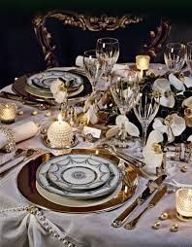**Collaboration with Ceylon Chamber Of Commerce – Colombo**

**Will be conducted**

On

**Date: 2015.11.12**

at

**Time: 1.00 p.m. – 3.30 p.m.**

at

**Venue: University Auditorium (Art)**

**Registration Available @ CGU**

**From 2nd to 10th November**

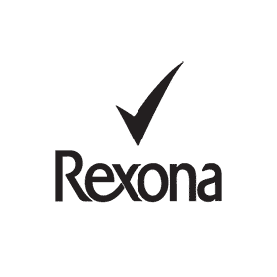

**Hosted by Career Guidance Unit – University of Ruhuna**

**CONTENT OF THE WORKSHOP**

|  |  |  |
| --- | --- | --- |
| **Topic** | **Content** | **Time** |
| **Understanding what is personality** |  | **1:00-1:15pm** |
| **Personal Grooming** | **•        Pay attention to your health and physical energy**  **•        Maintain a high standard of personal hygiene**  **•        Be fresh at all times and avoiding body odour**  **•        Look after your personal outlook by maintaining your hair, skin and nails** | **1:15pm- 1:45pm** |
| **Dress code** | **•        Understand what your attire tells about your personality**  **•        Identify the wardrobe categories office attire – Ladies and Gents**  **•        Essential accessories that create a total look  (jewellery, belts, glasses, shoes, handbags)**  **•        Common wardrobe mistakes** |
| **Etiquette** | •        **The difference between social and business etiquette**  **•        Fifteen second self introduction**  **•        How to remember names**  **•        Learn the correct handshake**  **•        business card etiquette**  **•        Importance of the correct introductions**  **•        Telephone etiquette**  **•        E- mail etiquette**  **•        use of facilities in an appropriate manner** | **1:45pm- 2:45pm** |
| **Table manners** | **•        Understanding the use of cutlery and crockery**  **•        Napkins**  **•        Bread and butter**  **•        Soup**  **•        Dessert**  **•        Other basics** | **2:45pm -3:15pm** |