问题描述：创建虚拟机错误或删除虚拟机错误或创虚拟机的命令执行一直卡顿

排错运维思路：
1、查询错误日志
cd /var/log/nova
grep 'ERROR' *
错误截图
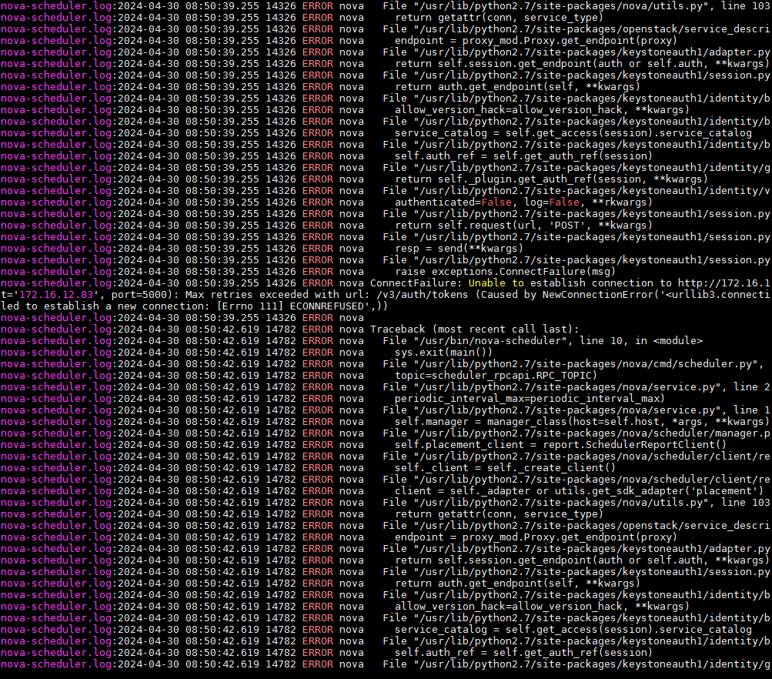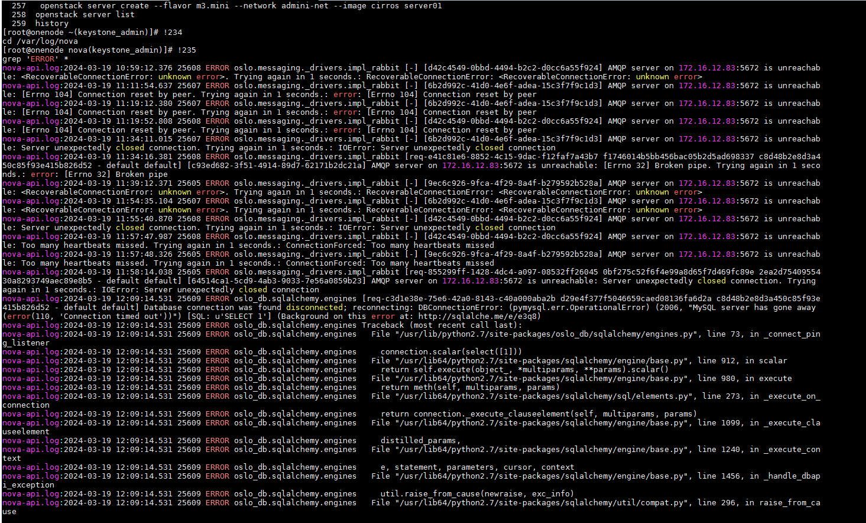

- 解决办法
查询服务状态并重启
systemctl status rabbitmq-server
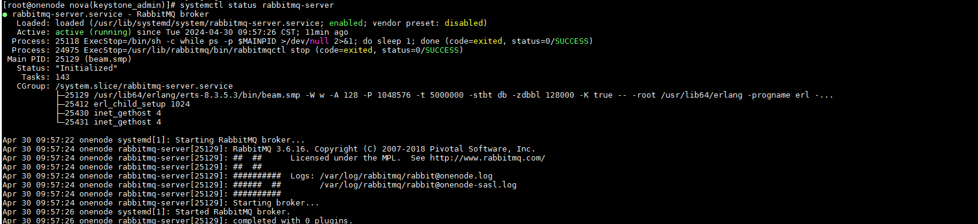
systemctl restart rabbitmq-server
systemctl restart httpd
systemctl restart mariadb
systemctl restart *nova*.service
systemctl restart *openstack*.service
systemctl restart libvirtd

systemctl restart neutron-server
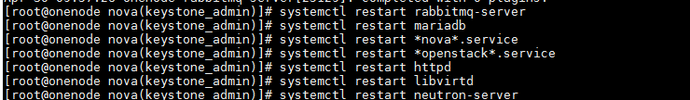
systemctl status ovsdb-server
这个服务被down掉
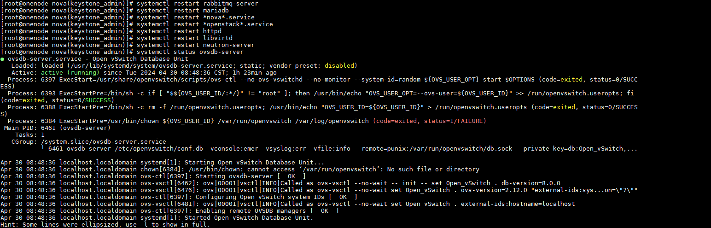

重启ovsdb-server服务
systemctl restart openvswitch
systemctl restart ovsdb-server
systemctl status ovsdb-server
