**PROJECT**

Pavani PH

**4. Boostrap 4 Crash Course**

We'll create a company blog page, where multiple users can log in, create blog posts, and update or delete their existing blog posts.

We use concepts, such as handling image files (users will have a profile image), adding pages, and how to use modals (Bootstrap pop ups).

PROJECT VIEWS:

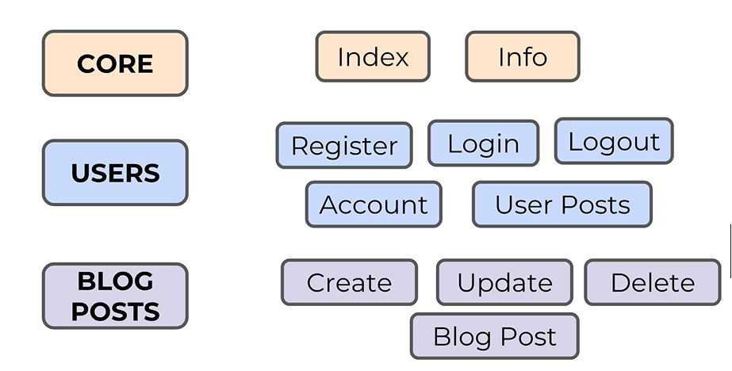

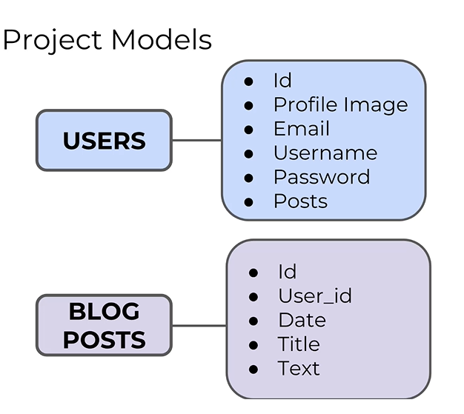

* We'll need to create CRUD forms for Users and Blog Posts.
* Then we'll need to create templates that correspond with the views.

BASIC STRUCTURE:

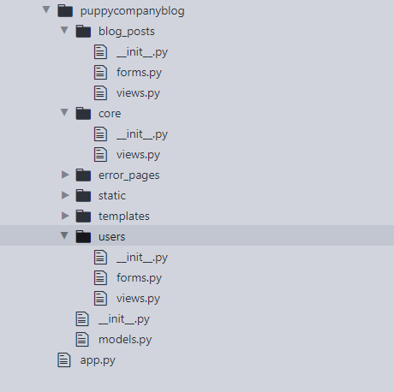

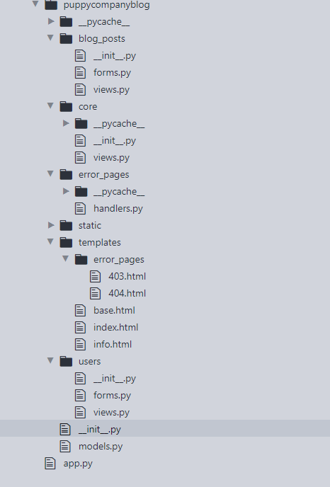

**USERS INTERFACE:**

