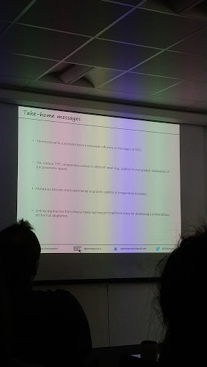

**20191010 seminar**

Deep-time evolution of biological responses to temperature changes

Dimitrios - Georgios Kontopoulos

Physiological responses in different time scales

Thermal performance curves

Highly variation between individuals

Poor knowledge on how this curve shapes evolution

Sharpe-Schoolfield model

Assume enzyme kinetics as max limit

Understand metabolic theory (assume thermal sensitivity fixed) frameworks work on thermal evolution

Thermodynamical constraints <-> biochemical adaptation

Weak constraints: Temp_op correlate with body size

Negative correlation: specialist BM extreme

Phylogenetic regression model

2 correlations

Weakly correlation, dominant by cold-adaptation species

Parameters evolve along with phylogeny, some with jumps

Cell volume increase, body height decrease

Evo-patterns in thermal sensitivity

Environmental selection across clades, convergence

No global optimum, species explore different local optima

Equator: thermal-specialists

Mid: thermal-generalists

See complexity of interacting components between interacting populations, multi-levels

Mutation more serious in high temperature

Substitution rates different between species living in different temperatures

^Tk, v mutation

Contradict metabolic theory (ox free-radicals = ^mutation)

Ancestral state from simulations close to median only -- data limitation (only have current species) -> high variation

Effective population size no data for temperature; mention theory predict decrease