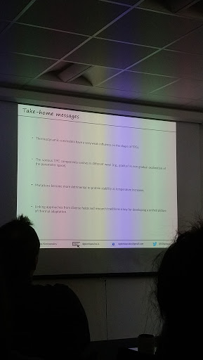

20191010 seminar

Deep-time evolution of biological responses to temperature changes
Dimitrios - Georgios Kontopoulos

Physiological responses in different time scales
Thermal performance curves
Highly variation between individuals
Poor knowledge on how this curve shapes evolution

Sharpe-Schoolfield model
Assume enzyme kinetics as max limit

Understand metabolic theory (assume thermal sensitivity fixed) frameworks work on thermal evolution

Thermodynamical constraints <-> biochemical adaptation
Weak constraints: Temp_op correlate with body size
Negative correlation: specialist BM extreme

Phylogenetic regression model

2 correlations
Weakly correlation, dominant by cold-adaptation species
Parameters evolve along with phylogeny, some with jumps

Cell volume increase, body height decrease

Evo-patterns in thermal sensitivity
Environmental selection across clades, convergence
No global optimum, species explore different local optima
Equator: thermal-specialists
Mid: thermal-generalists

See complexity of interacting components between interacting populations, multi-levels
Mutation more serious in high temperature

Substitution rates different between species living in different temperatures
^Tk, v mutation
Contradict metabolic theory (ox free-radicals = ^mutation)

Ancestral state from simulations close to median only -- data limitation (only have current species) -> high variation
Effective population size no data for temperature; metabolic theory predict decrease

