Section 4 — Mini-Project
Weather-Cancellation Analyzer (Goa & Manali, 2024)
Source: weather_cancellation_analyzer.ipynb (project/ folder)

README
What it does:
Fetches real 2024 daily weather (precipitation, max temperature) for Goa and Manali from the Open-Meteo Historical Weather API, merges it onto each booking's check-in date, and tests whether heavy rain or extreme temperature correlates with higher cancellation/no-show rates.
How to run:
Open weather_cancellation_analyzer.ipynb in Google Colab, mount Drive, update FILE_PATH to point to hotel_bookings.csv, then run all cells top to bottom (requires internet access for the live API call).
Design decision:
Weather is fetched once per city for the full year (2 API calls total) rather than once per booking or per unique date, since Open-Meteo accepts a date-range query — this satisfies the assignment's “batch sensibly” requirement and avoids redundant calls for days sharing the same city.
Limitation:
“Extreme temperature” is defined using each city's own top/bottom 10th percentile rather than a fixed global threshold, since Goa (tropical coastal) and Manali (Himalayan) have non-overlapping normal temperature ranges (dataset min 4.7°C, max 39.4°C across both cities combined) — a shared cutoff would have misclassified normal-for-Manali cold days as “extreme.”

Build Summary
Scope:
1,604 bookings (891 Goa, 713 Manali), all with checkin_date in 2024 (Jan 1 – Dec 31).
API integration:
- Cities mapped to coordinates manually: Goa (15.2993°N, 74.1240°E), Manali (32.2396°N, 77.1887°E)
- Called the Open-Meteo Historical Weather API (archive-api.open-meteo.com/v1/era5) exactly twice — once per city — covering the full 2024-01-01 to 2024-12-31 range in each call, rather than per-booking or per-unique-date calls
- Result: 732 rows returned (366 days x 2 cities — 2024 is a leap year), zero errors
Error handling (shown in code):
try:
response = requests.get(url, params=params, timeout=15)
response.raise_for_status()
data = response.json()
...
except requests.exceptions.Timeout:
print(f"Timeout fetching weather for {city}")
return pd.DataFrame()
except requests.exceptions.RequestException as e:
print(f"Error fetching weather for {city}: {e}")
return pd.DataFrame()
except (KeyError, ValueError) as e:
print(f"Malformed response for {city}: {e}")
return pd.DataFrame()
Covers network timeouts, connection/HTTP errors, and malformed JSON responses — none of these crash the run; each returns an empty DataFrame and the run continues.
Merge:
Joined on (property_city, checkin_date) after normalizing checkin_date to strip any time component. All 1,604 bookings matched successfully — 0 unmatched rows, confirming clean join keys and full date-range coverage.
Weather bucket definition:
- Heavy Rain: precipitation_sum ≥ 10mm (close to the dataset's own 75th percentile of 11.3mm)
- Extreme Temp: top or bottom 10% of temperature_2m_max, computed separately per city (not a shared cutoff)
- Priority: a day meeting both criteria is classified as Heavy Rain first, since precipitation is the more direct disruption driver
Result: 997 Normal days, 439 Heavy Rain days, 168 Extreme Temp days.

Analysis & Insight

Step 1 — Combined Goa + Manali Rates
Weather Bucket | Bookings | Cancelled/No-Show | Rate
Heavy Rain | 439 | 145 | 33.0%
Normal | 997 | 246 | 24.7%
Extreme Temp | 168 | 35 | 20.8%
Overall Goa+Manali (2024) cancellation+no-show rate: 26.6% — notably higher than the platform-wide rate of 22.2% (all cities, all years), meaning these two cities are higher-cancellation markets in general, independent of weather. This raised the question of whether the apparent Heavy Rain effect was real, or driven entirely by one city.

Step 2 — City-Level Breakdown (the key check)
City | Weather Bucket | Bookings | Rate
Goa | Heavy Rain | 253 | 39.5%
Goa | Normal | 551 | 25.8%
Goa | Extreme Temp | 87 | 17.2%
Manali | Heavy Rain | 186 | 24.2%
Manali | Normal | 446 | 23.3%
Manali | Extreme Temp | 81 | 24.7%
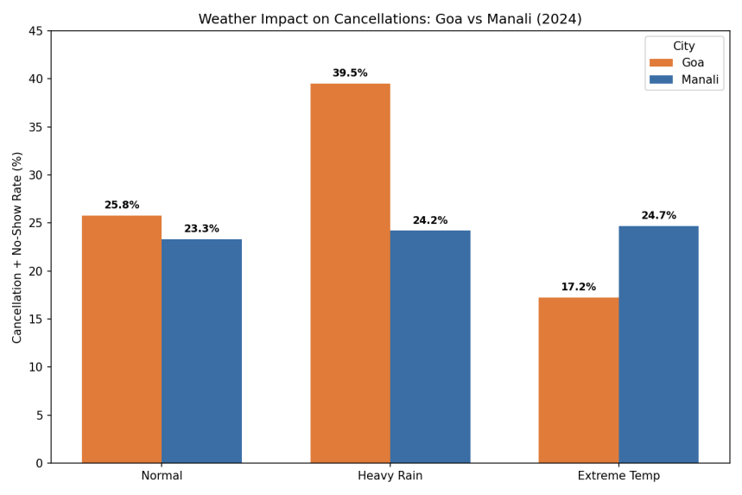
Splitting by city reveals the combined 33.0% Heavy Rain rate was misleading on its own. In Goa, Heavy Rain days show a real, large jump (39.5% vs 25.8% Normal, +13.7pp). In Manali, Heavy Rain days show almost no difference from Normal days (24.2% vs 23.3%, +0.9pp — noise-level). The effect is Goa-specific, not a general weather-cancellation pattern.

The Quantified Insight
Heavy rainfall on the check-in date is associated with a substantially elevated cancellation and no-show rate in Goa specifically — 39.5% on Heavy Rain days versus 25.8% on Normal days, a 13.7 percentage point increase — but shows no meaningful effect in Manali (24.2% vs 23.3%, a negligible 0.9pp difference).
This city-specific pattern would have been invisible without merging live weather data: the dataset alone has no way to distinguish a coincidental cancellation cluster from a genuine weather-driven pattern, let alone reveal that the effect is concentrated in one destination and absent in the other.
The likely explanation is that Goa's core appeal (beach, water sports, outdoor dining) is directly disrupted by rain, while Manali's appeal (mountains, snow, scenery) is comparatively weather-resilient. This suggests Goa-specific rain-contingent cancellation policies (e.g., flexible rebooking near forecasted heavy rain) would be a more targeted intervention than a platform-wide weather policy.

AI Usage Note
Used Claude to draft the initial API error-handling structure (try/except for Timeout, RequestException, and malformed JSON) and the merge logic.
Had to FIX: the AI's first draft of the “extreme temperature” bucket used a single fixed threshold (e.g., >35°C) across both cities — this was wrong, since it would mark all of Manali's winter days as extreme without ever flagging Goa's heat. Corrected this to a per-city percentile rank instead.
Also had to catch a real analytical error: the AI's first read of the combined Goa+Manali Heavy Rain rate (33.0%) was reported as “weather affects cancellations” without checking whether it held in both cities — only after explicitly requesting a city-level split did it surface that the effect is Goa-specific and absent in Manali, which became the actual reportable insight.

