Machine Learning IC Design Report HW1
File structure:
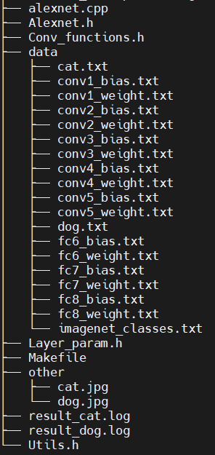

Dog result:
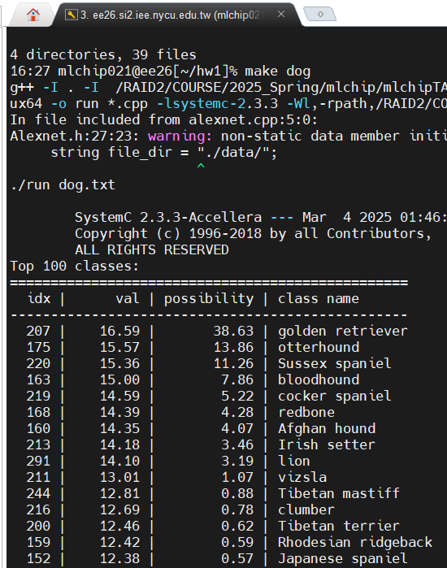

Cat result:
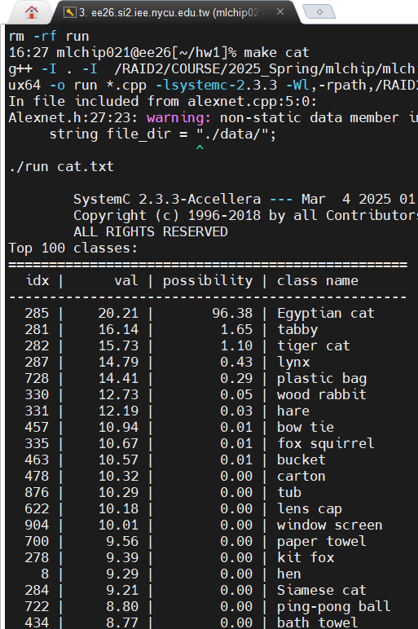

Implementation approach:
Using call function to implement the AlexNet, keep the code short.
The following are the functions.

Convolution
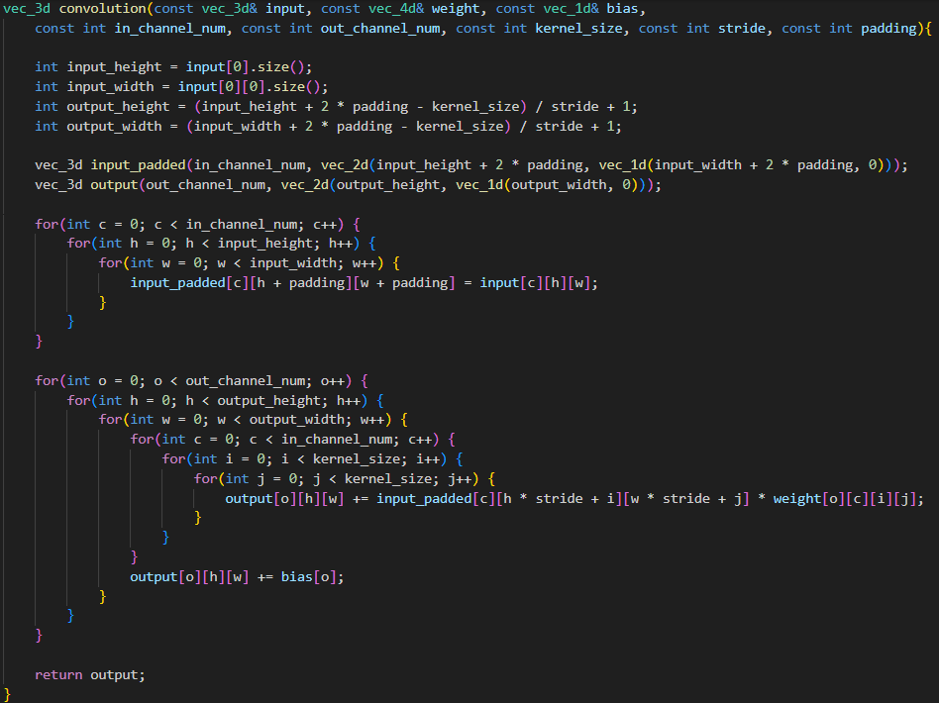

Max pool
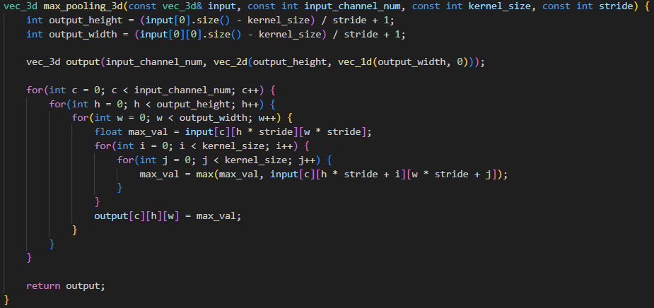

Relu
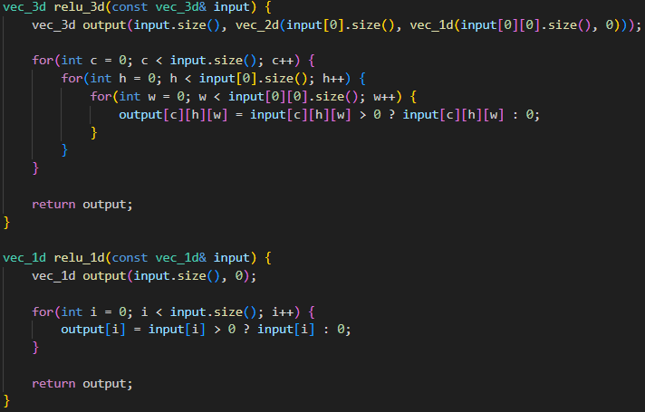

Softmax
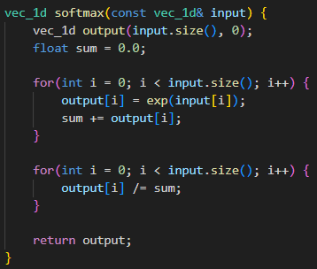

Challenges faced:
This is my first time implementing a large CNN using C++.
During the process, I was not very familiar with the use of vector at the beginning, and the operation of SystemC. I encountered compile problems. Because I could not use C++11, some places were a little different from the teacher's instructions in class, such as pair needs to use "> >" instead of ">>". In addition, some etymological output positioning libraries were used for the first time, so it took some time to understand the syntax. I hope that the teaching assistant's homework instructions will be clearer next time.

Observations:
I found that the padding is somewhat different from the NN I encountered before. Normally, it should be symmetrical padding, but this assignment uses a 2:1 padding method. I don’t know what the benefit is.

Comment:
After this assignment, I feel that I still don’t know what applications SystemC has in hardware. This is because the circuit was too large at the beginning, and I didn’t know how to implement it if I wanted to turn it into a real circuit. For example, it takes more than 20,000 cycles to pass the input data. Later, because I couldn’t realize it, I used software to complete this assignment.

Reference:
Lecture Note
Hw1 handout
ChatGPT

