Machine Learning IC Design Report HW2
File structure:
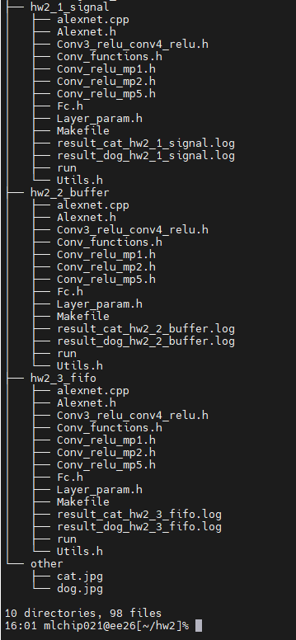

Dog result:
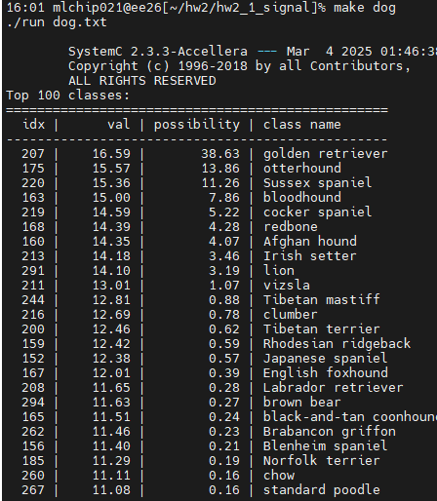

Cat result:
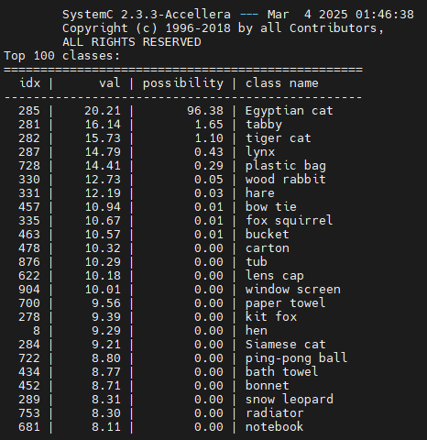

Implementation approach:
Divide the Alexnet into several module ex. Conv_relu_map1.h, Fc.h
Let the same function can do the same thing, to reduce the coding numbers.
The following are the functions.

Convolution
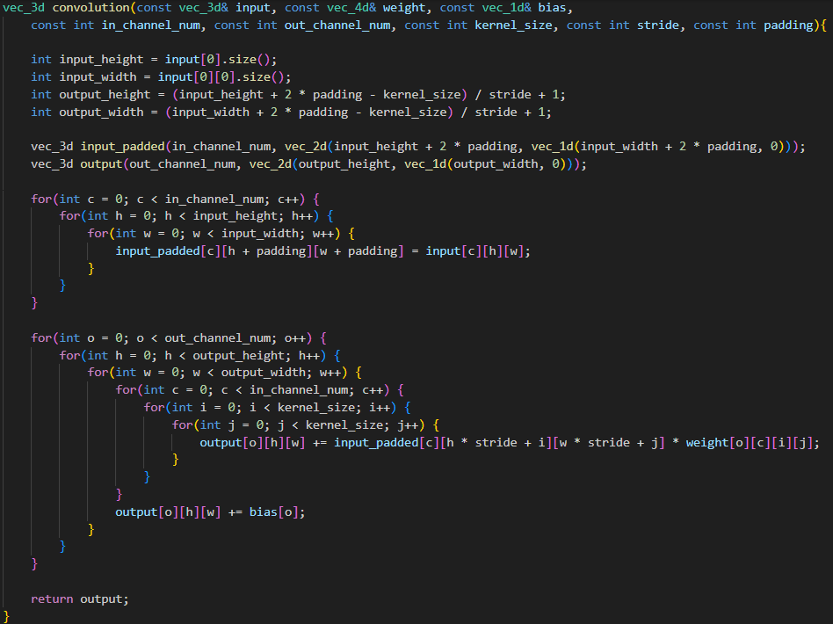

Max pool
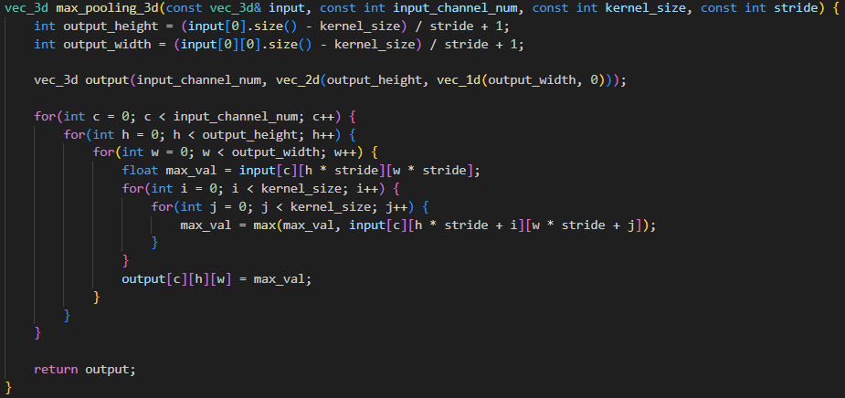

Relu
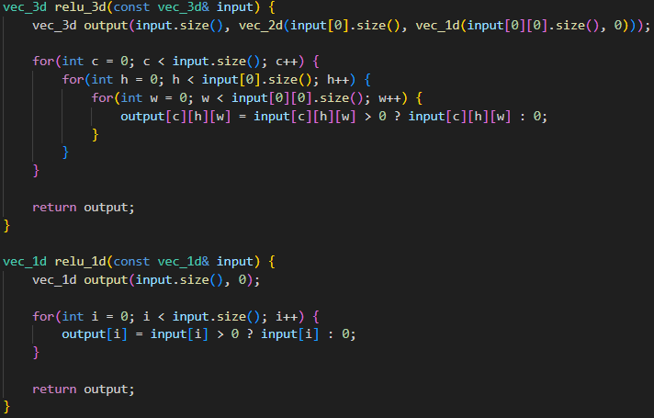

Softmax
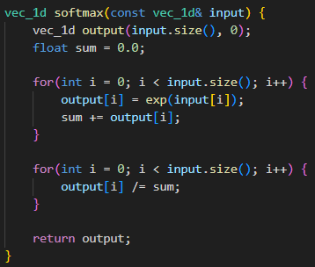

Conv_relu_mp module:
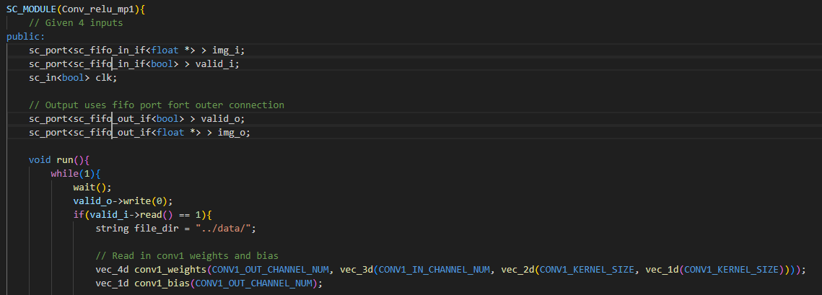

Fc module:
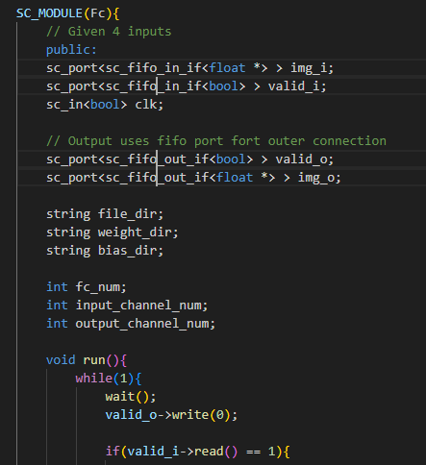

Challenges faced:
sc_port does not support complex dimensions in C++, such as four-dimensional vectors, which need to be converted into one-dimensional float data before being passed to the next module.
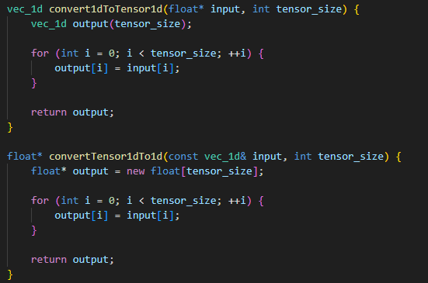

Observations:
Fifo needs to use SC_THREAD to get data. If SC_METHOD is used, it may not get data.

The differences among these three channels:
In SystemC, selecting the appropriate communication channel between modules is essential for ensuring correct synchronization, timing behavior, and simulation performance. The three commonly used channel types—sc_signal, sc_buffer, and sc_fifo—serve different purposes and exhibit distinct characteristics:
- sc_signal<T> represents a wire-like connection that holds a single value. It is typically used for control signals and synchronous communication. Writes to sc_signal take effect in the next delta cycle, and multiple writes in the same delta cycle are not allowed, making it suitable for modeling clocked registers or FSMs.
- sc_buffer<T> is similar to sc_signal, but allows multiple writes within the same delta cycle by overwriting the previous value. This channel is useful for asynchronous or event-driven communication where immediate updates are required, such as triggering events or modeling combinational logic.
- sc_fifo<T> is a first-in-first-out queue that can store multiple values. It supports both blocking and non-blocking operations and is ideal for modeling data streaming, pipelined processing, and communication between producer-consumer modules. FIFO channels help manage backpressure and data flow control effectively.
Choosing the right channel depends on the nature of the data being transferred and the synchronization requirements. sc_signal is best for control and synchronization, sc_buffer for immediate value updates, and sc_fifo for transmitting sequences of data in a structured and flow-controlled manner.

Comment:
After this assignment, I began to understand how to transfer data to different modules through channels and the timing and methods of using different channels. I also learned that I can use the same module to do the same thing, so that I can implement functions of different dimensions through different parameters, without having to write an extra one to save time.

Reference:
Lecture Note
Hw2 handout
Lab1 handout
ChatGPT

