Machine Learning IC Design Report HW3
File structure:
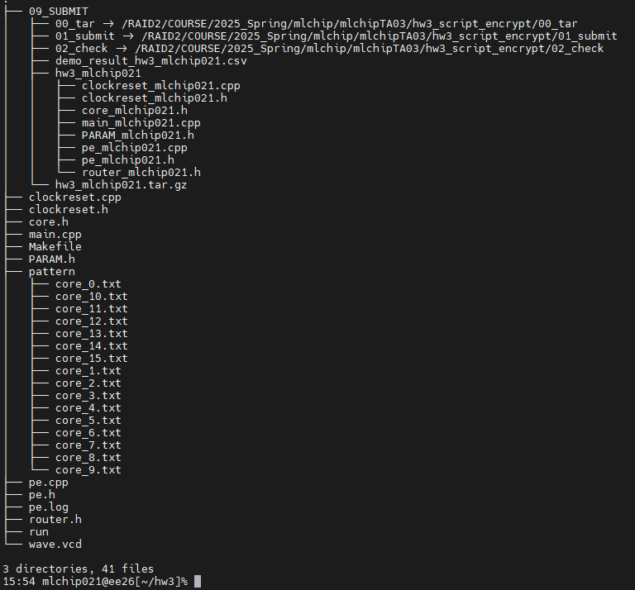

Simulation result:
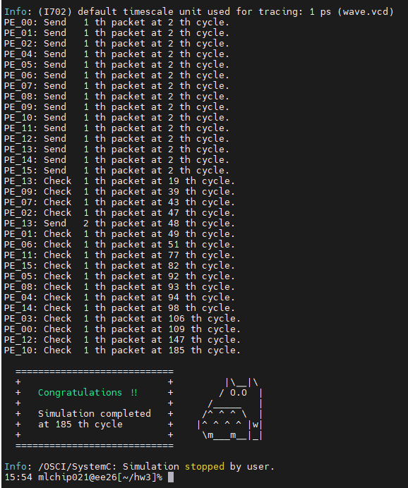

Some questions:
How do you design the router and NI?
I connected each router together to optimize the transmission path, and used handshake-base as the transmission protocol on NI. When transmitting the first header, the source and destination will be sent.
For switching techniques, I use the circuit switching. Because when I try to use wormhole switching I will go into deadlock.
I have tried to use virtual channel, but it is difficult to me. So I decided to use the circuit switching.

What routing algorithm do you use?
I use the XY-routing method to simple the routing algorithm.
In XY mode, I will find the direction closest to the destination and go X first and then Y.

What is the depth of the buffer?
In the input buffer at each Router, I use the depth one buffer for every Router.
Because the design is simple and easy to accomplish.

Do you use virtual channels?
No. Because I use the circuit switching and I can not implement the virtual channel by myself, I don’t use the virtual channel.

Implementation approach:
I first established the core transmission and reception logic, and after confirming that the data can be transmitted normally, I wrote the Router algorithm and protocol logic, and debugged the receiving logic during the implementation process. After confirming that the data can be transmitted normally, I wrote the Router algorithm and protocol logic, and debugged the receiving logic during the implementation process.

Challenges faced:
It was very difficult to trace the wave of SystemC at the beginning, because vcd was not easy to observe in vscode, so I spent a lot of time and effort in the debugging process. Finally, I found that using vcd2fsdb to use nWave to observe the waveform

Observations:
In the pattern, PE13 transmits two packets for unknown reasons, but PE.h is set to receive only one packet. It is also observed that each core of the NOC can transmit packets at the same time as long as the path is not occupied or blocked.

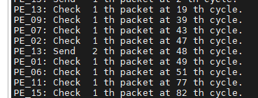

Comment:
Through this assignment, I learned a lot about the internal operation principles of NOC, such as data transmission methods, router algorithms and connection methods, how to establish, how each resource communicates, and most importantly, data is transmitted from a hardware architecture perspective, unlike the previous two times which were more software-oriented. This will be very helpful for my future hardware architecture design, but I still hope that the teaching assistant can provide more resources for learning, such as whether different switching methods can provide different examples to help understand and implement.

Reference:
Lecture Note
Hw3 handout
ChatGPT

