Paired T-tests (part of Ch 17)

Corinne Riddell, PhD

October 30, 2020

## Motivation

Suppose you received the following graphic illustrating cholesterol measurements following two alternate diets. What do you think about these data?

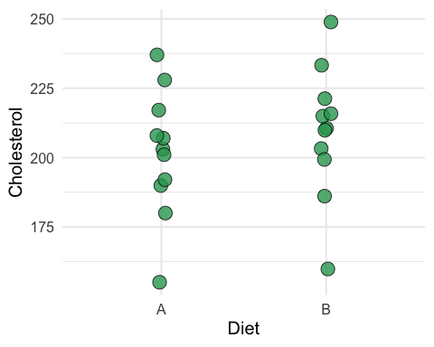

## Motivation

## `summarise()` ungrouping output (override with `.groups` argument)

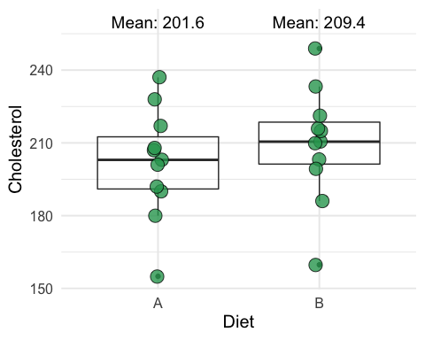

* What do you notice about the variability between participants under each diet?
* What is the mean difference?

## Motivation

An independent t-test reveals no evidence against the null hypothesis of no difference between the diets:

##   
## Two Sample t-test  
##   
## data: chol_dat %>% pull(B) and chol_dat %>% pull(A)  
## t = 0.78557, df = 20, p-value = 0.4413  
## alternative hypothesis: true difference in means is not equal to 0  
## 95 percent confidence interval:  
## -12.77356 28.20653  
## sample estimates:  
## mean of x mean of y   
## 209.3529 201.6364

…Oh my! I forgot to tell you that there were only 11 individuals in the study, and each of them tried out both diets. Let me update my visualization to reflect this a little bit better…

## Motivation

Now, what do you notice about the paired data?

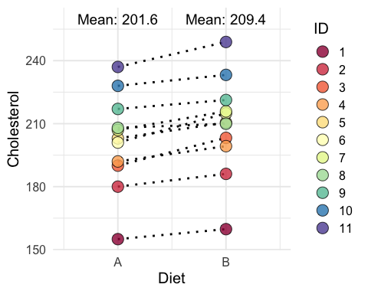

## List of 1  
## $ panel.grid.minor.x: list()  
## ..- attr(*, "class")= chr [1:2] "element_blank" "element"  
## - attr(*, "class")= chr [1:2] "theme" "gg"  
## - attr(*, "complete")= logi FALSE  
## - attr(*, "validate")= logi TRUE

## The paired t-test

* We use a paired t-test when the data is matched by design
  + two observations on each participant/patient
* A paired t-test is a test of the mean differences. It only uses the variation within subject.
* It reduces to a one-sample t-test of the differences. The test statistic is: $T=\frac{μ_{d}−0}{σ_{d}/\sqrt{n}}$
* The observed value of the test statistic is: $t=\frac{{\overline{x}}_{d}−0}{s_{d}/\sqrt{n}}$
* It can be compared to a critical value from the t distribution with $n−1$ degrees of freedom

## Calculate the test statistic, p-value, and 95% confidence interval

* First let’s have a look at the dataset as is:

head(chol_dat)

## A B id  
## 1 155 159.7581 1  
## 2 180 186.0793 2  
## 3 190 203.2348 3  
## 4 192 199.2820 4  
## 5 203 210.5172 5  
## 6 201 214.8603 6

## Calculate the test statistic, p-value, and 95% confidence interval

* We can use functions from the library dplyr to calculate the test statistic
* Use mutate to calculate each participant’s difference:

chol_dat <- chol_dat %>%   
 mutate(diff = B - A)  
  
head(chol_dat)

## A B id diff  
## 1 155 159.7581 1 4.758097  
## 2 180 186.0793 2 6.079290  
## 3 190 203.2348 3 13.234833  
## 4 192 199.2820 4 7.282034  
## 5 203 210.5172 5 7.517151  
## 6 201 214.8603 6 13.860260

## Calculate the test statistic, p-value, and 95% confidence interval

* Then use summarize to calculate the mean difference (${\overline{x}}_{d}$), its standard error ($s_{d}/\sqrt{n}$), and the observed t-statistic:

summary_stats <- chol_dat %>%   
 summarize(mean_diff = mean(diff), # mean difference  
 std_err_diff = sd(diff)/sqrt(n()), # SE of the mean   
 t_stat = mean_diff/std_err_diff) # test statistic  
  
summary_stats

## mean_diff std_err_diff t_stat  
## 1 7.716487 1.168587 6.603262

## Sidebar: The pull() function

What does pull() do in R and how does it compare to select()?

Examine the structure of the output after pull()ing vs. select()ing t_stat from the summary_stat data frame:

summary_stats %>% pull(t_stat) %>% str()

## num 6.6

summary_stats %>% select(t_stat) %>% str()

## 'data.frame': 1 obs. of 1 variable:  
## $ t_stat: num 6.6

## Sidebar: The pull() function

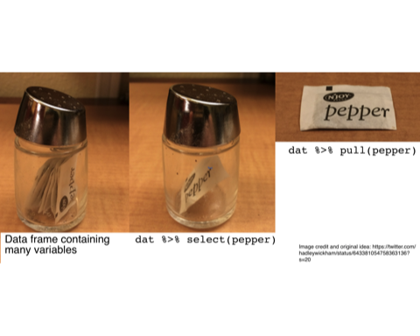

## Calculate the test statistic, p-value, and 95% confidence interval

What is the probability of observing a t-stat $≥$ 6.6 or $≤$-6.6 using the pt command.

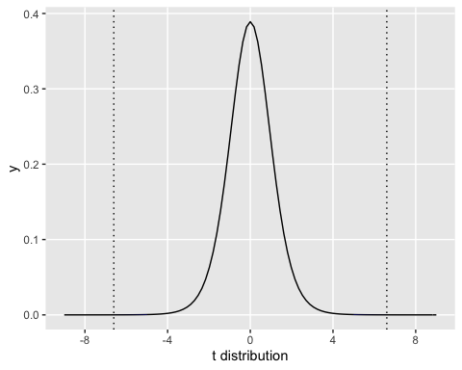

pt(q = summary_stats %>% pull(t_stat), lower.tail = F, df = 10) * 2

## [1] 6.053362e-05

## Calculate the test statistic, p-value, and 95% confidence interval

* To calculate the 95% confidence interval, we need to know the quantile of the t distribution such that 2.5% of the data lies above or below it.
* Ask R: What is the quantile such that 97.5% of the t-distribution is below it on 10 degrees of freedom using the qt command.

q <- qt(p = 0.975, lower.tail = T, df = 10)  
q

## [1] 2.228139

ucl <- summary_stats %>% pull(mean_diff) + (q * summary_stats %>% pull(std_err_diff))   
lcl <- summary_stats %>% pull(mean_diff) - (q * summary_stats %>% pull(std_err_diff))   
c(lcl, ucl) %>% round(2)

## [1] 5.11 10.32

The confidence interval is (5.1127122, 10.3202611).

## Calculate the test statistic, p-value, and 95% confidence interval

* Or, have R do the work for you! Just be sure to specify that paired = T.

paired_t <- t.test(chol_dat %>% pull(B), chol_dat %>% pull(A),   
 alternative = "two.sided", mu = 0, paired = T)  
paired_t

##   
## Paired t-test  
##   
## data: chol_dat %>% pull(B) and chol_dat %>% pull(A)  
## t = 6.6033, df = 10, p-value = 6.053e-05  
## alternative hypothesis: true difference in means is not equal to 0  
## 95 percent confidence interval:  
## 5.112712 10.320261  
## sample estimates:  
## mean of the differences   
## 7.716487

## Compare the outputs from the independent and paired tests

* Note this is the wrong test because these data are **paired**. We print it here to see what the results look like when we run the data as if it were not paired, that is, as if it were **independent**:

indep_t

##   
## Two Sample t-test  
##   
## data: chol_dat %>% pull(B) and chol_dat %>% pull(A)  
## t = 0.78557, df = 20, p-value = 0.4413  
## alternative hypothesis: true difference in means is not equal to 0  
## 95 percent confidence interval:  
## -12.77356 28.20653  
## sample estimates:  
## mean of x mean of y   
## 209.3529 201.6364

## Compare the outputs from the independent and paired tests

* This is the correct test. It accounts for the **paired** nature of the data. How does the test statistics (t), the p-value, and the degrees of freedom change from the previous output?

paired_t

##   
## Paired t-test  
##   
## data: chol_dat %>% pull(B) and chol_dat %>% pull(A)  
## t = 6.6033, df = 10, p-value = 6.053e-05  
## alternative hypothesis: true difference in means is not equal to 0  
## 95 percent confidence interval:  
## 5.112712 10.320261  
## sample estimates:  
## mean of the differences   
## 7.716487

## Compare the outputs from the independent and paired tests

* What is the same?
* What is different?
* What is the estimate of the standard error of the mean for each test?
  + To get the answer, rearrange the formula for the test statistic to solve for the SE. You know the value of the test statistic and the numerator of the test statistic from the R output.

## Compare the outputs from the independent and paired tests

* What is the same?
* What is different?
* What is the estimate of the standard error of the mean for each test?

SE_indep <- (indep_t$estimate[1] - indep_t$estimate[2]) / indep_t$statistic  
SE_paired <- paired_t$estimate / paired_t$statistic  
  
c(unname(SE_indep), unname(SE_paired))

## [1] 9.822822 1.168587

The first value is the SE when the data was treated as if it were independent. The second value is the SE when the data was treated as paired.

## Paired t-test: More juice per squeeze

* The standard error was much lower using the paired test. Why?
* Only variation within a subject was used to calculate the SE of the mean difference
* there was much less variation within a subject than between subjects

## The Statistical Method

**P**roblem **P**lan **D**ata **A**nalysis **C**onclusion

## The Statistical Method

**P**roblem **Plan** **D**ata **A**nalysis **C**onclusion

## Plan, a.k.a. experimental design

* Once the **problem** has been stated, the next step is to determine a **plan** to best answer the question. One of the tenets of design is to maximize **efficiency**.
* In our toy example, a paired test greatly maximized the efficiency by removing the noise introduced by between-subject variability.

## When is a paired design the appropriate design?

* 1. When “the treatment alleviates a condition rather than affects a cure.” (Hills and Armitrage, 1979)
  + The effect of treatment is short-term. After $t$ amount of time, participants return to baseline.
  + The $t$ above refers to the **wash-out** period. Before applying the second treatment, participants should have enough time to reach their baseline level. Otherwise there may be a **carry over** effect.
  + For example, could you run this study if Diet A led to a permanent change in cholesterol levels? No, because if individuals took Diet A first, then their cholesterol measures after Diet B would equal those after Diet A because the effect of Diet A on the outcome is persisting.

## When is a paired design the appropriate design?

* 1. The time between the alternative treatments isn’t so long as to introduce confounding by other factors.
  + For example, if you waited a year between applying treatments, other things may have changed in the world or in a person’s life that affects the outcome.
  + Thus, there is a balance between waiting too long or not waiting long enough.

## Example: Canned soup, fresh soup, and urinary bisphenol A (BPA)

Reference: Carwile JL, Ye X, Zhou X, Calafat AM, Michels KB. **Canned soup consumption and urinary bisphenol A: a randomized crossover trial**. *JAMA*. 2011. 306(20):2218-20.

* One group randomized to consuming canned soup for five days at lunch
* Second group randomized to consuming fresh soup
* After two day washout, treatment assignment were reversed
* On the 4th and 5th day of each treatment, urine samples were collected and pooled for each subject to measure BPA

## Example: Canned soup, fresh soup, and urinary bisphenol A (BPA)

* Paired t-test used to measure the difference
* After canned soup consumption, urinary BPA concentrations were 22.5 ug/L higher (95% CI: 19.6, 25.5) than those measured after fresh soup consumption (p < .001)

## Example: Canned soup, fresh soup, and urinary bisphenol A (BPA)

* Treatment sequence did not appear to affect the results

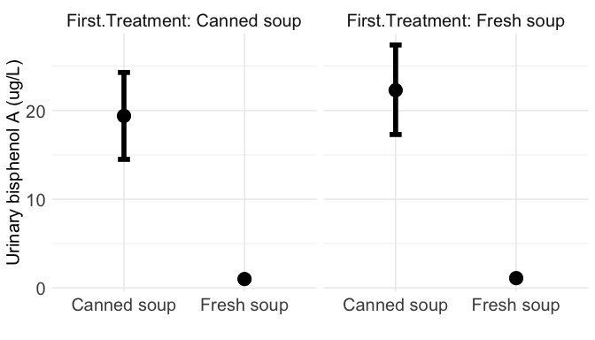

## Statistical assumptions of the paired t-test

* The sample is randomly chosen. How was the sample selected?
* The distribution of differences is normal. How could you examine this assumption?

## Observational analogues

* Recall from our earlier example the primary benefit of the paired t-test
* Total removal of between-subject variability
* Observational settings at high risk of confounding due to differences between subjects can also benefit from this design
* In observational studies, we’re less interested in hypothesis testing, and more interested in estimating the difference and its confidence interval.

## Example: Vaccination during infancy and healthcare utilization

* While there are many disproven concerns about vaccination, one potentially valid concern is that vaccination may trigger an immune response and lead to inflammation and associated hospital visits (Wilson et al, 2011)
* For non-live vaccines, any adverse inflammation event would occur within 3 days of vaccination
* How might you study the effect of vaccination on healthcare utilization?

## Example: Vaccination during infancy and healthcare utilization

* To fully remove confounding from differences between children, you could conduct a paired design in an observational setting
* You can compare a period of time after vaccination to a control period of time *for each child*

## Example: Vaccination during infancy and healthcare utilization

* When should the control period be?
* How long should the washout period be?

## Example: Vaccination during infancy and healthcare utilization

Reference: Wilson K, Hawken S, et al. *Vaccine*. 2011;29(21):3746-52.

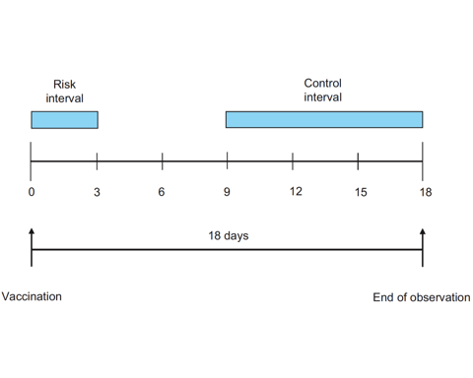

## Example: Vaccination during infancy and healthcare utilization

* “333,244 children received a vaccination at 62 days of age ±30 days, 86% of which were within a ±10 days window. Of these, 1388 experienced one of the combined end-points during the immediate 3 days post vaccination, compared to 4893 in the 9-day control period for our primary analysis. The relative incidence of an event was 0.85 (0.80–0.90).”

## Example: Vaccination during infancy and healthcare utilization

* 1388 events in 3 days after vaccination among 333,244 children
  + This implies 462.7 events per day for these children
* 4893 events in 9 days after vaccination among 333,244 children
  + This implies 543.7 events per day for the same number of children
* The relative difference is: 462.7/543.7 = 0.85, as stated in the paper
* The relative difference is <1 which indicates more events in the 9-18th day after vaccination vs. the 0-3rd day.

## Summary

1. Use a paired t-test in an experimental setting where the data is paired by design.
   * Pairing can greatly improve efficiency of the estimator
2. Incorporate pairing/clustering into observational analyses when the data is paired/clustered by design or in nature.
   * Pairing eliminates confounding from factors that differ between subjects

## Resources

* Gerald Dallal write-up on paired t-tests: <http://emerald.tufts.edu/~gdallal/paired.htm>
  + The cholesterol example was derived from this work.
* Mike Marin lecture on the t distribution (4.18): <https://www.youtube.com/watch?v=ETd-jPhI_tE>, and on conducting paired t tests (4.19): <https://www.youtube.com/watch?v=yD6aU0fY2lo>
  + Useful if you want a short introduction on conducting t tests in R.
* Hills M, Armitage P. The Two-Period Cross-over Clinical Trial. *Br J Clin Pharmac*. 1979. 8:7-20.
  + <https://www.ncbi.nlm.nih.gov/pubmed/15595959>
  + A bit advanced for this lecture. A really nice description of these trial designs.
* Carwile JL, Ye X, Zhou X, Calafat AM, Michels KB. **Canned soup consumption and urinary bisphenol A: a randomized crossover trial**. *JAMA*. 2011. 306(20):2218-20.
  + <https://www.ncbi.nlm.nih.gov/pubmed/22110104>
  + A simple and short example of an experimental crossover trial.
* Wilson K, Hawken S, et al. Patterns of emergency room visits, admissions and death following recommended pediatric vaccinations—a population based study of 969,519 vaccination events. *Vaccine*. 2011;29(21):3746-52.
  + <https://www.ncbi.nlm.nih.gov/pubmed/21443964>
  + Observational example of paired data (emphasis on estimation, not testing).