Chapter 23 (continued): Inference for Regression

Corinne Riddell

November 17, 2020

### Recap

* Last class we covered the assumptions necessary to perform linear regression
* Most of these assumptions can be investigated using plots of the residuals
* One of the assumptions could not be checked using plots. Which assumption was that?

### Recap on notation

|  |  |  |
| --- | --- | --- |
| Term | Population | Sample |
| Intercept | $a$ or $α$ | $\hat{a}$ |
| Slope | $b$ or $β$ | $\hat{b}$ |
| Residual | $e$ | $\hat{e}$ |

Note: I switched the notation for the residual from $r$ to $e$ in these slides, since $r$ was confusing since we used it to denote the correlation coefficient. From now on, use $\hat{e}$ to denote the estimated residual.

### Learning objectives for today

* Conduct a hypothesis test for the slope parameter.
  + Define the test statistic
  + Know how to calculate the test using R output after running lm()
* Create a 95% **confidence interval** for the slope parameter
* Create a 95% **confidence interval** for the predicted value, and a 95% **prediction interval** for an individual value. Know how to explain the difference between the two,
* Describe why the test for correlation is the same as the test of the slope parameter

### Frog data

Recall the frog data from last class on temperature and the frequency of mating calls:

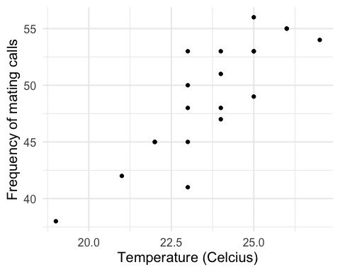

### Use lm() + broom functions to look at your linear model

* tidy(your_lm): Presents the output of the linear model in a tidy way
* glance(your_lm): Takes a quick (one line) look at the fit statistics.
* augment(your_lm): Creates an augmented data frame that contains a column for the fitted y-values ($\hat{y}$) and the residuals ($\hat{e}=y−\hat{y}$) among other columns

Know these functions, what they do, and how to use them.

### Use lm() + broom functions to look at your linear model

frog_lm <- lm(formula = freq ~ temp, data = frog_data)  
tidy(frog_lm)

## # A tibble: 2 x 5  
## term estimate std.error statistic p.value  
## <chr> <dbl> <dbl> <dbl> <dbl>  
## 1 (Intercept) -6.19 8.24 -0.751 0.462   
## 2 temp 2.33 0.347 6.72 0.00000266

glance(frog_lm)

## # A tibble: 1 x 12  
## r.squared adj.r.squared sigma statistic p.value df logLik AIC BIC  
## <dbl> <dbl> <dbl> <dbl> <dbl> <dbl> <dbl> <dbl> <dbl>  
## 1 0.715 0.699 2.82 45.2 2.66e-6 1 -48.1 102. 105.  
## # … with 3 more variables: deviance <dbl>, df.residual <int>, nobs <int>

frog_data_aug <- augment(frog_lm)  
head(frog_data_aug)

## # A tibble: 6 x 8  
## freq temp .fitted .resid .std.resid .hat .sigma .cooksd  
## <dbl> <dbl> <dbl> <dbl> <dbl> <dbl> <dbl> <dbl>  
## 1 38 19 38.1 -0.0952 -0.0430 0.384 2.90 0.000575   
## 2 42 21 42.8 -0.757 -0.293 0.160 2.90 0.00816   
## 3 45 22 45.1 -0.0876 -0.0326 0.0937 2.90 0.0000550  
## 4 45 22 45.1 -0.0876 -0.0326 0.0937 2.90 0.0000550  
## 5 41 23 47.4 -6.42 -2.34 0.0574 2.42 0.167   
## 6 45 23 47.4 -2.42 -0.883 0.0574 2.84 0.0237

* Only need to pay attention to the added columns .fitted and .resid

### New terminology: SSE

Sum of squared estimates of error (**SSE**): $SSE=\sum_{i}^{n}{(}y_{i}−\hat{y_{i}})^{2}$

* The SSE is the summation of the squared distance between each individual’s $y$ value and the fitted (or predicted) value based on the line of best fit
* The higher the **SSE** the worse the model fits the data

We are interested in knowing the average spread of the squared residual distances. Because small spread would indicate a good fitting model. To measure this, we calculate the **regression standard error**

### New terminology: Regression standard error

* The regression standard error can be calculated as: $s=\sqrt{\frac{1}{n−2}×SSE}$
* This can also be written as:
$$s=\sqrt{\frac{1}{n−2}\sum_{i=1}^{n}{{\hat{e}}^{2}}}$$

* or:
$$s=\sqrt{\frac{1}{n−2}\sum_{i=1}^{n}{(y−\hat{y})^{2}}}$$

* We divide by $n−2$ rather than $n$ because this produces an unbiased estimate of $s$.
* A good-fitting model will have a low regression standard error because $\hat{y}$ will be close to y.
* Look at $s$ after running a linear model to assess the model’s fit to the data.
* $s$ is on the same scale as $y$ (i.e., they have the same units).
* glance(your_lm) prints $s$, which is denoted by sigma.

### glance() to view the regression standard error

glance(frog_lm)

## # A tibble: 1 x 12  
## r.squared adj.r.squared sigma statistic p.value df logLik AIC BIC  
## <dbl> <dbl> <dbl> <dbl> <dbl> <dbl> <dbl> <dbl> <dbl>  
## 1 0.715 0.699 2.82 45.2 2.66e-6 1 -48.1 102. 105.  
## # … with 3 more variables: deviance <dbl>, df.residual <int>, nobs <int>

* $sigma=2.82$. This is the regression standard error.

### Another way to contextualize the regression standard error

You can compute a five number summary on the residuals using the augmented data frame:

frog_data_aug %>% summarise(min_resid = min(.resid),  
 q25_resid = quantile(.resid, 0.25),  
 mean_resid = mean(.resid),  
 q75_resid = quantile(.resid, 0.75),  
 max_resid = max(.resid))

## # A tibble: 1 x 5  
## min_resid q25_resid mean_resid q75_resid max_resid  
## <dbl> <dbl> <dbl> <dbl> <dbl>  
## 1 -6.42 -1.92 -2.63e-14 1.00 5.58

* The smallest residual is -6.42 and the largest is 5.58.
* The IQR for the residuals goes from -1.92 to 1.00.
* The mean residual is very close to 0.
* **The residual standard error (2.82) is capturing the standard deviation of this distribution of residuals.**

### Hypothesis testing for regression

* The regression standard error is used as part of the test statistic for the slope coefficient
* In this test, we’d like to know whether the slope is different from 0. That is $H_{0}:b=0$ and $H_{A}:b≠0$ for a two-sided test.

### Frog data showing the estimates slope vs. null hypothesis slope

## `geom_smooth()` using formula 'y ~ x'

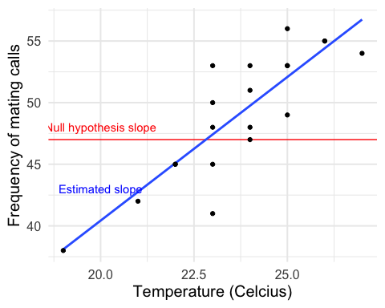

### Hypothesis testing for regression

What are the null and alternative hypotheses?

### Hypothesis testing for regression

$H_{0}:b=0$ (i.e., There is no association between temperature and the frequency of mating calls)

$H_{a}:b≠0$ (i.e., There is an association between temperature and the frequency of mating calls)

### Hypothesis testing for regression

$H_{0}:b=0$ (i.e., There is no association between temperature and the frequency of mating calls)

$H_{a}:b≠0$ (i.e., There is an association between temperature and the frequency of mating calls)

To test the null hypothesis, the t-test statistic is:

$$t=\frac{\hat{b}}{SE_{b}}$$

where $SE_{b}=\frac{s}{\sqrt{∑(x−\overline{x})^{2}}}$ and $s=\sqrt{\frac{1}{n−2}\sum_{i=1}^{n}{(y−\hat{y})^{2}}}$

We will use R to compute the test statistic, $SE_{b}$ and $s$. Be sure you know where $SE_{b}$, $s$, and $\hat{b}$ can be found using the R output and which functions to use to find them.

### Two-sided hypothesis testing for regression using tidy()

tidy(frog_lm)

## # A tibble: 2 x 5  
## term estimate std.error statistic p.value  
## <chr> <dbl> <dbl> <dbl> <dbl>  
## 1 (Intercept) -6.19 8.24 -0.751 0.462   
## 2 temp 2.33 0.347 6.72 0.00000266

Focus on the row of data for temp:

* estimate is the estimated slope coefficient $\hat{b}$: 2.33
* std.error is the standard error, $SE_{b}=0.347$
* statistic is the t-test statistic: $\frac{\hat{b}}{{SE}_{b}}=2.330816/0.3467893=6.72$
* The test has $n−2$ degrees of freedom, where $n$ is the number of observations in the data frame.
* p-value is the p-value corresponding to the test

pt(q = 6.7211302, df = 18, lower.tail = F)*2

## [1] 2.663401e-06

### Confidence intervals for the regression coefficient

We can also use the output from tidy(your_lm) to create a 95% confidence interval for the slope coefficient.

$\text{estimate}±\text{margin of error}$

$\hat{b}±t^{*}{SE}_{b}$

Where $t^{*}$ is the critical value for the t distribution with $n−2$ degrees of freedom with area C (e.g., 95%) between $−t^{*}$ and $t^{*}$.

### Confidence intervals for the regression coefficient

tidy(frog_lm)

## # A tibble: 2 x 5  
## term estimate std.error statistic p.value  
## <chr> <dbl> <dbl> <dbl> <dbl>  
## 1 (Intercept) -6.19 8.24 -0.751 0.462   
## 2 temp 2.33 0.347 6.72 0.00000266

First, find the critical value $t^{*}$, such that 95% of the area is between $t^{*}$ and $−t^{*}$:

t_star <- qt(p = 0.975, df = 18)  
t_star

## [1] 2.100922

95% CI:

$2.330816±t^{*}0.3467893$

$2.330816±2.100922×0.3467893$

95% CI: 1.60 to 3.06

Interpretation: The estimate for the slope coefficient is 2.33 (95% CI: 1.60 to 3.06). We found this interval using a method that gives an interval that captures the true population slope parameter ($b$) 95% of the time.

### Code for the confidence interval

Alternatively you can use the following code to calculate the confidence interval in R:

confint(frog_lm, "temp")

## 2.5 % 97.5 %  
## temp 1.602239 3.059393

### Inference for prediction

* So far we’ve learned only about inference for the slope coefficient $b$.
* But what if you wanted to use the model to make a prediction?
* We already know how to predict the **average** number of mating calls corresponding to a specific $x$ value, say of 21 degrees celcius:

$\hat{y}=−6.190332+2.330816x$

$\hat{y}=−6.190332+2.330816(21)=42.8$

We expect 42.8 mating calls, so 43 mating calls (rounding because the outcome is a discrete variable) when the temperature is 21 degrees celcius.

### Inference for prediction

How do we make a confidence interval for this prediction?

* It depends on whether you want to make a CI for the **average response** or for an **individual’s response**

## `geom_smooth()` using formula 'y ~ x'

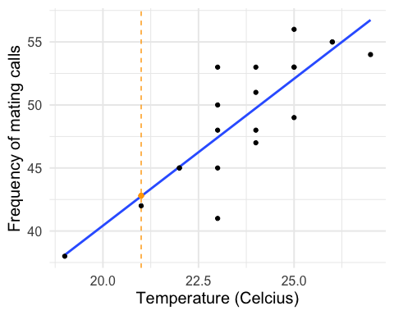

### Inference for prediction of average vs. individual response, visualized

If you want to make inference for the **mean response $μ_{y}$**  when $x$ takes the value $x^{*}$ (x*=21 in our example):

$\hat{y}±t*SE_{\hat{μ}}$, where $SE_{\hat{μ}}=s\sqrt{\frac{1}{n}+\frac{(x^{*}−\overline{x})^{2}}{∑(x−\overline{x})^{2}}}$

If you want to make inference for a **single observation $y$**  when $x$ takes the value $x^{*}$ (x*=21 in our example):

$\hat{y}±t*SE_{\hat{y}}$, where $SE_{\hat{y}}=s\sqrt{1+\frac{1}{n}+\frac{(x^{*}−\overline{x})^{2}}{∑(x−\overline{x})^{2}}}$

### Corresponding R code for prediction and confidence interval:

# specify the value of the explanatory variable for which you want the prediction:  
newdata = data.frame(temp = 21)   
  
# use `predict()` to make prediction and confidence intervals  
prediction_interval <- predict(frog_lm, newdata, interval = "predict")  
prediction_interval

## fit lwr upr  
## 1 42.7568 36.37187 49.14173

confidence_interval <- predict(frog_lm, newdata, interval = "confidence")  
confidence_interval

## fit lwr upr  
## 1 42.7568 40.38472 45.12887

### Inference for prediction, visualized

## `geom_smooth()` using formula 'y ~ x'  
## `geom_smooth()` using formula 'y ~ x'

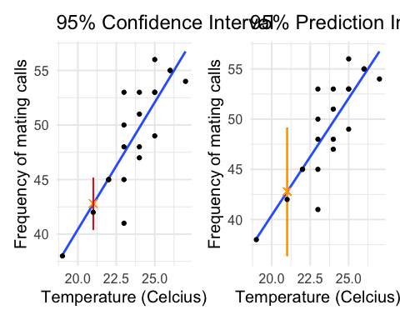

* Why is the prediction interval *wider* than the confidence interval?

### Test for a lack of correlation

* A lack of correlation occurs if and only if there is no association between the explanatory and response variables
* Thus, if your hypothesis test does not reject the null ($b=0$) than this also implies that you would not reject the hypothesis of no correlation between x and y.
* Can you describe the steps of a permutation test to test for a lack of correlation?
* Don’t worry about the book section on this topic “Testing lack of correlation”