Chapter 24: Comparing several continuous means (ANOVA)

Corinne Riddell

November 20 and 23, 2020

### Learning objective for today

* Learn how to conduct a hypothesis test to evaluate whether there is a difference across multiple means. This test is known as ANOVA, or the analysis of variance
* Conduct this test using the aov() function in R.
* After conducting the test, learn how to detect specifically which means are different from one another using Tukey’s HSD test in R.

### A) Is there a difference between these means?

Describe why or why not you think so.

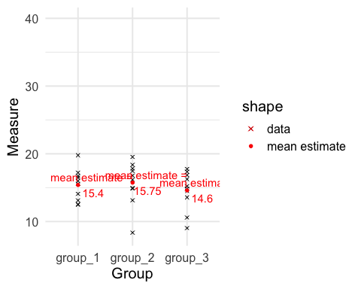

### B) Is there a difference between these means?

Describe why or why not you think so.

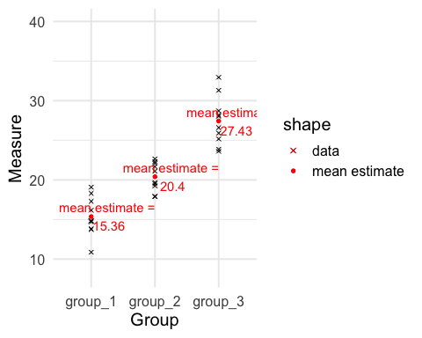

### C) Is there a difference between these means?

Describe why or why not you think so.

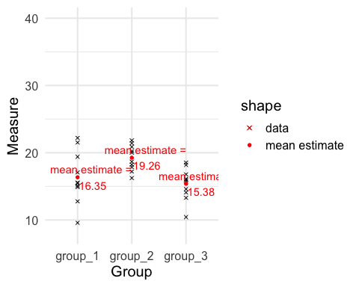

### D) Is there a difference between these means?

Describe why or why not you think so.

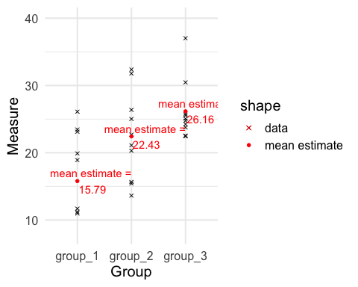

### Summary of the plots

Plot (A)

* The means (red dots) were not very different across the groups. This means the variation **between** the group means was small.
* The distribution of the data (black Xs) was wide enough that the distribution of points for each group overlapped almost completely. This means that the variation **within** each group was relatively wide

### Summary of the plots

Plot (B)

* The means are quite different across the groups. The variation **between** the group means would be larger than in plot (A)
* The distribution of the data overlaps between groups 1 and 2 and 2 and 3, but not 1 and 3. The variation **within** each group is as wide as it was in Plot (A) but doesn’t mask the mean differences, especially between group 1 and 2

### Summary of the plots

Plot (C)

* Here, the means for group 1 and 3 look similar, but the mean for group 2 appears a bit higher than the other two, though there is still overlap between the data from all the groups
* Is there evidence that at least one of the means is different?

### Summary of the plots

Plot (D)

* Plot (D) looked like Plot (B) but with more variation **within** groups
* This variation makes the difference between the means harder to detect

### Overall summary

* What we informally did on the previous slides was compare the variation **between** group means to the variation **within** the groups
* This focus on variation is why this test is called ANOVA: an **AN**alysis **O**f **VA**riance
* When the ratio of **between** vs. **within** variation is large enough then we detect a difference between the groups
* When the ratio isn’t large enough we don’t detect the difference.
* This ratio is our test statistic, denoted by

### Applet

Try out this [Applet](http://digitalfirst.bfwpub.com/stats_applet/stats_applet_1_anova.html).

* Try increasing the SD (this is the SD **within** each group)
* Try decreasing the sample size
* Try moving the means around (to increase or decrease the SD **between** groups)

After each change, notice how the statistic changes. A higher implies that there is much more variation between vs. within the groups. Notice also how the p-value for the test changes.

### The Analysis of Variance (ANOVA)

* ANOVA is used to compare the means of more than two groups when the comparison variable is continuous.
* ANOVA asks, “are the means different from each other?”, Or, “are one or more of the means different from the others?”

### Data

What would the data look like in a data frame?

### Data

What would the data look like in a data frame?

* One “grouping” explanatory variable (categorical)
* One continuous response variable

ANOVA asks if there is an association between the grouping variable and the response variable.

What test asks if there is an association between two categorical variables?

### Descriptive plots

How would you want to plot these data before you conduct a test?

### Descriptive plots

How would you want to plot these data before you conduct a test?

* Option 1: Box plot for each level of the grouping variable (with overlaid data points)

ggplot(diff_3_narrow, aes(x = Group, y = Measure)) +   
 geom_boxplot() +  
 geom_point() +  
 theme_minimal(base_size = 15)

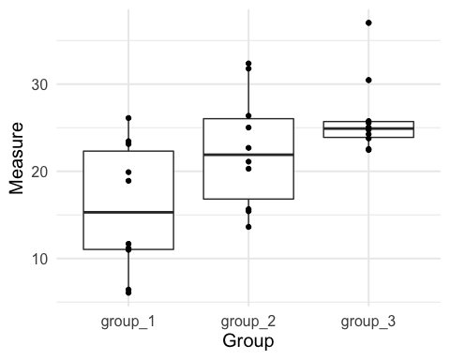

### Descriptive plots

How would you want to plot these data before you conduct a test?

* Option 2: Density plot for each level of the grouping variable

ggplot(diff_3_narrow, aes(x = Measure)) +   
 geom_density(aes(fill = Group), alpha = 0.5) +  
 theme_minimal(base_size = 15)

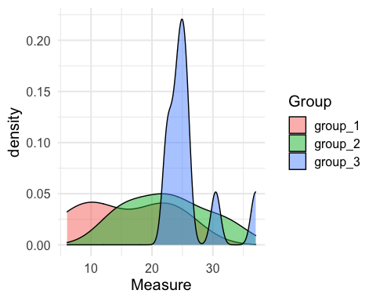

### Descriptive plots

How would you want to plot these data before you conduct a test?

* Option 3: Histogram for each level of the grouping variable

ggplot(diff_3_narrow, aes(x = Measure)) +   
 geom_histogram(aes(fill = Group), col = "white", binwidth = 2.5) +  
 theme_minimal(base_size = 15) + facet_wrap(~ Group, nrow = 3)

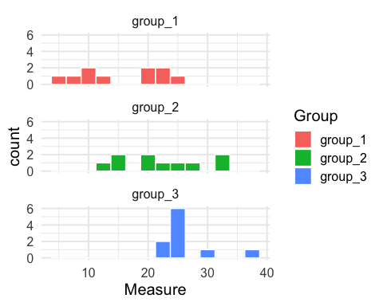

### The hypotheses

**Null hypothesis**

, where is the number of levels of the grouping variable

* Can you also state the null hypothesis in words?

**Alternative hypothesis**

not all , ,…, are equal

* In words: Not all means are the same. Or, at least one of the means differs from the others.

### Example: Cannabis to treat brain cancer in mice

High-grade glioma is an aggressive type of brain cancer with a low long-term survival rate. Cannabinoids, a chemical compounds found in cannabis, are thought to inhibit glioma cell growth. Researchers transplanted glioma cells into otherwise-healthy mice, and then randomly assigned these mice to 4 cancer treatments: irradiation alone, cannabinoids alone, irradiation combined with cannabinoids, or no treatment. The treatments were administered for 21 days, after which the glioma tumor volume (in cubic millimeters) was assessed in each mouse using brain imaging.

### The data

treatment <- c(rep("Irradiation", 4), rep("Cannabinoids", 5), rep("Both", 6),  
 rep("Neither", 7))  
  
tumor_volume <- c(30, 46, 46, 95, # Irradiation  
 12, 14, 16, 41, 47, # Cannabinoids   
 5, 4, 4, 4, 10, 9, # Both  
 24, 30, 43, 51, 62, 32, 96) # Neither  
  
cancer_data <- data.frame(treatment, tumor_volume)  
  
head(cancer_data, 15)

## treatment tumor_volume  
## 1 Irradiation 30  
## 2 Irradiation 46  
## 3 Irradiation 46  
## 4 Irradiation 95  
## 5 Cannabinoids 12  
## 6 Cannabinoids 14  
## 7 Cannabinoids 16  
## 8 Cannabinoids 41  
## 9 Cannabinoids 47  
## 10 Both 5  
## 11 Both 4  
## 12 Both 4  
## 13 Both 4  
## 14 Both 10  
## 15 Both 9

### Graph the data

* Thing about how you want the data to look.
* I want to plot the raw data points and display the mean for each treatment group
* I also want to specify the order that the treatment groups show up in the graph

# specify the order of the treatment groups for plotting  
library(forcats)  
cancer_data <- cancer_data %>%   
 mutate(trt_order = fct_relevel(treatment, c("Neither", "Irradiation",   
 "Cannabinoids", "Both")))  
  
# calculate the means and SD for each group  
summary_stats <- cancer_data %>%   
 group_by(trt_order) %>%   
 summarise(mean_vol = mean(tumor_volume),  
 sd_vol = sd(tumor_volume),   
 samp_size = n())

## `summarise()` ungrouping output (override with `.groups` argument)

summary_stats

## # A tibble: 4 x 4  
## trt_order mean_vol sd_vol samp_size  
## <fct> <dbl> <dbl> <int>  
## 1 Neither 48.3 24.8 7  
## 2 Irradiation 54.2 28.2 4  
## 3 Cannabinoids 26 16.6 5  
## 4 Both 6 2.76 6

### Graph the data

ggplot(cancer_data, aes(x = trt_order, y = tumor_volume)) +   
 geom_jitter(pch = 4, width = 0.1) + # use geom_jitter() to prevent overplotting  
 geom_point(data = summary_stats, aes(y = mean_vol, col = "Mean"), pch = 19) +  
 labs(y = "Tumor volume (mm cubed)", x = "Treatment") +  
 theme_minimal(base_size = 15)

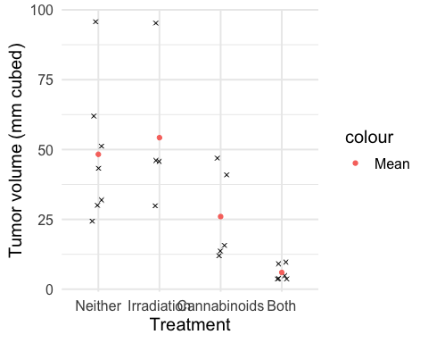

# geom_jitter() with width = 0.1 randomly "jitters" the location of the points   
# along the x axis so that we can see each of them since some have the exact  
# same values.

### The test statistic (a.k.a. the ANOVA F Statistic)

* Numerator is, fundamentally, the variance of the sample means
* Denominator is, fundamentally, an average of the group variances.
* The statistic follows an distribution

### The test statistic (a.k.a. the ANOVA F Statistic)

### Numerator: Mean squares for groups (MSG)

* Let represent the overall sample mean (across all the groups)
* The MSG is like an average of the squared deviations, where groups with high samples are upweighted.
* Each takes a squared difference between group ’s mean and the overall mean. Thus, the larger the , the further away the group means are from the overall mean, and the further away they are from each other in a global sense.

The numerator of the is also called the **sum of squares for groups**:

### Denominator: Mean squares for error (MSE)

* Let the variance for each group be represented by . The variance is our best measure of variation among individuals in the same group.
* The is like a weighted average of the variation among individuals with the same group:
* A higher MSE means there is more variation among individuals within groups.
* The numerator of the is also called the **sum of squares of error**:

### The test statistic (a.k.a. the ANOVA F Statistic)

* We are comparing the variation across the groups to the variation among indivduals in the same group
* If the F statistic is high, then there is relatively more variation across groups than there is within groups.
* If the F statistic is less than 1, then there is more variation across individuals in the same group, then there is between group means.
* Go back to the applet and move things around. See how the F-statistic changes. When is the F-stat very high vs.  when is it <1?

### The distribution

* Skewed right
* Take only positive values
* The distribution depends on the number of means being compared and the sample size for each of the groups
* Let be the number of groups being compared and (the total sample size across all the groups)
* Then the statistic follows an distribution with degrees of freedom in the numerator and degrees of freedom in the denominator
* The p-value of the ANOVA F statistic is always the area to the right of the test statistic

### ANOVA in R: use aov(), then tidy() it up!

* aov() stands for analysis of variance

#reference: https://broom.tidyverse.org/reference/anova_tidiers.html  
library(broom)  
cancer_anova <- aov(formula = tumor_volume ~ treatment, data = cancer_data)  
tidy(cancer_anova)

## # A tibble: 2 x 6  
## term df sumsq meansq statistic p.value  
## <chr> <dbl> <dbl> <dbl> <dbl> <dbl>  
## 1 treatment 3 8060. 2687. 6.70 0.00313  
## 2 Residuals 18 7218. 401. NA NA

* dfdisplays the numerator and denominator degrees of freedom for this dataset
* sumsq displays the **sum of squares for groups** and **sum of squares for error**, and meansq displays the and , respectively.
* You can calculate the meansq column by taking sumsq/df.
* statistic is the test statistic, the ratio of the and . This says that the variation between the means is nearly 7 times as large as the variation within the groups.
* p.value is the p-value for the test. This p-value is equal to 0.3%. There is a 0.3% chance of observing the statistic we observed (or more extreme) under the null hypothesis that all the means are the same. This chance is very low so we reject the null hypothesis in favor of the alternative hypothesis that at least one of the means differs from the others.

### ANOVA in R: use aov(), then tidy() it up!

tidy(cancer_anova)

## # A tibble: 2 x 6  
## term df sumsq meansq statistic p.value  
## <chr> <dbl> <dbl> <dbl> <dbl> <dbl>  
## 1 treatment 3 8060. 2687. 6.70 0.00313  
## 2 Residuals 18 7218. 401. NA NA

You can check that you can calculate the p-value from the F distribution. Remember, that you need to specify a degrees of freedom for the numerator and for the denominator:

pf(6.699489, df1 = 4 - 1, df2 = 22 - 4, lower.tail = F)

## [1] 0.003131703

The p-value equals 0.3%. Under the null hypothesis of no difference between the group means, there is a 0.3% change of observing the F-statistic that we calculated. This is a very small probability, and provides evidence against the null in favor of the alternative hypothesis that at least one mean is different from the others.

### Next steps

* The interpretation of the p-value leaves something to be desired: **What** group or groups is different from the others?
* You could look at all pairwise differences (i.e., comparing each combination of two treatments to each other using two-sample test), but we have to be careful because we will find differences “just by chance” if we compare enough groups.

### Tukey’s honestly significant differences (Tukey’s HSD)

* Tukey’s test maintains a 5% **experimentwise** or **“family”** error rate.
* Even if you make every pairwise comparison, the overall error rate is fixed at 5% (at most)
* Using Tukey’s HSD overcomes the issue of multiple testing. Recall: If you conducted 100 tests with a 5% error rate (i.e., ) AND the was always true, how many p-values would you expect to be < 0.05?
* The Tukey’s error rate is 5% **overall**, no matter how many tests you do. Thus it overcomes the problem of **multiple testing**

### TukeyHSD() to calculate the differences in R

Here is the R code and output:

diffs <- TukeyHSD(cancer_anova, conf.level = 0.95) %>% tidy()  
diffs

## # A tibble: 6 x 7  
## term contrast null.value estimate conf.low conf.high adj.p.value  
## <chr> <chr> <dbl> <dbl> <dbl> <dbl> <dbl>  
## 1 treatme… Cannabinoids-Both 0 20. -14.3 54.3 0.378   
## 2 treatme… Irradiation-Both 0 48.3 11.7 84.8 0.00756  
## 3 treatme… Neither-Both 0 42.3 10.8 73.8 0.00661  
## 4 treatme… Irradiation-Canna… 0 28.2 -9.72 66.2 0.190   
## 5 treatme… Neither-Cannabino… 0 22.3 -10.9 55.4 0.263   
## 6 treatme… Neither-Irradiati… 0 -5.96 -41.4 29.5 0.964

Each row in the table corresponds to a pairwise test. So the first row is looking at the difference between Cannabinoids vs. Both treatments. The estimated difference in means is 20 and the 95% CI is 13.54 to 26.45. The adjusted p-value is 0.38.

* “Adjusted” means that it is adjusted for conducting multiple tests. The unadjusted p-value would be smaller. You can tell the unadjusted p-value would be < 0.05 because the 95% CI doesn’t include 0.
* **Thus, when you have an adjusted test you can’t use the CI to infer the value of the p-value!**

### Visualize the pairwise differences

ggplot(diffs, aes(x = contrast, y = estimate)) + geom_point() +  
 geom_segment(aes(y = conf.low, yend = conf.high, xend = contrast)) +  
 theme_minimal(base_size = 15) +  
 geom_hline(aes(yintercept = 0), lty =2) +  
 geom_text(aes(label = paste0("p-value:\n ", round(adj.p.value, 2))), nudge_x = 0.3) +  
 labs(y = "Estimated difference", x = "") +   
 scale_x_discrete(labels = c("Cannabinoids\n vs. both", "Irradiation\n vs. both",  
 "Irradiation vs.\ncannabinoids", "Neither\n vs. both",   
 "Neither vs.\n Cannabinoids", "Neither vs.\n Irradiation"))

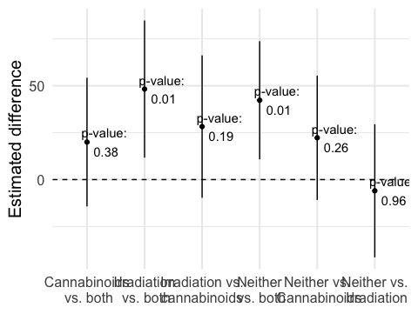

Using Tukey’s HSD, we would conclude that the mean for irradiation is different from the mean for both treatments and the mean for neither treatment is different from the mean for both treatments.

Even though the CIs don’t overlap with the null value, for three of the other comparisons, their adjusted p-values are > 5% so we cannot say for sure if these

### Conditions for ANOVA

**Condition 1: independent SRSs, one from each of populations.**

* The most important assumption, because this method, like the others in Part III of the course, depends on the premise of having taken a random sample.

### Conditions for ANOVA

**Condition 2: Each of the populations has a Normal distribution with an unknown mean .**

* This assumption is less necessary
* The ANOVA test is **robust** to non-Normality.
* What matters more is Normality of the sample means (guaranteed as increases because of the CLT).
* If the sample size is small (say 4-5 individuals per group) then need data that is roughly symmetric with no outliers.

### Conditions for ANOVA

**Condition 3: All the populations have the same standard deviation , whose value is unknown.**

* Hardest condition to satisfy and check
* If this condition is not satisfied ANOVA is often okay if the sample sizes are large enough and if they are similar across the groups
* Can use group_by() and summarize() to calculate the sample SDs to see if they’re similar and indicative that the population parameters are too
* Rule of thumb: want the largest sample standard deviation to be less than twice as largest as the smallest one. I.e.,

### Good video summarizing running ANOVA in R

<https://youtu.be/lpdFr5SZR0Q>

* 5 minutes long
* Mike also talks about the Kruskal Wallis test, which Mi-Suk will introduce you to after Thanksgiving.