Module2 - R Markdown Document 1
Philip Abenojar
May 5, 2026

This is a level 1 header

R Markdown

This is a level 3 header
This is an R Markdown document. Markdown is a simple formatting syntax for authoring HTML, PDF, and MS Word documents. For more details on using R Markdown see http://rmarkdown.rstudio.com.
Here is a link to GOOGLE
Here is a word in bold and another word in bold.
Here is a word in italics and another word in italics.
when we compile our document, we are using the rmarkdown package.
Here are some example R commands:
2+2
mean(c(1,2,3,4,5))
Here is an example of a non-numbered list:
- Breakfast
  - food
    - eggs
    - toast
    - bacon
  - drink
    - apple juice
- Lunch
  - taco
- Dinner
  - baked chicken
  - brocolli
  - rice
We can make this list numbered, but simply using numbers or letters.
Here is an example of a numbered list:
- Breakfast
  - food
    - eggs
    - toast
    - bacon
  - drink
    - apple juice
- Lunch
  - taco
- Dinner
  - baked chicken
  - brocolli
  - rice
Here is an example of blockquote:
This is a block quote. This paragraph has two lines.
- This is a list inside a block quote.
- Second item.
Here is an example of nested blockquote:
This is a block quote, This paragraph has two lines.
This text is nested
Here is an example of code is a blockquote:
2+2
mean(c(1,2,3,4,5))
When you click the Knit button a document will be generated that includes both content as well as the output of any embedded R code chunks within the document. You can embed an R code chunk like this:
summary(cars)
## speed dist
## Min. : 4.0 Min. : 2.00
## 1st Qu.:12.0 1st Qu.: 26.00
## Median :15.0 Median : 36.00
## Mean :15.4 Mean : 42.98
## 3rd Qu.:19.0 3rd Qu.: 56.00
## Max. :25.0 Max. :120.00

Including Plots
You can also embed plots, for example:
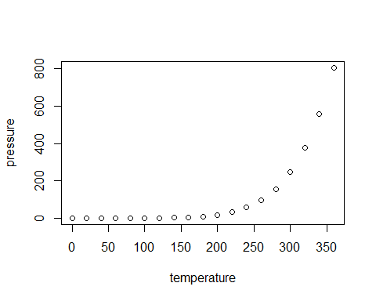
Note that the echo = FALSE parameter was added to the code chunk to prevent printing of the R code that generated the plot.

