**INSY 5341/Section 001**

**Analysis and Design**

**Fall 2022**

**Assignment 3b: Physical Data Model**

Date of submission: 10/29/2022

**Submitted By: Group#2**

Ankita Phadke

Durvakshi Anil Nare

Neil Tuscano

Rehan Rahim Khan

Tharunaa Sakthi Navulluri

Manideep Bavirishetty

**Physical data model: Part 1**

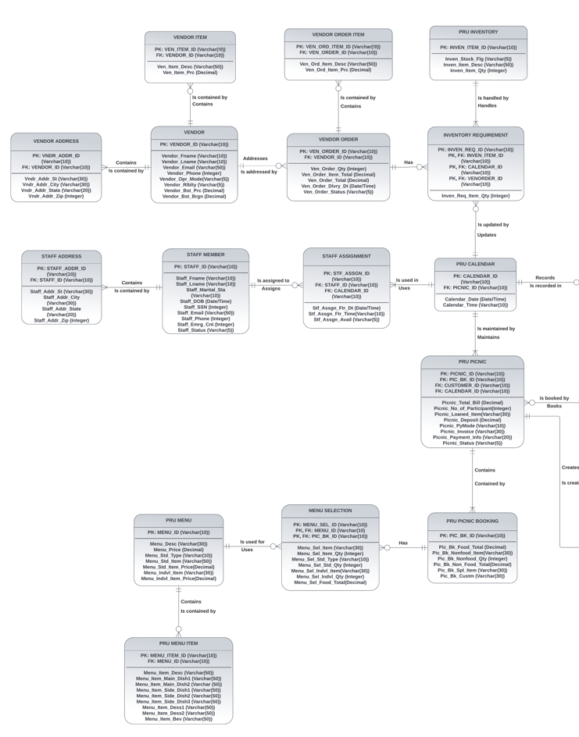

**Physical data model: Part 2**

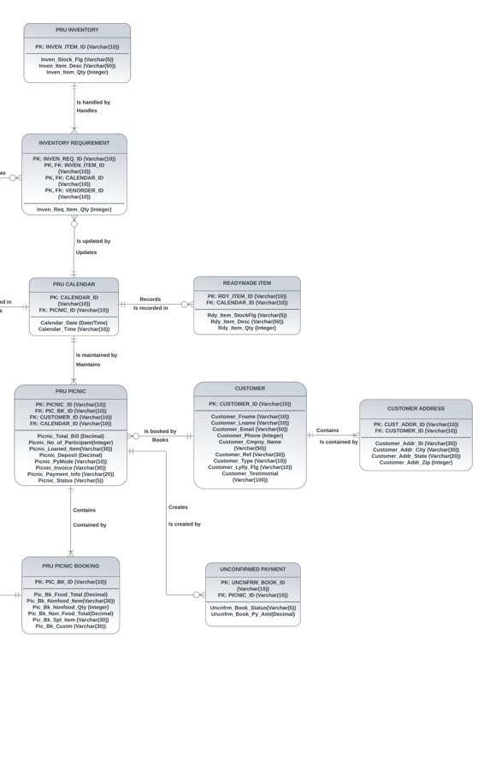

Assumptions:

1. Logical data model had 11 data stores; the no. of entities has increased as part of normalization.
2. Primary key and foreign key have been indicated by PK & FK.
3. M: N relationships are resolved using intersection entities.
4. Association between PRU Picnics - Unconfirmed payment list & PRU Calendar – Readymade Item List has been changed to 1: M vs. the DFD.

**CRUD matrix:**

Note:

1. For some entities, R, U, D appear before C in above diagram but that doesn’t mean the entities are being used before, they are created, this is because the processes are listed here in the same order as in the Use Case assignment and that is not necessarily their order of creation.

