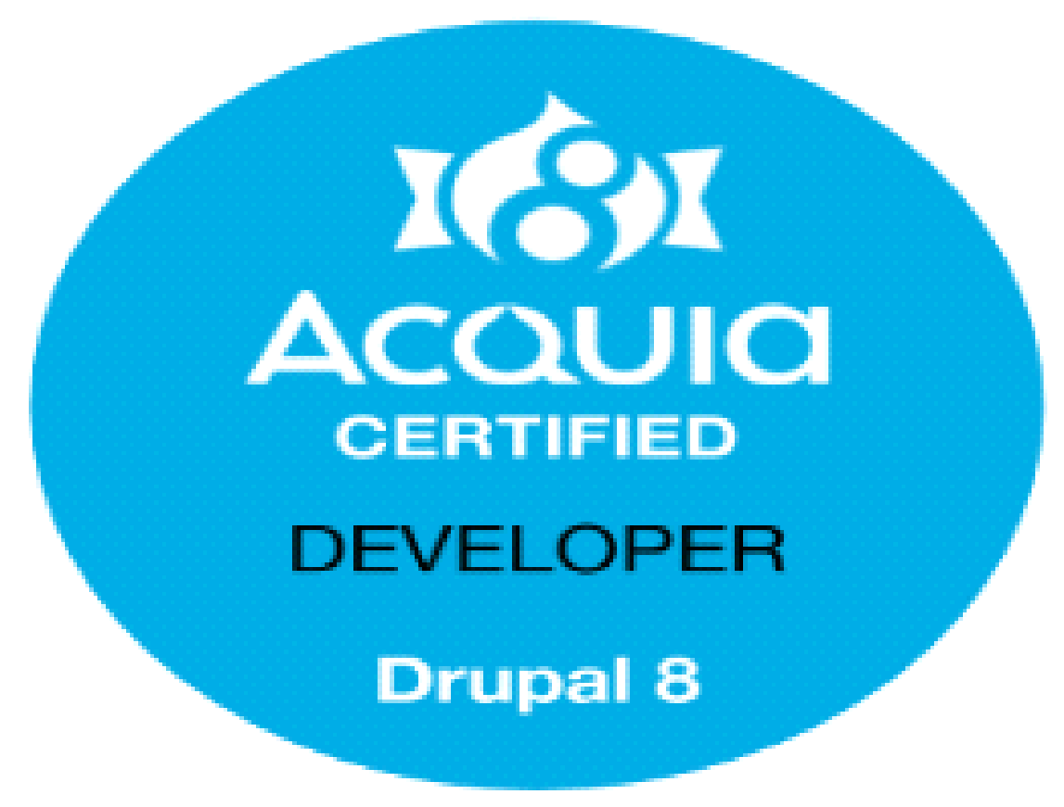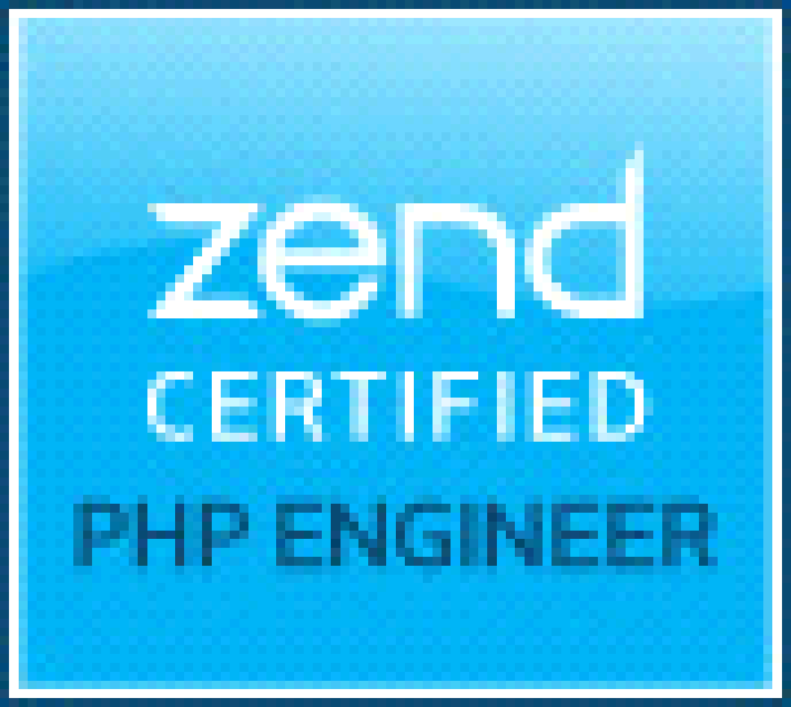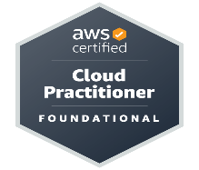

|  |  |
| --- | --- |
| **Name** | Anand Phadnis |
| **Designation** | Technical Lead |
| **Mobile no.** | +91 7600785824 |
| **Email** | phadnisanandhyd@gmail.com |
| **Portfolio website** | <https://phadnisanand.github.io/portfolio/> |
| **Github link** | <https://github.com/phadnisanand> |
| **Current Employer** | Working as Technical Lead in **Tata Consultancy Services** |

|  |
| --- |
| **PROFESSIONAL PROFILE** |

|  |  |
| --- | --- |
| **Brief Profile** | * 13 + years of work experience in web development (PHP, Drupal, WordPress, Symfony, MySQL, jQuery, HTML, CSS, JavaScript, Angular, React), analysis, design, coding * Working as Drupal / PHP Consultant * Writing and maintaining program code to meet system requirements, system designs and technical specifications in accordance with quality accredited standards. * Customer interaction for requirement clarification. * Maintaining and implementing quality guidelines. |
| **Total Experience** | 13 + Year |
| **Education** | **MCA** from **G.H. Raisoni college Nagpur Maharashtra** with **68.37 %** marks in 2010  **B.Sc.** from **Hislop College Nagpur Maharashtra** with **61.78**% marks in 2006 |
| **Certification** | ACQUIA CERTIFIED DRUPAL 8 DEVELOPER  <https://certification.acquia.com/user/2205>  ZEND CERTIFIED PHP ENGINEER  <http://www.zend.com/en/yellow-pages/ZEND021201>  MICROSOFT CERTIFIED UI DEVELOPER  <https://www.youracclaim.com/badges/8241a2b6-e026-4a11-90aa-98d34f9008ae>  REACT CERTIFIED UI DEVELOPER  <https://www.vskills.in/certification/66860-reactjs-certification-anand-phadnis>  Edureka Certified DevOps Engineer  <https://www.edureka.co/lms/certificate/cad1b36a32ee2f75616aaba29260bbe2>  Edureka Certified AWS Developer  <https://www.edureka.co/lms/certificate/cad1b36a32ee2f75616aaba29260bbe2>  AWS Certified Cloud Practitioner  https://www.credly.com/badges/73218382-9912-490b-9701-6aa1f1825b2d |
| **Operating Systems** | MAC, WINDOWS, LINUX |
| **UI DEVELOPMENT** | Bootstrap, HTML 5, CSS 3, SASS, Ajax, jQuery, JavaScript, Angular, React, XML, AJAX, JSON, XSLT |
| **Languages** | PHP, Drupal, Symfony, WordPress |
| **Databases** | MYSQL, MongoDB, SQL Server DB, Hybris |
| **Tools & Technology** | SVN, GITHUB, Gitlab, Travis CI, Bitbucket, JIRA, IRIS, FileZilla, MySQL workbench, Jenkins, Photoshop, Expert Knowledge of Acquia and Amazon web server (AWS) platform. |
| **Payment Gateway** | PayPal, Stripe, Braintree, Authorize.net, MultiSafePay |
| **DevOps** | Docker, Vagrant, Gitlab CI/CD, AWS, ACSF (Acquia cloud site factory), Cloud Acquia |

|  |
| --- |
| **WORK EXPERIENCE** |

❖       Currently working with **TCS Nagpur** as Technical Lead from Jan 2017 to present

❖       Past Worked with **Wipro Technologies Bhubaneswar** as a Senior Software Engineer from

Jul 2015 to Jan 2017

❖       Past Worked with **Infobeans Pune** as a Software Engineer from Sep 2014 to Jul 2015  
  
❖       Past Worked with **Smart data Nagpur** as a Software Engineer from June 2013 to July 2014

❖       Past Worked with **Vsplash techlabs Hyderabad** as a Software Engineer from May 2012 to

June 2013

❖       Past Worked with **21 century web Nagpur** as a Trainee Php developer from April 2011 to

April 2012

**Current Company Name: Tata Consultancy Services**

**(From Jan 2017- Current)**

**Environment**: Drupal 7, Drupal 8, Drupal 9, Symfony, Php

**Cloud Environment:**  ACSF (Acquia cloud site factory), Cloud Acquia, AWS

UI – Node, Angular, SASS, Html 5, CSS

**Project Overview**:  Handled development and support activities in Johnson and Johnson, Bayer, Boehringer Ingelheim, Bpost and Tate & Lyle account.

**Roles and Responsibilities**: As a developer  
❖       Support Drupal 7, Drupal 8, Drupal 9 applications

❖       Support Symfony plus Angular applications built in amazon web server platform.

❖ Performing site launch process including IPAM request, DNS pointing, htaccess, Cloudflare, Akamai rules, SSL installation using comodo portal

❖ Working on Drupal and Php related automation scripts

❖ Working on PHP, Drupal version upgrade

❖ Provide technical assistance to other junior developers and clients

❖     Working on Integration of third-party API

❖      Cross browser and responsive UI issue fixes.

**Past Company Name: Wipro Technologies Bhubaneswar**

**(From Jul 2015– Jan 2018)**

**Project**: VMware project  
**Duration**: Jul 2015 –Sep 2015

**Environment**: Zend, AngularJS  
**Project Overview**:  This project is internal application of VMware company to manage fair value conversion.

**Roles and Responsibilities**: As a developer  
❖       Develop custom Zend and AngularJS functionalities

**Project**: Novartis Alcon project  
**Duration**: Sep 2015 –May 2016

**Environment**: Drupal   
**Project Overview**:  In this project I worked on Drupal 7 functionalities

**Roles and Responsibilities**: As a developer  
❖       Develop Drupal modules

**Project**: Drupal Hybris Integration project   
**Duration**: Sep 2015 –Aug 2015

**Environment**: Drupal, Hybris  
**Project Overview**:  In this project I am working on integration of Hybris E-Commerce platform with Drupal 7 & Drupal 8

**Roles and Responsibilities**: As a developer  
❖       Develop Drupal modules and themes

**Project**: Maiami.com  
**Duration**: Aug 2015 - Current

**Environment**: Drupal, WordPress  
**Project Overview**:  In this project I am working on migration of Drupal 6 site to WordPress according to client requirements.

**Roles and Responsibilities**: As a developer  
❖       Develop migration to WordPress and WordPress plugins