# **Parking Calculator Bug Report**

**Defect ID: 01**

**Summary/Description**: In the Parking Calculator, when any valid Parking Lot options is selected and when Exit Date/Time (or Leaving Date/Time) is before the Entry Date/Time no error message appears stating that the Exit Date/Time is before the Entry Date/Time

**Steps to Replicate**:

1. Go to the URL <http://adam.goucher.ca/parkcalc/>
2. Select the **Short-Term Parking** Option from the *Choose a Lot* dropdown
3. Enter **2:00** **AM** and **01/01/2019** in the *Entry Date and Time* field
4. Enter **1:00 AM** and **01/01/2019** in the *Leaving Date and Time* field
5. Click on *Calculate* button.

**Expected Result:** The Cost should not be calculated and an error message “ERROR! YOUR EXIT DATE OR TIME IS BEFORE YOUR ENTRY DATE OR TIME” should be displayed.

**Actual Result:** The Cost is calculated and is displayed as $0. And the difference between Exit Date/Time and Entry Date/Time is calculated as (-1 Days, 23 Hours, 0 Minutes)

**Defect Severity:** Medium

**Defect Priority:** Medium

**Reported By:** Manisha P

**Assigned To:** -

**Status:** New

**Attachments:**

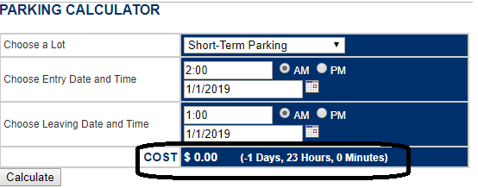

**Defect ID: 02**

**Summary/Description:** In the Parking Calculator, when any of the Parking Lot options is selected and when invalid entry date is entered in the form of 1/32/2018, no error message is displayed stating that the date is invalid, and the parking cost is still calculated.

**Steps to Replicate:**

1. Go to the URL <http://adam.goucher.ca/parkcalc/>
2. Select the **Short-Term Parking** Option from the *Choose a Lot* dropdown
3. Enter **2:00 AM** in the *Entry Time* field
4. Enter **1/32/2018** manually as the *Entry Date*.
5. Enter **1:00 AM** in the *Leaving Time* field
6. Enter the *Leaving Date* as **1/1/2019**.
7. Click on *Calculate* button

**Expected Result:** The Cost should not be calculated and an error message “ERROR! ENTER CORRECTLY FORMATTED DATE” should be displayed.

**Actual Result**: The Cost is displayed as $8,684.00. And the difference between Exit Date/Time and Entry Date/Time is calculated as (333 Days, 23 Hours, 0 Minutes)

**Defect Severity:** Medium

**Defect Priority:** Medium

**Reported By:** Manisha

**Assigned To:** -

**Status:** New

**Attachments:**

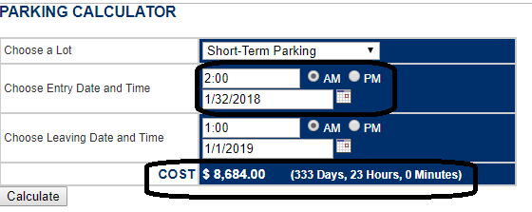

**Defect ID: 03**

**Summary/Description:** In the Parking Calculator, when any of the Parking Lot options is selected and when an invalid entry date is entered in the form of alphabets, no error message is displayed stating that the date is invalid, and the parking cost is still calculated.

**Steps to Replicate:**

1. Go to the URL <http://adam.goucher.ca/parkcalc/>
2. Select the **Short-Term Parking** Option from the *Choose a Lot* dropdown
3. Leave the **12:00 AM** in the *Entry Time* field
4. Enter the *Entry Date* as ‘**aa’** manually
5. Leave the **12:00 AM** in the *Leaving Time* field
6. Enter the *Leaving Date* as **1/1/2019**.
7. Click on *Calculate* button

**Expected Result:** The Cost should not be calculated and an error message “ERROR! ENTER CORRECTLY FORMATTED DATE” should be displayed.

**Actual Result:** The Cost is displayed as $181,300.00. And the difference between Exit Date/Time and Entry Date/Time is calculated as (6973 Days, 0 Hours, 0 Minutes)

**Defect Severity:** Medium

**Defect Priority:** Medium

**Reported By:** Manisha

**Assigned To:** -

**Status:** New

**Attachments:**

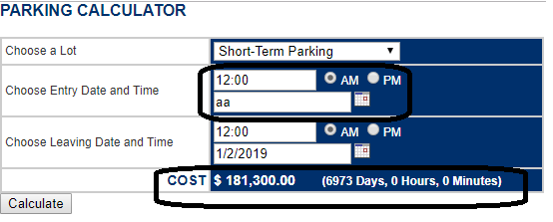

**Defect ID: 04**

**Summary/Description:** In the Parking Calculator, when any of the Parking Lot options is selected and when an invalid entry date is entered in the form of numbers, no error message is displayed stating that the date is invalid, and the parking cost is still calculated.

**Steps to Replicate:**

1. Go to the URL <http://adam.goucher.ca/parkcalc/>
2. Select the **Short-Term Parking** Option from the *Choose a Lot* dropdown
3. Leave the **12:00 AM** in the *Entry Time* field
4. Enter the *Entry Date* as ‘**2’** manually
5. Leave the **12:00 AM** in the *Leaving Time* field
6. Enter the *Leaving Date* as **1/1/2019**.
7. Click on *Calculate* button

**Expected Result:** The Cost should not be calculated and an error message “ERROR! ENTER CORRECTLY FORMATTED DATE” should be displayed.

**Actual Result:** The Cost is displayed as $53,307.00. And the difference between Exit Date/Time and Entry Date/Time is calculated as (6910 Days, 0 Hours, 0 Minutes)

**Defect Severity:** Medium

**Defect Priority:** Medium

**Reported By:** Manisha

**Assigned To:** -

**Status:** New

**Attachments:**

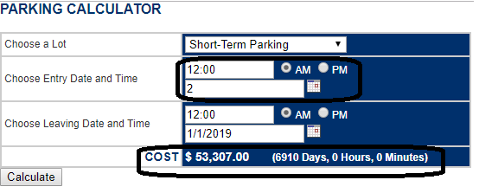

**Defect ID: 05**

**Summary/Description:** In the Parking Calculator, when any of the Parking Lot options is selected and when an invalid Leaving date is entered in the form of 1/41/2018, no error message is displayed stating that the date is invalid, and the parking cost is still calculated.

**Steps to Replicate:**

1. Go to the URL <http://adam.goucher.ca/parkcalc/>
2. Select the **Short-Term Parking** Option from the *Choose a Lot* dropdown
3. Leave the **12:00 AM** in the *Entry Time* field
4. Enter the *Entry Date* as **1/1/2017**.
5. Leave the **12:00 AM** in the *Leaving Time* field
6. Enter the *Leaving Date* as **1/41/2018** manually
7. Click on *Calculate* button

**Expected Result:** The Cost should not be calculated and an error message “ERROR! ENTER CORRECTLY FORMATTED DATE” should be displayed.

**Actual Result:** The Cost is displayed as $10,532.00. And the difference between Exit Date/Time and Entry Date/Time is calculated as (405 Days, 0 Hours, 0 Minutes)

**Defect Severity:** Medium

**Defect Priority:** Medium

**Reported By:** Manisha

**Assigned To:** -

**Status:** New

**Attachments:**

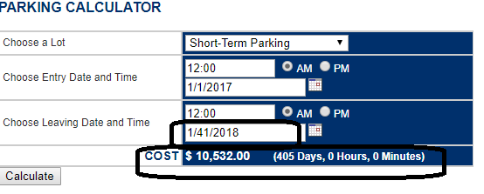

**Defect ID: 06**

Summary/Description: In the Parking Calculator, when any of the Parking Lot options is selected and when an invalid Entry time is entered in the form of 52:00, no error message is displayed stating that the time is invalid, and the parking cost is still calculated.

**Steps to Replicate:**

1. Go to the URL <http://adam.goucher.ca/parkcalc/>
2. Select the **Economy Parking** Option from the *Choose a Lot* dropdown
3. Enter the **52:00** in the *Entry Time* field and leave the **AM** option selected
4. Enter the *Entry Date* as **1/1/2017**.
5. Leave the **12:00 AM** in the *Leaving Time* field
6. Enter the *Leaving Date* as **1/3/2017**.
7. Click on *Calculate* button

**Expected Result:** The Cost should not be calculated and an error message for invalid time should be displayed.

**Actual Result:** The Cost is displayed as $9.00. And the difference between Exit Date/Time and Entry Date/Time is calculated as (-1 Days, 20 Hours, 0 Minutes)

**Defect Severity:** Medium

**Defect Priority:** Medium

**Reported By:** Manisha

**Assigned To:** -

**Status:** New

**Attachments:**

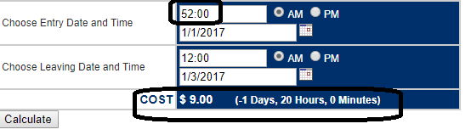

**Defect ID: 07**

**Summary/Description:** In the Parking Calculator, when any of the Parking Lot options is selected and when an invalid Entry time is entered in the form of -2:00 and an invalid Leaving Time is also entered in the form of -1:00, no error message is displayed stating that the time is invalid, and the parking cost is still calculated.

**Steps to Replicate:**

1. Go to the URL <http://adam.goucher.ca/parkcalc/>
2. Select the **Economy Parking** Option from the *Choose a Lot* dropdown
3. Enter the **-2:00** in the *Entry Time* field and leave the **AM** option selected
4. Enter the *Entry Date* as **1/1/2017**.
5. Enter the **-1:00** in the *Leaving Time* field and leave the **AM** option selected.
6. Enter the *Leaving Date* as **1/1/2017**.
7. Click on *Calculate* button

**Expected Result:** The Cost should not be calculated and an error message for invalid time should be displayed.

**Actual Result:** The Cost is displayed as $2.00. And the difference between Exit Date/Time and Entry Date/Time is calculated as (0 Days, 1 Hours, 0 Minutes)

**Defect Severity:** Medium

**Defect Priority:** Medium

**Reported By:** Manisha

**Assigned To:** -

**Status:** New

**Attachments:**

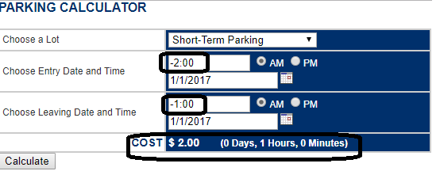

**Defect ID: 08**

**Summary/Description:** In the Parking Calculator, when any of the Parking Lot options is selected and when a blank Entry date is entered, no error message is displayed stating that the date is invalid, and cost is still calculated.

**Steps to Replicate:**

1. Go to the URL <http://adam.goucher.ca/parkcalc/>
2. Select the **Short-Term Parking** Option from the *Choose a Lot* dropdown
3. Leave the **12:00 AM** in the *Entry Time* field
4. Delete the contents of the *Entry Date* field to make it **empty/blank**.
5. Leave the **12:00 AM** in the *Leaving Time* field
6. Enter the *Leaving Date* as **1/1/2019**.
7. Click on *Calculate* button

**Expected Result:** The Cost should not be calculated and an error message “ERROR! ENTER CORRECTLY FORMATTED DATE” should be displayed.

**Actual Result:** The Cost is displayed as $181,274.00. And the difference between Exit Date/Time and Entry Date/Time is calculated as (6972 Days, 0 Hours, 0 Minutes)

**Defect Severity:** Medium

**Defect Priority:** Medium

**Reported By:** Manisha

**Assigned To:** -

**Status:** New

**Attachments:**

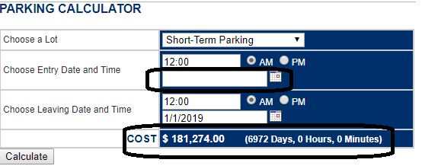

**Defect ID: 09**

**Summary/Description:** In the Parking Calculator, when any of the Parking Lot options is selected and Entry date and Leaving Date are entered as empty/blank, no error message is displayed stating that the date is invalid, and cost is still calculated.

**Steps to Replicate:**

1. Go to the URL <http://adam.goucher.ca/parkcalc/>
2. Select the **Short-Term Parking** Option from the *Choose a Lot* dropdown
3. Leave the **12:00 AM** in the *Entry Time* field
4. Delete the contents of the *Entry Date* field to make it **empty/blank**.
5. Leave the **12:00 AM** in the *Leaving Time* field
6. Delete the contents of *Leaving Date* field to make it **empty/blank**.
7. Click on *Calculate* button

**Expected Result:** The Cost should not be calculated and an error message “ERROR! ENTER CORRECTLY FORMATTED DATE” should be displayed.

**Actual Result:** The Cost is displayed as $2.00. And the difference between Exit Date/Time and Entry Date/Time is calculated as (0 Days, 0 Hours, 0 Minutes)

**Defect Severity:** Medium

**Defect Priority:** Medium

**Reported By:** Manisha

**Assigned To:** -

**Status:** New

**Attachments:**

