Project Proposal: Habitat Suitability Analysis for the Elusive
Red Hills Salamander (Phaeognathus hubrichti)

Coral Quering
Department of Biological Sciences, University of Alabama in Huntsville
AES 408: Python for GIS
Dr. Sean Freeman
07 March 2026

Project Proposal: Habitat Suitability Analysis for the Elusive
Red Hills Salamander (Phaeognathus hubrichti)

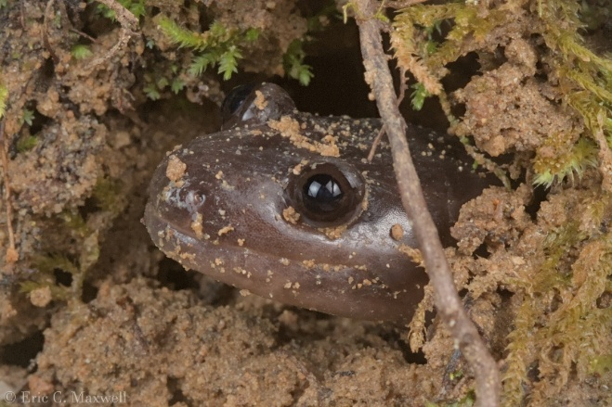
Project Overview
The goal of this project is to use available remote sensing data [including x, y, z] to identify potentially suitable habitat for the elusive and threatened Alabama state amphibian, the Red Hills Salamander (Phaeognathus hubrichti). P. hubrichti is considered extremely range-limited and is endemic to [region] Alabama. Based on current occurrence records, the species is present only in [counties/sites] with its range being bounded [rivers, directions].Traditionally, these rivers as well as the presence of claystone-based geologic layers have been treated as predictive indicators for species presence
Figure 1: A Red Hills Salamander in its burrow

2012: “the range of P. hubrichti is also naturally fragmented, as a result of the species’ reliance on a set of specific geologic formations (Tallahata, Hatchetigbee, and Nanafalia) and ecological conditions, including steep (generally greater than 30) slopes and mature hardwood canopy (Schwaner and Mount 1970; Jordan and Mount 1975; Dodd 1991) and the typically poor dispersal of amphibians in general (see, e.g., Blaustein et al. 1994; Pabijan et al. 2005; Measey and Tolley 2011).”

In addition to its recognition as an Alabama state symbol, P. hubrichti is
- Stakeholders
- Importance

Habitat suitability analysis/range mapping for Phaeognathus hubrichti (Caudata: Plethodontidae)
Overall goal: predict potential suitable sites by creating a habitat suitability raster for the species If I can get access to reliable occurrence site coordinates (ask Eric), use these to test whether the suitability model includes these sites. This can test whether the model is too selective to a certain degree, but cannot test whether the model is selecting too much potential habitat and should be more restrictive.
- Endangered (IUCN 2021 https://www.iucnredlist.org/species/16801/118974152)
- G2 Imperiled (NatureServe https://explorer.natureserve.org/Taxon/ELEMENT_GLOBAL.2.103613/Phaeognathus_hubrichti)
- Alabama-endemic
- Cryptic – first documented in 1960 and not found again until 1963
- Monotypic genus
Valentine 1963
- May often co-occur with trapdoor spiders. May occupy burrows created by the spiders; if this is the case, presence of trapdoor spiders could be used as a predictive parameter spoke w/ eric and this is probably not a good parameter

Proposed Plan and Deliverables
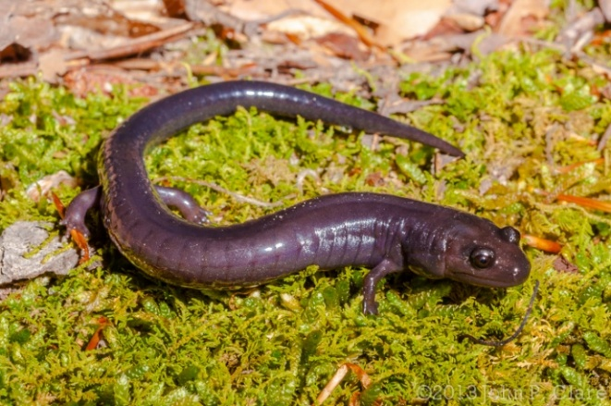

References

