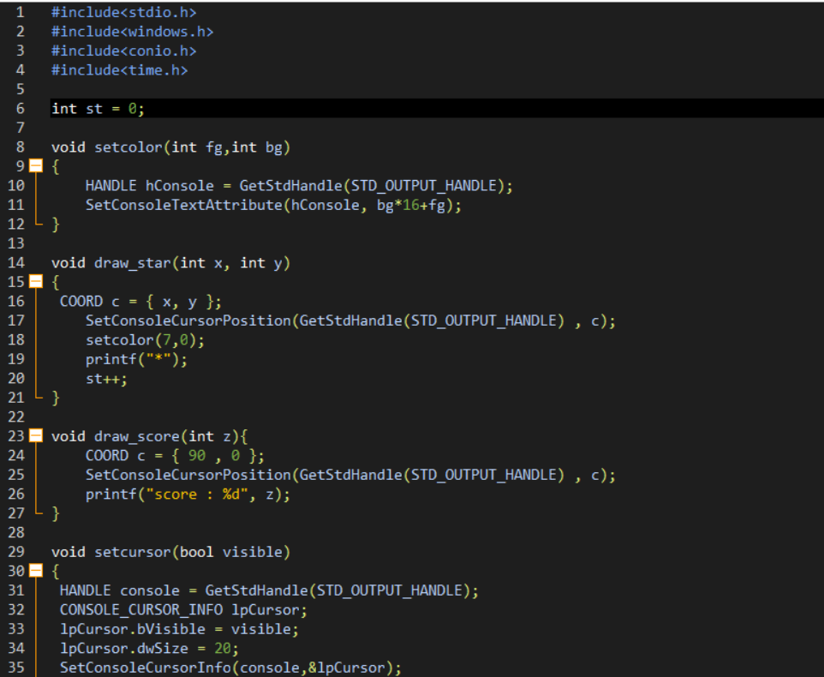

<https://github.com/phakmitl/daily_of_PF/blob/main/day7/main.cpp>

https://youtu.be/8m5h5vQeZrs