# Algorithm for file updates in Python

## Project description

This python script opens a file of IP addresses and removes a number of IP addresses from the file. The file is saved after the changes are made

## Open the file that contains the allow list

Opens file for reading of the allowed IP addresses from the text file “allow_list.txt”. The with statement opens the file as read-only

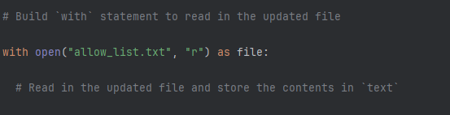

## Read the file contents

Moves the contents of the file into the variable ip_addresses.

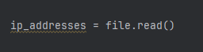

## Convert the string into a list

The .split function converts the string in to a list for searching for specific IP addresses

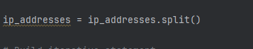

## Iterate through the remove list

search through ip_addresses list for the address in the remove_list

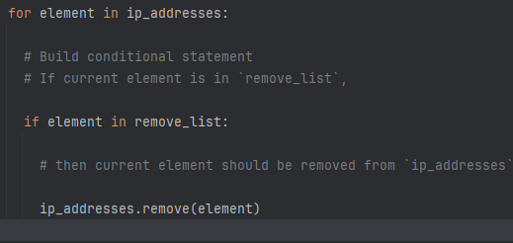

## Remove IP addresses that are on the remove list

Remove a specific address in the ip_address list.

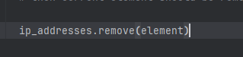

## Update the file with the revised list of IP addresses

Converts the list back into a string to be written into the file we initially used. This creates an updated file.

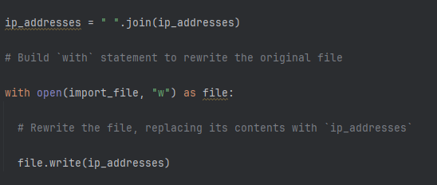

## Summary

This script provides an easy way to search trough a file and remove a series of IP addresses.