# ACTIVITIES

EXERCISE 1:

|  |  |
| --- | --- |
| Objective | Jack must sum the number on cell and paint on the dots cell.  **Your code shall work for the 2 cases!!!!** |
| Maximum number of instructions | 10 |
| Allowed instructions | IF <CONDITION> WHILE <CONDITION>  GO-RIGHT REPEAT <N TIMES>  PICK-UP PAINT-CELL SET <MY-NUMBER>TO<>  INCREMENT<MY-NUMBER> OF <> <MY-NUMBER> <value on cell> |
| Allowed conditions | <HAS DOT>  <HAS CELL ON RIGHT> |

Case 1:



Case 2:



GO-RIGHT

GO-RIGHT

SET <MY-NUMBER>TO<value on cell>

GO-RIGHT

INCREMENT<MY-NUMBER> OF < value on cell >

GO-RIGHT

GO-RIGHT

PAINT-CELL

REPEAT < MY-NUMBER >

GO-RIGHT

PAINT-CELL

EXERCISE 2:

|  |  |
| --- | --- |
| Objective | * Pick up all apples * Print the number of apples on the green cell.   **Your code shall work for the 2 cases!!!!** |
| Maximum number of instructions | 7 |
| Allowed instructions | IF <CONDITION> WHILE <CONDITION>  GO-RIGHT REPEAT <N TIMES>  PICK-UP PAINT-CELL WRITE<value> SET <MY-NUMBER>TO<>  INCREMENT<MY-NUMBER> OF <> <MY-NUMBER> |
| Allowed conditions | <HAS CELL ON LEFT> <HAS APPLE>  <HAS CELL ON RIGHT> |

Case 1:



Case 2:



SET <MY-NUMBER>TO<0>

WHILE < HAS CELL ON RIGHT> >

GO-RIGHT

IF < HAS APPLE >

PICK-UP

INCREMENT<MY-NUMBER> OF <1>

WRITE<value>

EXERCISE 3:

|  |  |
| --- | --- |
| Objective | * Paint on cell that has not apple from first cell * Print the number of apples on the green cell * លាបពណ៍នៅលើក្រលាដែលគ្មានផ្លែប៉ោមចាប់ពីក្រលាដំបូង​ ហើយសរសេរចំនូនផ្លែប៉ោមនៅក្នុងប្រអប់ពណ៍ប៉ែតង   **Your code shall work for the 2 cases!!!!** |
| Maximum number of instructions | 8 |
| Allowed instructions | GO-RIGHT PICK-UP GO-DOWN  WHILE <CONDITION> IF<CONDITION>  IF<CONDITION> ELSE PAINT-CELL  WRITE<value> SET<my_number>TO<>  INCREMENT<my_number> OF <>  <my_number > |
| Allowed conditions | <HAS APPLE>  <HAS CELL ON RIGHT> |

Case 1:

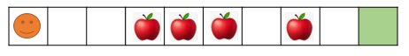

Case 2:



SET<my number>TO<0>

WHILE < HAS CELL ON RIGHT >

GO-RIGHT

IF< HAS APPLE >

PICK-UP

INCREMENT<my number> OF <1>

PAINT-CELL

GO-RIGHT

ELSE

WRITE<value>

EXERCISE 4:

|  |  |
| --- | --- |
| Objective | Bring apple into the black box |
| Maximum number of instructions | 10 |
| Allowed instructions | GO-RIGHT GO-LEFT PICK-UP GO-DOWN DROP  WHILE <CONDITION> REPEAT<N TIME> IF<CONDITION> WRITE<value> SET<my_number>TO<> GO-UP  INCREMENT<my_number> OF <>  <my_number > <value on cell> |
| Allowed conditions | <HAS APPLE> <HAS GREEN CELL>  <HAS CELL ON RIGHT> <HAS **NOT** GREEN CELL> |

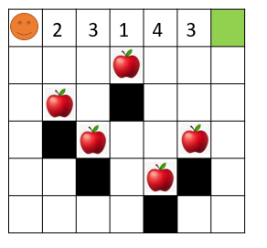

WHILE <CONDITION>

GO-RIGHT

REPEAT< value on cell >

SET<my number>TO< value on cell>

EXERCISE 5:

|  |  |
| --- | --- |
| Objective | Pick up all apples!!!  **Warning: your code shall work for the 2 cases!!!!** |
| Maximum number of instructions | 12 |
| Allowed instructions | IF <CONDITION> GO-RIGHT PICK-UP GO-DOWN GO-UP  REPEAT < > TIMES WHILE <CONDITION>  WRITE < > SET <MY-NUMBER>TO< >  INCREMENT<MY-NUMBER> OF < > <MY-NUMBER> |
| Allowed conditions | <HAS CELL ON LEFT> <HAS APPLE>  <HAS CELL ON RIGHT> |

**CASE 1 : CASE 2:**

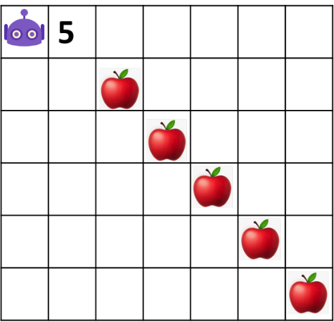 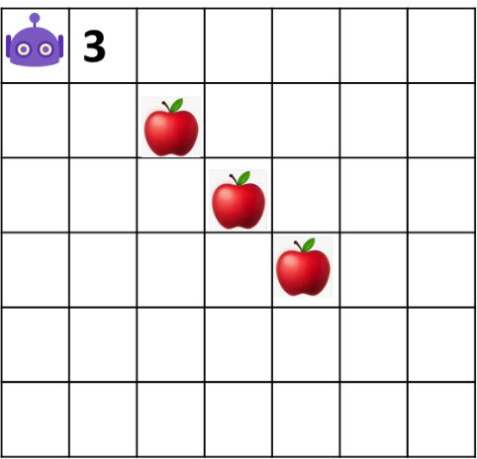

GO-RIGHT

SET <MY-NUMBER>TO< 1 >

INCREMENT<MY-NUMBER> OF < 1 >

GO-RIGHT

PICK-UP

GO-DOWN

REPEAT < HAS APPLE > TIMES

WHILE < HAS CELL ON RIGHT >