**USING LOOP IN LOOP**

1. Please write code to display like this.

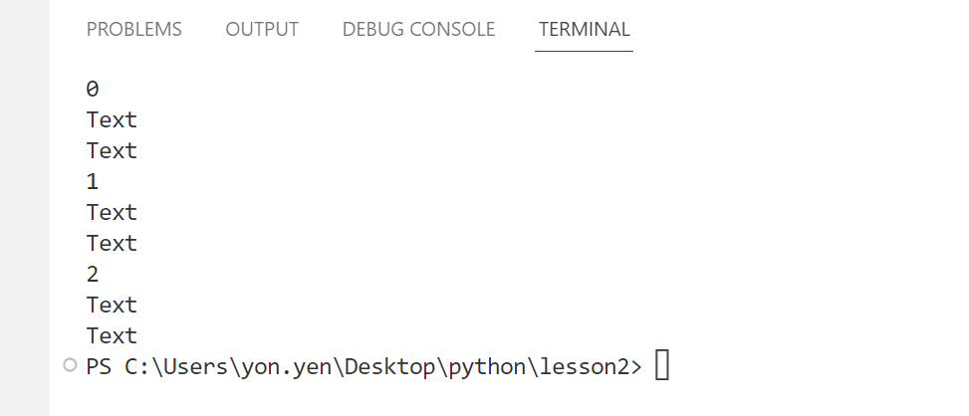

for i in range(3):

    print(i)

    for z in range(2):

        print("text")

1. Please write code to display like this.

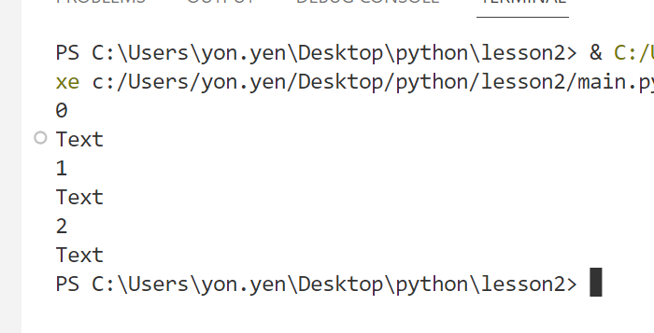

for i in range(3):

    print(i)

    for x in range(1):

        print("text")

1. Please write code to display like this.

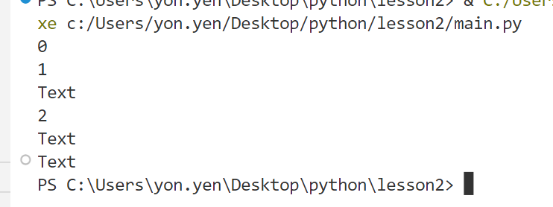

for i in range(3):

    print(i)

    for z in range(i):

        print("text")

1. Please write code to display like this.

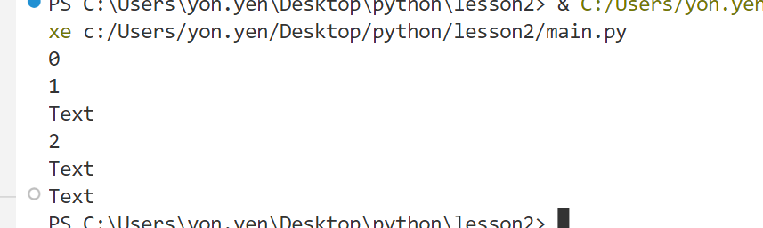

1. Please write code to display like this.

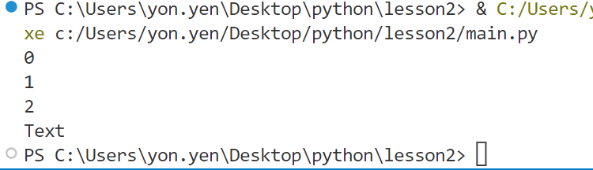

for i in range(3):

    print(i)

    for x in range(i-1):

        print("text")

1. Please write code to display like this.

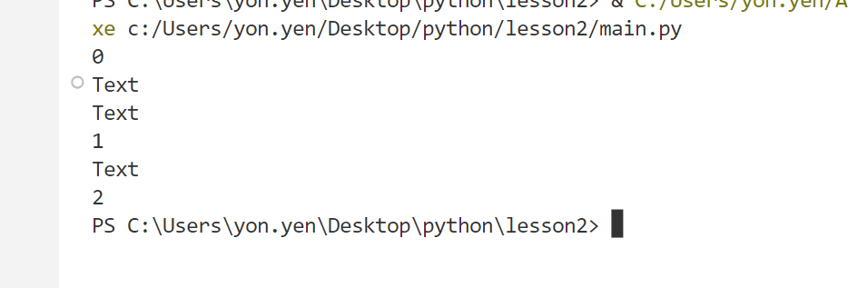

for i in range(3):

    print(i)

    for x in range(2-i):

        print("text")

1. Please write code to display like this.

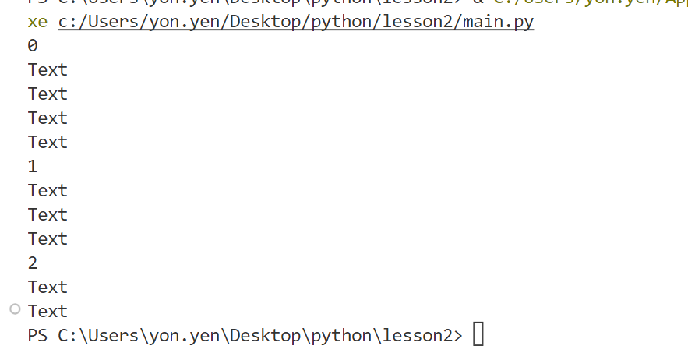

for i  in range(3):

    print(i)

    for x in range(4 - i):

        print("text")

1. Please write code

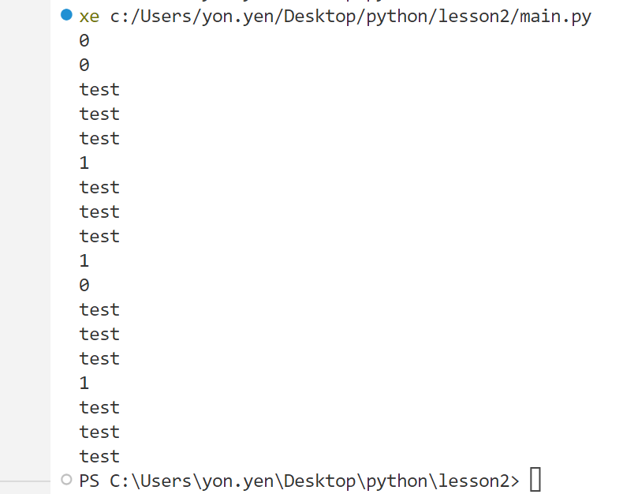

for i in range(2):

    print(i)

    for z in range(2):

        print(z)

        for x in range(3):

            print("text")

1. Please write

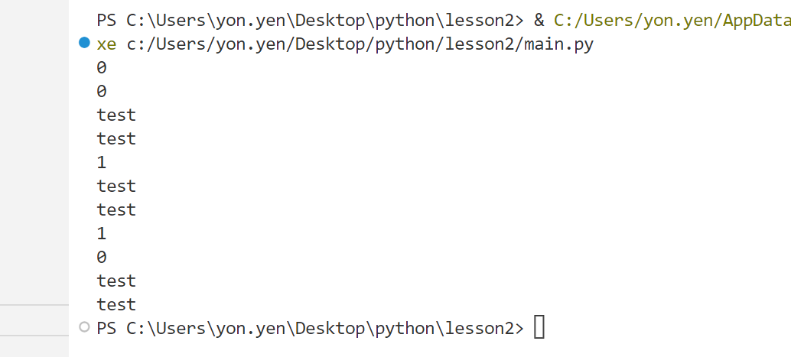

for i in range(2):

    print(i)

    for z in range(2-i):

        print(z)

        for x in range(2):

            print("text")

1. Please write code.

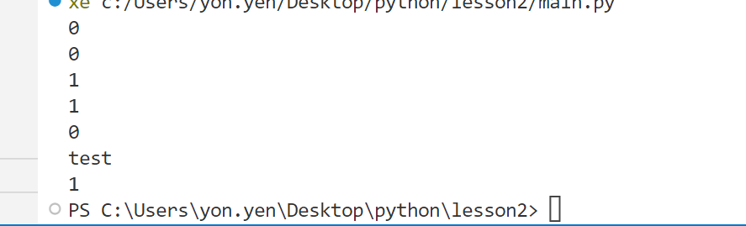

for i in range(2):

    print(i)

    for x in range(i+1):

        print(x)

        for z in range(i - x):

            print("text")

1. Please

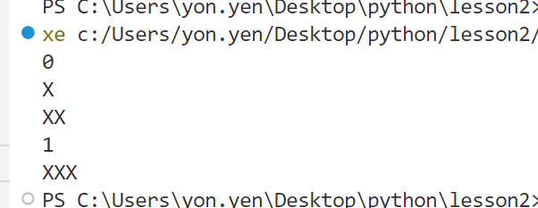

text =""

for i in range(2):

    print(i)

    for x in range(2-i):

        text = text+"X"

        print(text)

1. Please

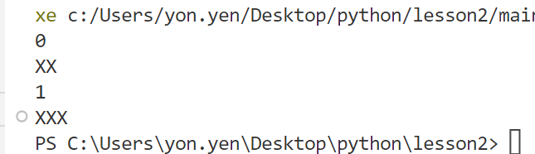

text =""

for i in range(2):

    print(i)

    for x in range(2-i):

        text = text+"X"

    print(text)

1. Please

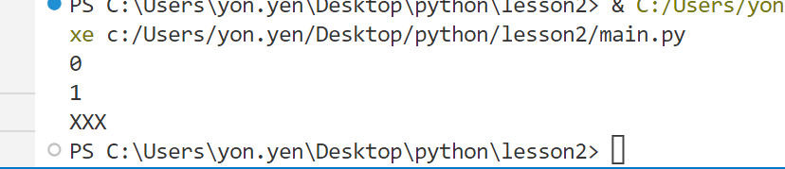

text = ""

for i in range(2):

    print(i)

    for z in range(2-i):

        text = text +"X"

print(text)

1. Please

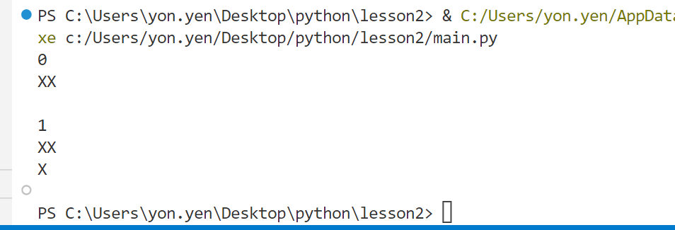

text = ""

for i in range(2):

    print(i)

    for z in range(2-i):

        text = text +"X"

    text = text+"\n"

    print(text)

1. Please

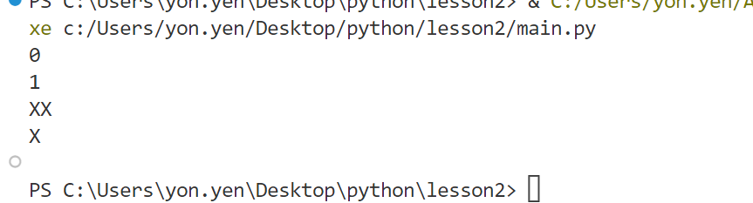

text = ""

for i in range(2):

    print(i)

    for z in range(2-i):

        text = text +"X"

    text = text+"\n"

print(text)

1. Please

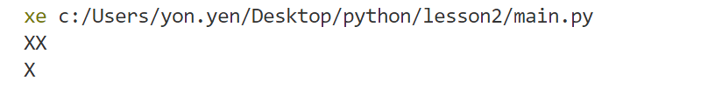

text = ""

for i in range(3):

    for z in range(2-i):

        text = text +"X"

    text = text + "\n"

print(text)

1. Please

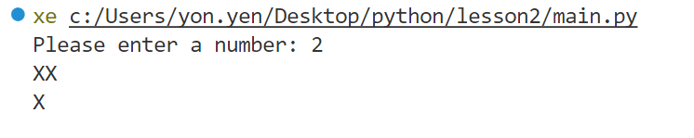

number = int(input("please enter the number:"))

text = ""

for i in range(number):

    for z in range(number-i):

        text = text +"X"

    text = text + "\n"

print(text)

1. Please

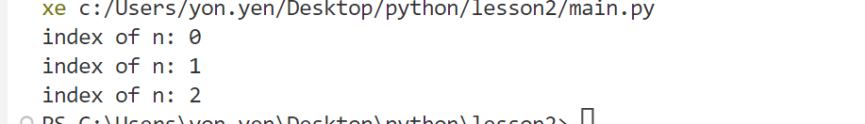

for i in range(3):

    print("index fo n:"+str(i))

1. Please

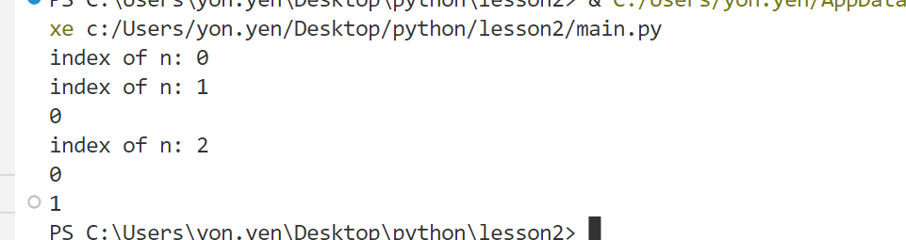

1. Please

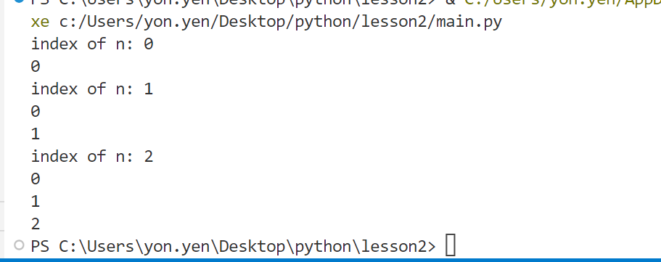

1. Please

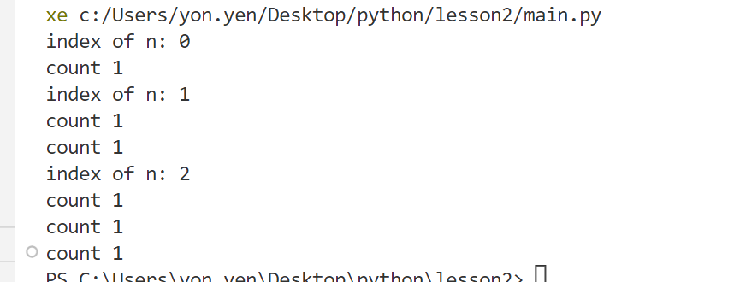

for i in range(3):

        print("index fo n:"+str(i))

        for z in range(i+1):

         print("count 1")

1. Please

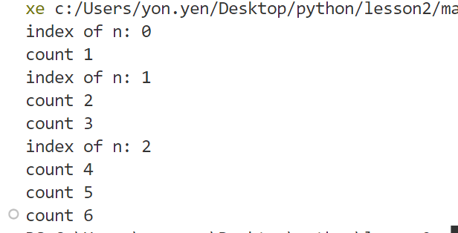

count = 0

for i in range(3):

        print("index fo n:"+str(i))

        for z in range(i+1):

            count = count+1

            print("count",end="")

            print(count)

1. Please

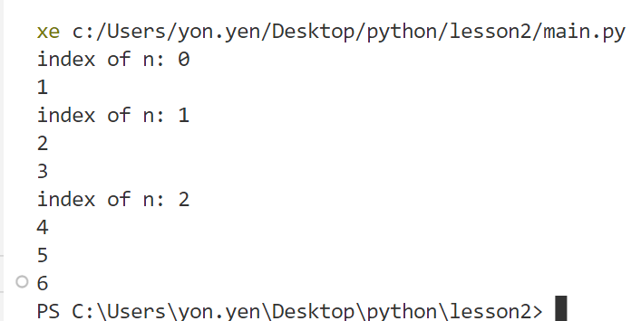

count = 0

for i in range(3):

        print("index fo n:"+str(i))

        for z in range(i+1):

            count = count+1

            print(count)

1. Please

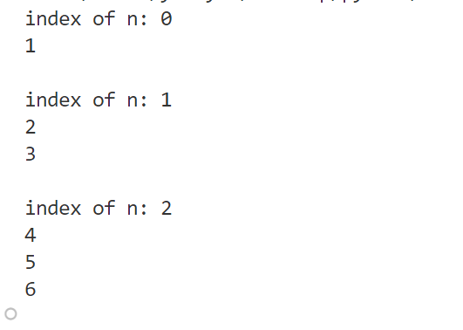

count = 0

for i in range(3):

        print("index fo n:"+str(i))

        for z in range(i+1):

            count = count+1

            print(count)

        print()

1. Please

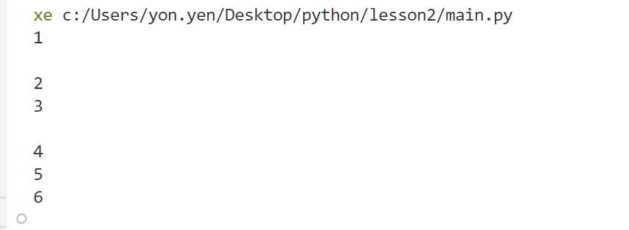

1. Please

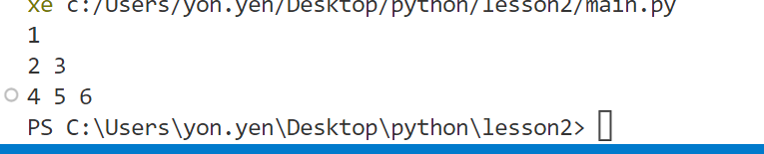

1. Please

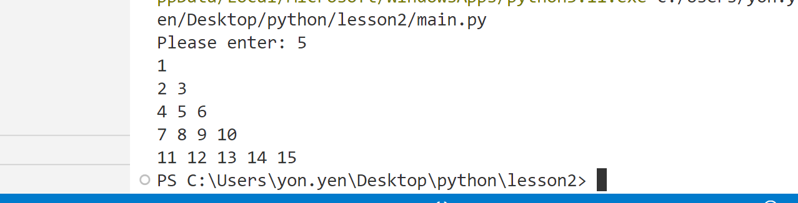

1. Please

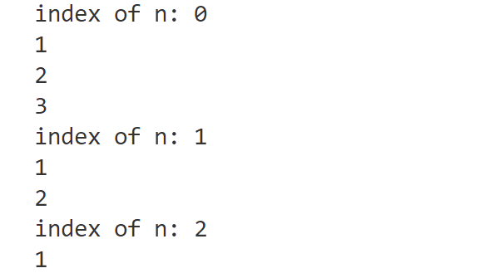

1. Please

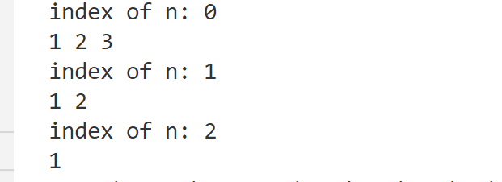

1. Please

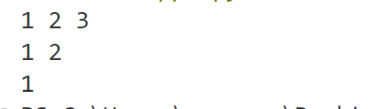

1. Please

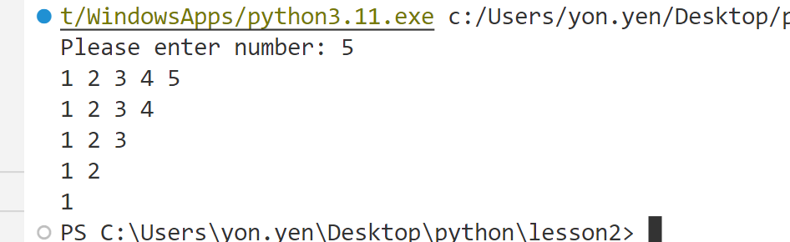

1. Please

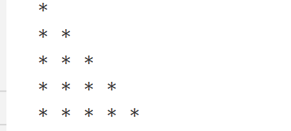

1. Please

