# C2- S4-PRACTICE

*NOTE: check your* ***THEORY slides*** *to answer those questions!*

# EXERCISE 1 – BOOK & AUTHORS

We want to manage books and authors:

* A book has always 1 author only
* An author could write many books.

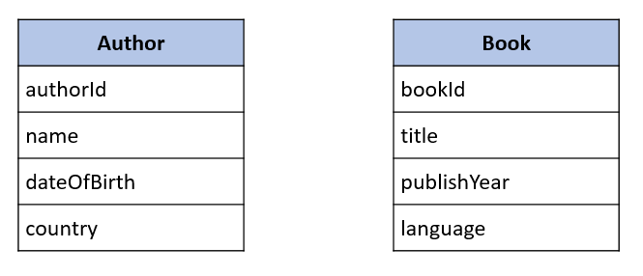

**Q1** – What is the relation between Book and Author tables?

* + Complete the missing attributes or table to allow this relation

1

Many

|  |
| --- |
| Book |
| Book_id |
| title |
| publishYear |
| language |
| Book_id |

|  |
| --- |
| Author |
| Author_ld |
| name |
| dataOfBirth |
| country |

**Q2** – For each table, complete the following arrays, by specifying for each attribute:

* + The field type (SQL type) and size
  + Can be null or not?
  + Is a primary key or foreign keys?

**AUTHOR TABLE**

|  |  |  |  |
| --- | --- | --- | --- |
| Attribute name | Type / size | Can be Null? | Key |
| Author_id | int | yes | PK |
| name | varchar | yes |  |
| dateOfBirth | molen | yes |  |
| country | varchar | yes |  |

**BOOK TABLE**

|  |  |  |  |
| --- | --- | --- | --- |
| Attribute name | Type / size | Can be Null? | Key |
| Book_id | int | yes | PK |
| title | varchar | yes |  |
| publishYear | date | yes |  |
| language | varchar | yes |  |
| Author_id |  | yes | FK |

**Q3** – Write the SQL statement to create the 2 tables with appropriate properties

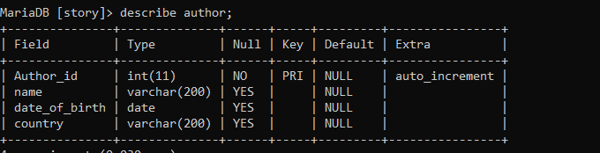

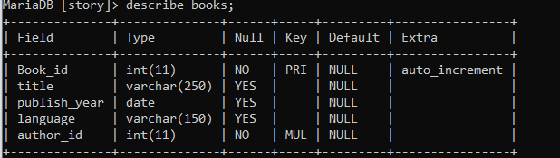

**Q4–** Write the statement to insert 5 books and 5 authors

* 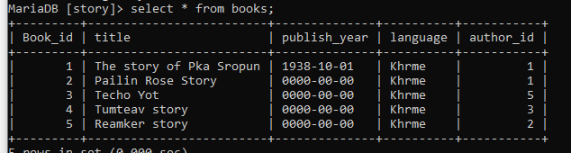5 books
* 5 authors

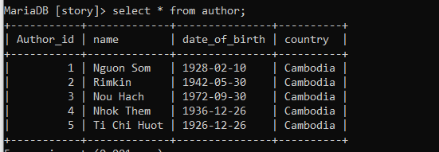

* + Find the book and author information on the Internet

**Q5–** Write the SQL statement to **delete 3 of your books** from the database

# 

# EXERCISE 2 – USERS & POSTS

We want to manage **users** and **posts** (like posts on Facebook)

* A post is related to **1 user only**
  + A post has a body (the text of the post)
* User can have **many posts**
  + A user has a first name, and a nick name (optional)

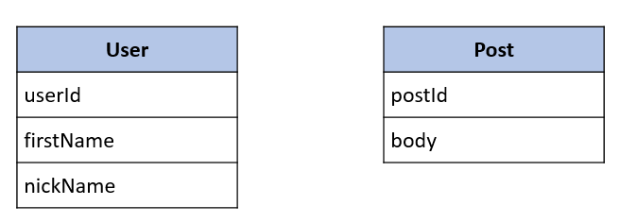

**Q1** – What is the relation between User and Post Table?

* + Complete the missing attributes or table to allow this relation

many

1

|  |
| --- |
| User |
| User_id |
| firstName |
| nickName |

|  |
| --- |
| Post |
| Post_id |
| body |
| User_id |

**Q2** – For each table, complete the following arrays, by specifying for each attribute:

* + The attribute type (SQL type) and size
  + Can be null or not?
  + Is a primary key or foreign keys?

**USER TABLE**

|  |  |  |  |
| --- | --- | --- | --- |
| Attribute name | Type / size | Null? | Key |
| Userld_id | int | no | PK |
| firstName | varchar | yes |  |
| nickName | varchar | yes |  |

**POST TABLE**

|  |  |  |  |
| --- | --- | --- | --- |
| Attribute name | Type / size | Null? | Key |
| Post_id | int | no | PK |
| body | varchar | yes |  |
| Userld_id |  | no | FK |

**Q3** – Write the SQL statement to create the 2 tables with appropriate properties

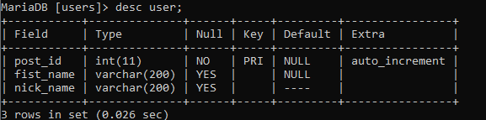

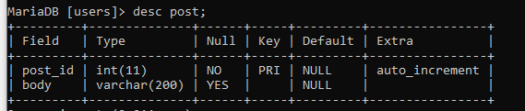

**Q4–** Write the statement to insert the following users and posts

Notes:

* ---- means: no value (the nickname is optional!)
* We don’t specify the KEY, it’s your business!

**USERS**

|  |  |
| --- | --- |
| First name | Nick name |
| Ronan | roro |
| Sokea | ---- |
| Edouard | doudou |



**POSTS**

|  |  |
| --- | --- |
| Post body | From |
| Hello all ! | Ronan |
| I like rice | Ronan |
| YES YES | Sokea |



**Q5–** Write the statement to delete the user Edouard

* 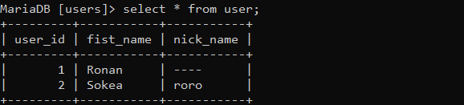What’s happen? Can we delete it? Why?

**Q6–** Write the statement to delete the user Ronan

* What’s happen? Can we delete it? Why?

- Cannot delete because it is a foreign key we want to delete we can log in to the user .

**Q7–** Write SQL statement to remove the rows related to Ronan user:

* Hello all!
* I like rice

**Q8–** now try again to delete the user Ronan

* 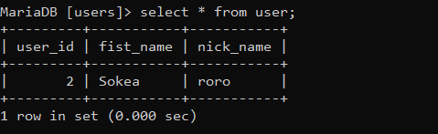What’s happen? Can we delete it? What can you conclude?

**Q9–** Add a new POST in the POST table with a userId which does not exist in the User table (ex: 45)

* What’s happen? Why?
* can not add the new post because it doesn't user_id in the user.