**FINAL Exam: DATABASE**

**WEP 2024**

**{3h 00}**

25 JAN 2023

**RULES:**

* Chatting and talking to other students is forbidden
* You are allowed to use PhpMyAdmin or VSCode or any other software. But it is not required
* Write (copy/paste) your answer below the question. Do not screenshot.

**HOW DO I SUBMIT THE EXAM?**

* Save this document as a yourfullname.PDF file
* In Google Classroom, attach this file to submit.

|  |  |
| --- | --- |
| **EXERCISES** | **POINTS** |
| THOERYS | 20 |
| EXERCISE 1 | 20 |
| EXERCISE 2 | 20 |
| EXERCISE 3 | 20 |
| EXERCISE 4 | 20 |
| EXERCISE 5 | 20 |
| **TOTAL** | **100** |

# Exercise 03 (20 points) Basic SQL Query

Write SQL query to create tables that have in Entity Relational Diagram (ERD) below:

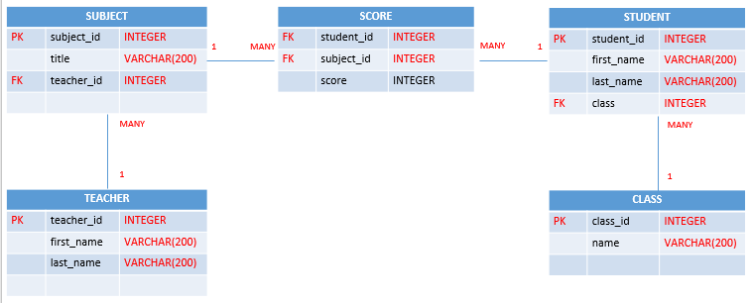

**Your Query:**

|  |
| --- |
| **create table teacher (**  **-> teacher_id int primary key,**  **-> fist_name varchar(200),**  **-> last_name varchar(200)**  **-> );**  **create table subject (**  **-> subject_id int primary key,**  **-> title varchar(200),**  **-> teacher_id int null,**  **-> foreign key(teacher_id) references teacher(teacher_id)**  **-> );**  **create table class (**  **-> class_id int primary key,**  **-> name varchar(200)**  **-> );**  **create table student (**  **-> student_id int primary key,**  **-> first_name varchar(200),**  **-> last_name varchar(200),**  **-> class_id int null,**  **-> foreign key(class_id) references class(class_id)**  **-> );**  **create table score (**  **-> student_id int null,**  **-> foreign key(student_id) references student(student_id),**  **-> subject_id int null,**  **-> foreign key(subject_id) references subject(subject_id),**  **-> score int**  **-> );** |

# Exercise 04 (20 points) SQL Query Select

***Important****: Import database name “database_final_exam.sql” into your databasae.*

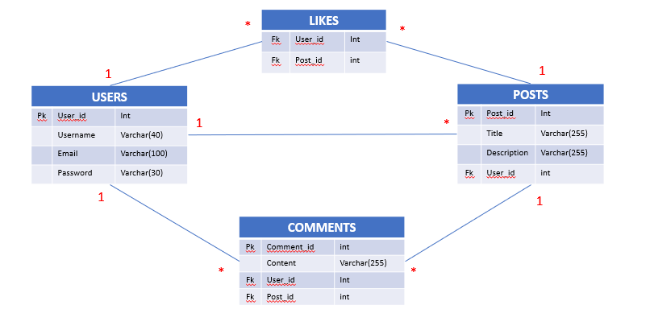

**Q1 – (10 POINTS):** Write a SQL statement to display all POSTS for the user named “**Rady Y**”

**Expected result:**

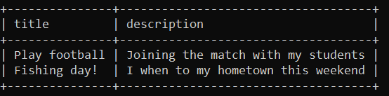

**Your Query:**

|  |
| --- |
| **select title, description from posts inner join users on posts.user_id=users.user_id where username ="Rady Y";** |

**Q2 – (10 POINTS):** Write a SQL statement to display the username of who likes on many posts.

**Expected result:**

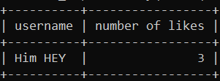

**Your Query:**

|  |
| --- |
| **select username from likes inner join users on likes.user_id=users.user_id where username= 'Him HEY' limit 3;** |