**FINAL Exam: DATABASE**

**WEP 2022**

**{3h 00}**

15 Mar 2022

* All documents allowed
* Chatting and talking to other students are forbidden
* You are allowed to use PhpMyAdmin or VSCode or any other software
  + *But it is not required*

|  |  |
| --- | --- |
| EXERCICES | POINTS |
| EXERCICE 1 | 50 |
| EXERCICE 2 | 50 |
| **TOTAL** | **100** |

# Exercise 1 – BUS TRAVELS

Before start:

* Open PHPMyAdmin and import the database database/pnc_bus_station.sql

We want to manage the bus trips in Cambodia

# 

**Q1 – (10 POINTS)** Write a query to display the first name and last name of the customers who are in **bus number 2**.

|  |
| --- |
| SELECT first_name,lastname FROM customer  INNER JOIN buses ON travel.bus_number = buses.bus_number  INNER JOIN travels ON customer_travels.trvel_number = travels.travel_number  INNER JOIN Customer_Travel ON customer.travel_id = customer.trvavel_id  Where buses.bus_number=”2”; |

**Expected result:**

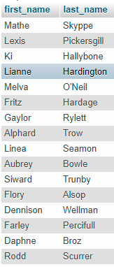

**Q2 – (10 POINTS)** Write a query to **create a view** to display data like expected result of the travels managed by the driver named *“HIM HEY”*.

|  |
| --- |
| Create view Driver_manage as  SELECT travel_number,provinces,departure_date,arrival_date  From drival |

**Expected result:**

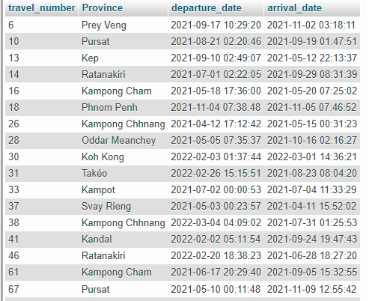

**Q3 – (10 POINTS)** Use the view above to display only the travels of driver *“HIM HEY”* on departure date: **2021-09-17**

*Note: you need to use date function to format datetime in MYSQL.*

*Ex: DATE (“*2021-09-17 10:29:20”) = ”2021-09-17”.

|  |
| --- |
| Select travel_numer,provinece,departure_date,arrival_date  From |

**Expected result:**



**Q4 – (10 POINTS)** Write the query to display **the number of buses** for each bus model

|  |
| --- |
|  |

**Expected result:**

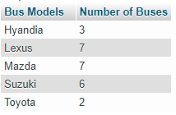

**Q5 – (10 POINTS)** Write query to display the **bus model** include the **first name** and **last name** of the customers who have traveled with bus **number 1**.

|  |
| --- |
|  |

**Expected result:**

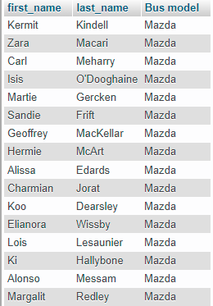

# Exercise 2 – PNC Facebook

We want to create a new **Facebook application** for PNC’s students. Please read the requirements and description of database for this application.

* **Users** are described by their full name, gender, email and password.
* **Posts** are described by their title, description and image (the name of the image file).
* **Comments** are described by their content.
* **Likes** contain user and post information.

Additional information about the relations between entities:

* A user can share many posts.
* A post is created by one user.
* A post can be commented by many users.
* A comment is created by one user.
* A post can have many likes from many users, and one like is related to one post.

**Q1 – (20 POINTS)** Design the ERD Physical Model related to this problem

* Create your ERD in the file EXERCICE-2-ERD.PPTX
* include the keys, types, and all necessary tables

**Q2 – (10 POINTS)** Insert fake data in the database: at least 5 rows in each table.

|  |
| --- |
| User table  insert into user(username,passworld)  -> values("Bora thom","bora499444"),("thary bun","thary833838gg"),("vana cahn","878887vana"),("Manra kun","man84849394"),("mary lam","mary848484583");  Post table  insert into post(post_date,post_title)  -> values("12/02/2021","Why my picture it so bad?"),("20/12/2019","Today is my good day."),("05/11/2018","This is a good place that is went"),("03/03/2017","Whey are you always blame me?"),("07/03/2014","This is my fell to your suggestion");  Comment table  insert into comment(comment_body,user_id,post_id)  -> values("You look so cool when you post ",1,2),("You never take my phone",1,1),("I hate you so much frind",4,3),("You lied me yesterday",3,4),("You post late today next you should fast than this",5,5);  Likes table  insert into likes(user_id, post_id)  -> values(1,3),(2,1),(3,4),(4,5),(5,4); |

**Q3 – (5 POINTS) -** Write a query to display **the user who have posted the most** on PNC Facebook.

|  |
| --- |
| SELECT username  FROM user  INNER JOIN comment on post in comment.post_id=post.post_id  INNER JOIN user on comment in comment.user_id=user.user_id; |

**Q4 – (5 POINTS)** - Create a **view** to show the **title of the post** with the **highest number of likes**

|  |
| --- |
| Create view as  Select post_title  From post  Inner join post on comment in post.post_id=comment.post_id; |

**Q5 – (10 POINTS) -** Write the query to display, for each comment **on the post of ID 1**, the username of the comment’s author and the comment’s content.

|  |
| --- |
| Select comment_body  From comment  Inner join |