# C2- S5 - PRACTICE

*NOTE: check your* ***THEORY slides*** *to answer those questions!*

# EXERCISE 1 – GOOGLE CLASSROOM DATABASE

Here is the Entity Relation Diagram of the Google Classroom Database you designed in Chapter 1. You are now going to put it in MySQL!

**Q1 –** Write a statement to create the google classroom database, and to tell MySQL you are now working with it.

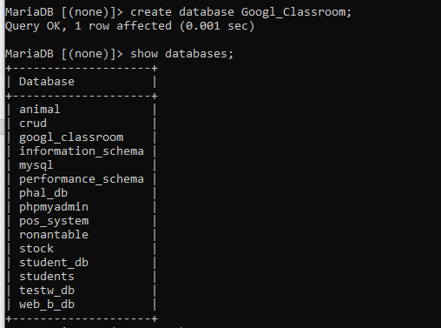

**Q2** – For each table (USER, USER_CLASSROOM, CLASSROOM, ASSIGNMENT, COMMENT), complete the following arrays, by specifying for each attribute:

* + The attribute type (SQL type) and size
  + Can be null or not?
  + Is a primary key or foreign keys?
* **USER TABLE**

|  |  |  |  |
| --- | --- | --- | --- |
| Attribute name | Type / size | Can be Null? | Key |
| User_id | int | yes | PK |
| email | varchar | yes |  |
| password | varchar | yes |  |
| name | varchar | yes |  |

**USER_CLASSROOM TABLE**

|  |  |  |  |
| --- | --- | --- | --- |
| Attribute name | Type / size | Null? | Key |
| User_id | int | yes | FK |
| Classroom_id | int | yes | FK |
|  |  |  |  |

**CLASSROOM TABLE**

|  |  |  |  |
| --- | --- | --- | --- |
| Attribute name | Type / size | Null? | Key |
| Classroom_id | int | yes | PK |
| name | varchar | yes |  |
| Section | varchar | yes |  |
| subject | varchar | yes |  |

**ASSIGNMENT TABLE**

|  |  |  |  |
| --- | --- | --- | --- |
| Attribute name | Type / size | Null? | Key |
| Assignment_id | int | yes | PK |
| title | varchar | yes |  |
| Description | text | yes |  |
| Deadlline | time | yes |  |
| Classroom_id | int | yes | FK |

**COMMENT TABLE**

|  |  |  |  |
| --- | --- | --- | --- |
| Attribute name | Type / size | Null? | Key |
| Comment_id | int | yes | PK |
| content | varchar | yes |  |
| User_id | int | yes | FK |
| Assignment_id | int | yes | FK |

**Q3** – Write the SQL statement to create the 5 tables with appropriate properties.

WARNING: Create the tables in the right order to respect the Foreign Key constraints.

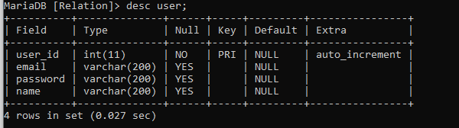

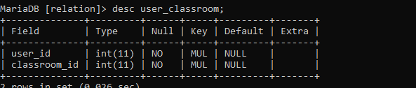

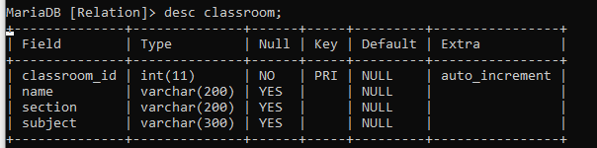

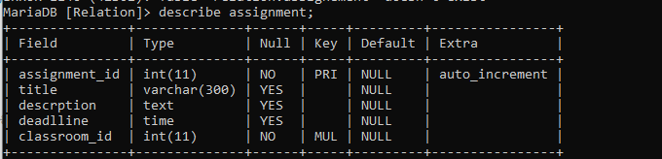

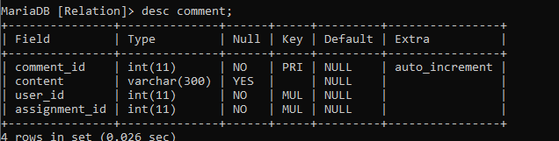

**Q4 –** Write statements to insert at least 3 records in each table.

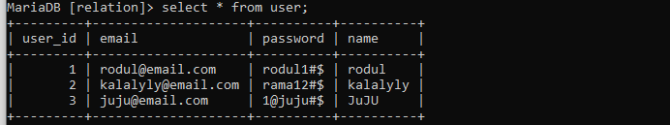

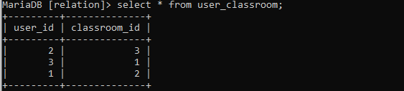

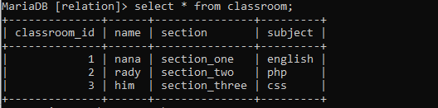

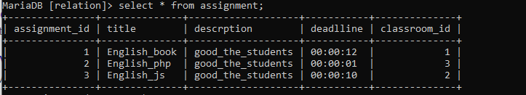

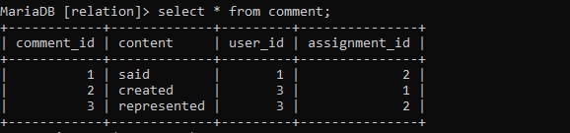

# EXERCISE 2 – FOODPANDA DATABASE

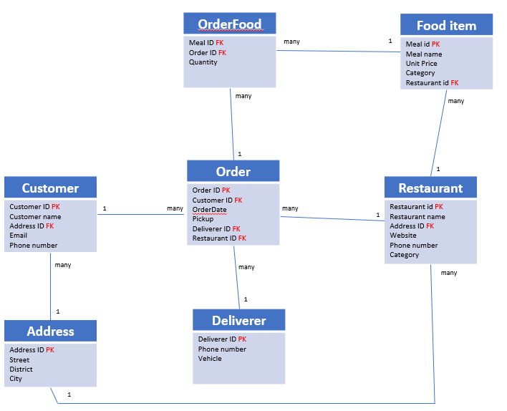

Here is the Entity Relation Diagram of the Foodpanda Database you designed in Chapter 1. You are now going to put it in MySQL!

**Q1 –** Write a statement to create the Foodpanda database, and to tell MySQL you are now working with it.

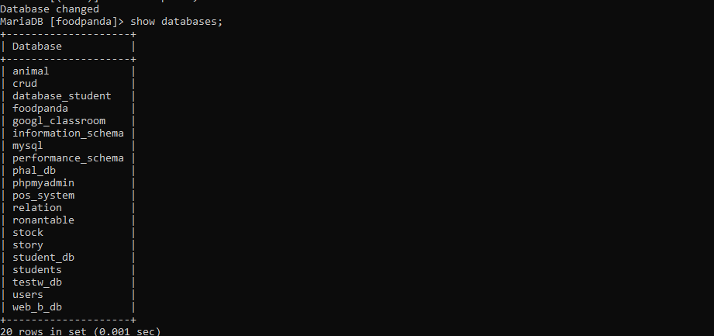

**Q2** – For each table of the database, complete the following array, by specifying for each attribute:

* + The attribute type (SQL type) and size
  + Can be null or not?
  + Is a primary key or foreign keys?

1. Address Table

|  |  |  |  |
| --- | --- | --- | --- |
| Attribute name | Type / size | Null? | Key |
| Address_id | int | no | PK |
| street | varchar | yes |  |
| district | varchar | yes |  |
| City | varchar | yes |  |

1. Customers Table

|  |  |  |  |
| --- | --- | --- | --- |
| Attribute name | Type / size | Null? | Key |
| Customer_id | int | no | PK |
| Customers name | varchar | yes |  |
| Address_id | int | no | FK |
| email | varchar | yes |  |
| Phone_nb | int | yes |  |

1. Deliverers Table:

|  |  |  |  |
| --- | --- | --- | --- |
| Attribute name | Type / size | Null? | Key |
| Deliverers_id | int | no | PK |
| Phone_nb | int | yes |  |
| Vehicle | varchar | yes |  |

1. Restaurants Table:

|  |  |  |  |
| --- | --- | --- | --- |
| Attribute name | Type / size | Null? | Key |
| Restaurnts_id | int | no | PK |
| Restaurnts_n | int | yes |  |
| Address_id | int | yes | FK |
| website | varchar | yes |  |
| Phone_n | int | yes |  |
| Category | varchar | no |  |

1. Food_items Table:

|  |  |  |  |
| --- | --- | --- | --- |
| Attribute name | Type / size | Null? | Key |
| Meal_id | int | no | PK |
| Meal name | varchar | yes |  |
| Unit price | int | yes |  |
| Caregory | varchar | yes |  |
| Restaurants_id | int | no | FK |

1. Orders Table:

|  |  |  |  |
| --- | --- | --- | --- |
| Attribute name | Type / size | Null? | Key |
| Order_id | int | no | PK |
| Customer_id | int | yes | FK |
| OrderDate | date | yes |  |
| Pirckup | int | no |  |
| Deliverer_id | int | no | FK |
| Restaurant_id | int | no | FK |

1. Order_food Table:

|  |  |  |  |
| --- | --- | --- | --- |
| Attribute name | Type / size | Null? | Key |
| Meal_id | int | yes | FK |
| Order_id | int | no | FK |
| Quantity | int | no |  |

**Q3** – Write the SQL statement to create the tables with appropriate properties.

WARNING: Create the tables in the right order to respect the Foreign Key constraints.

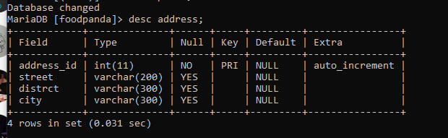

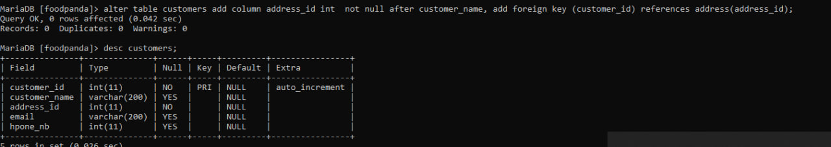

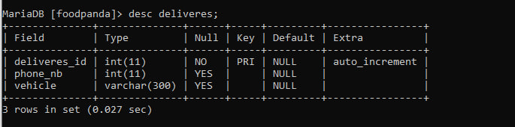

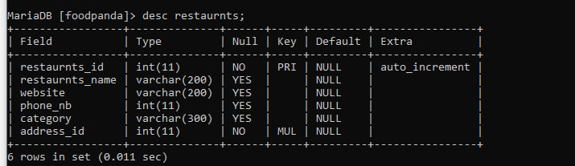

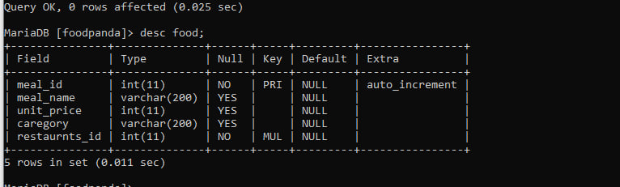

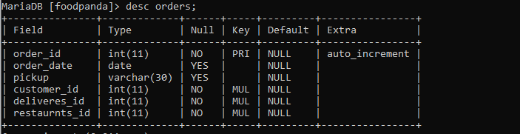

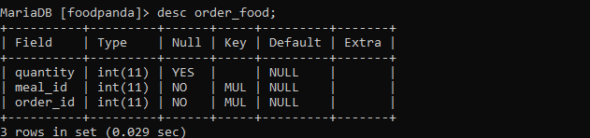

**Q4 –** Write statements to insert between 2 and 4 records in each table.

