DB-C4-S3-THEORY VIEW

This exercise is based on given ONLINE database:

<https://www.w3schools.com/sql/trysql.asp?filename=trysql_select_where>

* Test your queries on the online editor
* Copy / paste your answer for each question on this document

**Q1:** Write a query to create a view for all customers who are coming from France.

SELECT CustomerName AS [CustomerName] FROM Customers where Country="France" ;

**Q2:** Write a query to create a view of order quantity more than 50.

SELECT CustomerID AS [Order] FROM Customers where CustomerID>50 ;

**Q3**: Write a query to create a view of products with a price between $10 and $30.

SELECT Price AS [Price] FROM Products where Price > 10 and Price<30 ;

**Q4**: Write a query to create a view of suppliers coming from Japan and only from Tokyo city.

SELECT Country, City AS [City] FROM Suppliers where Country="Japan " and City="Tokyo";

**Q5:** Write a query to create a view to display product name in each category without any duplicate.

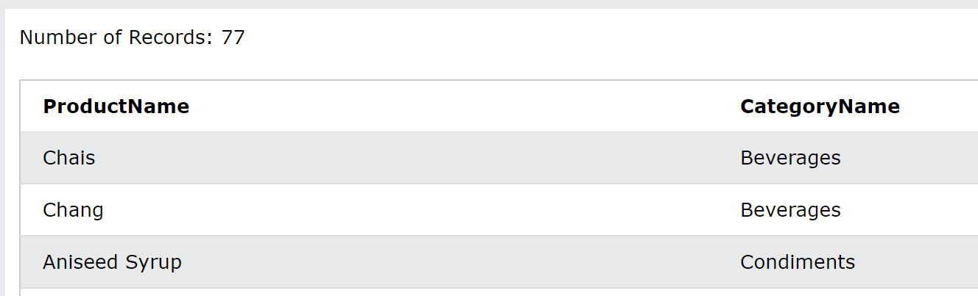

**Q6:** Write a query to create a view to display all customers and employees as seller

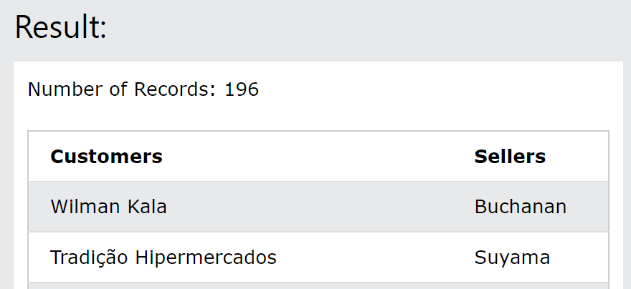

Q7: Write a query to create a view for those salesmen belongs to the city New York.

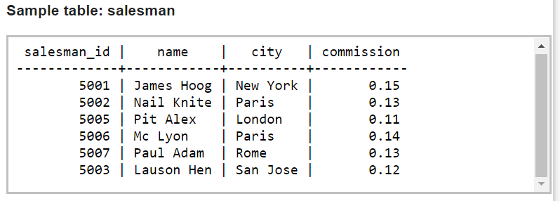

**Q8:** Write a query to find the salesmen of the city New York who achieved the commission more than 13% with the view you just created in Q7.