What is **element.closest()?**

The **element.closest()** method in JavaScript is used to find the closest ancestor of a given element that matches a specified CSS selector. It traverses up the DOM (Document Object Model) from the current element and returns the first ancestor that matches the provided selector. If no matching ancestor is found, it returns **null**.

**const closestElement = element.closest(selector);**

* selector, including classes, IDs, tag names, attribute selectors, etc.
* **element**: The DOM element for which you want to find the closest ancestor.

1. **Using a Class Selector:**

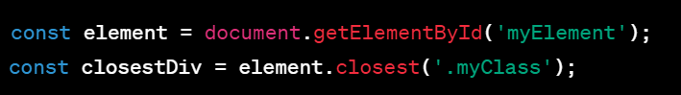

1. **Using an ID Selector:**

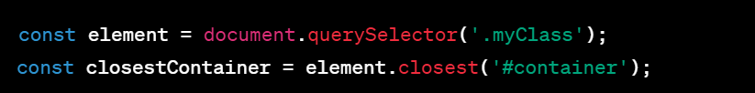

**Thanks**