# C2- S4 – PRACTICE- **BUS TRIP**



We want to manage BUS trips, and customers going to each trips

* A Trip
  + Has a list of customers,
  + The bus is going from a departure address to an arrival address
* A customer
  + Has a first/last name
  + Can have an address , but he/she does need to mention it
* Address must be defined using class , as it contains many information

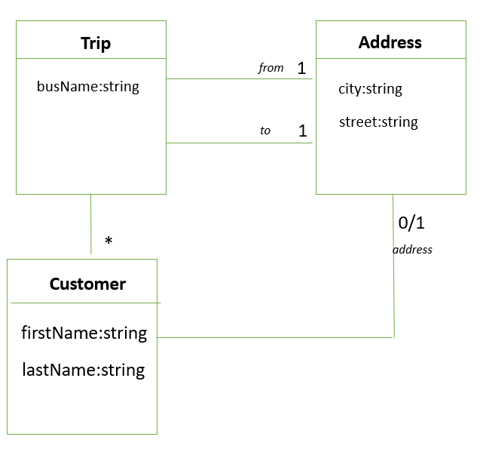

**Q1** Create the **OOP model** (classes / attributes/ constructors / setters) needed to match with this problem

**Q2** Create the following **instance** of this OOP model:

**CUSTOMERS**

|  |  |  |
| --- | --- | --- |
| **First name** | **Last Name** | **Address** |
| Ronan | Ogor | Paris, France |
| Him | Hey | *No address* |
| Sovanda | Chib | Phnom Penh, Cambodia |

**TRIPS**

|  |  |
| --- | --- |
| **Bus name** | KAKA Bus |
| **Departure place** | Phnom Penh, Cambodia |
| **Arrival place** | Kampot, Cambodia |
| **Customers** | Him, Sovanda |

|  |  |
| --- | --- |
| **Bus name** | LYHOR Express |
| **Departure place** | Phnom Penh, Cambodia |
| **Arrival place** | Sieam Reap, Cambodia |
| **Customers** | Him, Sovanda, Ronan |

class Trip{

    busName: string;

    constructor(name: string){

        this.busName = name;

    }

}

class Address{

    departurePlace: string;

    arrivalPlace: string;

    trip: Trip[] =[];

    constructor(departurePlace: string, arrivalPlace: string){

        this.departurePlace = departurePlace;

        this.arrivalPlace = arrivalPlace;

    }

    addTrip(trip: Trip){

        this.trip.push(trip);

    }

}

class Customer{

    firstName: string;

    lastName: string;

    address: Address[] =[];

    constructor(firstName: string, lastName: string){

        this.firstName = firstName;

        this.lastName = lastName;

    }

    addAddress(address: Address){

        this.address.push(address);

    }

}

let trip1 = new Trip("KAKA Bus");

let trip2 = new Trip("LYHOR Express");

let address1 = new Address("Phnom Penh, Cambodia","Kampot, Cambodia");

let address2 = new Address("Phnom Penh, Cambodia", "Sieam Reap, Cambodia");

let address3 = new Address("No","address")

let customer1 = new Customer("Him", "Hey");

let customer2 = new Customer("Sovanda","Chib");

let customer3 = new Customer("Ronan","Ogor");

customer1.addAddress(address3);

customer2.addAddress(address2);

customer3.addAddress(address3);

console.log(trip1, trip2, customer1, customer2, customer3);

BONUS

*(This part is optional: it will give you more points, but ONLY if the first part is correct!!!)*

We want now to manage when the bus is leaving and arriving at tis destination:

* The bus is leaving at a specific date/time and arriving at a specific date/time
* We create a class DateTime to manage both date and time together

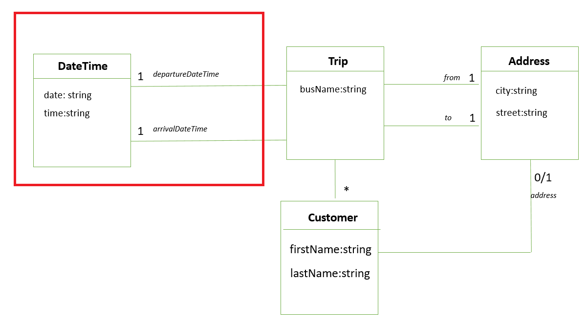

**Q1** Update the **OOP model** (classes / attributes/ constructors / setters) needed to match with this new problem

**Q2** Update your bus instances to add their start and end date and time

* + - *Any data / time you want*

class Trip{

    busName: string;

    date: DateTime[] = [];

    constructor(name: string){

        this.busName = name;

    }

    addDate(date: DateTime){

        this.date.push(date);

    }

}

class Address{

    departurePlace: string;

    arrivalPlace: string;

    trip: Trip[] =[];

    constructor(departurePlace: string, arrivalPlace: string){

        this.departurePlace = departurePlace;

        this.arrivalPlace = arrivalPlace;

    }

    addTrip(trip: Trip){

        this.trip.push(trip);

    }

}

class Customer{

    firstName: string;

    lastName: string;

    address: Address[] =[];

    constructor(firstName: string, lastName: string){

        this.firstName = firstName;

        this.lastName = lastName;

    }

    addAddress(address: Address){

        this.address.push(address);

    }

}

class DateTime{

    date: string;

    time: string;

    constructor(date: string, time: string){

        this.date = date;

        this.time = time;

    }

}

let trip1 = new Trip("KAKA Bus");

let trip2 = new Trip("LYHOR Express");

let address1 = new Address("Phnom Penh, Cambodia","Kampot, Cambodia");

let address2 = new Address("Phnom Penh, Cambodia", "Sieam Reap, Cambodia");

let address3 = new Address("No","address")

let customer1 = new Customer("Him", "Hey");

let customer2 = new Customer("Sovanda","Chib");

let customer3 = new Customer("Ronan","Ogor");

let date1 = new DateTime("Monday - Sunday","07:00 AM");

let date2 = new DateTime("Monday -Sunday","07:00 PM");

customer1.addAddress(address3);

customer2.addAddress(address2);

customer3.addAddress(address3);

trip1.addDate(date1)

trip2.addDate(date2)

console.log(trip1, trip2, customer1, customer2, customer3);