1- Why we need to do sprint planning?

* Sprint planning involves setting up the strategies, goals, and timelines for the current sprint.
* 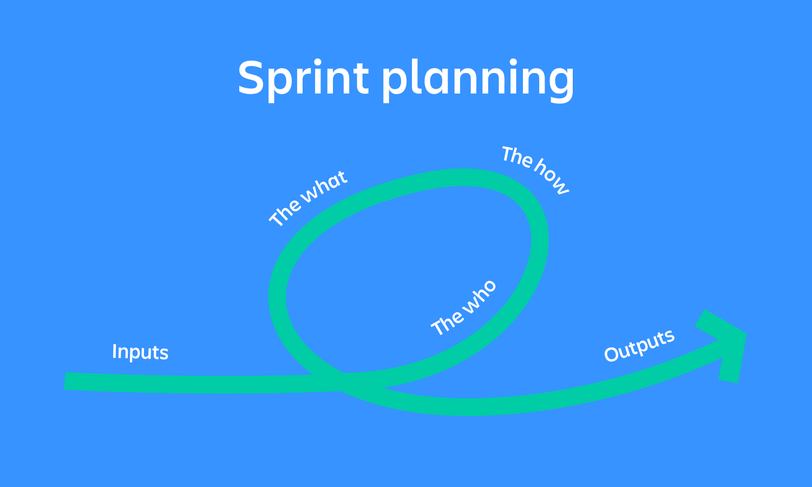This meeting is a great opportunity to get the entire team together and collaborate to determine what everyone is responsible for over the next sprint.

2- Why we need to do stand-up meeting?

* The daily stand-up is a short
* the meeting should be kept short
* daily meeting to discuss progress and identify blockers
* we use three simple questions to generate structure:
  + What did I work on yesterday?
  + What am I working on today?
  + What issues are blocking me?

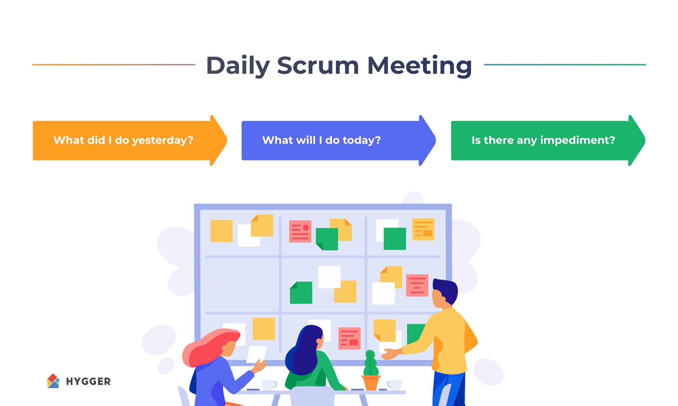

3- Why we need to do sprint retrospective?

* The Sprint Retrospective is the last event in the Sprint and is the time set aside for the Scrum Team to find ways to improve their effectiveness and how they work as a team.
* The team typically discusses:
  + How well the team members interact and communicate
  + Any impediments they’ve encountered
  + How well impediments were removed
  + If the Definition of Done still serves them as written, or if it needs to be updated
  + If there are any improvements to how the team works that can be implemented in future Sprints

4- Why we need to do sprint review?

* The Sprint Review is a working meeting where the Scrum Team presents their completed work to their stakeholders and asks for feedback and guidance.
* More specifically, there are three main differences between these two meetings:
  + **Participants.** Sprint reviews involve a variety of different stakeholders, anyone related to the product.
  + **Deliverables.** The main output of a sprint review is an updated product backlog.
  + **Goals.** A sprint review is carried out with the goal of reaching alignment between the scrum team and product stakeholders.

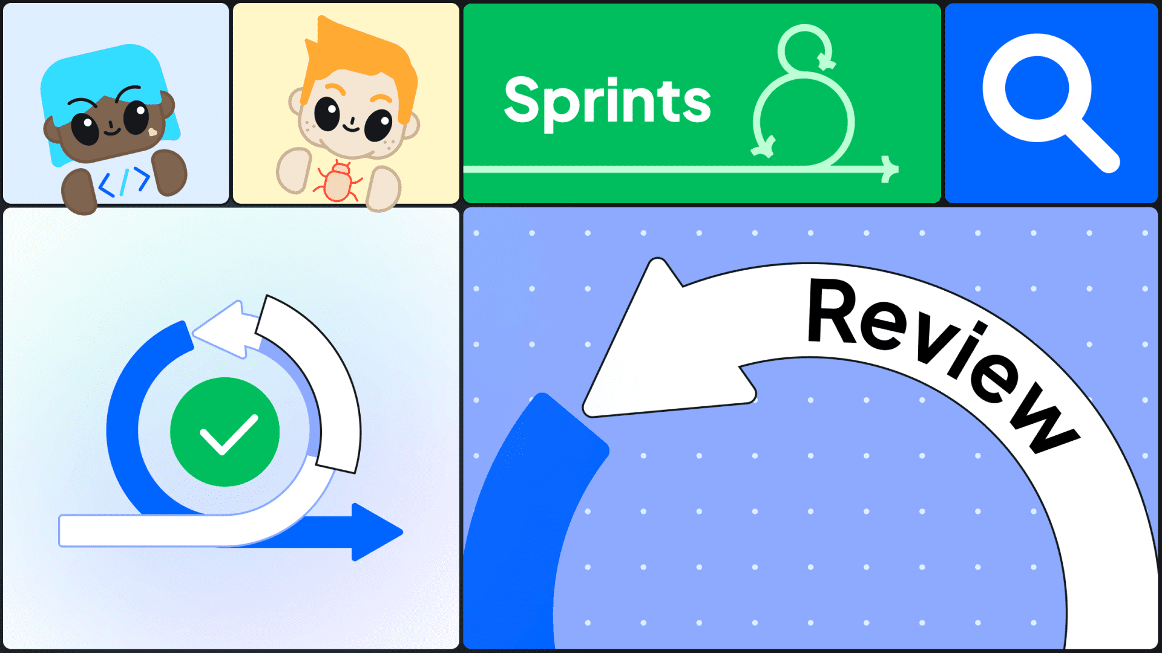

5- Why we need to separate project in to sprint?

* Here are some reasons why it happens:
  + Sprints pull teams from abstract to concrete thinking
  + Sprints prompt teams to focus on what is important.
  + Sprints sharpen the decision-making process
  + Sprints incite faster follow-ups

