|  |  |  |  |  |
| --- | --- | --- | --- | --- |
| **Revised**  **No.** | **Revised Date** | **Execution Date** | **Revised Item** | **Revised Content** |
| 00 | 2017.04.25 | 2017.05.03 | All | New establishment *Thiết lập mới* |
|  |  |  |  |  |
|  |  |  |  |  |
|  |  |  |  |  |
|  |  |  |  |  |
|  |  |  |  |  |
|  |  |  |  |  |
|  |  |  |  |  |
|  |  |  |  |  |
|  |  |  |  |  |
|  |  |  |  |  |
|  |  |  |  |  |



|  |  |  |  |  |  |
| --- | --- | --- | --- | --- | --- |
| Preparation | | Agreement | | | Approval |
| Prepared | Confirmed | R&D | Prd. | ADM |
|  |  |  |  |  |  |

INTRODUCTION *Giới thiệu* 3

1. COMPANY HISTORY AND CONTACT INFORMATION *Lịch sử công ty và thông tin liên lạc* 4

1.1. Company history: *Lịch sử công ty* 4

1.2. Contact information *Thông tin liên lạc* 4

2. SCOPE *Phạm vi* 4

2.1 General *Khái quát* 4

2.2 Application *ÁPdụng* 4

2.3 Remote support locations identification *Nhận xét xác nhận vị trí* 4

3. Quality management system and its processes *Hệ thống quản lý chất lượng và quy trình của nó* 5

4.Quality Management System *Hệ thống quản lý chất lượng* 9

4.1 General requirements 9

4.2 Documentation requirements 9

5. Management responsibility 11

5.1 Management commitment 11

5.2 Customer focus 11

5.3 Quality policy 11

5.4 Planning 11

5.5 Responsibility, authority and communication 12

5.6 Management review 12

6. Resource management 13

6.1 Provision of resources 13

6.2 Human resources 14

6.3 Infrastructure 14

6.4 Work environment 15

7. Product realization 15

7.1 Planning of product realization 15

7.2 Customer-related processes 16

7.3 Design and development 18

7.4 Purchasing 21

7.5 Production and service provision 22

7.6 Control of monitoring and measuring devices 25

8. Measurement, analysis and improvement 27

8.1 General 27

8.3 Control of nonconforming product 30

8.4 Analysis of data 31

8.5 Improvement 32

ANNEX 1: PROCESS MATRIX 34

ANNEX 2: STANDARD MATRIX 40

# INTRODUCTION

Halla Electronics Vina Co., Ltd recognizes its responsibility as a manufacturer of quality products/provider of quality services. To this end, Halla Electronics Vina Co., Ltd has developed and documented a quality management system. The quality management system complies with the international standard ISO/TS 16949:2009, Automotive Quality Management System Standard. The quality management system is commonly referred to as the quality system or QMS.

This Quality Manual applies to sites of the organization where customer-specified parts, for production and/or service, are manufactured, supporting functions, whether on-site or remote and throughout the entire automotive supply chain.

The purpose of this manual is to provide comprehensive evidence to all customers, suppliers and employees of what specific controls are implemented to ensure product/service quality. This manual also governs the creation of quality related documented information. It will be revised, as necessary, to reflect the quality system currently in use. It is issued on a controlled copy basis to all internal functions affected by the quality management system and on an uncontrolled copy basis to customers and suppliers. It may be issued to customers on a controlled copy basis upon customer request.

# 1. COMPANY HISTORY AND CONTACT INFORMATION

## 1.1. Company history:

* 2016.01.25 Established Company
* 2016.03.01 Start Construction
* 2016.08.30 Set up Machine
* 2016.09.01 Start MP
* 2016.09.29 Start Delivery to Customer

## 1.2. Contact information

Company name : Halla Electronics Vina Co., Ltd.

Abbreviation name : HEV

Address : Lot L4, Trang Due Industrial Park, Hong Phong Commune, An Duong district,

Hai Phong city, Viet Nam.

Tel (+84) : 02252299798 Fax: 02252299796

Tax code : 0201709861

Represented by : Mr. Kim Chang Su – Director

# 2. SCOPE

## 2.1 General

The quality manual outlines the policies, procedures and requirements of the Quality Management System. The system is structured to comply with the conditions set forth in the International Standard ISO/TS 16949:2009 covers production process, quality control and delivery.

## 2.2 Application

* HEV shall apply the ISO/TS 16949:2009 in the following activities:
* Manufacturing the IVI products
* HEV shall apply all requirements of ISO 9001:2008 & ISO/TS 16949:2009 in QMS except for the following clause with the explanation hereunder:
* Clause 8.3 shall not be applied: Product design and development
* Reason: All the product was designed by HEV's client
* Place of implementation the QMS:

At HEV's factory: Lot L4, Trang Due Industrial Park, Hong Phong Commune, An Duong district, Hai Phong city, Viet Nam

## 2.3 Remote support locations identification

Supporting functions, whether on-site or remote (corporate headquarters - Halla Electronic in Korea), shall be included in the scope of the QMS.

The company define Halla Cast CO., LTD at address: 59, Eunbong-ro 105 beon-gil, Namdong-gu 405-838, Incheon, Korea is remote function support.

Its scope is:

1) Die casting manufacturing

2) Manufacturing process design and development

For more details, please see clause 4.4 (Process MAP and inter-action each other)

# 3. Quality management system and its processes

HEV has establish, implement, maintain and continually improve a QMS, including the processes needed and their interactions, in accordance with the requirements of ISO 9001:2008 &

ISO/TS 16949:2009. HEV has determined the processes needed for the quality management system and their application throughout the company as bellow diagram:

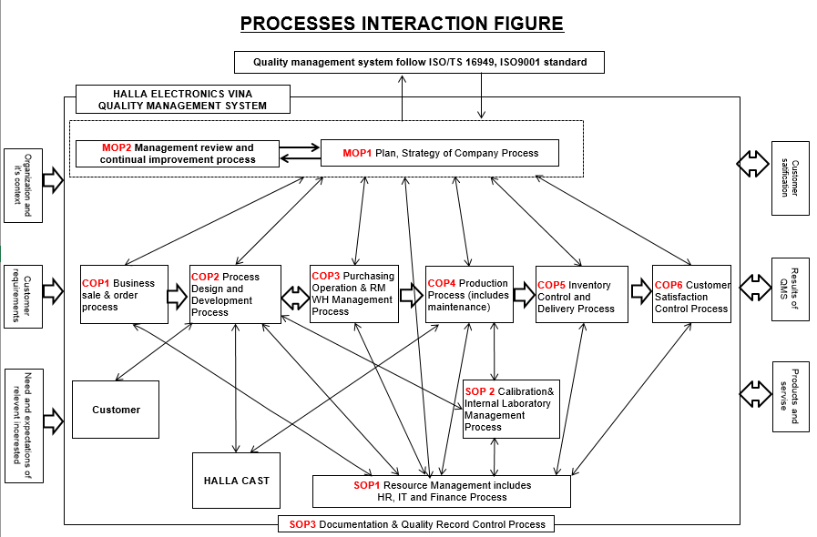

* In each process, HEV shall:
* Determine the necessary input factors and expected results of the process;
* Determine sequences and interactions of these processes;
* Determine and apply criteria and methods (including supervision, measurements and relevant operation indexes) needed to ensure effective operation and control of these processes;
* Determine necessary resources for processes and ensure their availability;
* Assign tasks and give authorizations relating to these processes;
* Deal with risks and opportunities which are determined suitable with the requirements of 6,1;
* Evaluate procedures and make any necessary changes to ensure the achievement of the intended results;
* Improve processes and QMS.
* To the necessary extent, HEV shall:
* Remain documented information to support these processes;
* Retain documented information to obtain the trust that processes are on progress.
* For further details, please see:
* Process Turtle diagram

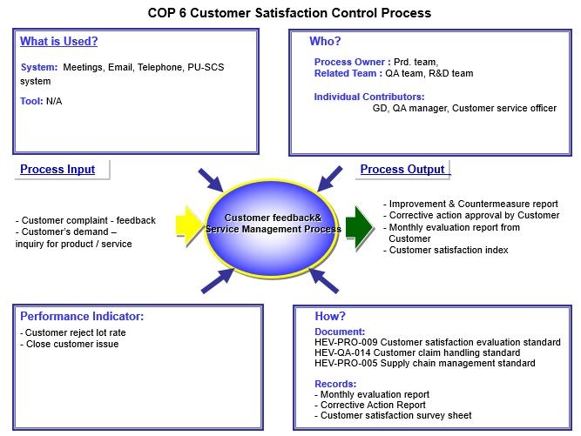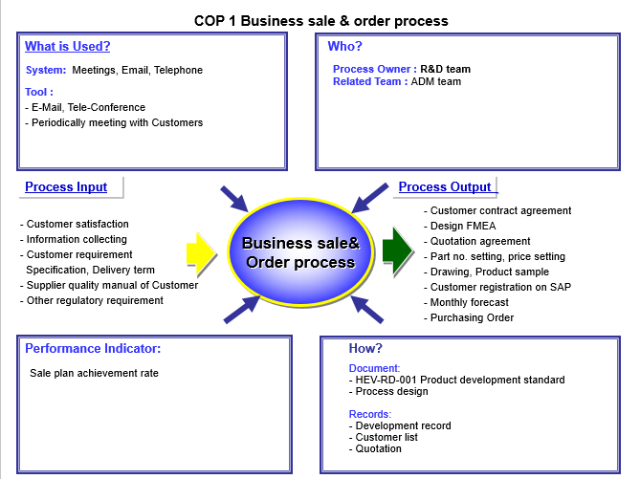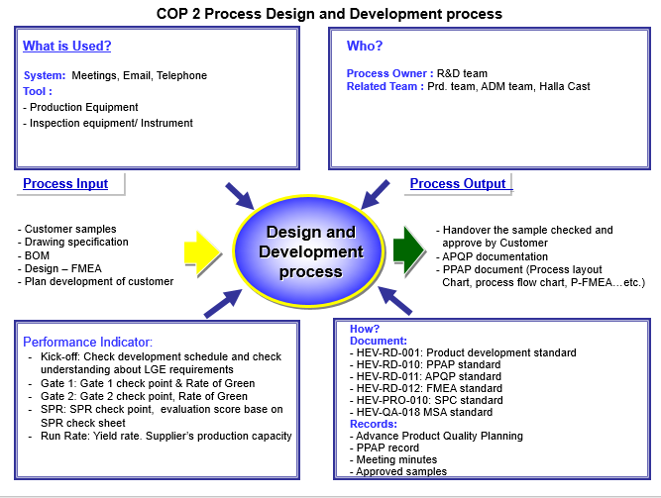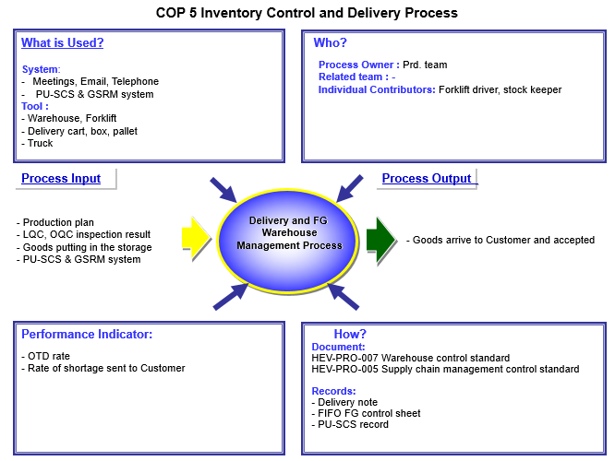

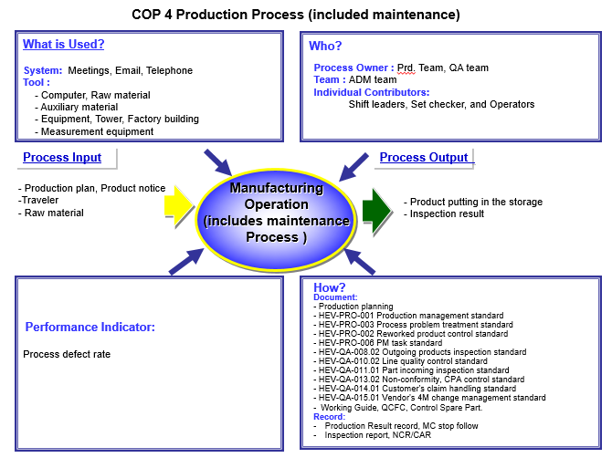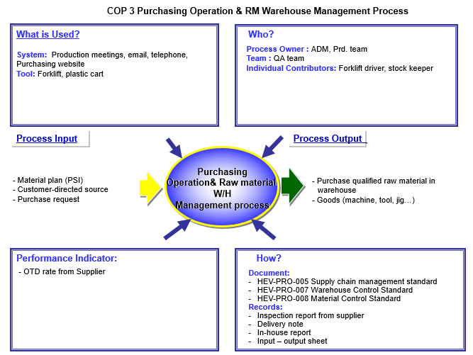

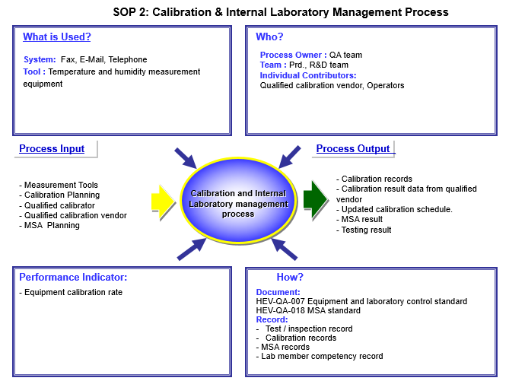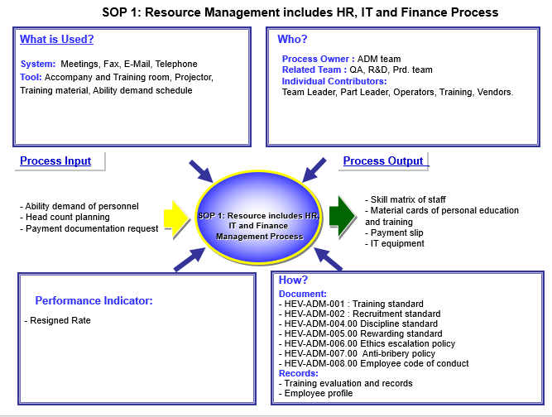

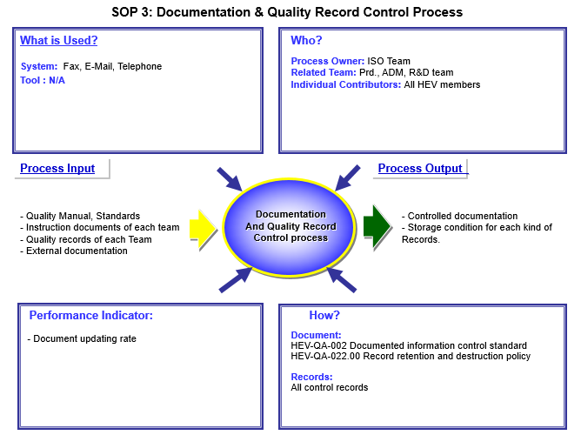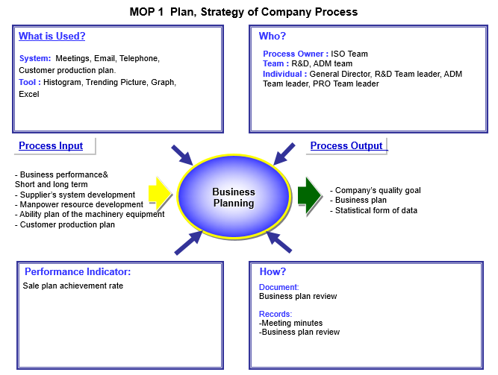

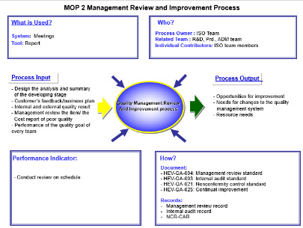

**4.Quality Management System**

The Quality Management System of HEV meets the requirements of the international standard ISO/TS 16949:2009 which establish, document, implement and maintain a quality management system and continually improve its effectiveness from the input process until product delivery.

## 4.1 General requirements

To design and implement the Quality Management System, HEV has:

a) Identified the processes needed for the Quality Management System Planning and their application throughout the organization (see also 5.4.2),

b) Determined criteria and methods needed to ensure that both the operation and control of these processes are effective,

c) Ensured the availability of resources and information necessary to support the operation and monitoring of these processes,

d) Monitored, measured and analyzed these processes follow the procedure, and

e) Implemented actions necessary to achieve planned results and continual improvement of these processes.

These processes will be managed by the organization in accordance with the requirements of his International Standard ISO/TS 16949:2009 and ISO 9001:2008.

Where an organization chooses to outsource any process that affects product conformity with requirements, the organization will ensure control over such processes. Control of such outsourced processes will be identified within the quality management system.

### 4.1.1 General requirements – Supplemental

Ensuring control over outsourced processes will not absolve the organization of the responsibility of conformity to all customer requirements. Now, there is no policy to outsource for any activities.

## 4.2 Documentation requirements

The Quality Management System documentation includes a documented Quality Policy and Objectives, this Quality Manual, documented procedures, documented identified as needed for the effective planning, operation and control of processes, and Quality records.

* Structure of QMS document system:

Quality manual

Standard

Form

Instruction document

Level 1

Level 2

Level 3

General Director

General Director

Team Leader

**Level**

Level 4

Team Leader

**Approval**

ISO team

ISO team

Owner team

ISO team

Owner team

**Control team**

Note 1: Quality Manual of HEV meets the requirements of the international standard ISO/TS 16949:2009.

* + Advance Product Quality Planing & Control Plan (APQP)
  + Failure Mode and Effects Analysis (FMEA)
  + Measurement System Analysis (MSA)
  + Statistical process Control (SPC)
  + Production Part Approval Process (PPAP)

### 4.2.2 Quality Manual

HEV has established and maintains a quality manual that includes;

1. The scope of the quality management system which meets the requirements of the international standard ISO/TS 16949:2009,
2. The documented procedures established for the quality management system, or reference to them, and
3. A description of the interaction between the processes of the quality management system

### 4.2.3 Control of documents

All the Quality Management System documents are controlled according to the International Standard ISO/TS 16949:2009, related regulations, supplier manual and customer’s drawing which have a structure as follow;

The documented procedure defines the process for:

* Approving documents for adequacy with serial numbers prior to issue
* Reviewing and updating as necessary and re-approving documents
* Ensuring that documents of external origin are identified and their distribution controlled
* Ensuring that documents remain legible and readily identifiable. Any changes and current revision status of documents are clearly identified, and
* Preventing the unintended us of obsolete documents and to apply suitable identification to them if they are retained for any purpose by marked “OBSOLETED DOCUMENT” in red

#### 4.2.3.1 Engineering Specifications

* HEV have documented a Process Change Control to assure the timely review, distribution and implementation of all customer engineering standards / specifications and changes based on customer-required schedule. Timely review should be as soon as possible and should not exceed 2 working weeks. This will maintain a record of the date on which each change is implemented in production. Implementation also updated in Control Plan, FMEA and Work Instruction documents.

### 4.2.4 Control of records

* Quality records are maintained to provide evidence of conformity to requirements and of the effective operation of the Quality Management System. This procedure requires that quality records remain legible, readily identifiable and retrievable. The procedure defines the controls needed for identification, storage, protection, retrieval, retention time and disposition of quality records.

#### 4.2.4.1 Records retention

* APQP, Production Part Approvals, Tools Notes, Purchase Orders, Contracts, etc. should retain for another 1 year after stop manufacturing or until customer required. Except Quality Control Records and Management Reviews should retain for another 3 years or until customer required. The company has the procedure for defining specific retention time of each kind of quality records.
* References:

HEV-QA-002 Document control standard

HEV-QA-022 Record retention and destruction policy

# 5. Management responsibility

## 5.1 Management commitment

General Director of HEV has been actively involved in implementing the Quality Management System. It has been provided the vision and strategic direction for the growth of the QMS and established quality objectives and the quality policy, conducted management reviews and ensured the availability of resources.

### 5.1.1 Process efficiency

General Director also reviews the product realization processes and the support processes to assure the effectiveness and efficiency.

## 5.2 Customer focus

General Director strives to identify current and future customer needs to meet customer requirements and exceed customer expectations.

## 5.3 Quality policy

General Director ensures that the quality policy is communicated to all employees. It is included in new employee training and training on the QMS. It is also posted in prominent places throughout the offices to maintain high -standards within our organization.

Management reviews the quality policy at each management review meeting to determine the policy’s continuing suitability for our organization.

## 5.4 Planning

### 5.4.1 Quality objectives

Quality objectives are established to support our organization’s efforts in achieving our quality policy and review for suitability. Quality objectives are measurable and reviewed against performance goals which are increase customer satisfaction, reduce customer complaints, reduce wastes and scraps from production.

#### 5.4.1.1 Quality Objectives-supplemental

General Director defines the quality objectives and measurements to meet customer requirements in a specific period of time which are included in the business plan and used to deploy the quality policy as follow;

* Market information
* Project growth
* Cost target
* Research and development plan
* Sales and marketing plan
* Internal audit evaluation and cost finance analysis
* Factory plan and human resource development plan
* Health, safety and environment

HEV has established both short-term (1-2 years) and long-term (3 years up) up to date and flexible business plan which have goals and plans to analyze and define:

* The current and future capability of the company;
* The current and future customer’s requirement

To make the plan up to date, the company has reviewed the plan in every 12 months.

### 5.4.2 Quality management system planning

General Director has ensured that the quality management system planning is carried out in order to meet the requirements given in 4.1 as well as the quality objectives and the integrity of the quality management system which maintained when plans are implemented.

## 5.5 Responsibility, authority and communication

### 5.5.1 Responsibility and authority

General Director has provided responsibilities, authority for all executives who work at HEV

Reference: HEV-ADM-010 Responsibilities and authorities

## 5.6 Management review

### 5.6.1 General

Top management will review the organization’s quality management system, at planned intervals, to ensure its continuing suitability, adequacy and effectiveness. This review includes assessing opportunities for improvement and the need for changes to the quality management system, including the quality policy and quality objectives.

#### 5.6.1.1 Quality management system performance

These reviews include:

1. All requirements of the quality management system
2. Performance trends
3. Continual improvement process
4. Monitoring of quality objectives
5. Regular reporting and evaluation of the cost of poor quality

These results will be recorded for 3 years as a minimum to provide evidence of the achievement of the quality objectives specified in the business plan and customer satisfaction with product supplied.

### 5.6.2 Review Input

General Director of the Company specified the management review at least once a year or as needed in order to review the quality system that is still appropriate and satisfactory performance is consistent with the requirements of the standard ISO/TS16949: 2009. And the quality policy, the agenda would be reviewed to ensure the appropriateness and effectiveness continued. The management review will be published and stored in the reference and evaluation of the quality system.

The input to management review should be included information on

1. Results of audits
   1. Internal audit
   2. External audit
2. Customer feedback

2.1 Customer complaint

2.2 Customer Satisfaction

1. Process performance and product conformity
2. Status of preventive and corrective actions
3. Follow-up actions from previous management reviews
4. Review quality policy, quality objective and resources
5. Changes that could affect the quality management system
6. Recommendations for improvement

#### 5.6.2.1 Review input – supplemental

1. An analysis of actual and potential field-failures
2. An impact on quality, safety or the environment

### 5.6.3 Review Output

The output from the management review will include any decisions and actions related to:

* 1. Improvement of the effectiveness of the quality management system and its processes
  2. Improvement of product related to customer requirements
  3. Resource needs

General Director, Team Leaders and QMR Committees will attend the meeting by having QMRC records the meeting.

Reference:

* HEV-QA-004 Management review standard
* HEV-PRO-005 Supply Chain Management Standard
* HEV-ADM-003 Determining organization' context standard
* HEV-QA-020.00 Communication standard

# 6. Resource management

## 6.1 Provision of resources

HEV has determined and provided the resources needed to implement and maintain the quality management system and continually improve its effectiveness, and to enhance customer satisfaction by meeting customer requirements.

## 6.2 Human resources

### 6.2.1 General

The company has specified personnel performing work affective product quality should be competent on the basis of appropriate education, training, skills and experience.

### 6.2.2 Competence, awareness and training

The company has:

* 1. Determined the necessary competence for personnel performing work affecting product quality,
  2. Provided training or taken other actions to satisfy these needs,
  3. Evaluated the effectiveness of the actions taken,
  4. Ensured that its personnel are aware of the relevance and importance of their activities and how they contribute to the achievement of the quality objectives, and
  5. Maintained appropriate records of education, training, skills and experience
     + 1. Training

The organization has established and maintained documented procedures for identifying training needs and achieving competence of all personnel performing activities affecting product quality. Personnel performing specific assigned tasks will be qualified as required with attention to the satisfaction of customer requirements.

* + - 1. On the job training

The company has provided on-the-job training for personnel in any new or modified job affecting product quality, including contract or agency personnel. Personnel whose work can affect quality will be informed about the consequences to the customer of nonconformity to quality requirements.

* + - 1. Employee motivation and empowerment

The company has a process to motivate employees to achieve quality objectives, to make continual improvements, and to create an environment to promote innovation. The process includes the promotion of quality and technological awareness throughout the whole organization.

In addition, the company has a process to measure the extent to which its personnel are aware of the relevance and importance of their activities and how they contribute to the achievement of the quality objectives

## 6.3 Infrastructure

The organization will determine, provide and maintain the infrastructure needed to achieve conformity to product requirements, Infrastructure includes, as applicable

1. Buildings, workspace and associated utilities,
2. Process equipment (both hardware and software), and
3. Supporting services (such as transport or communication).

### 6.3.1 Plant, facility and equipment planning

The company uses a multidisciplinary approach including APQP for developing plant, facility and equipment plans. Plant layouts will optimize material travel, handling and value-added use of floor space, and shall facilitate synchronous material flow. Methods will be developed and implemented to evaluate and monitor the effectiveness of existing operations.

### 6.3.2 Contingency plans

The organization will prepare contingency plans to satisfy customer requirements in the event of an emergency such as utility interruptions, labor shortages key equipment failure and field returns.

## 6.4 Work environment

The company has determined and managed the work environment including dust particle, dust collector, mixing, grinding, wet scrubber and water curtain spray booth which needed to achieve conformity to product requirements.

### 6.4.1 Personnel safety to achieve product quality

The company has addressed the product safety and means to minimize potential risks to employees especially in the design and development process and in manufacturing process activities.

### 6.4.2 Cleanliness of premises

The organization will maintain its premises in a state of order, cleanliness and repair consistent with the product and manufacturing process needs

Reference:

* HEV-ADM-001 Training standard
* HEV-ADM-009.00 5S standard

# 7. Product realization

## 7.1 Planning of product realization

HEV has planned and developed the processes needed for product realization. Planning of product realization is consistent with the requirements of the other processes of the quality management system and the company has determined the following as appropriate:

1. Quality objectives and requirements for the product;
2. The need to establish processes, documents, and provide resources specific to the product;
3. Required verification, validation, monitoring, inspection and test activities specific to the product and the criteria for product acceptance;
4. Records needed to provide evidence that the realization processes and resulting product meet requirements

The output of this planning will be in a form suitable for the organization’s method of operations.

### 7.1.1 Planning of product Realization-Supplemental

The company has included customer requirements and references to its technical specifications such as FMEA in the planning of product realization as a component of the quality plan.

### 7.1.2 Acceptance criteria

Acceptance criteria is defined by the organization and, where required, approved by the customer. For attribute data sampling, the acceptance level will be zero defects.

### 7.1.3 Confidentiality

The company ensures the confidentiality of customer-contracted products and projects under development, and related product information by published HEV Integrity and distributed to all employees.

### 7.1.4 Change control

The company has a process to control and react to changes that impact product realization. The effects of any change, including those changes caused by any supplier, will be assessed, and verification and validation activities will be defined to ensure compliance with customer requirements. Changes will be validated before implementation. For proprietary designs, impact on form, fit and function (including performance and/or durability) will be reviewed with the customer so that all effects can be properly evaluated. When required by the customer, additional verification / identification requirements, such as those required for new product introduction, will be met.

## 7.2 Customer-related processes

### 7.2.1 Determination of requirements related to the product

The company has determined:

1. Requirements specified by the customer, including the requirements for delivery and post-delivery activities;
2. Requirements not stated by the customer but necessary for specified or intended use, where known, and statutory and regulatory requirements related to the product;
3. Any additional requirements determined by the company

#### 7.2.1.1 Customer-designated special characteristics

HEV will demonstrate conformity to customer requirement for designation, documentation and control of special characteristics in PFMEA, Control Plan and Work Instruction.

### 7.2.2 Review of requirements related to the product

The company will review the requirements related to the product. This review will be conducted prior to the company’s commitment to supply a product to the customer (ie. Submission of tenders, acceptance of contracts or order, acceptance of changes to contracts or orders) and Production Planning & Control will ensure that:

1. Product requirements are defined;
2. Contract or order requirements differing from those previously expressed are resolved, and
3. The organization can meet the defined requirements

Records of the results of the review and actions arising from the review will be maintained.

Where the customer does not provide documented statement of requirement, the customer requirements will be confirmed by the organization before acceptance.

Where product requirements are changed, the organization will ensure that relevant documents are amended and relevant personnel are made aware of the changed requirements.

#### 7.2.2.1 Review of requirements related to the product – supplemental

Waiving the requirements stated in 7.2.2 for a formal review will require customer authorization.

#### 7.2.2.2 Organization manufacturing feasibility

The company will investigate, confirm and document the manufacturing feasibility of the proposed products and APQP in the Team Feasibility Commitment which including risk analysis.

Factors have been brought into the feasibility study are:

* Cost of production
* Raw material, parts, machine and working area
* Product and process engineering
* Production process and quality control
* Production capability
* Personnel skills

### 7.2.3 Customer communication

The company has determined and implemented effective arrangements for communicating with customers in relation to:

1. Product information

The company should have a meeting or communication with customer when a new product will be establishment.

1. Production planning and delivery plan

SCM Part leader must contact Customers in respect of its production plans and delivery

c. CS department have to inquiries, contracts and orders as well as other changes.

1. Quality Department must contact customer in item of quality concern or customer complaint. Traceability customer data including customer complaint after delivery.

#### 7.2.3.1 Customer communication-supplemental

The company has ability to communicate necessary information, including data, in a customer-specified language and format (Telephone, fax, or e-mail)

Reference:

* HEV-RD-010 PPAP Standard
* HEV-RD-011 APQP Standard
* HEV-RD-013 Sale Standard
* HEV-QA-014 Customer's claim handling standard

## 7.3 Design and development

### 7.3.1 Design and development planning

- As claim in the scope of QMS, product design and development planning shall be implemented by HEV’s clients.

#### 7.3.1.1 Multidisciplinary approach

The company has used a multidisciplinary approach from sales marketing, engineering, production, purchasing, production planning department to prepare for product realization, including:

1. Development / finalization and monitoring of special characteristics,
2. Development and review of FMEAs, including actions to reduce potential risks, and
3. Development and review of control plans

### 7.3.2 Design and development input

Inputs relating to product requirements will be determined and records maintained which include;

* Functional and performance requirements,
* Applicable statutory and regulatory requirements,
* Where applicable, information derived from previous similar designs, and
* Other requirements essential for design and development

These inputs will be reviewed for adequacy. Requirements will be complete, unambiguous and not in conflict with each other.

#### 7.3.2.1 Product design input

- Product design input will be taken place by HEV’s clients

#### 7.3.2.2 Manufacturing process design input

Company’s multidisciplinary approach has identified, documented and reviewed the manufacturing process design input requirements, including:

1. Product design output data (drawing)
2. Targets for productivity, process capability and cost,
3. Customer requirements, if any, and
4. Experience from previous developments

Note: The manufacturing process design includes the use of error-proofing methods to a degree appropriate to the magnitude of the problems and commensurate with the risks encountered.

#### 7.3.2.3 Special characteristics

The APQP team has identified special characteristics in the control plan which complies with customer-specified definitions and symbols. In addition, APQP team has identified process control documents including drawings, FMEAs, control plans, and operator instructions with the customer’s special characteristic symbol or the company’s equivalent symbol or notation to include those process steps that affect special characteristics.

### 7.3.3 Design and development outputs

The outputs of design and development will be provided in a form that enables verification against the design and development input and will be approved prior to release.

Design and development outputs will:

1. Meet the input requirements for design and development,
2. Provide appropriate information for purchasing, production and for service provision,
3. Contain or reference product acceptance criteria, and
4. Specify the characteristics of the product that are essential for its safe and proper use

#### 7.3.3.1 Product design outputs-supplemental

- Product design output is taken place by HEV’s clients.

#### 7.3.3.2 Manufacturing process design output

The manufacturing process design output will be expressed in terms that can be verified against manufacturing process design input requirements and validated. The manufacturing process design output will include:

1. Specifications and drawings
2. Manufacturing process flow chart / layout
3. Manufacturing process FMEAs,
4. Control Plan
5. Work instructions
6. Process approval acceptance criteria
7. Data for quality, reliability, maintainability and measurability
8. Results of error-proofing activities, as appropriate, and
9. Methods of rapid detection and feedback of product / manufacturing process nonconformities

### 7.3.4 Design and development review

At suitable stages, systematic reviews of design and development will be performed in accordance with planned arrangements:

* To evaluate the ability of the results of design and development to meet requirements, and
* To identify any problems and propose necessary actions.

Participants in such reviews will include representatives of functions concerned with the design and development stage(s) being reviewed. Records of the results of the reviews and any necessary actions will be maintained.

#### 7.3.4.1 Monitoring

Measurements at specified stages of design and development including quality risks, costs, lead-times, critical paths and others as appropriate will be defined, analyzed and reported with summary results as an input to management review.

### 7.3.5 Design and development verification

The verification of product design shall be performed in accordance with planned arrangement (see 7.3.1) to ensure that the design& development outputs have met the design and development input requirements. The design and development product verification will be conducted by HEV’s Clients. The products are manufactured follow the format and requirements of customers. Therefore, the application of this provision in the verification of design and product development. The Company has verified the design and development process as the following according to planned. Because this process is regarded as the end of the procedure. Verification and record. Practices need to be preserved

### 7.3.6 Design and development validation

Design and development validation will be performed in accordance with planned arrangements to ensure that the resulting product is capable of meet the requirements for the specified application or intended us, where known. Wherever practicable, validation will be completed prior to the delivery or implementation of the product. Records of the results of validation and any necessary actions will be maintained.

#### 7.3.6.1 Design and development validation-supplemental

Design and development validation will be performed in accordance with customer requirements including program timing.

#### 7.3.6.2 Prototype program

When required by the customer, the company will have a prototype program and control plan. The company will use, wherever possible, the same suppliers, tooling and manufacturing processes as will be used in production.

All performance-testing activities will be monitored for timely completion and conformity to requirements.

While services may be outsourced, the company will be responsible for the outsourced services, including technical leadership.

#### 7.3.6.3 Product approval process

The company will conform to a product and manufacturing process approval procedure recognized by the customer. Product approval should be subsequent to the verification of the manufacturing process. This product and manufacturing process approval procedure will also be applied to suppliers.

### 7.3.7 Control of design and development changes

Design and development changes will be identified and records maintained.

* The changes will be verified and validated, as appropriate.
* The changes must be approved before implementation.
* The review of design and development changes will include evaluation of the effect of the changes on constituent parts and product already delivered.
* Records of the results of the review of changes and any necessary actions will be maintained.

Reference:

* HEV-RD-011 APQP Standard
* HEV-RD-010 PPAP Standard
* HEV-RD-006 4M Change In-House Management Standard

## 7.4 Purchasing

### 7.4.1 Purchasing process

The company has ensured that purchased product conforms to specified purchase requirements. The type and extent of control applied to the supplier and the purchased product will be dependent upon the effect of the purchased product on subsequent product realization or the final product.

The company will evaluate and select suppliers based on their ability to supply products in accordance with the company’s requirements. Criteria for selection, evaluation, and re-evaluation will be established. Records of the results of evaluations and any necessary actions arising from the evaluation will be maintained.

#### 7.4.1.1 Regulatory conformity

All purchased products or materials used in product will conform to applicable regulatory requirements.

#### 7.4.1.2 Supplier quality management system development

The company will perform supplier quality management system development with the goal of supplier conformity with this Technical Specification conformity with ISO/TS 16949:2009 is the first step in achieving this goal. Unless otherwise specified by the customer, suppliers to the company will be third party registered to ISO 9001:2008 by an accredited third-party certification body.

#### 7.4.1.2 Supplier quality management system development - supplemental

For suppliers who already supplied to the company prior to implementing ISO/TS 16949:2009 time of the company, they is required to provide ISO 9001:2008 development & implementation project schedule.

#### 7.4.1.3 Customer-approved sources

Where specified by the contract (eg. Customer engineering drawing, specification), the company will purchase products, materials or services from approved sources.

The use of customer-designated sources, including tool/gauge suppliers, does not relieve the responsibility of the organization for ensuring the quality of purchased products.

### 7.4.2 Purchasing information

Purchasing information will describe the product to be purchased, including where appropriate

1. Requirements for approval of product, procedures, process and equipment,
2. Requirements for qualification of personnel, and
3. Quality management system requirements

The company will ensure the adequacy of specified purchased requirements prior to their communication to the supplier.

### 7.4.3 Verification of purchased product

The company will establish and implement the inspection or other activities necessary for ensuring that purchased product meets specified purchase requirements.

Where the company or its customer intends to perform verification at the supplier’s premises, the company will state the intended verification arrangements and method of product release in the purchasing information.

#### 7.4.3.1 Incoming product quality

The company will have a process to assure the quality of purchased product utilizing one or more of the following methods

1. Receipt of, and evaluation of, statistical data by the organization

If the deliver was attached the statistical data as seem to be the control method. Statistical process control methods must comply with the requirements of the manual process by using statistical method.

## 7.5 Production and service provision

### 7.5.1 Control of product provision

The company will plan and carry out production provision under controlled conditions which include the availability of information that describes the characteristics of the product, work instruction, the use of suitable equipment, monitoring and measuring devices, the implementation of monitoring and measurement, and the implementation of release, delivery and post-delivery activities.

#### 7.5.1.1 Control plan (QCFC)

The company has developed the control plans at the system, subsystem, component and material level since the production process until delivery which covers all 3 steps;

- Prototype: To describe the dimensions of the test material and performance that will occur between the master and the master control plan is required.

- Pre-Launch: To explain the measured dimension. Testing and Materials.  
Performance that occurs after the pre-production prototype and complete. Before starting, production is set to produce one of the products. This may require the creation of a master.

- Production:

The control plan lists the controls used for the manufacturing process control and includes methods for monitoring of control exercised over special characteristics defined by both the customer-required and the company which initiate the specified reaction plan when the process becomes unstable or not statistically capable.

The company will review and update the control plans when any change occurs and affect to;

* Product and manufacturing process
* Measurement
* Logistics and supply sources
* FMEA

#### 7.5.1.2 Work instructions

The company prepares documented work instructions for all employees having responsibilities for the operation of processes that impact product quality. These instructions will be accessible for use at the work station. These instructions will be derived from sources such as the quality plan, the control plan and the product realization process.

#### 7.5.1.3 Verification of job set-ups

Job set-ups will be verified whenever performed, such as an initial run of a job, material changeover or job change. Work instructions will be available for set-up personnel. The company will use statistical methods of verification where applicable.

#### 7.5.1.4 Preventive and predictive maintenance

The company will identify key process equipment and provide resources for machine/equipment maintenance and develop an effective planned total preventive maintenance system. As a minimum, this system will include the following:

* Planned maintenance activities;
* Packaging and preservation of equipment, tooling and gauging;
* Availability of replacement parts for key manufacturing equipment;
* Documenting, evaluating and improving maintenance objectives;

The company will utilize predictive maintenance methods to continually improve the effectiveness and the efficiency of production equipment.

#### 7.5.1.5 Management of production tooling

The company will provide resources for tool and gauge design, fabrication and verification activities. The company will establish and implement a system for production tooling management including;

* Maintenance and repair facilities and personnel;
* Storage and recover;
* Set-up;
* Tool-change programs for perishable tools;
* Tool design modification documentation, including engineering change level;
* Tool modification and revision to documentation;
* Tool identification, defining the status, such as production, repair or disposal.

The company will implement a system to monitor these activities if any work in outsourced.

#### 7.5.1.6 Production scheduling

Production will be scheduled to meet customer requirements, such as just-in-time supported by an information system that permits access to production information at key stages of the process and is order driven.

#### 7.5.1.7 Feedback of information from service

HEV’s establishes and maintains procedures to communicate information from customers to the various agencies involved to ensure the company aware of nonconforming and manage the inconsistency.

#### 7.5.1.8 Servicing agreement with customer

Currently, HEV does not have the after-sales service. However, in case that there is a service agreement with the customer; the company shall verify the effectiveness of

- Any special- purpose tools or measurement equipment, and

- The training of service personnel

### 7.5.2 Validation of processes for production provision

The company will validate any processes for production and service provision where the resulting output cannot be verified by subsequent monitoring or measurement. This includes any processes where deficiencies become apparent only after the product is in use or the service has been delivered. Validation will demonstrate the ability of these processes to achieve planned results.

The company will establish arrangements for these processes including, as applicable

1. Defined criteria for review and approval of the processes,
2. Approval of equipment and qualification of personnel,
3. Use of specific methods and procedures,
4. Requirement for records, and
5. Revalidation

#### 7.5.2.1 Validation of processes for production and service provision – supplemental

The requirements of 7.5.2 will apply to all processes for production and service provision.

### 7.5.3 Identification and traceability

The company has identified the product by suitable means throughout product realization and identified the product status with respect to monitoring and measurement requirement. Where traceability is a requirement, the company will control and record the unique identification of the product as follow;

1. Identification
   1. Product label and location of product
   2. Record
      1. Product name
      2. Batch number
      3. Production quantity
2. Traceability by batch number
3. Product status

The company by Quality department has possibility to document and maintain the product identification and traceability since raw material, product process, until finished goods in order to meet customer needs.

### 7.5.4 Customer property

The company exercises care with customer property while it is under the organization’s control or being used by the company. The company will identify, verify, protect and safeguard customer property provided for use or incorporation into the product. If any customer property is lost, damaged or otherwise found to be unsuitable for use, this will be reported to the customer and records maintained.

### 7.5.5 Preservation of product

The company will preserve the conformity of product during internal processing and delivery to the intended destination. This preservation will include identification, handling, packaging, storage and protection. Preservation will also apply to the constituent parts of a product.

* 1. Relocation

Provide a relocation instruction to avoid misuse or parts mix-up

* 1. Storage

Provide a safety location to prevent damage and deteriorate during waiting for production or delivery. FIFO has been used for inventory management.

* 1. Packaging

Provide an instruction for packaging, care and marking to make sure the conformity of product.

* 1. Delivery

Provide a preservation of product during delivery to customer’s premise or other specified destination.

#### 7.5.5.1 Storage and inventory

To detect deterioration, the condition of product in stock will be assessed at appropriate planned intervals. The company will use an inventory management system to optimize inventory turns over time and assure stock rotation, such as “first-in-first-out” (FIFO). Obsolete product will be controlled in a similar manner to nonconforming product.

Reference:

* HEV-PRO-011 Identification and traceability standard
* HEV-PRO-005 Supply Chain Management Standard
* HEV-PRO-007 Warehouse Control Standard

## 7.6 Control of monitoring and measuring devices

The company will determine the monitoring and measurement to be undertaken and the monitoring and measuring devices needed to provide evidence of conformity of product to determined requirements.

The company will establish processes to ensure that monitoring and measurement can be carried out and are carried out in a manner that is consistent with the monitoring and measurement requirements.

Where necessary to ensure valid results, measuring equipment will

1. Be calibrated or verified at specified intervals, or prior to use, against measurement standards traceable to international or national measurement standards; where no such standards exist, the basis used for calibration or verification will be recorded;
2. Be adjusted or re-adjusted as necessary;
3. Be identified to enable the calibration status to be determined;
4. Be safeguarded from adjustments that would invalidate the measurement result;
5. Be protected from damage and deterioration during handling, maintenance and storage.

In addition, the company will assess and record the validity of the previous measuring results when the equipment is found not to conform to requirements. The company will take appropriate action on the equipment and any product affected. Records of the results of calibration and verification will be maintained.

When used in the monitoring and measurement of specified requirements, the ability of computer software to satisfy the intended application will be confirmed. This will be undertaken prior to initial use and reconfirmed as necessary.

### 7.6.1 Measurement system analysis

Statistical studies will be conducted to analyze the variation present in the results of each type of measuring and test equipment system. This requirement will apply to measurement systems referenced in the control plan. The analytical methods and acceptance criteria used will conform to those in customer reference manuals on measurement systems analysis. Other analytical methods and acceptance criteria may be used if approved by the customer.

### 7.6.2 Calibration/verification records

* Equipment identification, including the measurement standard against which the equipment is calibrated,
* Revisions following engineering changes,
* Any out-of-specification readings as received for calibration/verification,
* An assessment of the impact of out-of-specification condition,
* statements of conformity to specification after calibration/verification, and
* Notification to the customer if suspect product or material has been shipped.

### 7.6.3 Laboratory requirements

#### 7.6.3.1 Internal laboratory

The company’s internal laboratory facility will have a defined scope that includes its capability to perform the required inspection, test or calibration services. This laboratory scope will be included in the quality management system documentation. The laboratory will specify and implement, as a minimum technical requirement for

1. Adequacy of the laboratory procedures
2. Competency of the laboratory personnel
3. Testing of the product
4. Capability to perform these services correctly, traceable to the relevant process standard such as ASTM, EN
5. Review of the related records

#### 7.6.3.2 External laboratory

External/commercial/independent laboratory facilities used for inspection, test or calibration services by the company will have a defined laboratory scope that includes the capability to perform the required inspections, test or calibration, and either there is evidence that the external laboratory is acceptable to the customer or the laboratory will be accredited to ISO/IEC 17025 or national equivalent.

Note: when a qualified laboratory is not available for a given piece of equipment, calibration services may be performed by the equipment manufacturer. In such cases, the company will ensure that the requirements listed in 7.6.3.1 have been met

Reference:

* HEV-QA-007.02 Equipment and laboratory control standard
* HEV-QA-018 Measurement system analysis standard

# 8. Measurement, analysis and improvement

## 8.1 General

The company has planned and implemented the monitoring, measurement, analysis and improvement processes needed

1. To demonstrate conformity of the product
2. To ensure conformity of the quality management system, and
3. To continually improve the effectiveness of the quality management system

This includes determination of applicable methods, including statistical techniques, and the extent of their use.

### 8.1.1 Identification of statistical tools

1. Identification of need

The company has documented the technical process and identified the need of process control.

1. Selection of statistical tools

The company has determined the appropriate statistical tools for each process during advance quality planning and included in the control plan.

### 8.1.2 Knowledge of basic statistical concepts

Basic statistical concepts, such as variation, control (stability), process capability and over-adjustment will be understood and utilized throughout the company.

Monitoring and measurement

### 8.2.1 Customer satisfaction

As one of the measurements of the performance of the quality management system, the company will monitor information relating to customer perception as to whether the company has met customer requirements. The methods for obtaining and using this information will be determined.

Note: Consideration should be given to both internal and external customers.

#### 8.2.1.1 Customer satisfaction – supplemental

Customer satisfaction with the company will be monitored through continual evaluation of performance of the realization processes. Performance indicators will be based on objective data and include, but not be limited to;

1. Delivered part quality performance
2. Customer disruptions including field returns
3. Delivery schedule performance (including incidents of premium freight)
4. Customer notifications related to quality or delivery issues

The company will monitor the performance of manufacturing processes to demonstrate compliance with customer requirements for product quality and efficiency of the process.

### 8.2.2 Internal audit

The company will conduct internal audits at planned intervals at least once a year to determine whether the quality management system.

* 1. Internal audit objectives
  2. Conform to the planned arrangements, to the requirements of this Internal Standard and to the quality management system requirements established by the company, and
  3. Effectiveness of implemented and maintained.
  4. Internal audit planning

An audit program will be planned, taking into consideration the status and importance of the processes and areas to be audited, as well as the results of previous audits. The audit criteria, scope, frequency and methods will be defined.

* 1. Selection of auditors

Auditors will not audit their own work

* 1. Conduct of audits

Will ensure objectivity and impartiality of the audit process

* 1. Internal audit report and verification

The management responsible for the area being audited will ensure that actions are taken without any delay to eliminate detected nonconformities and their causes. Follow-up activities will include the verification of the actions taken and the reporting of verification results.

* 1. The responsibilities and requirements for planning and conducting audits, and for reporting results and maintaining records will be defined in a documented procedure and kept at least 3 years.

#### 8.2.2.1 Quality management system audit

The company will audit the quality management system to verify compliance with this Technical Specification, ISO/TS 16949:2009, and any additional quality management system requirements

#### 8.2.2.2 Manufacturing process audit

The company will audit each manufacturing process follow control plan to determine the effectiveness at least once a year.

#### 8.2.2.3 Product audit

The company will audit products at appropriate stages of production and delivery to verify conformity to all specified requirements, such as product dimensions, functionality, packaging and labeling, at a defined frequency.

#### 8.2.2.4 Internal audit plans

QMR will cover all quality management related processes, activities, and shifts, and will be scheduled according to an annual plan.

#### 8.2.2.5 Internal auditor qualification

The company will have internal auditors who are qualified to audit the requirements of this Technical Specification.

### 8.2.3 Monitoring and measurement of process

The company will apply suitable methods for monitoring and, where applicable, measurement of the quality management system processes. These methods will demonstrate the ability of the processes to achieve planned results. When planned results are not achieved, correction and corrective action will be taken, as appropriate, to ensure conformity of the product.

#### 8.2.3.1 Monitoring and measurement of manufacturing processes

The company will perform process studies on all new manufacturing (including assembly or sequencing) processes to verify process capability and to provide additional input for process control. The results of process studies will be documented with specifications, where applicable, for means of production, measurement and test, and maintenance instructions. These documents will include objectives for manufacturing process capability, reliability, maintainability and availability, as well as acceptance criteria.

The company will maintain manufacturing process capability or performance as specified by the customer part approval process requirements. The company will ensure that the control plan and process flow diagram are implemented, including adherence to the specified

1. measurement techniques
2. sampling plans
3. acceptance criteria, and
4. reaction plans when acceptance criteria are not met

Significant process events, such as tool change or machine repair, will be recorded.

The company will initiate a reaction plan from the control plan for characteristics that are either not statistically capable or are unstable. These reaction plans will include containment of product and 100% inspection as appropriate. A corrective action plan will then be completed by the company, indicating specific timing and assigned responsibilities to assure that the process becomes stable and capable. The plans will be reviewed with and approved by the customer when so required. The company will maintain records of effective dates of process changes.

### 8.2.4 Monitoring and measurement of product

The company will monitor and measure the characteristics of the product to verify that product requirements have been met. This will be carried out at appropriate stages of the product realization process in accordance with the planned arrangement.

Evidence of conformity with the acceptance criteria will be maintained. Records will indicate the person authorizing release of product.

Product release and service delivery will not proceed until all the planned arrangements have been satisfactorily completed, unless otherwise approved by a relevant authority, and where applicable by the customer.

#### 8.2.4.1 Layout inspection and functional testing

A layout inspection and a functional verification to applicable customer engineering material and performance standards will be performed for each product as specified in the control plans which are annual or as customer required. Results will be available for customer review.

#### 8.2.4.2 Appearance items

For company’s manufacturing parts designated by the customer as “appearance items”, the company will provide

* Appropriate resources including lighting for evaluation,
* Masters for color, grain, gloss, metallic brilliance, texture, as appropriate,
* Maintenance and control of appearance masters and evaluation equipment, and
* Verification that personnel making appearance evaluations are competent and qualified to do so.

## 8.3 Control of nonconforming product

The organization will ensure that product which does not conform to product requirements is identified and controlled to prevent its unintended use or delivery. The controls and related responsibilities and authorities for dealing with nonconforming product will be defined in a documented procedure.

The company will deal with nonconforming product by one of more of the following ways:

1. By taking action to eliminate the detected nonconformity;
2. By authorizing its use, release or acceptance under concession by a relevant authority and, where applicable, by the customer;
3. By taking action to preclude its original intended use or application

Records of the nature of nonconformities and any subsequent actions taken, including concessions obtained, will be maintained.

When nonconforming product is corrected it will be subject to re-verification to demonstrate conformity to the requirements.

When nonconforming product is detected after delivery or use has started, the company will take action appropriate to the effects, or potential effects, of the nonconformity.

### 8.3.1 Control of nonconforming product – supplemental

Product with unidentified or suspect status will be classified as nonconforming product.

### 8.3.2 Control of reworked product

Instructions for rework, including re-inspection requirements, will be accessible to and utilized by the appropriate personnel.

### 8.3.3 Customer information

Customers will be informed promptly in the event that nonconforming product has been shipped.

### 8.3.4 Customer waiver

The company will obtain a customer concession or deviation permit prior to further processing whenever the product or manufacturing process is different from that which is currently approved.

The company will maintain a record of the expiration date or quantity authorized. The company will also ensure compliance with the original or superseding specifications and requirements when the authorization expires. Material shipped on an authorization will be properly identified on each shipping container.

This applies equally to purchase product. The company will agree with any requests from suppliers from submission to the customer.

## 8.4 Analysis of data

The company will determine, collect and analyze appropriate data to demonstrate the suitability and effectiveness of the quality management system and to evaluate where continual improvement of the effectiveness of the quality management system can be made. This will include data generated as a result of monitoring and measurement and from other relevant sources.

The analysis of data will provide information relating to:

1. Customer satisfaction
2. Conformity to product requirements
3. Characteristics and trends of processes and products including-opportunities for preventive action, and
4. Suppliers

### 8.4.1 Analysis and use of data

Trends in quality and operational performance will be compared with progress toward objectives and lead to action to support the following:

1. Development of priorities for prompt solutions to customer-related problems;
2. Determination of key customer-related trends and correlation for status review, decision-making and longer term planning;
3. An information system for the timely reporting of product information arising from usage.

Note: Data will be compared with those of competitors and/or appropriate benchmarks.

## 8.5 Improvement

### 8.5.1 Continual improvement

The company will continually improve the effectiveness of the quality management system through the use of the quality policy, quality objectives, audit results, analysis of data, corrective and preventive actions and management review.

#### 8.5.1.1 Continual improvement of the organization

The company will define a process for continual improvement.

#### 8.5.1.2 Manufacturing process improvement

Manufacturing process improvement will continually focus upon control and reduction of variation in product characteristics and manufacturing process parameters.

Note: Continual improvement is implemented once manufacturing processes are capable and stable, or product characteristics are predictable and meet customer requirements.

### 8.5.2 Corrective action

The company will take action to eliminate the cause of nonconformities in order to prevent recurrence. Corrective actions will be appropriate to the effects of the nonconformities encountered.

A documented procedure will be established to define requirements for

1. Reviewing nonconformities (including customer complaints),
2. Determining the causes of nonconformities,
3. Evaluating the need for action to ensure that nonconformities do not recur
4. Determining and implementing action needed,
5. Records of the results of action taken, and
6. Reviewing corrective action taking.

#### 8.5.2.1 Problem solving

The company has a defined 7 QC Tools for problem solving leading to root cause identification and elimination.

If a customer-prescribed problem-solving format exists, the company will use the prescribed format.

#### 8.5.2.2 Error-proofing

The company will use error-proofing methods in the corrective action process which specified in the control plan.

#### 8.5.2.3 Corrective action impact

The company will apply to other similar processes and products the corrective action, and controls implemented, to eliminate the cause of nonconformity.

#### 8.5.2.4 Rejected product test/analysis

The company will analyze parts rejected by the customer’s manufacturing plants, engineering facilities and dealerships. The company will minimize the cycle time of this process within 4 days. The company will perform the analysis and initiate corrective action to prevent recurrence.

Note: Cycle time related to rejected product analysis should be consistent with the determination of root cause, corrective action and monitoring the effectiveness of implementation.

### 8.5.3 Preventive action

The company will determine action to eliminate the causes of potential nonconformities in order to prevent this occurrence. Preventive actions will be appropriate to the effects of the potential problems.

A documented procedure will be established to define requirements for;

1. Determining potential nonconformities and the causes;
2. Evaluating the need for action to prevent occurrence of nonconformities;
3. Determining and implementing action needed;
4. Records of results of action taken; and
5. Reviewing preventive action taken.

Reference:

* HEV-QA-003 Internal audit standard
* HEV-QA-013 Non-conformity, CPA control standard
* HEV-QA-016 Continual improvement standard

# ANNEX 1: PROCESS MATRIX

Note: ●: Main process

🞅: Related process

|  |  |  |  |  |  |  |  |  |  |  |  |
| --- | --- | --- | --- | --- | --- | --- | --- | --- | --- | --- | --- |
| Clause's name | COP1 | COP 2 | COP 3 | COP 4 | COP 5 | COP 6 | SOP 1 | SOP 2 | SOP 3 | MOP 1 | MOP 2 |
| Business Sale & Order Process | Process  Design & Development Process | Purchasing Operation & RM Warehouse Management Process | Production Process (includes maintenance) | Inventory Control and Delivery Process | Customer Satisfaction Control Process | Resource Management includes HR, IT and Finance Process | Calibration & Internal Laboratory Management Process | Documentation & Quality Record Control Process | Plan, Strategy of Company Process | Management Review and Improvement Process |
| Process owner | R&D | R&D | ADM, Prd. | Prd., QA, R&D | Prd. | Prd. | ADM | QA | ISO Team | ISO Team | ISO Team |
| Related team | ADM | ADM, Prd., HLC | QA | ADM | - | R&D, QA | R&D, Prd., QA | R&D, Prd. | R&D, Prd., ADM | R&D, ADM | R&D, Prd., ADM |
| **4 Quality management system** |  |  |  |  |  |  |  |  |  |  |  |
| 4.1 General requirements |  |  |  |  |  |  |  |  |  |  |  |
| 4.1.1 General requirements —Supplemental |  |  |  |  |  |  |  |  |  |  |  |
| 4.2 Documentation requirements |  |  |  |  |  |  |  |  |  |  |  |
| 4.2.1 General |  |  |  |  |  |  |  |  |  |  |  |
| 4.2.2 Quality manual |  |  |  |  |  |  |  |  |  |  |  |
| 4.2.3 Control of documents |  |  |  |  |  |  |  |  |  |  |  |
| 4.2.3.1 Engineering specifications |  |  |  |  |  |  |  |  |  |  |  |
| 4.2.4 Control of records |  |  |  |  |  |  |  |  |  |  |  |
| 4.2.4.1 Records retention |  |  |  |  |  |  |  |  |  |  |  |
| **5 Management responsibility** |  |  |  |  |  |  |  |  |  |  |  |
| 5.1 Management commitment |  |  |  |  |  |  |  |  |  |  |  |
| 5.1.1 Process efficiency |  |  |  |  |  |  |  |  |  |  |  |
| 5.2 Customer focus |  |  |  |  |  |  |  |  |  |  |  |
| 5.3 Quality policy |  |  |  |  |  |  |  |  |  |  |  |
| 5.4 Planning |  |  |  |  |  |  |  |  |  |  |  |
| 5.4.1 Quality objectives |  |  |  |  |  |  |  |  |  |  |  |
| 5.4.1.1 Quality objectives — Supplemental |  |  |  |  |  |  |  |  |  |  |  |
| 5.4.2 Quality management system planning |  |  |  |  |  |  |  |  |  |  |  |
| 5.5 Responsibility, authority and communication |  |  |  |  |  |  |  |  |  |  |  |
| 5.5.1 Responsibility and authority |  |  |  |  |  |  |  |  |  |  |  |
| 5.5.1.1 Responsibility for quality |  |  |  |  |  |  |  |  |  |  |  |
| 5.5.2 Management representative |  |  |  |  |  |  |  |  |  |  |  |
| 5.5.2.1 Customer representative |  |  |  |  |  |  |  |  |  |  |  |
| 5.5.3 Internal communication |  |  |  |  |  |  |  |  |  |  |  |
| 5.6 Management review |  |  |  |  |  |  |  |  |  |  |  |
| 5.6.1 General |  |  |  |  |  |  |  |  |  |  |  |
| 5.6.1.1 Quality management system performance |  |  |  |  |  |  |  |  |  |  |  |
| 5.6.2 Review input |  |  |  |  |  |  |  |  |  |  |  |
| 5.6.2.1 Review input —Supplemental |  |  |  |  |  |  |  |  |  |  |  |
| 5.6.3 Review output |  |  |  |  |  |  |  |  |  |  |  |
| **6 Resource management** |  |  |  |  |  |  |  |  |  |  |  |
| 6.1 Provision of resources |  |  |  |  |  |  |  |  |  |  |  |
| Clause's name | COP1 | COP 2 | COP 3 | COP 4 | COP 5 | COP 6 | SOP 1 | SOP 2 | SOP 3 | MOP 1 | MOP 2 |
| Business Sale & Order Process | Process  Design & Development Process | Purchasing Operation & RM Warehouse Management Process | Production Process (includes maintenance) | COP5 Inventory Control and Delivery Process | Customer Satisfaction Control Process | Resource Management includes HR, IT and Finance Process | Calibration & Internal Laboratory Management Process | Documentation & Quality Record Control Process | Plan, Strategy of Company Process | Management Review and Improvement Process |
| Process owner | R&D | R&D | ADM, Prd. | Prd., QA, R&D | Prd. | Prd. | ADM | QA | ISO Team | ISO Team | ISO Team |
| Related team | ADM | ADM, Prd., HLC | QA | ADM | - | R&D, QA | R&D, Prd., QA | R&D, Prd. | R&D, Prd., ADM | R&D, ADM | R&D, Prd., ADM |
| 6.2 Human resources |  |  |  |  |  |  |  |  |  |  |  |
| 6.2.1 General |  |  |  |  |  |  |  |  |  |  |  |
| 6.2.2 Competence, training and awareness |  |  |  |  |  |  |  |  |  |  |  |
| 6.2.2.1 Product design skills |  |  |  |  |  |  |  |  |  |  |  |
| 6.2.2.2 Training |  |  |  |  |  |  |  |  |  |  |  |
| 6.2.2.3 Training on the job |  |  |  |  |  |  |  |  |  |  |  |
| 6.2.2.4 Employee motivation and empowerment |  |  |  |  |  |  |  |  |  |  |  |
| 6.3 Infrastructure |  |  |  |  |  |  |  |  |  |  |  |
| 6.3.1 Plant, facility and equipment planning |  |  |  |  |  |  |  |  |  |  |  |
| 6.3.2 Contingency plans |  |  |  |  |  |  |  |  |  |  |  |
| 6.4 Work environment |  |  |  |  |  |  |  |  |  |  |  |
| 6.4.1 Personnel safety to achieve conformity to product requirements |  |  |  |  |  |  |  |  |  |  |  |
| 6.4.2 Cleanliness of premises |  |  |  |  |  |  |  |  |  |  |  |
| **7 Product realization** |  |  |  |  |  |  |  |  |  |  |  |
| 7.1 Planning of product realization |  |  |  |  |  |  |  |  |  |  |  |
| 7.1.1 Planning of product realization —Supplemental |  |  |  |  |  |  |  |  |  |  |  |
| 7.1.2 Acceptance criteria |  |  |  |  |  |  |  |  |  |  |  |
| 7.1.3 Confidentiality |  |  |  |  |  |  |  |  |  |  |  |
| 7.1.4 Change control |  |  |  |  |  |  |  |  |  |  |  |
| 7.2 Customer-related processes |  |  |  |  |  |  |  |  |  |  |  |
| 7.2.1.1 Customer-designated special characteristics |  |  |  |  |  |  |  |  |  |  |  |
| 7.2.2 Review of requirements related to the product |  |  |  |  |  |  |  |  |  |  |  |
| 7.2.2.1 Review of requirements related to the product —Supplemental |  |  |  |  |  |  |  |  |  |  |  |
| 7.2.2.2 Organization manufacturing feasibility |  |  |  |  |  |  |  |  |  |  |  |
| 7.2.3 Customer communication |  |  |  |  |  |  |  |  |  |  |  |
| 7.2.3.1 Customer communication —Supplemental |  |  |  |  |  |  |  |  |  |  |  |
| 7.3 Design and development |  |  |  |  |  |  |  |  |  |  |  |
| 7.3.1 Design and development planning |  |  |  |  |  |  |  |  |  |  |  |
| Clause's name | COP1 | COP 2 | COP 3 | COP 4 | COP 5 | COP 6 | SOP 1 | SOP 2 | SOP 3 | MOP 1 | MOP 2 |
| Business Sale & Order Process | Process  Design & Development Process | Purchasing Operation & RM Warehouse Management Process | Production Process (includes maintenance) | COP5 Inventory Control and Delivery Process | Customer Satisfaction Control Process | Resource Management includes HR, IT and Finance Process | Calibration & Internal Laboratory Management Process | Documentation & Quality Record Control Process | Plan, Strategy of Company Process | Management Review and Improvement Process |
| Process owner | R&D | R&D | ADM, Prd. | Prd., QA, R&D | Prd. | Prd. | ADM | QA | ISO Team | ISO Team | ISO Team |
| Related team | ADM | ADM, Prd., HLC | QA | ADM | - | R&D, QA | R&D, Prd., QA | R&D, Prd. | R&D, Prd., ADM | R&D, ADM | R&D, Prd., ADM |
| 7.3.1.1 Multidisciplinary approach |  |  |  |  |  |  |  |  |  |  |  |
| 7.3.2 Design and development inputs |  |  |  |  |  |  |  |  |  |  |  |
| 7.3.2.1 Product design input |  |  |  |  |  |  |  |  |  |  |  |
| 7.3.2.2 Manufacturing process design input |  |  |  |  |  |  |  |  |  |  |  |
| 7.3.2.3 Special characteristics |  |  |  |  |  |  |  |  |  |  |  |
| 7.3.3 Design and development outputs |  |  |  |  |  |  |  |  |  |  |  |
| 7.3.3.1 Product design outputs —Supplemental |  |  |  |  |  |  |  |  |  |  |  |
| 7.3.3.2 Manufacturing process design output |  |  |  |  |  |  |  |  |  |  |  |
| 7.3.4 Design and development review |  |  |  |  |  |  |  |  |  |  |  |
| 7.3.4.1 Monitoring |  |  |  |  |  |  |  |  |  |  |  |
| 7.3.5 Design and development verification |  |  |  |  |  |  |  |  |  |  |  |
| 7.3.6 Design and development validation |  |  |  |  |  |  |  |  |  |  |  |
| 7.3.6.1 Design and development validation —Supplemental |  |  |  |  |  |  |  |  |  |  |  |
| 7.3.6.2 Prototype program |  |  |  |  |  |  |  |  |  |  |  |
| 7.3.6.3 Product approval process |  |  |  |  |  |  |  |  |  |  |  |
| 7.3.7 Control of design and development changes |  |  |  |  |  |  |  |  |  |  |  |
| 7.4 Purchasing |  |  |  |  |  |  |  |  |  |  |  |
| 7.4.1 Purchasing process |  |  |  |  |  |  |  |  |  |  |  |
| 7.4.1.1 Statutory and regulatory conformity |  |  |  |  |  |  |  |  |  |  |  |
| 7.4.1.2 Supplier quality management system development |  |  |  |  |  |  |  |  |  |  |  |
| 7.4.1.3 Customer-approved sources |  |  |  |  |  |  |  |  |  |  |  |
| 7.4.2 Purchasing information |  |  |  |  |  |  |  |  |  |  |  |
| 7.4.3 Verification of purchased product |  |  |  |  |  |  |  |  |  |  |  |
| 7.4.3.1 Incoming product conformity to requirements |  |  |  |  |  |  |  |  |  |  |  |
| 7.4.3.2 Supplier monitoring |  |  |  |  |  |  |  |  |  |  |  |
| Clause's name | COP1 | COP 2 | COP 3 | COP 4 | COP 5 | COP 6 | SOP 1 | SOP 2 | SOP 3 | MOP 1 | MOP 2 |
| Business Sale & Order Process | Process  Design & Development Process | Purchasing Operation & RM Warehouse Management Process | Production Process (includes maintenance) | COP5 Inventory Control and Delivery Process | Customer Satisfaction Control Process | Resource Management includes HR, IT and Finance Process | Calibration & Internal Laboratory Management Process | Documentation & Quality Record Control Process | Plan, Strategy of Company Process | Management Review and Improvement Process |
| Process owner | R&D | R&D | ADM, Prd. | Prd., QA, R&D | Prd. | Prd. | ADM | QA | ISO Team | ISO Team | ISO Team |
| Related team | ADM | ADM, Prd., HLC | QA | ADM | - | R&D, QA | R&D, Prd., QA | R&D, Prd. | R&D, Prd., ADM | R&D, ADM | R&D, Prd., ADM |
| 7.5 Production and service provision |  |  |  |  |  |  |  |  |  |  |  |
| 7.5.1 Control of production and service provision |  |  |  |  |  |  |  |  |  |  |  |
| 7.5.1.1 Control plan |  |  |  |  |  |  |  |  |  |  |  |
| 7.5.1.2 Work Instructions |  |  |  |  |  |  |  |  |  |  |  |
| 7.5.1.3 Verification of job set-ups |  |  |  |  |  |  |  |  |  |  |  |
| 7.5.1.4 Preventive and predictive maintenance |  |  |  |  |  |  |  |  |  |  |  |
| 7.5.1.5 Management of production tooling |  |  |  |  |  |  |  |  |  |  |  |
| 7.5.1.6 Production scheduling |  |  |  |  |  |  |  |  |  |  |  |
| 7.5.1.7 Feedback of information from service |  |  |  |  |  |  |  |  |  |  |  |
| 7.5.1.8 Service agreement with customer |  |  |  |  |  |  |  |  |  |  |  |
| 7.5.2 Validation of processes for production and service provision |  |  |  |  |  |  |  |  |  |  |  |
| 7.5.2.1 Validation of processes for production and service provision —Supplemental |  |  |  |  |  |  |  |  |  |  |  |
| 7.5.3 Identification and traceability |  |  |  |  |  |  |  |  |  |  |  |
| 7.5.3.1 Identification and traceability—Supplemental |  |  |  |  |  |  |  |  |  |  |  |
| 7.5.4 Customer property |  |  |  |  |  |  |  |  |  |  |  |
| 7.5.4.1 Customer-owned production tooling |  |  |  |  |  |  |  |  |  |  |  |
| 7.5.5 Preservation of product |  |  |  |  |  |  |  |  |  |  |  |
| 7.5.5.1 Storage and inventory |  |  |  |  |  |  |  |  |  |  |  |
| 7.6 Control of monitoring and measuring equipment |  |  |  |  |  |  |  |  |  |  |  |
| 7.6.1 Measurement system analysis |  |  |  |  |  |  |  |  |  |  |  |
| 7.6.2 Calibration/verification records |  |  |  |  |  |  |  |  |  |  |  |
| 7.6.3 Laboratory requirements |  |  |  |  |  |  |  |  |  |  |  |
| 7.6.3.1 Internal laboratory |  |  |  |  |  |  |  |  |  |  |  |
| 7.6.3.2 External laboratory |  |  |  |  |  |  |  |  |  |  |  |
| Clause's name | COP1 | COP 2 | COP 3 | COP 4 | COP 5 | COP 6 | SOP 1 | SOP 2 | SOP 3 | MOP 1 | MOP 2 |
| Business Sale & Order Process | Process  Design & Development Process | Purchasing Operation & RM Warehouse Management Process | Production Process (includes maintenance) | COP5 Inventory Control and Delivery Process | Customer Satisfaction Control Process | Resource Management includes HR, IT and Finance Process | Calibration & Internal Laboratory Management Process | Documentation & Quality Record Control Process | Plan, Strategy of Company Process | Management Review and Improvement Process |
| Process owner | R&D | R&D | ADM, Prd. | Prd., QA, R&D | Prd. | Prd. | ADM | QA | ISO Team | ISO Team | ISO Team |
| Related team | ADM | ADM, Prd., HLC | QA | ADM | - | R&D, QA | R&D, Prd., QA | R&D, Prd. | R&D, Prd., ADM | R&D, ADM | R&D, Prd., ADM |
| **8 Measurement, analysis and improvement** |  |  |  |  |  |  |  |  |  |  |  |
| 8.1 General |  |  |  |  |  |  |  |  |  |  |  |
| 8.1.1 Identification of statistical tools |  |  |  |  |  |  |  |  |  |  |  |
| 8.1.2 Knowledge of basic statistical concepts |  |  |  |  |  |  |  |  |  |  |  |
| 8.2 Monitoring and measurement |  |  |  |  |  |  |  |  |  |  |  |
| 8.2.1 Customer satisfaction |  |  |  |  |  |  |  |  |  |  |  |
| 8.2.1.1 Customer satisfaction —Supplemental |  |  |  |  |  |  |  |  |  |  |  |
| 8.2.2 Internal audit |  |  |  |  |  |  |  |  |  |  |  |
| 8.2.2.1 Quality management system audit |  |  |  |  |  |  |  |  |  |  |  |
| 8.2.2.2 Manufacturing process audit |  |  |  |  |  |  |  |  |  |  |  |
| 8.2.2.3 Product audit |  |  |  |  |  |  |  |  |  |  |  |
| 8.2.2.4 Internal audit plans |  |  |  |  |  |  |  |  |  |  |  |
| 8.2.2.5 Internal auditor qualification |  |  |  |  |  |  |  |  |  |  |  |
| 8.2.3 Monitoring and measurement of processes |  |  |  |  |  |  |  |  |  |  |  |
| 8.2.3.1 Monitoring and measurement of manufacturing processes |  |  |  |  |  |  |  |  |  |  |  |
| 8.2.4 Monitoring and measurement of product |  |  |  |  |  |  |  |  |  |  |  |
| 8.2.4.1 Layout Inspection and functional testing |  |  |  |  |  |  |  |  |  |  |  |
| 8.2.4.2 Appearance items |  |  |  |  |  |  |  |  |  |  |  |
| 8.3 Control of nonconforming product |  |  |  |  |  |  |  |  |  |  |  |
| 8.3.1 Control of nonconforming product —Supplemental |  |  |  |  |  |  |  |  |  |  |  |
| 8.3.2 Control of reworked product |  |  |  |  |  |  |  |  |  |  |  |
| 8.3.3 Customer information |  |  |  |  |  |  |  |  |  |  |  |
| 8.3.4 Customer waiver |  |  |  |  |  |  |  |  |  |  |  |
| 8.4 Analysis of data |  |  |  |  |  |  |  |  |  |  |  |
| 8.4.1 Analysis and use of data |  |  |  |  |  |  |  |  |  |  |  |
| 8.5 Improvement |  |  |  |  |  |  |  |  |  |  |  |
| 8.5.1 Continual improvement |  |  |  |  |  |  |  |  |  |  |  |
| Clause's name | COP1 | COP 2 | COP 3 | COP 4 | COP 5 | COP 6 | SOP 1 | SOP 2 | SOP 3 | MOP 1 | MOP 2 |
| Business Sale & Order Process | Process  Design & Development Process | Purchasing Operation & RM Warehouse Management Process | Production Process (includes maintenance) | COP5 Inventory Control and Delivery Process | Customer Satisfaction Control Process | Resource Management includes HR, IT and Finance Process | Calibration & Internal Laboratory Management Process | Documentation & Quality Record Control Process | Plan, Strategy of Company Process | Management Review and Improvement Process |
| Process owner | R&D | R&D | ADM, Prd. | Prd., QA, R&D | Prd. | Prd. | ADM | QA | ISO Team | ISO Team | ISO Team |
| Related team | ADM | ADM, Prd., HLC | QA | ADM | - | R&D, QA | R&D, Prd., QA | R&D, Prd. | R&D, Prd., ADM | R&D, ADM | R&D, Prd., ADM |
| 8.5.1.1 Continual improvement of the organization |  |  |  |  |  |  |  |  |  |  |  |
| 8.5.1.2 Manufacturing process improvement |  |  |  |  |  |  |  |  |  |  |  |
| 8.5.2 Corrective action |  |  |  |  |  |  |  |  |  |  |  |
| 8.5.2.1 Problem solving |  |  |  |  |  |  |  |  |  |  |  |
| 8.5.2.2 Error-proofing |  |  |  |  |  |  |  |  |  |  |  |
| 8.5.2.3 Corrective action impact |  |  |  |  |  |  |  |  |  |  |  |
| 8.5.2.4 Rejected product test/analysis |  |  |  |  |  |  |  |  |  |  |  |
| 8.5.3 Preventive action |  |  |  |  |  |  |  |  |  |  |  |

# ANNEX 2: STANDARD MATRIX

Note: ●: Owner Team

🞅: Related Team

|  |  |  |  |  |  |  |  |  |  |
| --- | --- | --- | --- | --- | --- | --- | --- | --- | --- |
| **No.** | **Code** | **Standard** | **ISO/TS 16949 Clause** | **Related team** | | | | | |
| **ISO Team** | **QA** | **R&D** | **Prd** | **ADM** | **EE**  **SH** |
| 1 | HEV-ADM-001 | Training standard | 6.2.1, 6.2.2 |  |  |  |  | ● |  |
| 2 | HEV-ADM-002 | Recruitment standard | 6.2.1, 6.2.2 |  |  |  |  | ● |  |
| 3 | HEV-ADM-003 | Determining organization' context standard | - |  |  |  |  | ● |  |
| 4 | HEV-ADM-004 | Discipline standard | 6.2.2.4 |  |  |  |  | ● |  |
| 5 | HEV-ADM-005 | Rewarding standard | 6.2.2.4 |  |  |  |  | ● |  |
| 6 | HEV-ADM-006 | Ethics escalation policy | - |  |  |  |  | ● |  |
| 7 | HEV-ADM-007 | Anti-bribery policy | - |  |  |  |  | ● |  |
| 8 | HEV-ADM-008 | Employee code of conduct | - |  |  |  |  | ● |  |
| 9 | HEV-ADM-009 | 5S standard | 6.4.2 |  |  |  |  | ● |  |
| 10 | HEV-ADM-010 | Responsibilities and authorities | 5.5  4.1 |  |  |  |  | ● |  |
| 11 | HEV-ADM-012 | Supplier selection and evaluation standard | 7.4.3.2 |  |  |  |  | ● |  |
| 12 | HEV-ADM-013 | Vendor Cost and Contract management standard | 7.4 |  |  |  |  | ● |  |
| 13 | HEV-PRO-001 | Manufacturing control standard | 7.5 |  |  |  | ● |  |  |
| 14 | HEV-PRO-002 | Reworked product control standard | 8.3.2 |  |  |  | ● |  |  |
| 15 | HEV-PRO-003 | Process problem treatment standard | 7.5 |  |  |  | ● |  |  |
| 16 | HEV-PRO-004 | Model change control standard | 7.1.4 |  |  |  | ● |  |  |
| 17 | HEV-PRO-005 | Supply Chain Management Standard | 7.5.1 |  |  |  | ● |  |  |
| 18 | HEV-PRO-006 | PM task standard | 7.5.1.4 |  |  |  | ● |  |  |
| 19 | HEV-PRO-007 | Warehousing control standard | 7.5.5 |  |  |  | ● |  |  |
| 20 | HEV-PRO-008 | Material control standard | 7.4.3.1 |  |  |  | ● |  |  |
| 21 | HEV-PRO-009 | Evaluation of customer's satisfaction | 8.2.1 |  |  |  | ● |  |  |
| 22 | HEV-PRO-010 | SPC standard | 8.1 |  |  |  | ● |  |  |
| 23 | HEV-PRO-011 | Identification and traceability standard | 7.5.3 |  |  |  | ● |  |  |
| 24 | HEV-PRO-012 | Mold & jig management standard | 7.5.1.5 |  |  |  | ● |  |  |
| 25 | HEV-PRO-013 | Free issue parts management system | 7.5.4 |  |  |  | ● |  |  |
| 26 | HEV-QA-001 | Quality manual | 4.1, 4.2.2, 7.5.1.1 |  | ● |  |  |  |  |
| 27 | HEV-QA-002 | Document control standard | 4.2 | ● |  |  |  |  |  |
| 28 | HEV-QA-003 | Internal audit standard | 8.2.2 | ● |  |  |  |  |  |
| 29 | HEV-QA-004 | Management review standard | 5.6 | ● |  |  |  |  |  |
| 30 | HEV-QA-005 | Quality meeting standard | - |  | ● |  |  |  |  |
| 31 | HEV-QA-006 | Inspector evaluation standard | 6.2.1, 6.2.2 |  | ● |  |  |  |  |
| 32 | HEV-QA-007 | Equipment and laboratory control standard | 7.6 |  | ● |  |  |  |  |
| 33 | HEV-QA-008 | Out-going products inspection standard | 7.5.2 |  | ● |  |  |  |  |
| 34 | HEV-QA-009 | Hazardous substances management standard | 6.4.1 |  | ● |  |  |  |  |
| **No.** | **Code** | **Standard** | **ISO/TS 16949 Clause** | **Related team** | | | | | |
| **ISO Team** | **QA** | **R&D** | **Prd** | **ADM** | **EE**  **SH** |
| 35 | HEV-QA-010 | Line quality control standard | 8.2.3.1 |  | ● |  |  |  |  |
| 36 | HEV-QA-011 | Part incoming inspection standard | 7.4 |  | ● |  |  |  |  |
| 37 | HEV-QA-012 | OS&D management standard | 7.5.2 |  | ● |  |  |  |  |
| 38 | HEV-QA-013 | Non-conformity, CPA control standard | 8.5.2 |  | ● |  |  |  |  |
| 39 | HEV-QA-014 | Customer's claim handling standard | 8.2.1 |  | ● |  |  |  |  |
| 40 | HEV-QA-015 | Vendor's 4M change management standard | 7.1.4 |  | ● |  |  |  |  |
| 41 | HEV-QA-016 | Continual improvement standard | 8.5.1 | ● |  |  |  |  |  |
| 42 | HEV-QA-017 | Addressing risks and opportunities standard | - | ● |  |  |  |  |  |
| 43 | HEV-QA-018 | Measurement system analysis standard | 7.6.1 |  | ● |  |  |  |  |
| 44 | HEV-QA-019 | Sub-contractor quality control standard | 7.4.3.2 |  | ● |  |  |  |  |
| 45 | HEV-QA-020 | Communication standard | 5.5.3 | ● |  |  |  |  |  |
| 46 | HEV-QA-021 | Property belong to customers and suppliers management standard | 7.5.4 |  | ● |  |  |  |  |
| 47 | HEV-QA-022 | Record retention and destruction policy | 4.2.4 | ● |  |  |  |  |  |
| 48 | HEV-QA-023 | Contingency standard | 6.3.2 |  | ● |  |  |  |  |
| 49 | HEV-QA-024 | Products liability safety control standard | 6.4.1 |  | ● |  |  |  |  |
| 50 | HEV-RD-001 | Product development standard | 7.2.1  7.3.2.2  7.3.3.2 |  |  | ● |  |  |  |
| 51 | HEV-RD-002 | Drawing control standard | 7.5.4 |  |  | ● |  |  |  |
| 52 | HEV-RD-003 | BOM standard | 7.2.1 |  |  | ● |  |  |  |
| 53 | HEV-RD-004 | ECO control standard | 4.2.3.1 |  |  | ● |  |  |  |
| 54 | HEV-RD-005 | Part Development Standard | 7.2.1 |  |  | ● |  |  |  |
| 55 | HEV-RD-006 | 4M change procedure (for internal) | 7.1.4 |  |  | ● |  |  |  |
| 56 | HEV-RD-007 | Mold Development Standard | 7.2.1 |  |  | ● |  |  |  |
| 57 | HEV-RD-008 | JIG & Foolproof Development Standard | 8.5.2.2 |  |  | ● |  |  |  |
| 58 | HEV-RD-009 | Cost Standard | - |  |  | ● |  |  |  |
| 59 | HEV-RD-010 | PPAP standard | 7.1, 7.3 |  |  | ● |  |  |  |
| 60 | HEV-RD-011 | APQP standard | 7.1. 7.3 |  |  | ● |  |  |  |
| 61 | HEV-RD-012 | FMEA standard | 7.3 |  |  | ● |  |  |  |
| 62 | HEV-RD-013 | Sales standard | 7.5.1.8  8.3.3  8.3.4 |  |  | ● |  |  |  |