Elicitation of information through prioritisation
This work is licensed under a
Creative Commons Attribution-Noncommercial-Share Alike 3.0 United States License. http://www.websitehoncho.com/about Ric McLaughlin

It’s mid August, and suddenly there is a new website project. Get supertoybox.com live November 15 for the critical Christmas retail season.
At least they know what they want the site do. Supertoybox.com is a full featured e-commerce site with tons of features - so many features that it will take your team until the Christmas after next to get them all done.
And the kicker - you can only use internal, available staff… no additional resources, not even temps. That leaves you with a design team and development team of 5.
Ok. After a bit of chatting, it’s clear that there is no changing the project end date or the amount of folks that can get the work done. But there is something good. They do have a site design worked out and agreed upon.
So far, the supertoybox.com project has a large defined set of features we need to prioritize for the first site release on 11/5, just in time for the Christmas season. Here is our feature list:

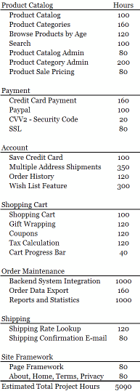
Using some simple calculations, our timeframe of about 13 weeks and 5 resources cranking about 170 hours a week gives up a project time box of 2210 hours. Given that, our mission is to prioritize the list of features and end up with about 2210 hours of work that will yield a good first release of the supertoybox.com website.
1. Prioritize “Must have” features - On the first pass through the list I like identify the “Must have” features. At a minimum our site has to have a basic product catalog, search, and a shopping cart with tax and shipping calculations. We will also need to do credit card transactions, have some way of getting orders out of the system and a page framework to hang the functionality on. That’s pretty much the bare minimum. So our first pass looks like:
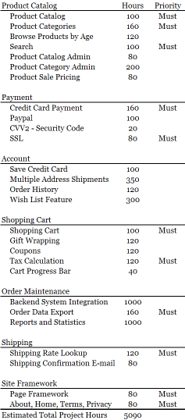
Using this initial prioritization, the “Must have” hours they are about 57% of total time box hours, which is about where we want to be.
2. Prioritize “Won’t have” features - Next, I like to see what I can easily defer out of the project to make it nearly the size of the time box. I try to look for large features than can be worked around and are not technically required to make the project work. For this project I would look to defer system integration and do manual order entry. We can also safely defer the reporting and statistics feature because we could likely get that information from our ERP system. Features like multiple address shipments, product category admin and the wish list can also safely be deferred. That puts us with a prioritization like:
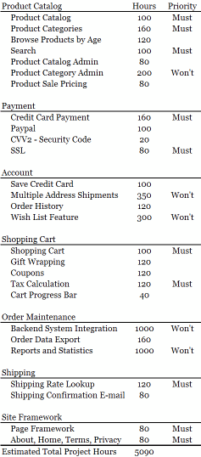
After deferring these features, our project is down to an estimated 2240 hours, which is just about 1% larger than our time box. That’s good.

3. Prioritize the “Should have” features - “Should have” features complete functionality that are categorized “Must have.” I’d look at browse product by age, the CVV2 and paypal and shipping confirmation emails as very important but not critical features to include in this first release. Now our prioritization looks like:
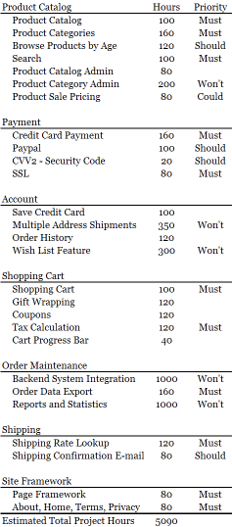

4. Prioritize the “Could have” features - I like this step; all the rest of the features are “Could have” features by default. That puts us to a completed prioritization that looks like:
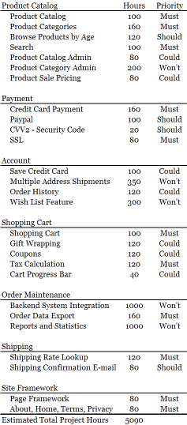
We get pretty lucky on this project because the “Won’t have” features are pretty easy to defer and the “Must”, “Should” and “Could” features are not much bigger than the 2210 time box:
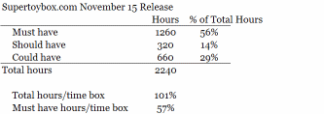
At first glance, we have enough time to deliver the 1260 hours of “Must have” features in our time box of 2210 which ends up at 57% of the total time box hours. That’s good. The total project feature hours for this release is only 101% of the time box hours.

