 

ASSIGNMENT 1 FRONT SHEET

|  |  |  |  |
| --- | --- | --- | --- |
| **Qualification** | **BTEC Level 5 HND Diploma in Computing** | | |
| **Unit number and title** | Cloud computing | | |
| **Submission date** |  | **Date Received 1st submission** |  |
| **Re-submission Date** |  | **Date Received 2nd submission** |  |
| **Student Name** | Bùi Đình Kha | **Student ID** | GCH17468 |
| **Class** | GCH0709 | **Assessor name** | Đỗ Quốc Bình |
| **Student declaration**  I certify that the assignment submission is entirely my own work and I fully understand the consequences of plagiarism. I understand that making a false declaration is a form of malpractice. | | | |
|  | | **Student’s signature** |  |

### Grading grid

|  |  |  |  |  |  |  |
| --- | --- | --- | --- | --- | --- | --- |
| P1 | P2 | P3 | P4 | M1 | M2 | D1 |
|  |  |  |  |  |  |  |

|  |  |  |
| --- | --- | --- |
| * **Summative Feedback:  Resubmission Feedback:** | | |
| **Grade:** | **Assessor Signature:** | **Date:** |
| **Internal Verifier’s Comments:** | | |
| **Signature & Date:** | | |

**Contents**

Introduction 5

1. Cloud computing fundamental 5
   1. Client server 5
   2. High performance computing 5
   3. Parallel Computing 6
   4. Distributed Computing 7
   5. Cluster Computing 7
   6. Grid Computing 8
   7. Cloud computing 8
2. Cloud Computing Essentials 8

Characteristics of cloud computing 9

Deployment models: 9

* 1. Public Cloud 9
  2. Private Cloud 10
  3. Community Cloud 10
  4. Hybrid Cloud 10

Services Models 10

1. Infrastructure as a Service (IaaS) 10
2. Software as a Service (SaaS) 11
3. Platform as a Service (PaaS) 11

Cloud architecture: 13

Solution For ATN 13

Development Model 14

Service Model 14

Cloud Provider: Heroku 15

Programming Languages: 16

Conclusion 17

Bibliography 18

**Table of figures**

Figure 1: parallel computing (Barney, 2019) 7

Figure 2: services models (Choudary, 2019) 10

Figure 3: SAAS provider 11

Figure 4: PAAS provider 12

Figure 5: Who Manages Cloud IaaS, PaaS, and SaaS Services (JAMESMBOND, 2013) 12

Figure 6: cloud architecture 13

Figure 7: paas benefits (Rathore, 2016 ) 15

Figure 8: Heroku (guru99, 2018) 16

# Introduction

Nowadays, internet had become so much important to our lives also to each organization that lead to the evolution of how computer communicate with others that give the born of Cloud computing. As a developer in any aspect of IT, we understand that any kind of program or application need a platform also devices to run and communicate, this process also need high experience engineers, it had made so much more work need to be done. Cloud is a combination of devices and programs of 1 or many organizations work together to save data, run projects, or a place for computers work with others… it give so much opportunity for developer also user to work and doing their job. That’s why developers are really need to improve their skills of Cloud computing.

For example, facebook.com is very popular web and app services right now and they have so much information from customer, to make sure those information correctly and the server must always on for user can log in and use at any time or they will lost a lot of income and other unpredictable damage. This is one thing that Cloud computing will do, manage the server, upload services, manage and protect data… with an internet connection, we can access and work this job at anywhere.

# Cloud computing fundamental

## Client server

In client server model, the workloads and tasks will be partitions between servers and Clients in which, Servers will be the devices that provide services, data and resources while Clients are devices or app run on devices of user that will send request to servers to get the results of events.

Client and server can communicate by network on different hardware although they still on the same system. Client will not share resources with server, Client just request to server for server’s services function and resources.

Example: Many websites run on this model with

* + - Clients can be Chrome, Firefox, IE… that run on user computers, smartphones …
    - Servers can be Apache, Microsoft IIS… that run on server devices of company or provider

## High performance computing

High performance computing system can be understand as “a pool of processors (processor machines or central processing units [CPUs]) connected (networked) with other resources like memory, storage, and input and output devices, and the deployed software is enabled to run in the entire system of connected components. (Chandrasekaran, 2014, p. 2)” We also can understand that it very similar to supercomputer, but it not fully true at the moment While it can included many types of computer as

personal computer, desktop computer and even supercomputer. Those processors can be homogeneous or heterogeneous. Because this system can calculate very fast, it usually used in application to solve scientific problems, study simulations…

## Parallel Computing

Parallel computing is known as one of the facets of high-performance computing. According to (Chandrasekaran, 2014, p. 2) , a set of processors work cooperatively to solve a computational problem. These processor machines are mostly of homogeneous type.

In other computer, problems will be solved in these steps:

Step 1: A problem will be broken down into series of instructions. Step 2: Then those instructions are executed one after another.

Because these computers are single computer/processor machine that having a single CPU. They called serial or sequential computers.

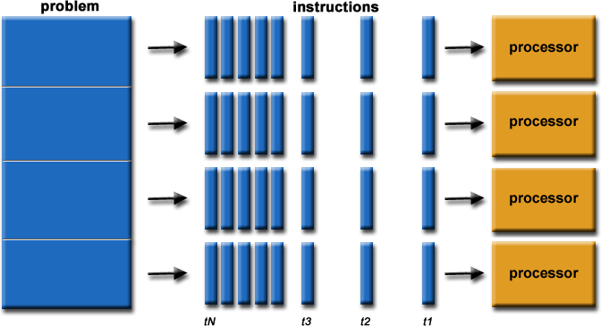Different from those, in parallel computing, it is run using multiple processors/CPU: Problem will be divided into many parts that can be solved at the same time

In each part, they can be divided further into a series of instructions Then those instructions are executed by different processor, CPU.

And also An overall control/coordination mechanism is employed (Chandrasekaran, 2014, p)

**Figure 1: parallel computing (Barney, 2019)**

## Distributed Computing

Distributed Computing is a computing system in which multiple computers or processor machines connected through a network, this mean it can be 1 of homogeneous or heterogeneous. But more important is that it run as single system (Chandrasekaran, 2014, p. 3).

This system aim to make a Network system into a single computer and it can give support for some characteristic features like:

- Scalability: It is the ability of the system that it can be expand with new parts (machines) easily without affecting the existed system.

-Redundancy or replication: At this way, several machines can provide the same services, so when 1 of them broke down, others can replace immediately so it will not stop because the others similar computing supports will be available for them.

## Cluster Computing

Cluster computing system is the system that has sets of the same, similar type of processor machines that connected using a dedicated network infrastructure.

Cluster computing system is also a kind of HPC category.

The individual computers in a cluster can be understand to as nodes, they can work together to solve a problem larger than when each computer can do and it will be easily solved.

## Grid Computing

Grid computing is a network of computing or processor machines which use software such as middleware to manage in order to be able to access and use the resources remotely.

The process that using middleware to manage called grid services and they provide access control, security, access to data including digital libraries and databases (Chandrasekaran, 2014, p. 4).

With Grid computing, some advantages can be:

* Reducing investments by making use of unused computing power, reduce requirement for hardware in many aspects.
* The ability to solve problems in line with any HPC-based application
* Using heterogeneous resources of computers to work cooperatively that will help increase speed, performance, effectively on solving a scientific problem.

## Cloud computing

To easier understand, Cloud computing is the process that store and access the data, programs or resources through the internet from other location, computer instead of using user’s computer’s hard drive to do so.

The word “Cloud” is just metaphor for Internet. With a connection to Internet, the Cloud computing process can be done at anywhere, anytime with any different devices.

# Cloud Computing Essentials

**Cost:** While using Cloud provider’s services, it will reduce the cost of managing and maintaining IT systems also the cost of buying those expensive systems devices and equipment for business. As a result, no need to pay for some high salary employee for those high skills works. (Chandrasekaran, 2014, p. 14).

**Scalability:** It very easy to expand the system for suiting the situation, giving much more flexibility while developers just need to change the services given of provider to other. It much easier and less time, cost if that organization have to purchase new devices and install by themselves. (Chandrasekaran, 2014, p. 14).

**Quality and performance:** it is so clearly that compare to professional at that jobs, the services of provider can be much more better with experienced staffs and specific devices that can give better quality of cloud and performance. Or it will very time consuming on learning and working on this task from the beginning. (Chandrasekaran, 2014, p. 14).

**Security:** with the case of so much hacker out there, to control a perfect cloud is never an easy job, giving professional job to professional stakeholder can be a great ideal. (Chandrasekaran, 2014, p. 14).

**Keep up to date:** time by time, many technologies are invented. Keep them up to date will be 1 of the great way to ensure the quality of services of organization, also at cloud computing. Using the servies will release the workload for organization, also the cost, (Chandrasekaran, 2014, p. 14).

## Characteristics of cloud computing:

**On-demand self-service:** user can unilaterally provision computing capabilities, like the server time and network storage, for the needed automatically without interacting with the provider face to face but using just the system of provider to make the contract (Chandrasekaran, 2014, p. 14).

**Broad network access:** The Capabilities are always available on the Internet and can be accessed through some standard mechanisms those promote use by heterogeneous thin or thick client platforms (Chandrasekaran, 2014, p. 14).

**Elastic resource pooling:** The provider’s computing resources are pooled to serve multiple consumers using a multitenant model, if user wants to change the need then just relocate different physical and virtual resources (Chandrasekaran, 2014, p. 15).

**Rapid elasticity:** the services can be provided very quickly, in some cases can even automatically, in order to quickly scale out and rapidly released to quickly scale in. At some cases, the capabilities can be unlimited as the user need. (Chandrasekaran, 2014, p. 15).

**Measured service**: Sometimes, Cloud systems can automatically control and optimize resources use by leveraging a metering capability at some level of abstraction appropriate to the type of service. Those can be the limit of storage, bandwidth… (Chandrasekaran, 2014, p. 15).

## Deployment models:

Those are the way that Cloud services can be implement or provide to customer, it depend on the organization structure and the provisioning location.

According to (Chandrasekaran, 2014, pp. 15,16). There are 4 usually used model called: public, private, community, and hybrid cloud service usage

1. **Public Cloud**

In this type of services, customers will have no control of the location for the infrastructure while it is based on the shared cost model for every different users, also can be in the form of a policy as pay per user. It can be own, managed and operate by 1 or many cooperate organizations. And most important is it exists on the premises of the cloud provider.

This type usually cheaper with normal quality and performance depend on the demand. But most important part is it less security compare to others.

1. **Private Cloud**

The cloud infrastructure and the services itself are owned, managed, and operated by the organization themselves or together with some other third party or combination of them. It may exist on or off premises.

The best thing of this model is everything can be managed by the organization themselves so the quality will be the best. But on the other hand, it come will a lot of extra money and not many organization can afford. Only who working with very high security data should use this model.

1. Community Cloud

If a Cloud that aim to supports a specific community that has shared concerns, then the cloud infrastructure can be shared between organizations to reduce cost, enhance efficiency of working … In this case, it can be managed, operated by many sides and may exist on premise or off premise.

1. Hybrid Cloud

This model is more like the combination of both Private and Public model. While the normal data can be storage at public and the important can be storage at private (customer’s data at public and their data at private). This model will clear afford those want security but don’t want to use too much money on cloud.

## Services Models

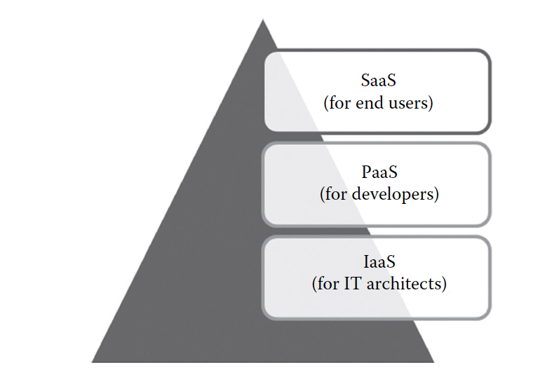According to (Chandrasekaran, 2014, pp. 15,16), there are 3 types: SAAS, PAAS and IAAS

**Figure 2: services models (Choudary, 2019)**

1. **Infrastructure as a Service (IaaS)**

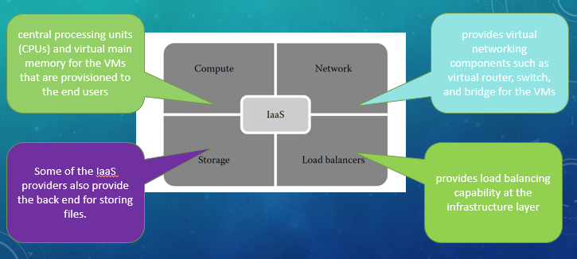This services will provide for the customer the processing, storage, networks, and other fundamental computing resources on a pay-per-use basis, with those things the user can be able to deploy any software include the operate systems or applications.

**Figure 2 Services provided by PaaS provider**

In this case, the customer will not allowed to control the Infrastructure but they can control the operate system, storage and their deployed app system and lastly can limit control of select networking components.

1. **Software as a Service (SaaS)**

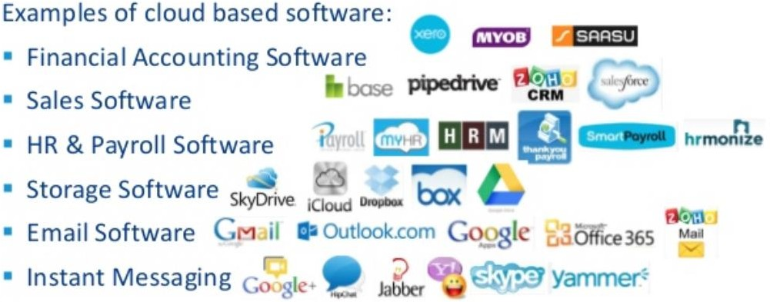In this model, everything provided to customer are from the provider from the infrastructure, including network, servers to the applications but only with the possible exception of limited user-specific application configuration settings.

Example of application can use this service usually relate to management: like business intelligence analytics, and online accounting software…

**Figure 3: SAAS provider**

1. **Platform as a Service (PaaS)**

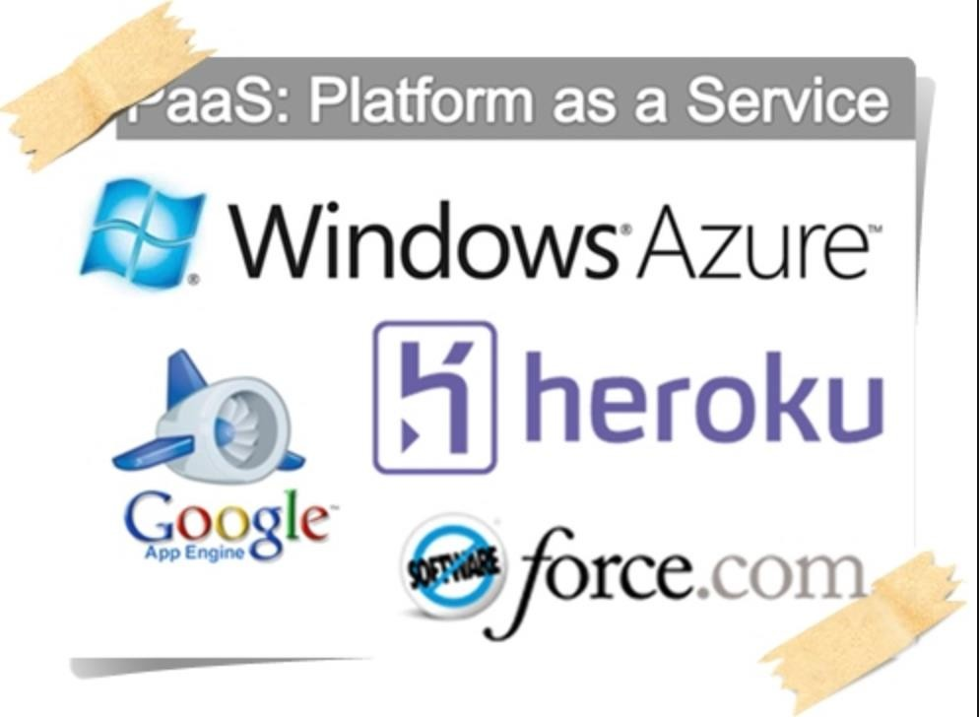In this model, customer will use the tools provider give to combine with their application or implement their application which will run on the platform of provider included the infrastructure, network, servers, operate syste

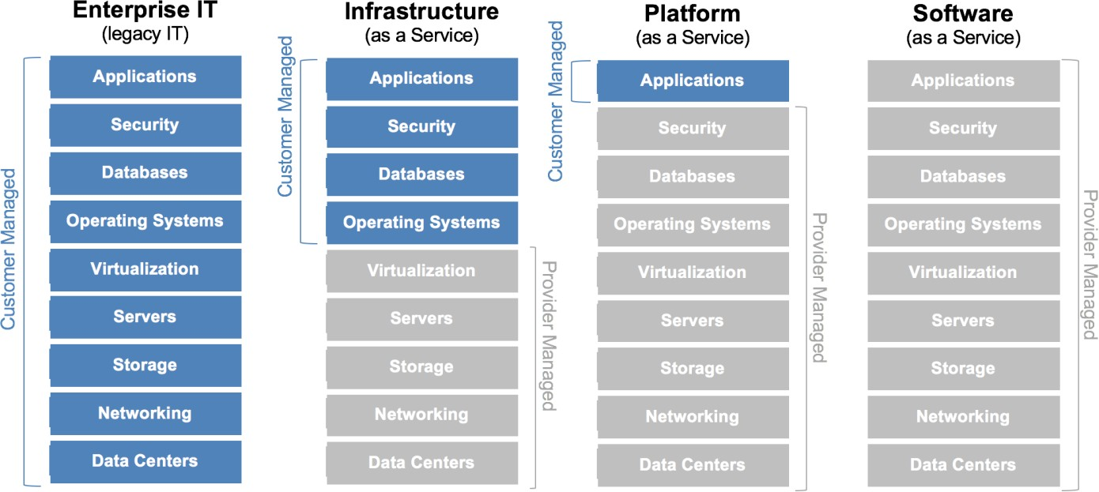 **Figure 4: PAAS provider**

**Figure 5: Who Manages Cloud IaaS, PaaS, and SaaS Services (JAMESMBOND, 2013)**

## Cloud architecture:

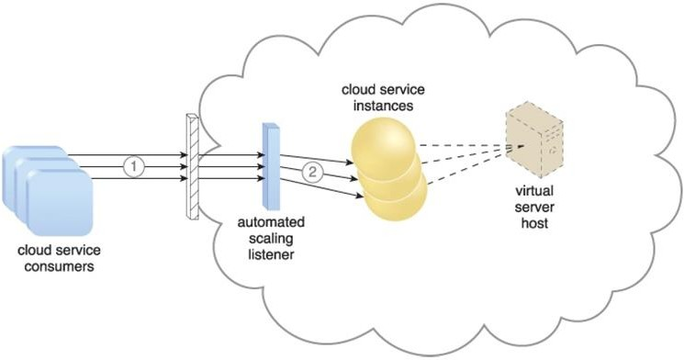

**Figure 6: cloud architecture**

The dynamic scalability architecture can be applied to a range of IT resources, including virtual servers and cloud storage devices. Besides the core automated scaling listener and resource replication mechanisms, the following mechanisms can also be used in this form of cloud architecture:

Cloud Usage Monitor: By using some specialized cloud usage monitors, developer can track the runtime usage in response to any dynamic change which caused by this architecture.

Hypervisor: The hypervisor is invoked by a dynamic scalability system to create or remove virtual server instances, or to be scaled itself.

Pay Per Use Monitor: The pay per use monitor is engaged to collect usage cost information in response to the scaling of IT resources.

# Solution For ATN

As Brif:

ATN is a Vietnamese company which is selling toys to teenagers in many provinces all over Vietnam. The company has the revenue over 700.000 dollars/year. Currently each shop has its own database to store

transactions for that shop only. Each shop has to send the sale data to the board director monthly and the board director need lots of time to summarize the data collected from all the shops. Besides the board can’t see the stock information update in real time.

With this scenario: as a developer will focus to request on using these solutions Using cloud services because:

Cost - Scalability - Quality and performance - Security - Keep up to date that have discussed above: to summary, it will reduce the cost in many aspect, reduce workloads for company, improve working performance, and improve quality of services of company, easier to manage work in future.

## Development Model:

The suitability of cloud for ATN is Public Cloud, because ATN is a toy company, there not much important information that need to be so secured then Private, hybrid is denied. Toys usually for kids that can become a community type can match as Community Cloud if possible, but it will be hard to find someone to cooperate with because there is so little these organization types. While public Cloud is very cheap, easy to work with and security is not bad while information is just about kids, it not have so much affection and relate to many other people.

## Service Model:

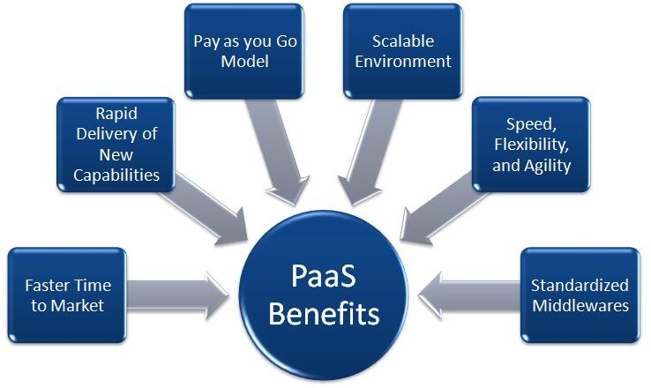Platform as a Service (Paas) would be the best because as discussed, this project is selling toys so the price will not very high, customer mostly kids and parent, the risk of being hacked, stolen data and others are so small. There no need to spend money on those not efficiency ways.

This service will have development team working faster while the resources will focus on other important part. This also mean company can implement next step sooner, reduce time from creating to deploy the project ( faster time to market)

**Figure 7: paas benefits (Rathore, 2016 )**

## Cloud Provider: Heroku

This provider is one of the most popular that is likely to use at the moment, using heroku, user can:

-Allows the developer to focus on code instead of infrastructure because its cloud services.

-Enhance the productivity of cloud app development team with very good public cloud.

-Monitor and enhance performance though rich application monitoring.

-Many support to developer with many kind of packet build

-Many plugins, tools help developer so much on their works

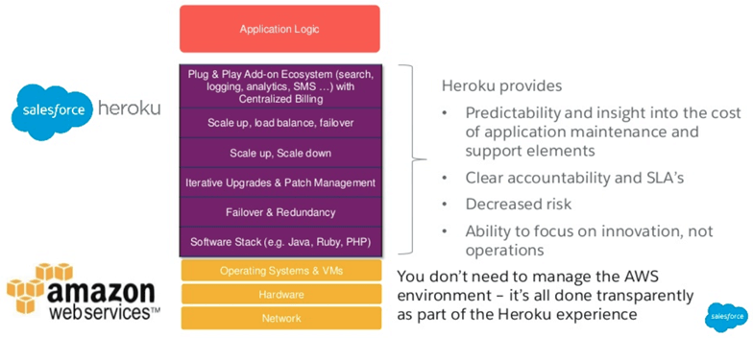-…

**Figure 8: Heroku (guru99, 2018)**

## Programming Languages

Database: progestsql should be the best while it has a free plugin to try at first, later on can upgrade to better premium types.

Front end: combination of css, boostrap and javascript will be the best solution while this always the right popular combo these day. These are the Client side coding that will improve both UI and the performance of cloud also reduce to workload for cloud so company don’t need to spend more money on cloud.

Back-end: php will be best way while it is very famous scripting language that match very well with progestsql, also the human resources of this also very full, it will be more easy to find some good developer of php.

# Conclusion

ATN has income of $700.00/year, by spending less money as possible for cloud and focus more on the quality and staffs that will give the company better chance to get income. While the cloud is don’t need to be so expensive, the app that run with the cloud should be more quality, staff will be hired carefully to reduce the risks… In the future, some money should be saved in case of the need for upgrade cloud services and things can happened.

In conclusion, cloud computing is 1 aspect that very important these days for developers, they should be trained, learned many new knowledge about using cloud, develop with cloud… to be better at any aspect of Information Technology.

# Bibliography

Barney, B. (2019, 10 17). *Introduction to Parallel Computing*. Retrieved 10 20, 2019, from computing.llnl.gov: https://computing.llnl.gov/tutorials/parallel_comp/

Chandrasekaran, K. (2014). Essentials of CLOUD. In K. Chandrasekaran, *Essentials of CLOUD.* Taylor & Francis Group, LLC.

Choudary, A. (2019, 5 22). *Cloud Computing Services: A Deeper Dive Into Cloud Computing*. Retrieved 10 20, 2019, from edureka.co: https://[www.edureka.co/blog/cloud-computing-services-types/](http://www.edureka.co/blog/cloud-computing-services-types/)

guru99. (2018). *Heroku vs AWS: 10 Most Important Differences You Must Know!* Retrieved 2019, from https://[www.guru99.com:](http://www.guru99.com/) https://[www.guru99.com/heroku-vs-aws.html](http://www.guru99.com/heroku-vs-aws.html)

JAMESMBOND. (2013, 6 19). *Who Manages Cloud IaaS, PaaS, and SaaS Services*. Retrieved 10 20, 2019, from mycloudblog7.wordpress.com: https://mycloudblog7.wordpress.com/2013/06/19/who-manages-cloud- iaas-paas-and-saas-services/

Rathore, D. (2016 , 6 20). *What is PaaS and what are its benefits for your business?* Retrieved 10 20, 2019, from https://[www.znetlive.com:](http://www.znetlive.com/) https://[www.znetlive.com/blog/what-is-paas-in-cloud-computing/](http://www.znetlive.com/blog/what-is-paas-in-cloud-computing/)