**ASSIGNMENT 1**

|  |  |  |  |
| --- | --- | --- | --- |
| **Qualification** | **BTEC Level 5 HND Diploma in Computing** | | |
| **Unit number and title** | Unit 30: Application Development | | |
| **Submission date** | 17/4/2020 | **Date Received 1st submission** |  |
| **Re-submission Date** | 21/4/2020 | **Date Received 2nd submission** |  |
| **Student Name** | Bui Dinh Kha | **Student ID** | GCH17468 |
| **Class** | GCH0709 | **Assessor name** | Truong Cong Doan |
| **Student declaration**  I certify that the assignment submission is entirely my own work and I fully understand the consequences of plagiarism. I understand that making a false declaration is a form of malpractice. | | | |
|  |  | **Student’s signature** |  |

**Grading grid**

|  |  |  |  |  |  |
| --- | --- | --- | --- | --- | --- |
| P1 | P2 | P3 | M1 | M2 | D1 |
|  |  |  |  |  |  |

|  |  |  |
| --- | --- | --- |
| **❒ Summative Feedback: ❒ Resubmission Feedback:** | | |
| **Grade:** | **Assessor Signature:** | **Date:** |
| **Lecturer Signature:** | | |

Contents

**1.** **Introduction** 7

1.1 Document Purpose 7

1.2 Product Scope 7

1.3 Intended Audience and Document Overview. 7

1.4 Definitions, Acronyms and Abbreviations. 8

1.5 Document Conventions. 10

1.6. References and Acknowledgments. 10

**2. Overall Description** 11

2.1 Product Overview 11

2.2 Product Function. 11

2.3 Design and Implementation Constraints 12

2.4 Assumptions and Dependencies. 13

**3. Specific Requirements** 13

3.1 External Interface Requirements 13

3.2 Functions Requirement. 28

**4. Other Non-functional Requirements** 33

4.1 Performance requirements 33

4.2 Safety and Security Requirements. 33

4.3 Software Quality Attributes. 35

4.3 Software Quality Attributes. 36

**5. Design tools** 36

5.1 UML definition 36

5.2 Example using selected UML tool 37

5.3 Design tools 38

5.4 Chosen design tools 39

**6. Development tools and techniques** 40

6.1 Cloud provider 40

6.2 Select cloud provider 43

**7. Development languages** 43

7.1 Introduce some development languages 43

7.2 Compare between those languages 46

7.3 Justify the selected Java language 46

**8. Database servers** 47

8.1 Introduce some database server 47

8.2 Compare between them 48

8.3 Justify the selected MySQL to manage database. 49

**9. Software Models** 49

**9.1** **Some models** 49

9.2 Compare between Waterfall model & V model 53

9.3 Justify the selected Model 54

**10. Conclusion** 54

**Appendix A – Data Dictionary** 55

**Appendix B - Group Log** 58

**12.** **References** 62

Software Requirements Specification

for

FPT Education Management System

Version <1.0>

Prepared by

Group Name: Chinh, Kha, Dat, Thang, Duy

|  |  |  |
| --- | --- | --- |
| Name | StudentID | E-mail |
| Truong Ba Chinh | GCH17527 | chinhtbgch17527@fpt.edu.vn |
| Bui Dinh Kha | GCH17468 | [khabdgch17468@fpt.edu.vn](mailto:khabdgch17468@fpt.edu.vn) |
| Pham Thanh Dat  Nguyen Duc Thang  Ngo Viet Duy | GCH17575  GCH17549  GCH17574 | datptgch17575[@fpt.edu.vn](mailto:Kyeongkmgch17621@fpt.edu.vn)  thangndgch17549[@fpt.edu.vn](mailto:Hieuntgch17588@fpt.edu.vn)  duynvgch17574[@fpt.edu.vn](mailto:Hieuntgch17588@fpt.edu.vn) |
|  |  |  |

|  |  |
| --- | --- |
| Instructor: | Truong Cong Doan |
| Course: | Application Development |
| Date: | 03/03/2020 |

**History Revision**

| Version | Primary Author(s) | Description of Version | Date Completed | |
| --- | --- | --- | --- | --- |
| Draft | Bui Dinh Kha | Software Requirements Specification Document Initial Release | | 17/4/2020 | |
| Draft | Pham thanh Dat | Software Requirements Specification Document Initial Release | | 17/4/2020 | |
| Draft | Truong Ba Chinh | Software Requirements Specification Document Initial Release | | 17/4/2020 | |
| Draf | Ngo Viet Duy | Software Requirements Specification Document Initial Release | | 17/4/2020 | |
| Draf | Nguyen Duc Thang | Software Requirements Specification Document Initial Release | | 17/4/2020 | |

# **Introduction**

## 1.1 Document Purpose

The purpose of the Software Requirements Specification (SRS) document is to describe and build a continuous learning environment throughout FPT Corporation. Need to develop web-based systems, manage the operation of internal training programs of internal training programs of the company. The specification specifies and describes the operations, interfaces, performance, and quality assurance requirements of the System. The document also describes non-functional requirements such as user interfaces. It also describes the design constraints that will be considered when the system is designed and other essentials to provide a complete and comprehensive description of the requirements for the software. The software requirements specification (SRS) captures the complete software requirements for the system or part of the system. The requirements described in this document are taken from the Vision Document prepared for FPT's Continuing Learning Environment System.

## 1.2 Product Scope

**1.2.1 Limit**

The scope of this project is to develop a web-based system, managing the operation of the internal training program of the company's internal training program. This system can be used for student account management, faculty management, course catalog management, course management, subject management, course assignment for courses, and assignment Members to the topic, assign students. This system is used exclusively for FPT Education and can be used by members such as coaches, trainers, trainees and administrators.

**1.2.2 Benefits of the product**

* Having a continuous learning environment in FPT Education Group.
* The online training program of the internal education system of the education system can be easily managed and operated.
* Create a convenient and easy-to-use application for users in the FPT education system.
* This system is based on relational database with management functions. Above all, we hope to provide the best and simplest user experience.

## 1.3 Intended Audience and Document Overview.

**1.3.1 Intended Audience.**

This project was implemented to develop a website system. It manages the activity of FPT Greenwich University training program. So, the audience for this project is the following.

* Professor is tutor who guided us conduct the project to build website for FPT Greenwich University. Therefore after our project is completed. They will check of our project have met the requirements yet. Besides, they are also the reviewers of the project's strengths and weaknesses.
* Client in our case are trainer, trainee, training staff, admin in FPT Greenwich University, they are the main performers of the project system functions such as: trainee account management, course management, assign trainer for topics and assign trainees, etc.
* Developer in our case are students in my group. They are readers who understand this document in order to build the requirements and functionalities that require a web site.

Our report begins with the project overview and then the sequence details. Therefore, readers who read this document should read the project in sequential order.

**1.3.2 Document Overview.**

Our report begins with a project overview covering the purpose of the project, the scope and target audience of the project, and then the sequence details as these project features provide, requirement in our project with clear and coherent descriptions of each item by drawing, graphic or scholarly study in information technology majors.

So, readers who read this document should read the project sequentially to understand the content and idea of our project. Besides, those who read our projects should have a good knowledge of English and information technology. This will help them understand what our project is about to build.

## 1.4 Definitions, Acronyms and Abbreviations.

|  |  |  |  |
| --- | --- | --- | --- |
| **ID** | **Acronyms and Abbreviations** | **Words or phrases** | **Definition** |
| 1 | DBMS | Database Management System | DBMS is a software package designed to identify, manipulate, retrieve and manage data in a database. |
| 2 | SQL | Structured query language | SQL is a structured query language. It is used to communicate with the database |
| 3 | UX | User Experience | UX is a person's feelings and attitudes toward using a particular product, system or service. |
| 4 | UI | User Interface | UI is a means for users and computer systems to interact with each other, especially the use of input devices and software. |
| 5 | UML | Unified Modeling Language | UML is a standardized modeling language that allows developers to specify, visualize, build, and document software systems. |
| 6 | ERD | Entities Relationship Diagram | ERD is a data modeling technique that illustrates the information system organization and the relationships between entities. |
| 7 | IT | Information Technology | IT refers to anything related to computing technology, like networks, hardware, software, the Internet, or people working with these technologies. |
| 8 | PHP | Personal Home Page | PHP is server side scripting language |
| 9 | HTML | Hypertext Markup Language | HTML is the language used to create web pages. |
| 10 | CSS | Cascading Style Sheets | CSS is used to format the layout of Web pages. Such as determines the type of text, table size, and other aspects of Web pages. |
| 11 | IDE | Integrated Development Environment | IDE is a suite of software that unifies the basic tools needed to write and test software. |
| 12 | UCD | Use case diagram | The use case diagram is a representation of user interaction with the system showing the relationship between the user and different usage. |
| 13 | FR | Function Requirement | Function requirements are clearly defined requirements that are essential signs on the path to a successful project. |
| 14 | NFR | Non – Function Requirement | Non-functional requirement is criteria’s that a software system needs to achieve when it is executed. |
| 15 | MVC | Model - View – Controller | MVC is a model designed to separate Code and Interface parts for easy maintenance, development, and management. |
| 16 | SRS | Software requirements specification | SRS is a document that communicates the functional and functional requirements that a product must provide. |
| 17 | HR | Human resources | Human resources are used to describe people who work for a company or organization and department responsible for managing related resources. |
| 18 | OS | Operation System. | Operating system is a software running on computers and mobile devices, used to operate, manage hardware devices and software resources on computers. |

Table 1 Abbreviations in report.

## 1.5 Document Conventions.

This document follows the IEEE standard:

According to (ieee, n.d.) Document style requirements for IEEE 802.22 documents include:

**Paper size**: US letter (8.5"x11")

**Margins:** top margin: 0.6", bottom margin: 0.5 ", inner margin: 0.75", outer margin: 0.75", header and footer 0.3" from edge.

**Header:** Each page shall have a header with the following attributes:

* Font and size Times (New) Roman, Bold, 14 point for portrait-oriented documents
* Font and size Times (New) Roman, Bold, 18 point for landscape-oriented documents (e.g. PowerPoint)
* Line below, with 2 points separation from text
* Left, aligned with margin: the month and year of the publication (the venue date)
* Right aligned to the margin: the document designator, which includes the document number

**Footer:** Each page shall have a footer with the following attributes

* Font and size Times (New) Roman, Normal, 12 point
* Line above
* Left, aligned with margin: the word "Submission"
* Center: the word "page" followed by the page number
* Right aligned to the margin: the first author and company

## References and Acknowledgments.

* + 1. **References**

**System Requirements Specifications:**

https://anphanhv.wordpress.com/2015/03/21/tong-quan-ngon-ngu-java/  
https://www.guru99.com/what-is-php-first-php-program.html  
https://www.hostinger.vn/huong-dan/javascript-la-gi/  
https://www.paessler.com/sql-server-   
https://www.softwaretestinghelp.com/what-is-stlc-v-model/  
http://sqladvice.com/he-quan-tri-co-so-du-lieu-pho-bien/  
https://www.tutorialspoint.com/mongodb/mongodb_overview.htm  
https://viblo.asia/p/mo-hinh-thac-nuoc-la-gi-va-khi-nao-nen-su-dung-

**1.6.2 Acknowledgments.**

In order to do this project, we need a lot of support from team members, teachers and many other friends. The teachers have helped us navigate the work we need to do, and track us every step of the way. The team members are constantly trying and trying to make the project achieve the highest results. In the process of implementing the project, they helped us a lot, especially thanks to the guidance of the teachers, here I would like to thank everyone who helped us to complete the project.

# **2. Overall Description**

## 2.1 Product Overview

Currently, FPT Corporation wishes to build a continuous learning environment throughout the corporation. It is necessary to develop a web-based system, managing the operation of the internal training program of the internal training program of the company. This system can be used for trainee account management, faculty management, course portfolio management, course management, topic management, assigning topics for the course, assigning lecturers for the topic, assigning students to attend the course. All data are stored on the database system. The student information system and Academic information system can get data from Training management system.

## 2.2 Product Function.

The project is implemented using SQL Server to uploading, storage and management of data and user interface to allow users access. The following table describes overview of each person's functions and roles.

|  |  |  |
| --- | --- | --- |
| **ID** | **Objective** | **Function.** |
| 1 | Administrator | * Login/logout as an instructors of system. * Manage trainee accounts, trainers account. * Assign/ change username or password. |
| 2 | Training staff | * Login/logout as the manager of system. * Manage trainee accounts. * Manage trainer’s accounts. * Manage course categories. * Manage courses. * Manage topics. |
| 3 | Trainer | * Login/Logout as the client of system. * View courses which have a topic he is assigned to |
| 4 | Trainee | * Login/Log out as a viewer * View Courses they have been study. |

## 2.3 Design and Implementation Constraints

**2.3.1 Hardware Requirement**

Hardware must be able to store data with hundreds of megabytes of data on demand. In particular, must be able to store online and store near the route. With online storage capability, gigabytes of data storage space are needed. With near-offline storage, all user and application data, as well as software configuration and installation files, must be backed up weekly.

Regarding the network, Application Server and Database Server must be balanced at the application level load to ensure stability and maximum availability. The system will use, as appropriate, standard data communication hardware and hardware provided by the AASTU data center.

Have use browsers that support HTML 5, CSS, JavaScript and Bootstrap. Using PC and laptop running

Windows operating system. PC and laptop install all IDE, tools that support to develop my project.

**2.3.2 Software Requirement**

**Backup software** - Data and application backup will be managed through fully supported backup software solutions.

**Web browser** Can support requirements External interface, popular supported web browsers will be used to deploy thin client architecture. HTTP is an application protocol of the TCP / IP protocol suite (the underlying protocols for the Internet). The web will be the main delivery protocol for the application, so HTTP and HTTP server related applications will be required to support system functionality.

**Relational database management system** - As the main data storage mechanism for the company's standard relational database management system, MySQL Server will be required to support system functionality.

**Browser Google Chrome:** Because it is the most popular browser today, high performance. So we used it in the process of developing and testing the project.

**Server Xampp:** It is a fairly common software application and is often used to build and develop PHP based website projects.

**The Eclipse IDE** is well known for the Java Integrated Development Environment (IDE). You can easily combine multiple supported languages and other features into any. The Eclipse market allows for customization and expansion virtually unlimited.

**Program Language:** HTML 5, CSS, JavaScript, Bootstrap, PHP, ASP.NET, Spring Boot. Because it is all a common website building bad language, I chose it for our project.

## 2.4 Assumptions and Dependencies.

• All team members have the necessary knowledge and skills.

• All necessary equipment is in good repair.

• The request from the partner provides clear, detailed and easy to understand.

• The server is always running in stable condition.

• Internet connection ensures the project development process.

• All customers know English, because the system is completely designed in English.

• All users know how to use Windows, Android, iOS, MacOS operating systems to use the system.

• All service providers are able to meet requirements when needed.

# **3. Specific Requirements**

## 3.1 External Interface Requirements

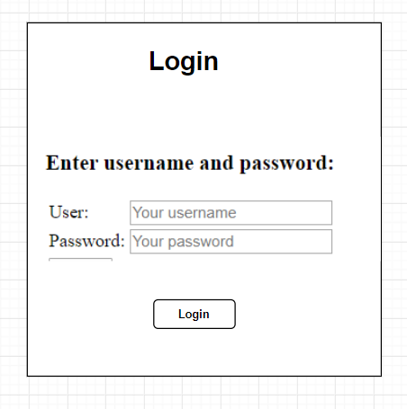**3.1.1 Interface Design (UI)**

**a. Admin**

Figure 1. Login

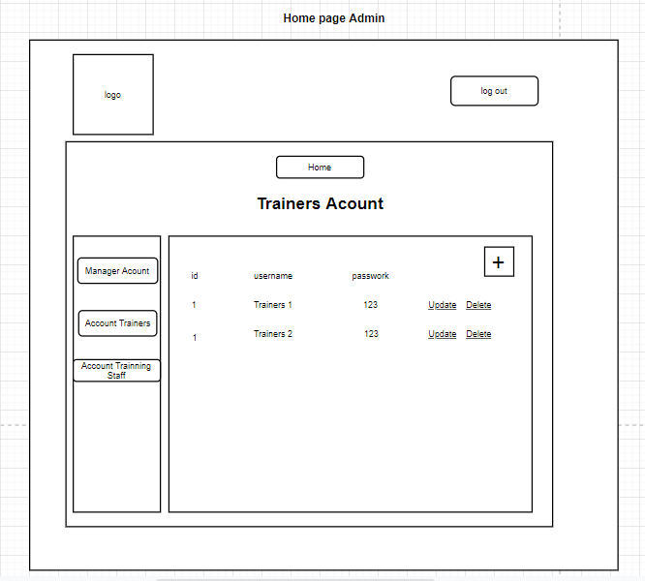

Figure 2. Home page.

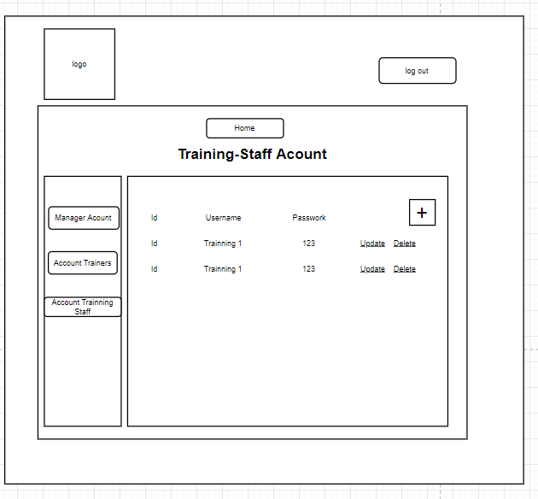

Figure 3. Manage to training staff account (Admin).

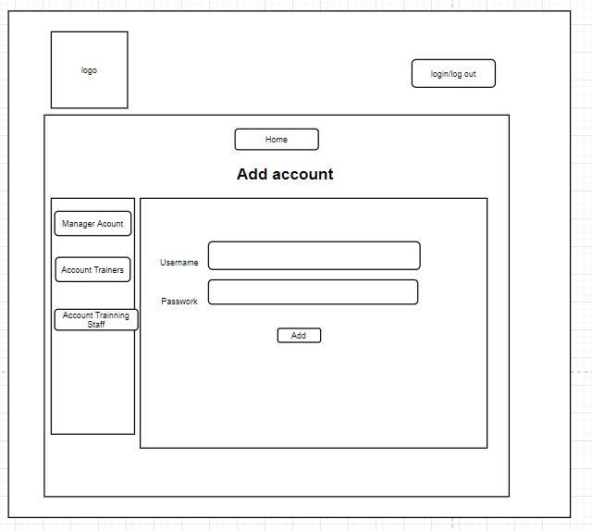

Figure 4 add account

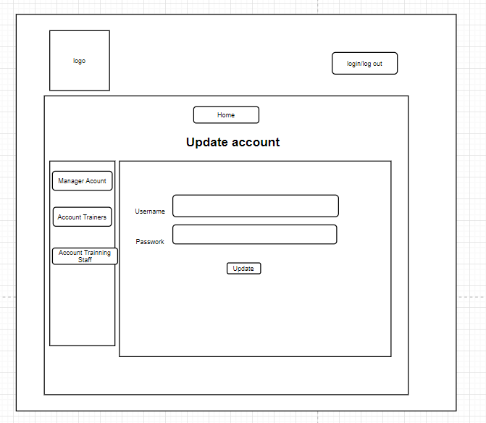

Figure 5.update account.

**b. Trainer.**

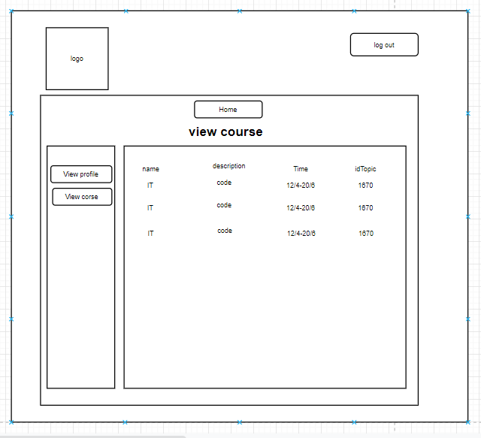

Figure 6 view course

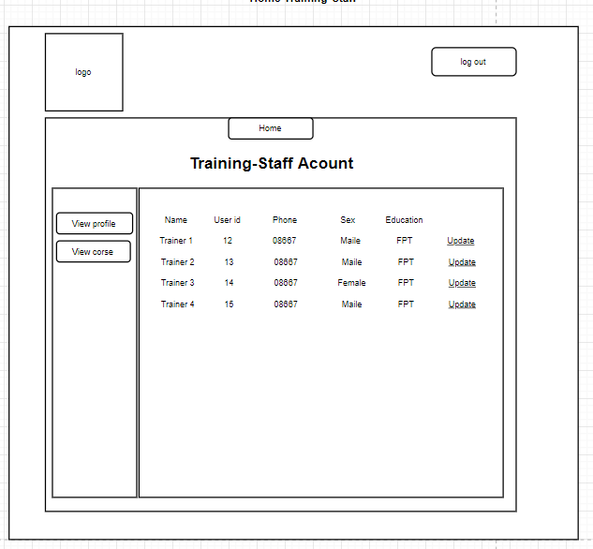

Figure 7 Training-Staff account

Figure 8 Home Page

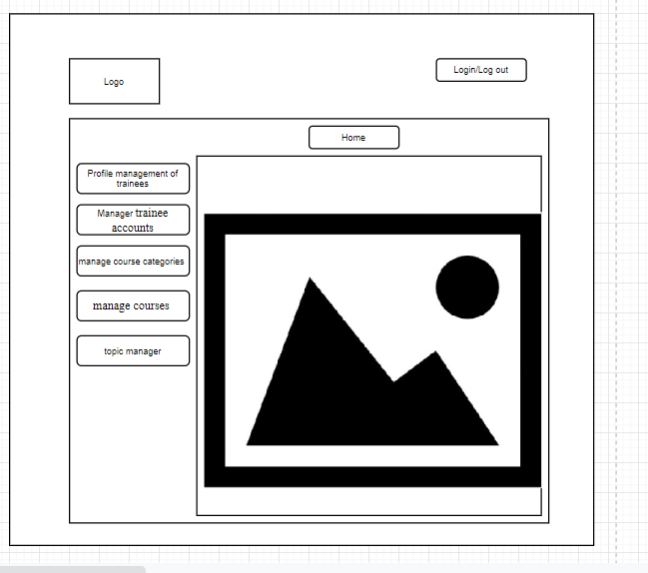**c. Training Staff.**

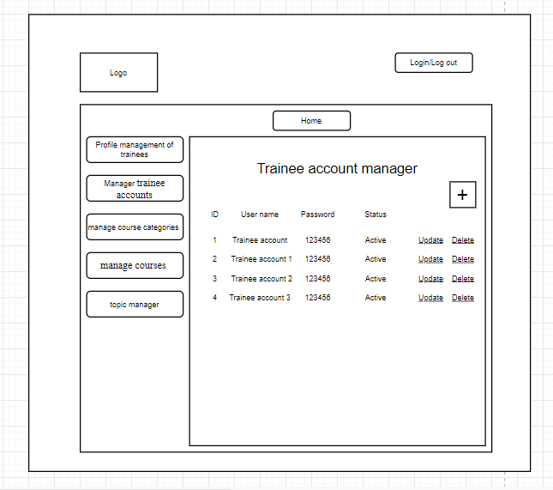

Figure 9 List of Trainee

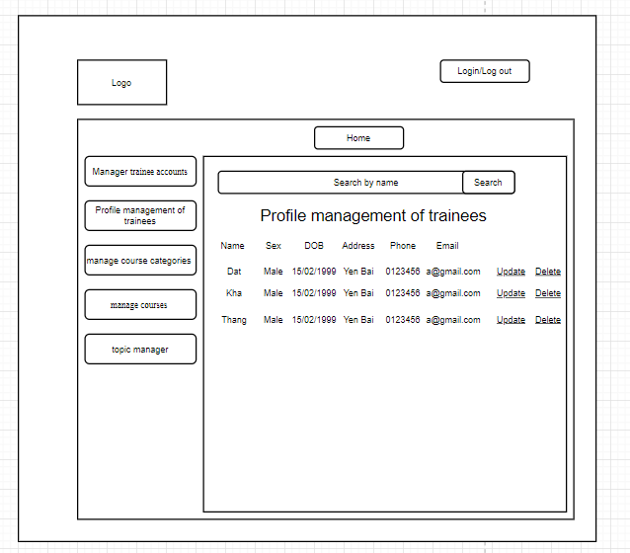

Figure 10 Profile management of trainees

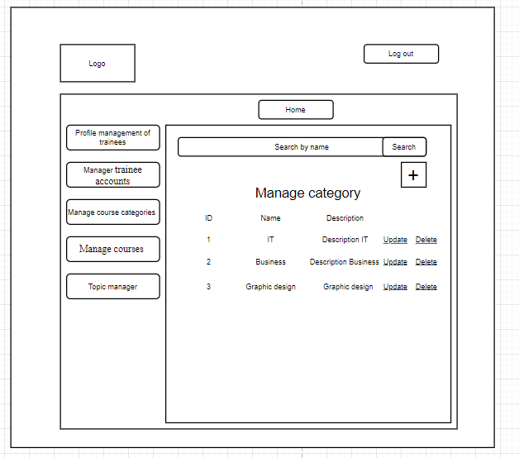

Figure 11 Manage category

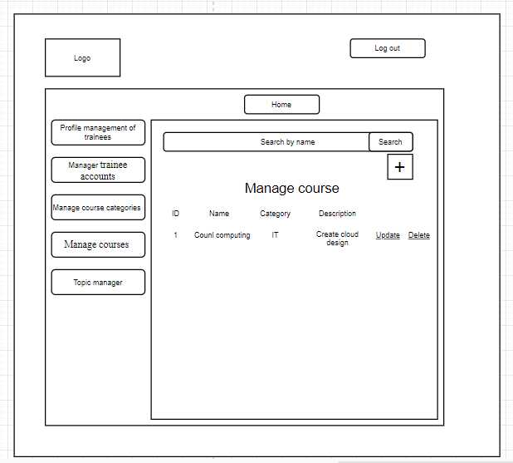

Figure 12 manage course

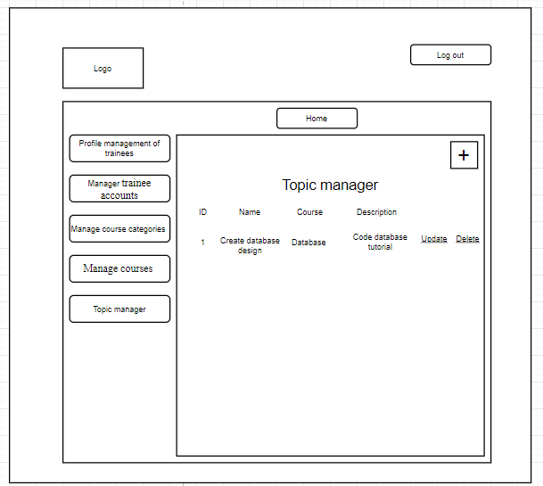

Figure 13 Topic manager

**c. Trainee**

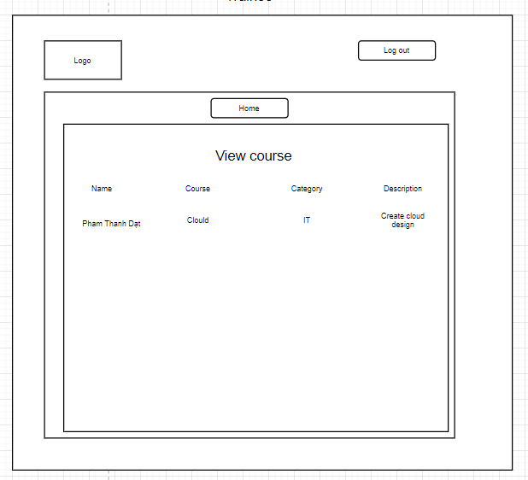

Figure 14 Home page of Trainee

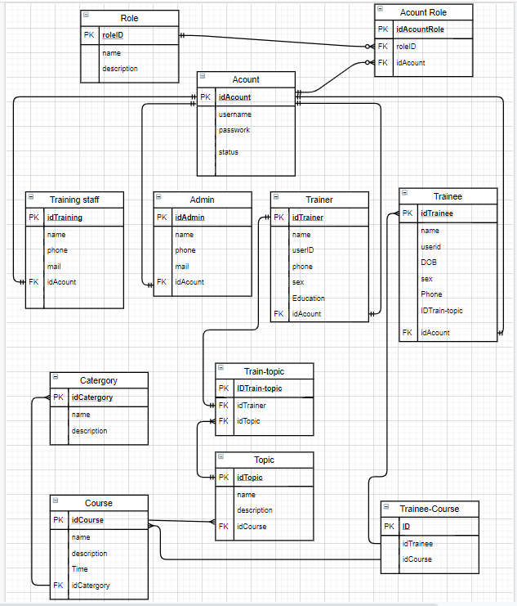**3.1.2 ERD Diagram**

Figure 15 ERD Diagram

## 3.2 Functions Requirement.

This is a system used by the HR department include three main roles in this system, an administrator, training staff and Trainer. Besides the system also provides and describes the function of the trainee*.* Below is a detailed description of the functions and roles of each person.

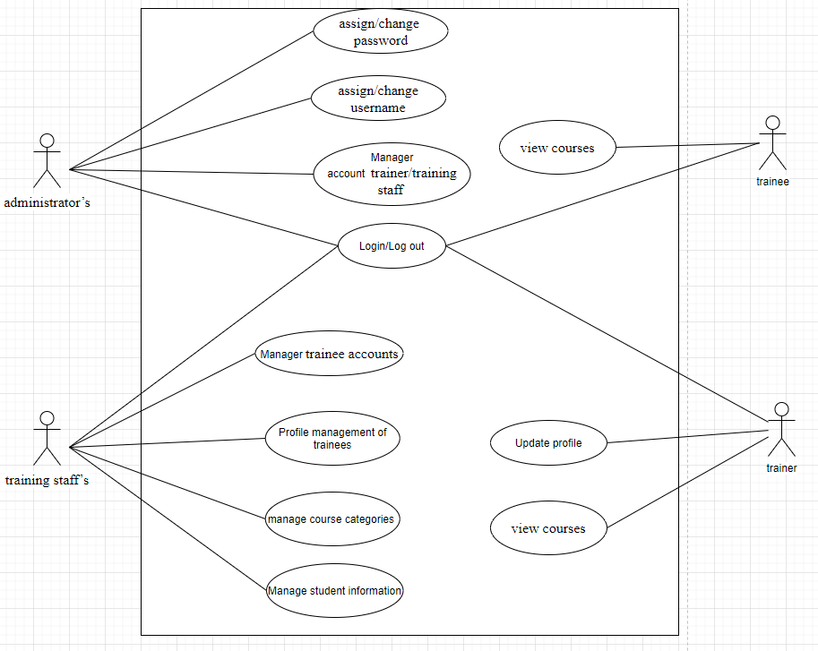

Figure 16 Use case overview.

Administrator roles.

* Can login to the system through the first page of the application
* Can create/edit/delete new user account for trainer/training staff and assign/change(if existing user) username and  a password

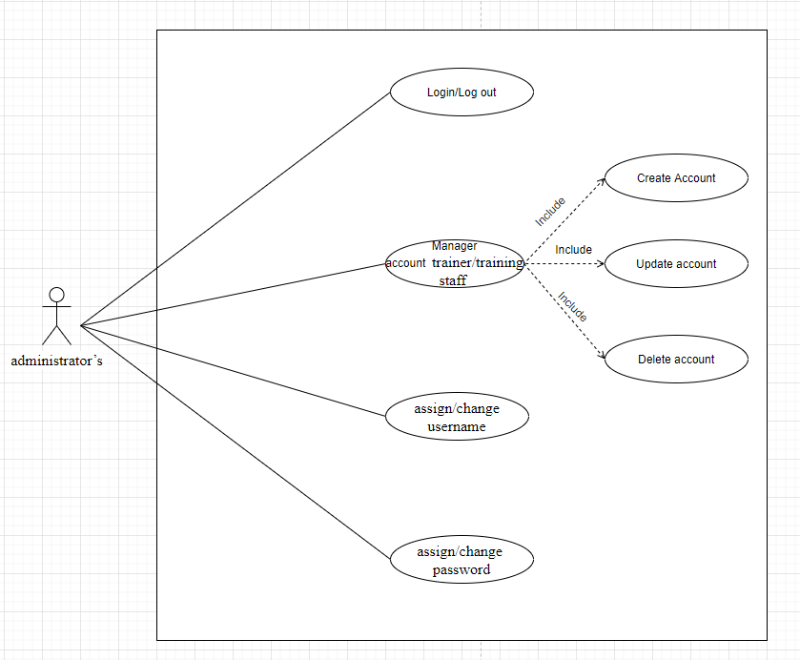

Figure 17 Administrator use case

Training staff roles.

* A registered training staff, who is assigned a user name and a password by the administrator logs in can create trainee accounts by entering details like trainee name, trainee accounts, age, date of birth, education, main programming language, TOEIC score, experience details, department, location, etc.
* After entering successfully all details for trainees, his/her details are then stored in the database. The training staff is given a list of trainees for him to view and search. From the list of trainees, he can also search by trainee account, programming language, TOEIC score…
* Can update, delete trainee accounts
* Can manage course categories such as searching, adding, updating and deleting course categories. Course category includes the information such as course category name and descriptions.
* Can manage courses such as searching, adding, updating and deleting courses. Course includes course name and description.
* Can add topics such as topic name and topic descriptions into a course, add courses into a category.
* Can manage trainer profile such as adding, updating and deleting the information: Trainer name, External or Internal Type, working place, telephone, and email address.
* Can assign trainer to a topic.
* Can assign trainee to a course

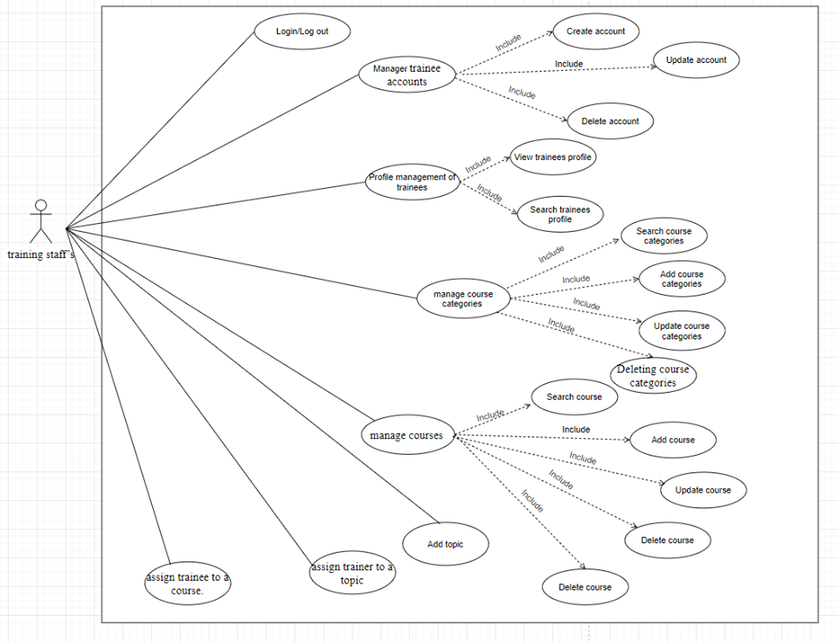

Figure 18 Training use case.

Trainer roles.

* In the same system, the trainer who have been registered by the administrator can login and can update his profile such as Trainer name, External or Internal Type, education, working place, telephone, and email address.
* Can view courses which have a topic he is assigned to.

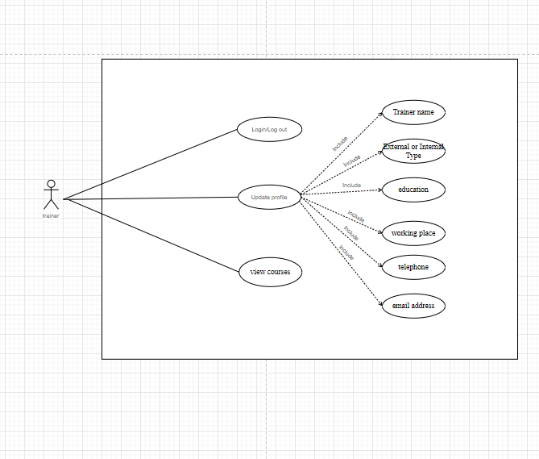

Figure 19 Trainer use case.

Trainee role.

* Login/Log out as a viewer.
* View Courses they have been study.

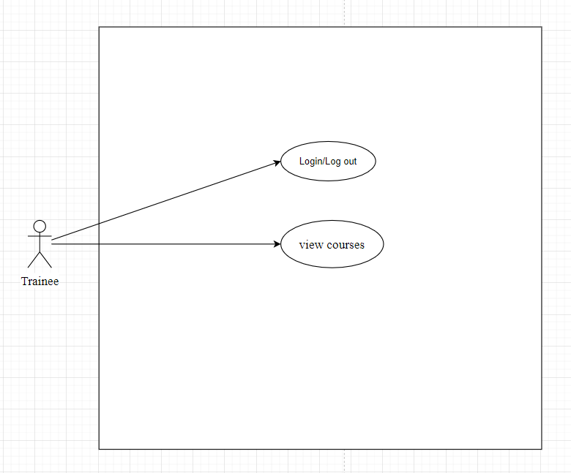

Figure 20 Trainee use case.

# **4. Other Non-functional Requirements**

## Performance requirements

Next, given the above requirements, the developer must actively accept and provide the design. The developer opens a login window that allows administrators, trainees, and coaches to log in to the system. If you are a new member, you will be directed to a window where you can join. When the information is matched and you are logged in, you can connect each other window according to the personal information of the manager, trainee, and coach. Because administrators can see the window for managing all the information, trainees can see the schedule window to check their course, coach, schedule, etc. In addition, the administrator can register new members and update or delete existing member information, so the manager's management list must have the Add, Delete, Update buttons.

## Safety and Security Requirements.

**4.2.1 Risk**

|  |  |  |
| --- | --- | --- |
| Risk category | Description | Example |
| Strategic | Actions that come in contact with dangers, threatening a company's long-term goals A | A strategic example of a company that does not pursue new technology of security, using old technology will be easily attacked by hackers. |
| Compliance | Compliance risk is the risk of an individual not following certain regulations or standards of an organization | For example, a certain employee does not comply with the prohibition of bringing USB into the company, resulting in the whole system being infected virus |
| Financial | Financial risks are risks related to financial transactions and market factors | The impact of the global financial crisis has reduced the economy of many countries |
| Operational | Operational risks are risks arising from events of an organization | Some examples of operational risks such as fraud, fire, power outages.... |
| Environmental | Environmental risks are actions  from the environment that cause great damage to an organization | Examples include storms, tornadoes, earthquakes, tsunamis ... |
| Technical | Technical risks are losses caused by technical problems affecting the system | Errors about SQl, virus ... |
| Managerial | Management risks are the  disadvantages for top managers | The key staff suffered from an  accident, the company director  suffered from a long-term illness |

**4.2.2 Requirement related to loss, damage or harm.**

* Hijacking account: The account of the training is taken. Hackers can use that account to change, tamper with the work in the site. Therefore, it is necessary to change the password every 3 months and require to set the password including letters, lowercase letters and numbers
* Data theft: Data on course information for trainee, information of trainee, training staff and lecturers is also one of the top concerns of FPT Greenwich University when using our system. Hackers often launch an intentional attack or exploit security holes to reveal data. Therefore, user information data should be managed and checked regularly by FPT System's IT staff.
* Losing control leads to unauthorized access: Risk of this system is that software providers no longer have full control over the rights and restrictions of access of each user. In addition, FPT Greenwich University staff may also accidentally delete data resulting in data loss or exposing sensitive data to unauthorized users resulting in data leakage. Therefore, user information data should be managed and checked regularly by FPT System's IT staff.
* Impersonation: Forging a person's identity in FPT Greenwich University system to access the system for the purpose of changing, stealing and deleting data. Therefore, user has an account of the system. They need be responsible for not providing account information to anyone.

**4.2.3 Methods of protection.**

Personnel at FPT Greenwich University using computers can describe their needs for information security and trust the systems according to three main requirements:

* Information security: The system should ensure the confidentiality of all information to users, preventing unauthorized disclosure of sensitive data to other individuals. User personal data is collected only with the user's explicit consent, so users need to show their consent to the company. Information from courses, subjects and student grades are saved by the system and cannot be leaked to the outside
* Integrity: ensuring that information and programs are changed only in a manner specified and authorized; and
* Availability: ensure that authorized users continue to access information and resources.
* Authentically: The system must ensure the legitimacy and validity of the identity. The system needs permissions for the objects including "System Administrator ...", the objects can only access within the limits that they are allowed to.
* Maintenance: The system needs regular maintenance and repair immediately when problems occur.
* Advertising issue: Do not cooperate with any party on the use of advertising in the system.
* Illegal activity: Do not perform any illegal activity through the system. Strictly even revoke access when any individual violates.

## 4.3 Software Quality Attributes.

**Portability:** This project uses code such as Java, Html, CSS, etc. It possesses high mobility. And they can operate easily and well on other computer configurations that meet the above software and hardware requirements.

**Recoverability:** The time and effort required to recover directly affected data in the event of an error, so the entire source code and database are saved on the Google Driver cloud system to recover when the problem occurred.

**Reliability:** The code in my project possesses such reliability that it can be expected to adequately perform its intended functions.

**Flexibility:** The project possesses the ability to modify properties at a high level, which facilitates the incorporation of changes when requested by the end user such as adding the score update feature to the trainee.

**Interoperability:** System functions meet end-user (FPT Greenwich University) requirements. This will increase the end user's interaction with the system.

**Adaptability:** The properties and programming languages are selected in accordance with the integrated development environment supporting programming languages

**Maintenance:** The system needs regular maintenance and repair immediately when problems occur.

**Advertising issue:** Do not cooperate with any party on the use of advertising in the system.

**Illegal activity:** Do not perform any illegal activity through the system. Strictly even revoke access when any individual violates.

## 4.3 Software Quality Attributes.

**Portability:** This project uses code such as Java, Html, CSS, etc. It possesses high mobility. And they can operate easily and well on other computer configurations that meet the above software and hardware requirements.

**Recoverability:** The time and effort required to recover directly affected data in the event of an error, so the entire source code and database are saved on the Google Driver cloud system to recover when the problem occurred.

**Reliability:** The code in my project possesses such reliability that it can be expected to adequately perform its intended functions.

**Flexibility:** The project possesses the ability to modify properties at a high level, which facilitates the incorporation of changes when requested by the end user such as adding the score update feature to the trainee.

**Interoperability:** System functions meet end-user requirements. This will increase the end user's interaction with the system

**Adaptability:** The properties and programming languages are selected in accordance with the integrated development environment supporting programming languages.

# **5. Design tools**

## 5.1 UML definition

According to (Beeck, 2001, October), UML stands for "Unified Modeling Language." This is a programming language that is used for object-oriented software development. To organize program code more efficiently, programmers often create "objects" that are sets of structured data within programs. UML, which has been standardized by the Object Management Group (OMG), was designed for this purpose. The language has gained enough support that it has become a standard language for visualizing and constructing software programs.

Figure 21: UML

Modeling UML helps describe the information system structure and how an object works. This helps people who design and systematize the amount of information in the process of using it. Create a comprehensive and complete view of the information system to build.

UML is linked to object-oriented design and analysis. UML uses elements and forms links between them to form a diagram. UML diagrams can be categorized into 2 types:

* Structure diagram: Describes aspects of the structure. In the structure diagram, there are Component Diagrams, Object Diagrams, Class Diagrams and Deployment Diagrams.
* Behavior Diagrams: Describe the aspect of system behavior. Behavioral diagrams include Use Case Diagram, Activity Diagrams, State Diagrams, Interaction Diagrams.

## 5.2 Example using selected UML tool

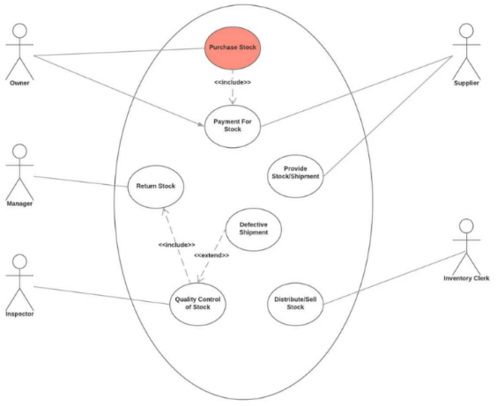The example below depicts the Use case UML diagram for an inventory management system. In this case, we have the owner, the supplier, the manager, the inventory clerk and the inventory inspector.

The example above shows how UML diagrams can be used to describe the dynamic behavior of a system, the structural organization, and interaction among objects.

The diagram has a starting and ending point, just like any activity diagram. Then, on a top-level view it depicts interactions and interaction uses through the use of the rectangular frames. Within the interactions (rectangular frames), we have included a complete stand-alone sequence diagram, containing three main actors: the assistant, the middleware reporting system and the inspector. Once the sequence of actions is completed, the flow state branches out and either repeats the previous interaction or moves on to a new interaction and then ends the flow.

Figure 22: Use case UML diagram

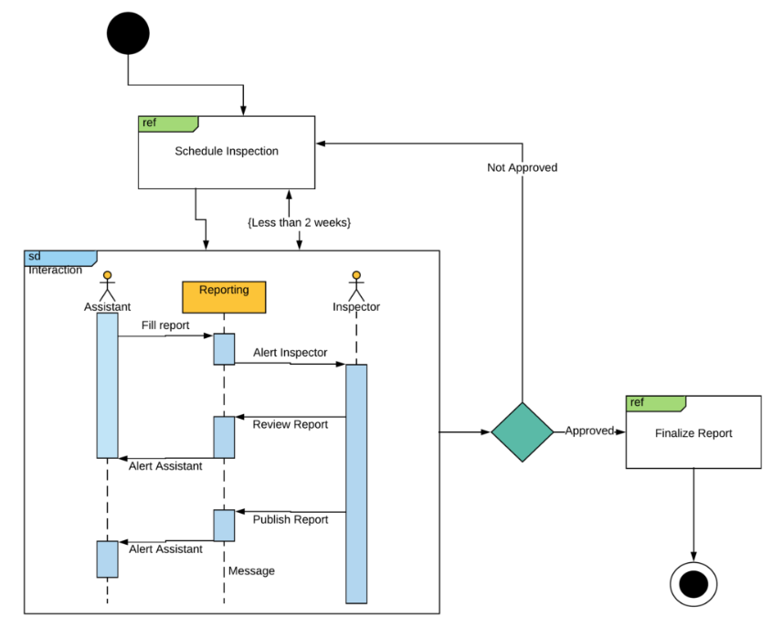

Figure 23: Activities Diagram

## 5.3 Design tools

**UMLet** is an open source Windows application designed to assist users to draw, edit and render UML diagrams into BMP, EPS, GIF, JPG, PDF, PNG or SVG formats in the simplest way along with calculating Code format support.

**Visual Paradigm Community Edition** is a software tool designed for software development teams to model business information system and manage development processes.

Figure 24: Visual Paradigm

**Drawing tool** is a toolbar that allows users to quickly draw shapes and icons in the form available and to get the Drawing toolbar in Word very simple, especially with new versions of Word today.

**Draw.io** is a free website and great user support for creating UML. Users can easily use and create UML effectively with all the functions provided by the application. It was a reasonable option for me when creating UML.

Figure 25 Draw.io

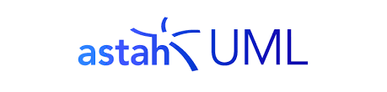**Astah UML** is a lightweight URL editor that integrates features that support software development. It has the maximum support for designing a URL chart. Express your ideas in the form of images that include the basic symbols and functions that best express the relationship.

Figure 26 Astah UML

## 5.4 Chosen design tools

**Draw.io:** Draw.io is an easy-to-use, easy-to-use charting tool, with support for multiple shapes, running online without installation. Moreover, it is free for users and unlimited number of charts like many other drawing tools on the web. You can draw any diagram you want such as: network diagrams, grid diagrams, business and production process drawings or any system diagram. Moreover, Draw.io also allows users to draw software, hardware and system design diagrams. With the extensive sample libraries, you can start drawing the diagrams you want faster without having to redraw them all yourself.

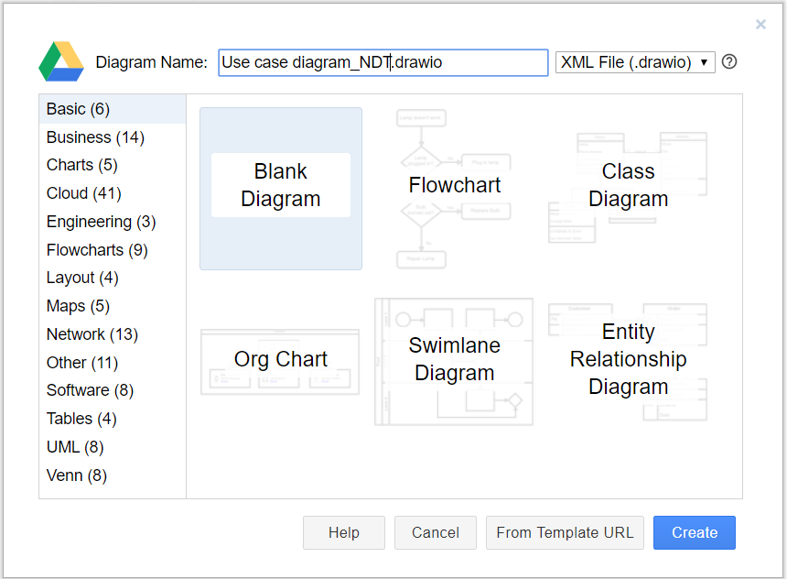With outstanding advantages compared to other tools, Draw.io is currently the top drawing tool of my choice. Moreover, you can easily share your diagram file with others, they do not need specialized software to read, just open the browser is enough, many people can even view at the same time. We guarantee that this is a best option for your project design.

Figure 27: Draw.io

# **6. Development tools and techniques**

## 6.1 Cloud provider

Figure 28: Amazon Web Services

**1. Amazon Web Services**

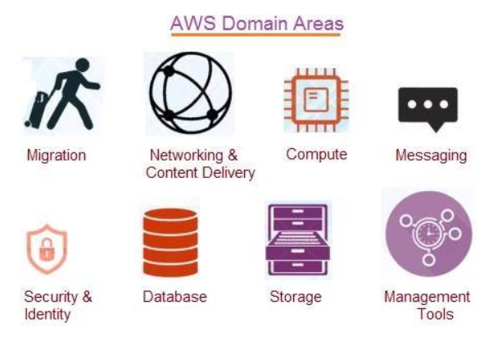AWS is secure cloud services platform which offers services in various domain areas such as migration, compute, networking and content delivery, messaging, storage, database, security & identity and management tools.

* It offers global cloud platform which is used by 80% of fortune 500 companies.
* It offers Infrastructure as service, Platform as service, software as service and cloud storage platform.

**Advantages of AWS:**

* It offers easy to sign up process and easy to use UI (User Interface) or Management Console. Moreover, all the AWS services are well documented for beginners.
* It offers simple billing with dynamic options as per need including per hour billing, region specific pricing, term specific pricing etc.
* Amazon is trusted vendor and ensures stability of services.
* AWS services are available at global scale which covers about 15 regions which include US, Europe and Asia pacific. There are multiple availability zones in each of these regions. Moreover, it offers massive data centers.
* Amazon continuously focuses on machine learning, SAAS (Software as a Service) products and reduction in the costs of their services.
* Like other cloud computing platforms, AWS offers no limitations on capacity, offers speed and agility, secure and reliable environment and so on.

**Disadvantages of AWS:**

* There are limits on resources available on Amazon EC2 and Amazon VPC console. However, one can request to increase the same.
* There are limitations on security features. For example, EC-2 classic supports max. 500 per instance and each group supports max. of 100 permissions. Moreover, EC2 VPC supports max. 100 groups per VPC.
* There are technical support fees which vary as per different packages which include developers, businesses and enterprises.
* There are generic cloud computing drawbacks such as internet dependency, security concerns and so on.

**2. Heroku** is a cloud platform based on container applications in the form of a PaaS service that uses Heroku to manage, expand, and deploy applications. It is easy to use and has many advanced functions. cloud services and scalable applications with tightly managed services.

**Advantages:**

* Heroku is easy to get started, you only need to install Heroku ruby gem.

Figure 29: Heroku

* They having sufficient documentation to follow up.
* Heroku is the cheapest option for a low traffic site.
* You don't have to add your credit card for payment at early stage.
* They offer no of Dyno for upgrade and downgrade app instance.
* Database integration is pretty simple with PostgreSQL.

**Disadvantages:**

* Pricey - after the free tier the pricing is steep, you will pay literally 3x - 5x more than a comparable performing setup through an IaaS
* Performance - as highlighted by rap genius recently the switch away from being purely a Rails PaaS and the updates to the routing engine has worse performance which translates to more dynos and still higher costs
* Lock-In - since you aren't managing your infrastructure you can't move it to take advantage of savings
* Single point of failure - granted it happens rarely but it's there. Architecting around this on your own requires a lot of experience but you'll be glad once you get past the learning curve.

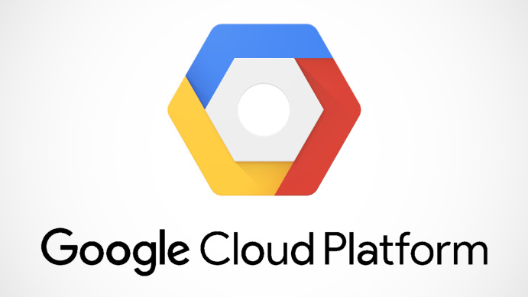**3. Google Cloud Platform** is a set of public cloud services provided by Google. The platform includes a range of hosted services for calculating, hosting, and developing applications that run on Google's hardware.

**Advantages:**

* Designed for cloud-native businesses.
* Commitment to open source and portability.

Figure 30: Google Cloud Platform

* Deep discounts and flexible contracts.
* DevOps expertise.

**Disadvantages:**

* Late entrant to IaaS market.
* Fewer features and services.
* Fewer worldwide data centers.

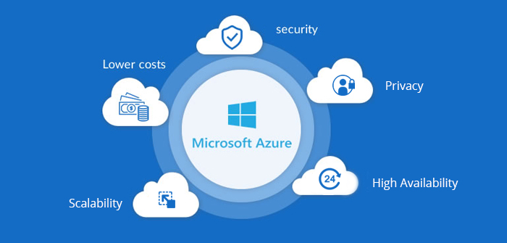**4. Microsoft Azure** is just another set of cloud services that is used to construct, establish, and manage applications through Microsoft’s globally distributed network of data centers. It’s an elastic platform, that can be used to run applications on the cloud or simply improve the current applications with cloud capabilities.

**Advantages:**

Figure 31: Microsoft Azure

* Leverage your existing relationship and contracts with Microsoft to place your data in Azure. In most cases, Azure is free with your Microsoft ELA, so as you look at Office 365, SharePoint, and other platforms, it may make sense for you to leverage your agreement to test Azure.
* It’s Op-Ex friendly. Many company’s financial mandates are to reduce capital expenditures on the balance sheet to help with cash flow. Azure provides companies with a consumption model that is essentially, “pay as you go.”
* Redundant & Resilient. Azure offers a wide area of global data centers which ensures continuous availability.
* Security and privacy are a top priority. Microsoft has made leading advances to data privacy and protection by meeting compliance standards and implementing strict regulations and policies. Azure also has several security tools and capabilities built into the platform.

**Disadvantages:**

* Although it’s affordable to put data into Azure, it’s more expensive to take data out. Often times, there are hidden and unexpected costs related to recovering data from a cloud provider that can grow exponentially if not researched first.
* Single Vendor strategy. Using a single vendor can be akin to putting all your eggs in one basket, which brings unnecessary risk to your business.
* Credit Card Cloud Strategy. Opening an S3 or cloud account is fairly easy and the business may not have to approve this if an individual application owner is empowered to do this.

## 6.2 Select cloud provider

We chose GitHub to be the cloud for this project because it is popular, multifunctional and connected to personal computers via git desktop. It shows the cohesiveness when bringing resources from the laptop to the cloud. Ensuring safety, ease of use and convenience, meeting all requirements of cloud tools for this project.

# **7. Development languages**

* 1. Introduce some development languages

To understand the languages, their advantages and disadvantages, and why we chose one of them to develop this project.

* **PHP** **Languages**

PHP is a language run on server cloud, its code is processed before being returned to the user's browser, so all we see is just HTML and no native PHP code. PHP is often used in conjunction with MySQL to retrieve information from databases and display information to users. (guru99, 2019)

Advantages :

The syntax and structure of PHP is relatively easy.

PHP has very fast performance and high efficiency. This proves that a normal server can also meet millions of hits per day.

Disadvantages of PHP

PHP is still limited in the structure of grammar.

PHP can only work and be used on web applications. That is why it is hard to compete with other programming languages

Figure 32 PHP image

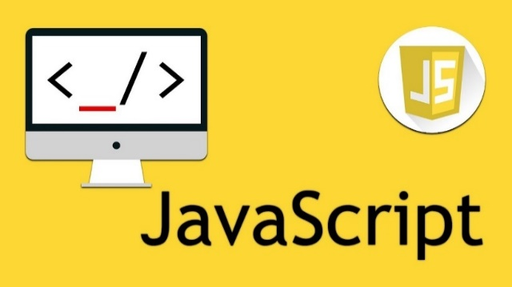**JavaScript**

JavaScript is an object-oriented scripting language that resembles Java, JavaScript has the same syntax as C, but it is closer to Self than Java. As a client-side language, it runs in the web browser on the client with a simple set of commands, easier code and does not need to be compiled. (hostinger, 2018)

Figure 33 java script

**Advantages:**

* Errors are easier to spot and therefore easier to correct;
* It helps the website to interact better with visitors;
* It is faster and lighter than other programming languages.

**Disadvantages:**

* Vulnerable to exploitation;
* Not as secure as PHP

**Java and spring boot framwork**

Spring boot

* Spring Boot is a module of Spring Framework, providing RAD (Rapid Application Development) - Rapid application development.
* Spring Boot is used to create standalone applications based on Spring.
* Spring Boot does not require XML configuration
* It is a standard for software design configuration, increasing productivity for developers.

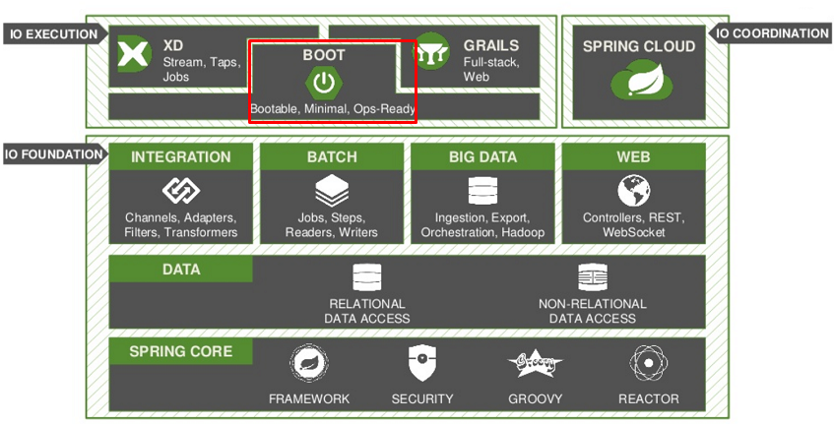

**Java**

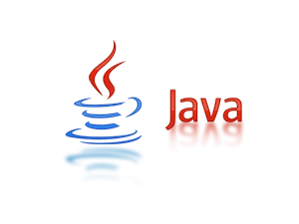Java is a programming language and computing platform first distributed by Sun Microsystems in 1995. Many applications and websites are written in Java. Java is fast, secure, and reliable.

Java is a modern, high-level, object-oriented, secure and powerful programming language. and is a Platform. With its own runtime environment (JRE) and API, Java is called Platform. (anphanhv, 2019)

**Advantages :**

* Independent hardware and operating system, therefore a program written in Java can run on many devices, many different operating systems

Figure 34 Java

* Automatically detect errors at compile time.
* The process of allocating and releasing memory is done automatically.

**Disadvantages:**

* When compiling, the compiler only compiles into executable files for programs corresponding to the operating system of the current machine.
  1. Compare between those languages

Both JavaScript and PHP are the two most popular and flexible programming languages used for website development. However, Java is a language that can be used to write software, and also to build websites.

While JavaScript is a client-side scripting language, PHP is the most popular server-side scripting language. JavaScript handles things on the browser side without going back to the server side, whereas PHP handles things at the server side.

* 1. Justify the selected Java language

After analyzing the weaknesses and strengths of the languages, our team decided to choose Java to build this project for the following reasons.

* PHP and Javascript can only be combined with html / css, java web can be combined with many other programming languages.
* Strongly supported by the large number of pre-written functions, if you already use C /C++, implementing some functions may require you to write a lot of methods, but Java contains a huge amount of APIs and methods already implemented in the SDK installer, so it helps You save a lot of time building applications
* A rich collection of open source libraries, it can be said that open source libraries play a very important role in a unit deciding on which programming language to build its own application, especially the projects that want to save costs. Produced at school, Java has a rich repository of open source frameworks supported and supported by the community. Some examples like the web we have Spring framework
* Eclipse tool for powerful, simple development. It not only help complete the code but also provide powerful error correction, which is essential for development in the real world. The integrated development environment (IDE) makes Java development easier, faster and more fluent. It's easy to find, refactor and read code using the IDE.

# **8. Database servers**

* 1. Introduce some database server

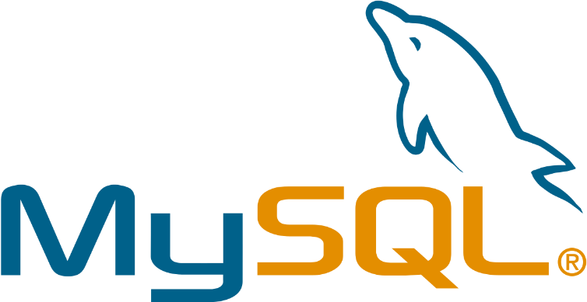**Mysql**

In fact, this is a popular free and popular open source software in the world. MySQL is developed, distributed and supported by Oracle Corporation. The software is named after the daughter of co-founder Monty Widenius: My.

SQL statement is the MySQL language used to exchange data between the Client and the MySQL Server installation machine. (sqladvice, 2017)

Figure 35 MY SQL

**SQLServer**

SQL Server is a relational data management system that uses SQL statements to exchange data between a SQL Server installation machine and a Client computer. A Relational Database Management System - RDBMS includes: databases, datase engine and application programs used to manage parts in RDBMS and other data. (paessler, 2019)



Figure 36 SQL Server

**MongoDB**

-MongoDB is an open source database management system of NoSQL. It is designed in an object-oriented fashion, the tables in MongoDB are very flexible structure, allowing the data stored on the table does not need to follow a certain structure at all. (tutorialspoint, 2019)

Figure 37 MongoDB

-MongoDB stores data in the direction of the document (document), the data is stored in JSON-style document so the query will be very fast.

8.2 Compare between them

Generally, all three software is used to manage the database and use SQL statements to exchange between client and server, they all have access to databases on the Internet.However, they will have different advantages and characteristics, the following I will compare these 3 software.

MySQL:

* has high data processing speed
* Use a productivity booster and lots of features
* Can restore data if needed

SQLServer :

* Supply, effectively manage the volume of work
* Allow multiple users to use the same database

MongoDB :

* This is a database capable of handling large amounts of data, but also allows you to use internal memory to be able to access data more easily.
* Using complex joins is not available
* Scaling can be done easily

## 8.3 Justify the selected MySQL to manage database.

As you can see, the above software has its own characteristics and strengths, to suit each project. In this project we decided to choose MySQL.

1. MySQL uses a standard form of the famous data language, SQL. This is the data language that all my teammates have learned.
2. MySQL is open source. Therefore, to use it, you do not have to lose a penny.
3. MySQL works on many operating systems that work well with the java language.
4. With the advantages of speed as well as high security, MySQL is suitable for applications with database access on the Internet.

# **9. Software Models**

* 1. **Some models**

**Waterfall Model**

1. Introduce

The waterfall model is a project management method based on sequential and sequential design processes. A simple waterfall model has 6 stages: requirements, design, implementation (construction), verification, deployment and maintenance. (viblo, 2019)

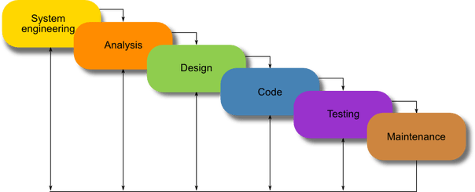

Figure 38 Waterfall model

**6 phases of the waterfall model:**

* Identify requirements: The possible requirements of an application are systematically analyzed in order to create a specific document for the future development process.
* Analysis: In the next phase, the system is analyzed to be able to create a model and logic of the appropriate system that will be used in the application.
* Design: This phase largely addresses technical design requirements, such as programming languages, data layers, services, etc. A typical design will be completed as specifically as possible.
* Code writing: The final coding work is done in this fourth phase, which will execute all of the models, system logic, and integration services that were clarified in the previous phases.
* Testing: All testers will look into reporting errors in the system that need to be handled.
* Operation: Finally, the application will be deployed in a real-world environment. However, the operational phase is not just a project implementation, it also includes support and maintenance to keep the application working and up to date.

1. **Compare advantages and disvantages**

|  |  |
| --- | --- |
| Advantages | Disadvantages |
|  |  |
| Simple waterfall model, easy to understand and | If the previous stage of the waterfall model is |
| easy to use | malfunctioning, you will not be able to go back to |
|  | repeat the previous step. Therefore the project |
|  | will become more complex to implement |
|  |  |
| Easy project management, every stage is | The waterfall model needs clarity on the |
| approved and process reviewed | requirements, but most customers have not |
|  | clearly defined their requirements and any |
|  |  |

Compare advantages and disvantages Waterfall model

**V Model**

1. **Introduce**

The waterfall model has some problems so a newly developed development model is called "Model V". In model V, the test is performed right at the request stage. V model is also called verification model and verification model. (softwaretestinghelp, 2019)

Verification: Verification is a static analysis technique. In testing, this technique is implemented without having to run the code. It includes a number of activities such as review, inspection and inspection from start to finish (walkthrough).

Validation: Validation is a dynamic analysis technique in which testing is performed by executing code.

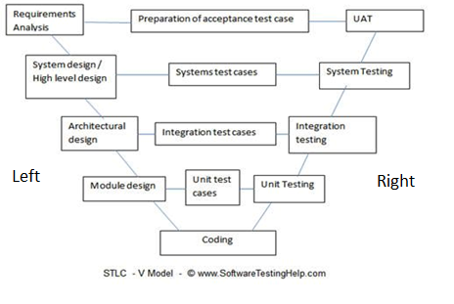

Figure 39 V Model (softwaretestinghelp, 2019)

**The left side:**  
Request analysis: In this phase the requirements are collected, analyzed and studied. Brain storming / walkthrough, interviews need to be done to have clear goals.

* Verification Activity: Requirements review.
* Validation Activity: Create test case UAT (User acceptance test)
* Output required: Document of requirements understanding, UAT test case.

System Requirements / High level design: The team will study and investigate how the requirements can be fulfilled. The technical feasibility of the request is also explored. The team also learns about modules to be created / dependent, hardware / software needs

* Verification activity: Design evaluation (Design reviews)
* Validation activities: Create test plans and test cases, create traceability metrics
* Output required: System test cases, Feasibility reports, System test plan, documentation on hardware requirements and modules, etc.

Architectural design: Modules, their relationships and dependencies, architectural diagrams, database tables, technology details are all completed during this phase.

* Verification activity: Design evaluation
* Validation activities: Integrated test plan and test cases.
* Outputs required: Design documents, Integrated test plans and test cases, Database table design,

Modular design / Low-level design: Methods, classes, interfaces, data types, etc. are all completed in this phase.

* Verification activity: Design evaluation
* Operation validation: Create and review unit test cases.
* Output required: Units for unit testing

Code: In this phase, the code is executed.

* Operation verification: Review code, check the test case
* Validation: Create functional test cases
* Outputs required: test cases, review lists.

**The right side:**

Unit testing: During this phase all unit test cases created during the low-level design phase will be executed.

Integration test: During this phase the integrated test cases performed were created during the architectural design phase. In case of any anomalies, the bug is recorded and monitored.

System testing: During this phase, functional and non-functional tests are performed. Errors are detected and monitored for correction. Progress reports are also an important part of this phase.

User acceptance test: Acceptance testing basically involves examining business requirements. Here the test is performed to confirm that the business requirements are met in the user environment.

1. **Advantages and disadvantages**

|  |  |
| --- | --- |
| **Advantages** | **Disadvantages** |
|  |  |
| The project development process is detailed and | For large and complex projects, the V model is not |
| clear | suitable |
|  |  |
| Suitable for small and medium projects | Not suitable for frequently changing requirements |
|  |  |
| Testing begins at the beginning, so clearly defined | There is no scope for risk mitigation and risk |
| ambiguous requirements | management |
|  |  |
| Easily manage and easily track project progress |  |
|  |  |

. Compare advantages and disvantages V model

* 1. Compare between Waterfall model & V model

|  |  |
| --- | --- |
| WATERFALL MODEL | V-MODEL |
| The cost of Waterfall model is low. | V-model is expensive. |
| Simplicity of Waterfall model is simple. | Simplicity of V-model is Intermediate. |
| Flexibility of Waterfall model is Rigid. | Flexibility of V-model is Little flexible. |
| Waterfall model is a sequential execution process. | It is also a sequential execution process. |
| Waterfall model’s steps move in a linear way. | V-model’s steps don’t move in linear way. |
| Re-usability of Waterfall model is Limited. | V-model can be Re-use for some extent. |
| User involvement in Waterfall model is only in beginning. | User involvement in V-model is also only in beginning. |
| Waterfall model testing activities start after the development activities are over. | In V-model testing activities start with the first stage. |
| Guarantee of success through Waterfall model is low. | Guarantee of success through V-model is high. |
| Waterfall model is a continuous process. | V-model is a simultaneous process. |

## Justify the selected Model

After learning about the models, our team decided to choose the Waterfall model, because Fpt Company clearly stated the project's requirements in the best way, the requirements are clear and very stable.

This is a short term project and will be managed by the user, the waterfall is suitable for a short term project like this project.

Administrator roles, training staff’s role, training staff’s role, user privileges and features are all clearly defined in the system requirements.

The Waterfall model allows us to analyze requirements and design solutions to problems. Analyze requirements and provide solutions such as UML, ERD, User Interface and rewrite the preparation and reporting process for managers.

# **10. Conclusion**

Through this task, I designed the diagram of the FPT project as required. We have provided SRS for this project with detailed information. Besides, I have identified the risks when implementing the project. Next, our team provides the design interface for the project. And fianlly, we have evaluated the project also identifying the development tools and techniques for this project in the best way such as cloud provider, programming language, database server and model software.

# **Appendix A – Data Dictionary**

**Database.**

Acount Role Table

|  |  |  |  |  |
| --- | --- | --- | --- | --- |
| P/F | Field Name | DataType | Field Size | Others |
| FK | idAcountRole |  |  |  |
| FK | roleID |  |  |  |

Acount table

|  |  |  |  |  |
| --- | --- | --- | --- | --- |
| P/F | Field Name | DataType | Field Size | Others |
| PK | idAcount |  |  |  |
|  | usename |  |  |  |
|  | passwork |  |  |  |
|  | status |  |  |  |

Trainning staff

|  |  |  |  |  |
| --- | --- | --- | --- | --- |
| P/F | Field Name | DataType | Field Size | Others |
| PK | idTraining |  |  |  |
|  | name |  |  |  |
|  | phone |  |  |  |
| FK | idAcount |  |  |  |

Admin table

|  |  |  |  |  |
| --- | --- | --- | --- | --- |
| P/F | Field Name | DataType | Field Size | Others |
| PK | idAdmin |  |  |  |
|  | name |  |  |  |
|  | phone |  |  |  |
|  | mail |  |  |  |
| FK | idAcount |  |  |  |

Trainer table

|  |  |  |  |  |
| --- | --- | --- | --- | --- |
| P/F | Field Name | DataType | Field Size | Others |
| PK | idTrainer |  |  |  |
|  | name |  |  |  |
|  | Phone |  |  |  |
|  | userid |  |  |  |
|  | sex |  |  |  |
|  | education |  |  |  |
| FK | idAcount |  |  |  |
| FK | IDTraner-topic |  |  |  |

Trainee table

|  |  |  |  |  |
| --- | --- | --- | --- | --- |
| P/F | Field Name | DataType | Field Size | Others |
| PK | idTrainee |  |  |  |
|  | name |  |  |  |
|  | DOB |  |  |  |
|  | userid |  |  |  |
|  | sex |  |  |  |
|  | phone |  |  |  |
| FK | idAcount |  |  |  |
| FK | IDTraner-topic |  |  |  |

Train-topic table

|  |  |  |  |  |
| --- | --- | --- | --- | --- |
| P/F | Field Name | DataType | Field Size | Others |
| PK | IDTrain-topic |  |  |  |
| FK | idTopic |  |  |  |
| FK | idCatergory |  |  |  |

Course table

|  |  |  |  |  |
| --- | --- | --- | --- | --- |
| P/F | Field Name | DataType | Field Size | Others |
| PK | idCourse |  |  |  |
|  | name |  |  |  |
|  | description |  |  |  |
|  | idTopic |  |  |  |
|  | Time |  |  |  |
| FK | idCatergory |  |  |  |

Topic table

|  |  |  |  |  |
| --- | --- | --- | --- | --- |
| P/F | Field Name | DataType | Field Size | Others |
| PK | idTopic |  |  |  |
|  | name |  |  |  |
|  | description |  |  |  |

Catergory

|  |  |  |  |  |
| --- | --- | --- | --- | --- |
| P/F | Field Name | DataType | Field Size | Others |
| PK | idCatergory |  |  |  |
|  | name |  |  |  |
|  | description |  |  |  |

# **Appendix B - Group Log**

|  |  |  |  |  |
| --- | --- | --- | --- | --- |
| **Schedule discussion** |  |  |  |  |
| Task | Predicted Completion | Actual Completion | Predicted time  Expended | Actual time  Expended |
| Discuss and divide the work | 13/04/2020 | 13/04/2020 | 1hours ( group meetings ) | 2 hours ( group meetings ) |
| SRS plan first draf | 14/04/2020 | 14/04/2020 | 2 hours ( group meetings ) | 3 hours ( group meetings ) |
| SRS plan final draf | 17/04/2020 | 17/04/2020 | 1 hours ( group meetings ) | 2 hours ( group meetings ) |
| SRS plan edited | 21/04/2020 | 21/03/2020 | 1.5 hours | 1.5 hours |
| Evaluation Report | 17/04/2020 | 17/04/2020 | 4 hours ( group meetings ) | 4 hours ( group meeting ) |
| Design Section | 21/04/2020 | 21/04/2020 | 2 hours ( group works ) | 2 hours (group work ) |
| Report Document draf | 21/04/2020 | 21/04/2020 | 1.5 hours ( group works ) | 2.5 hours ( group works ) |
| Report Document final draf | 21/04/2020 | 21/04/2020 | 0.5 hours ( each member) | 0.5 hours ( each member ) |

**Planning**

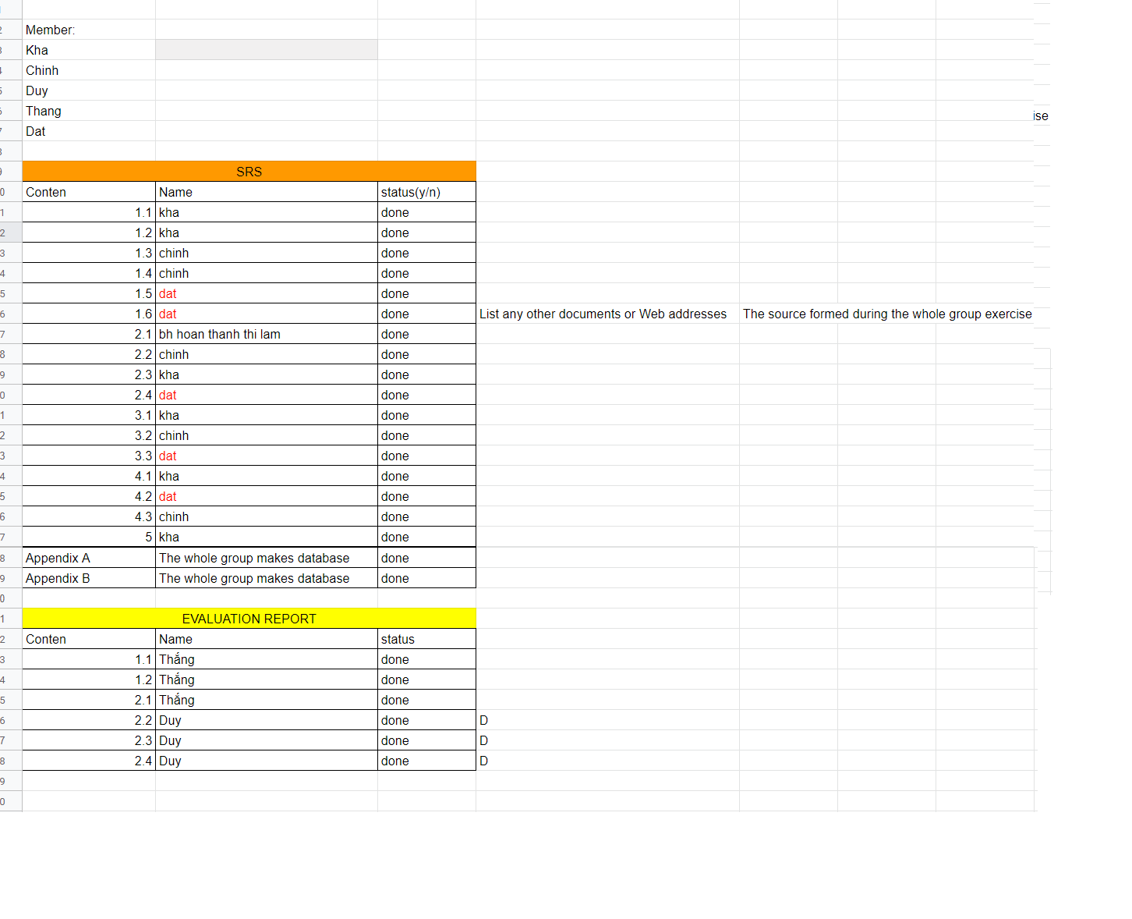Linh: <https://docs.google.com/spreadsheets/d/1XrplpG9hqmDJRSeH2hOE02QJp6KeMuTZOUJl3POL0b4/edit#gid=0>

Figure 40 planning of project

Link Interface: https://drive.google.com/file/d/1gCMCoViWWuy4YB2f7I9DPE5WvqaOEKzu/view?usp=sharing

Link ERD:

https://drive.google.com/file/d/1Frl_A4NY6hlvk7uTis81FwhLgDpZgjw9/view?usp=sharing

Use case:

[https://drive.google.com/file/d/1ZzDWgy9JfsQeF8HxU9THzMCCr9SH3_sT/view?usp=sharing](https://drive.google.com/file/d/1ZzDWgy9JfsQeF8HxU9THzMCCr9SH3_sT/view?usp=sharing&fbclid=IwAR0aB6x-vCuWTjlr1pGbOY0q5A3Mdtz5O23EA6Wlp5kOx3DLyyrAS0oKYMw)

**Figure:**

Figure 1. Login 13

Figure 2. Home page. 14

Figure 3. Manage to training staff account ( Admin). 15

Figure 4 add account 16

Figure 5. update account. 17

Figure 6 view course 18

Figure 7 Training-Staff Acount 19

Figure 8 Home Page 20

Figure 9 List of Trainee 21

Figure 10 Profile management of trainees 22

Figure 11 Manage category 23

Figure 12 manage course 24

Figure 13 Topic manager 25

Figure 14 Home page of Trainee 26

Figure 15 ERD Diagram 27

Figure 16 Use case overview. 28

Figure 17 Administrator use case 29

Figure 18 Training use case. 30

Figure 19 Trainer use case. 31

Figure 20 Trainee use case. 32

Figure 21: UML 36

Figure 22: Use case UML diagram 37

Figure 23: Activities Diagram 38

Figure 24: Visual Paradigm 38

Figure 25 Draw.io 38

Figure 26 Astah UML 39

Figure 27: Draw.io 39

Figure 28: Amazon Web Services 40

Figure 29: Heroku 41

Figure 30: Google Cloud Platform 42

Figure 31: Microsoft Azure 42

Figure 32 PHP image 44

Figure 33 java script 44

Figure 34 Java 45

Figure 35 MY SQL 47

Figure 36 SQL Server 47

Figure 37 MongoDB 48

Figure 38 Waterfall model 49

Figure 39 V Model (softwaretestinghelp, 2019) 51

Figure 40 planning of project 60

**Table:**

Table 1 Abbreviations in report. 9

# **12.** **References**

anphanhv, 2019. [Online]   
Available at: https://anphanhv.wordpress.com/2015/03/21/tong-quan-ngon-ngu-java/

guru99, 2019. *guru99.* [Online]   
Available at: https://www.guru99.com/what-is-php-first-php-program.html

hostinger, 2018. *hostinger.* [Online]   
Available at: https://www.hostinger.vn/huong-dan/javascript-la-gi/

paessler, 2019. [Online]   
Available at: https://www.paessler.com/sql-server-monitoring?utm_source=bing&utm_medium=cpc&utm_campaign=ROW_EN_Search-nonBrand_exact_3&utm_term=software%20sql%20server&utm_content=software-sql-server

softwaretestinghelp, 2019. [Online]   
Available at: https://www.softwaretestinghelp.com/what-is-stlc-v-model/

sqladvice, 2017. [Online]   
Available at: http://sqladvice.com/he-quan-tri-co-so-du-lieu-pho-bien/

tutorialspoint, 2019. [Online]   
Available at: https://www.tutorialspoint.com/mongodb/mongodb_overview.htm

viblo, 2019. *viblo.* [Online]   
Available at: https://viblo.asia/p/mo-hinh-thac-nuoc-la-gi-va-khi-nao-nen-su-dung-OeVKBD8MlkW