**Domain**

**Tile: Create web apps to sell websites and assist users in managing and evaluating website quality.**

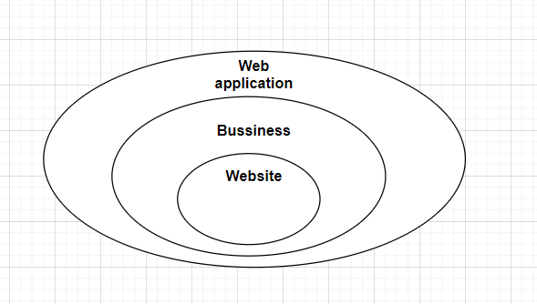

**Figure 1 Domain of project**

Accoding to (C. Atkinson & , 2002) a Web application is an application called by a Web browser over the Internet. Since 1994 when the Internet was widely available and especially in 1995 when the World Wide Web made a useful face on the Internet, the Internet has become a platform of choice for a large number of everyday Web applications. more complex and more creative. In just a decade, the Web has grown from an archive of pages used primarily for accessing static, primarily scientific information, into a powerful platform for developing and deploying applications. New Web technologies, languages ​​and methodologies make it possible to create dynamic applications that represent a new model of collaboration and collaboration among a large number of users. Web application development has rapidly adopted component-oriented and standard component-oriented software engineering techniques. For example, searching, informing, and tagging have become standard components of the new generation of applications and collaboration. Future developments in Web applications will be driven by advancements in browser technology, Internet Web infrastructure, protocol standards, software engineering approaches, and application trends.

Many businesses use the Internet as a cost-effective communication channel. It allows them to exchange information with their target markets and execute transactions quickly, securely. However, effective commitment is only possible when the business can capture and store all the necessary data, and have the means to process this information and present the results to users.

Web applications use a combination of server-side scripts to handle information storage and retrieval, and client-side scripts to present information to users. This allows users to interact with the company using online forms, content management systems, shopping carts, and more. In addition, the apps allow employees to create documents, share information, collaborate on projects, and work on common documents regardless of location or device.

**The benefits of web apps**

* The web application runs on multiple platforms regardless of operating system or device as long as the browser is compatible
* All users access the same version, eliminating any compatibility issues
* They are not installed on the hard drive, thus removing space restrictions
* They reduce software piracy in subscription-based web applications (i.e. SaaS)
* They reduce costs for both the business and the end user because the business requires less support and maintenance and lower requirements for end-user computers.

The increasing use of the Internet between companies and individuals has influenced the way businesses operate. This has led to widespread adoption of web applications as companies move from the traditional model to the cloud and mesh based model. Web applications offer businesses the ability to streamline their operations, increase efficiency and reduce costs.

These online applications like email clients, word processors, spreadsheets, and others provide the same functionality as the desktop versions. However, they have the added advantage of being cross-platform, having a wider reach, and being easily accessible from anywhere.

Xu hướng phát triển:

Hela Oueslati, Mohammad Masudur Rahman, Lotfi ben Othmane, "Literature Review of the Challenges of Developing Secure Software Using the Agile Approach", *Availability Reliability and Security (ARES) 2015 10th International Conference on*, pp. 540-547, 2015.