January 1, 2020

Phạm thanh dạt, nguyễn đức thắng, Bùi Đình Kha, ngô viết duy,Minkyeong Kim, anh tú

Enterprise Web software development

essay group1

Table of Contents

I. Introduction 3

1.1. Our project – System of University Magazine 3

1.2. Software development methodology – Agile model 3

II. System of University Magazine 3

2.1. Database 3

2.2. Site design 3

2.3. Functionality 3

2.4. Testing 3

2.5. Agile methodology 3

2.5.1. Product backlog 3

2.5.2. User stories 3

2.5.3. Sprint backlog 4

2.5.4. Minutes of meetings 4

2.5.5. Burn down chart 4

2.6. Summary 4

III. Evaluation 4

3.1. Evaluation of system 4

3.2. Reflection and team contribution 4

IV. References 4

IMG

# Introduction

There are many examples of Scrum used during software development so far. This means that many software developers use the Agile model to develop their programs without failure. With iterative cycles and a lot of testing to get better results, the Agile model is an efficient development method for both companies and developers. With this essay, our team members learn the principles of the Agile Model and learn how to apply it to this project. At the end of this essay, we will discuss the reflection or future development of this project so we can do better research.

## Our project – System of University Magazine

There are a total of four roles within the magazine university system. Student, coordinator, administrator, manager. Our team has divided six team roles to meet the requirements of these four roles. 2 frontend developers, 3 backend developers, and 1 interface designer. We developed according to the roles of the system. The requirements for each of the four roles follow the list below.

* Students: Contributions can be submitted in word format, and high quality images can also be submitted. Contribution submissions must be submitted before the first deadline, and submissions cannot be made after the time has passed. The students can make further edits to their contributions before the last deadline. Discussing contributions can interact with coordinators belonging to the same faculty. If they want to see other faculty's contributions, they can use a separate guest account to view them. However, they can only view it, and cannot download or modify it.
* Coordinator: When students in the same faculty submit contributions, coordinator will be notified via email. Comments are sent to students for 14 days between the first and last deadlines. They can only view other faculty's contributions using the guest account.
* Administrator: Administrator can access the database and manage information such as student information and deadlines. In addition, they can manage the accounts of all users using the system. Also, they can see all the statistics about the system.
* Managers: Manager can view the contributions submitted by each faculty and can be downloaded after the last deadline in ZIP file format and can only be viewed. Also, managers can view all statistics about the system.

## Software development methodology – Agile model

육하원칙에 따라 작성?

What

Agile viết tắt của Agile Software Development, là một phương thức phát triển linh hoạt các phần mềm, nhằm mục đích tạo ra sản phẩm đến với người dung sớm nhất. Agile được biết đến như một phương pháp luận, nó dựa trên nguyên tắc phân đoạn vòng lặp và tang trưởng.

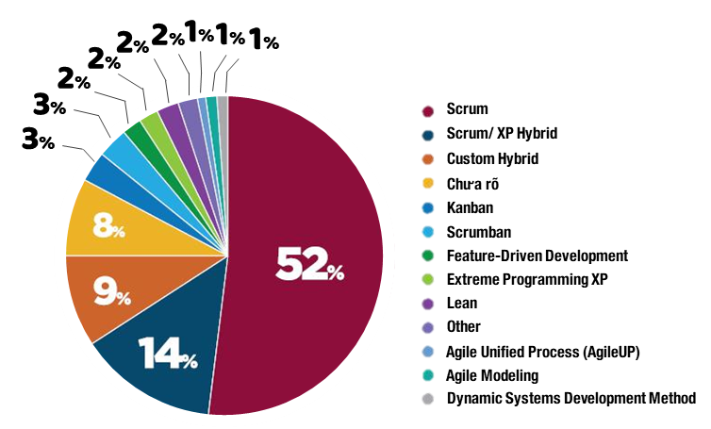

Trong phương pháp Agile:

-Cá nhân quan trọng hơn công cụ và quy trình. Con người được coi là trung tâm và sự tương tác và hỗ trợ giữa các thành viên được đặt lên hang đầu.

-Sản phẩm dùng được tốt hơn tài liệu đầy đủ. Tập trung thời gian để đưa ra sản phẩm sớm nhất, đáp ứng nhu cầu khách hàng.

-Cộng tác với khác hàng quan trọng hơn đàm phán hợp đồng. Hiểu được rõ yêu cầu khách hàng đưa ra, giúp họ tư vấn và điều chỉnh sản phẩm sẽ quan trong hơn những điều khoản có trong hợp đồng.

-Phản hồi thay đổi tốt hơn bán sát kế hoạch. Sự thay đổi về công nghệ, nhân sự, deadline,.. được Agile khuyến khích thích nghi.

Why

Where

How

…

# System of University Magazine

## Database

## Site design

## Functionality

## Testing

## Agile methodology

### Product backlog

Figure 1. Product backlog

The product backlog was created using an agile model. The total role consists of Manager, Student, Coordinator, and Administrator. Each task (Action) was created based on system requirements (distributed according to each role). Priority is assigned to each task so that the system can be developed efficiently. The product backlog can be referenced in the sprint backlog, so I have written more details in the Note section.

### Sprint backlog

User stories can be written with various details of some of the goals. Therefore, the tasks of the product backlog can be too big of a goal to carry out development. Therefore, it speeds up development and improves completion by making detailed lists through user stories in daily meetings.

Sprint Backlog was mainly performed on tasks with priority 1. We put the database, prototype design, frontend, backend, and tests in one package for each task, so that everyone can work together collaboratively. With a user story, we can meet user request in more detail. In addition, we can see the contribution of development by entering how much time each day was invested to perform the given tasks for 10 days.

Below is a description of the Sprint Backlog. There are a total of 4 sprint backlogs, and each sprint backlog will handle 5 tasks. In addition, user stories were written for each task, which added detail and efficiency to performing each step.

* Sprint backlog 1

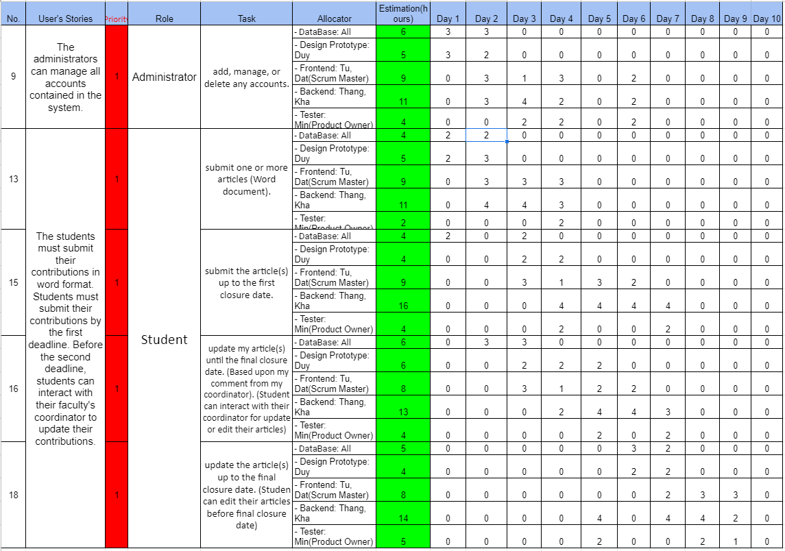

Figure 2. Sprint backlog 1

The first step was to create a login, home page and then create a system where administrators can manage the accounts of all users using the system. After performing the admin's request, I created a student system. The student system we will create in Sprint 1 includes requests for submitting contributions, submitting by the first deadline, communicating with your Coordinator, and updating by the second deadline.

* Sprint backlog 2

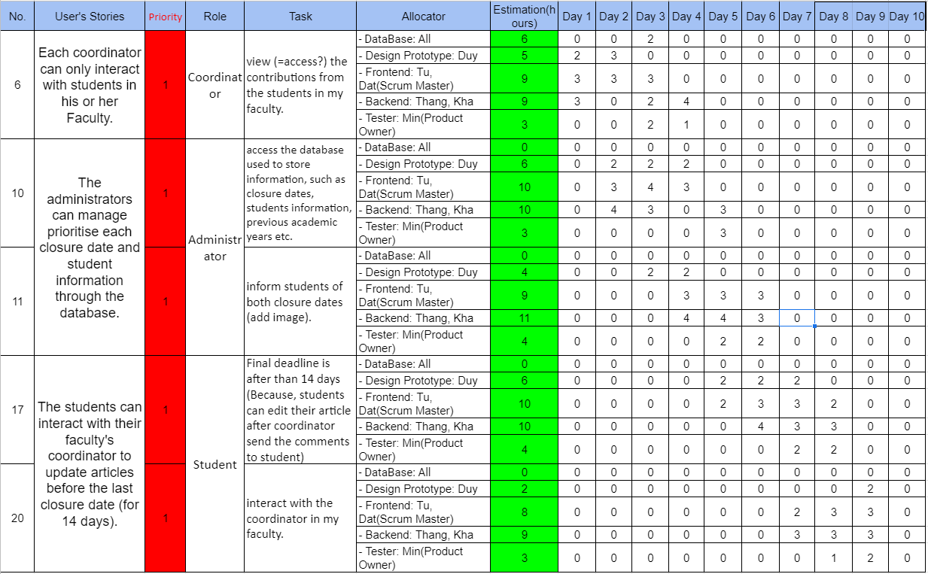

Figure 3. Sprint backlog 2

In the second sprint, we started the stage of building the coordinator's system. At this stage, the coordinator included a request to only view other faculty's contributions. The next step was to continue the development of Admin. 'Administrator can manage information such as deadlines and student information by accessing the database. Admin can also attach photos together.' It contains a task called. Finally, the student system development was continued. The student system at this stage includes 'During 14 days, students can receive comments and update from their coordinator. Student can connect with the coordinator in your faculty.' It contains a task included.

* Sprint backlog 3

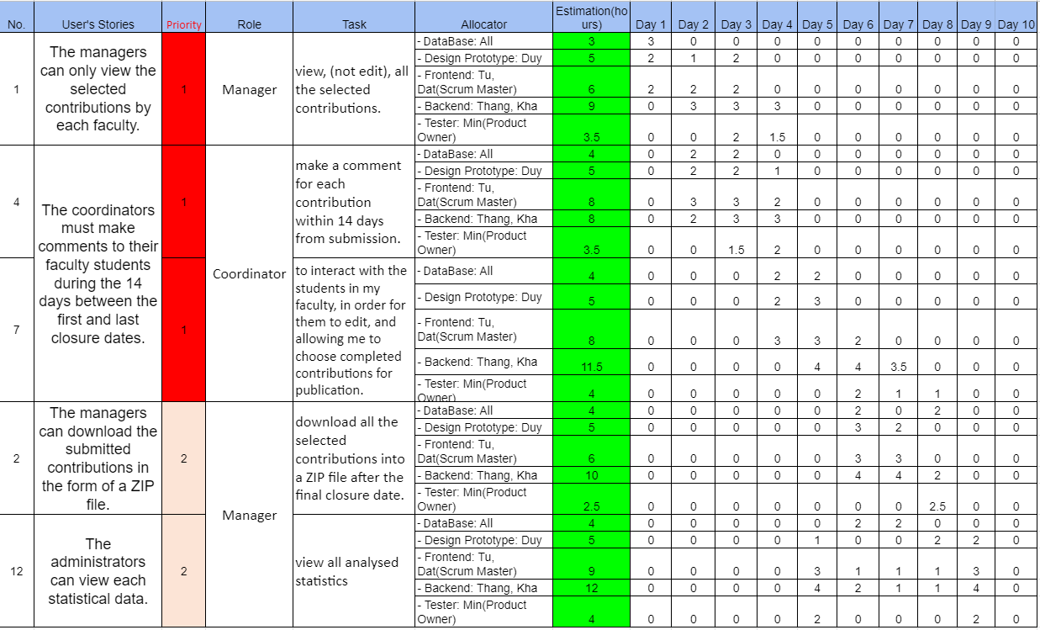

Figure 4. Sprint backlog 3

Sprint Backlog 3 covered system development for managers and coordinators. Developing a manager system with a priority of 1 ’Manager can only view the submitted contributions'. A task to do is included. Next, the coordinator development continued. 'Send comments to students in their faculty within 14 days.' I developed a system called. Finally, a manager system with priority 2 was developed. 'After the last deadline has passed, the submitted contributions can be downloaded by the manager in ZIP file format. Also, Manager can see all the statistics.' has developed a request.

* Sprint backlog 4

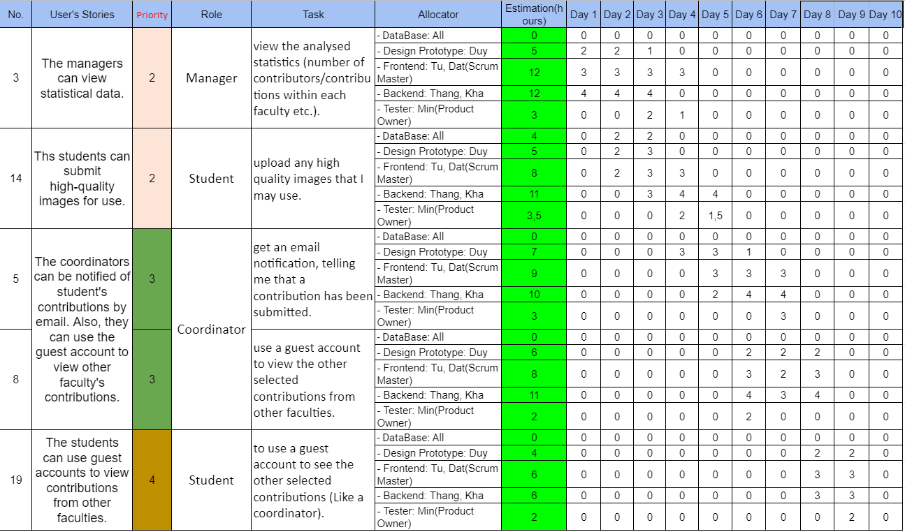

Figure 5. Sprint backlog 4

In Sprint Backlog 4, the manager, coordinator, and student continued to develop the system. Sprint Backlog 4 Finally, you have finished all sprint backlogs. With the development of a manager system with a priority of 2, we continued to 'Manager can view statistical data'. 'Student can submit high-quality images' of the student system with a priority of 2. Was developed. When students in their faculty submit contributions from the Priority 3 Coordinator System, Coordinator will receive an email notification. Coordinator can also use the guest account to view other faculty's contributions.' Was developed. Finally, Student can use the student system's 'Student can use a guest Account to view other faculty's contributions'. We finished the development of this project by developing it.

### Minutes of meetings

Our team members use spreadsheets to make their own daily schedules, reducing the time required to meet, and increasing work efficiency. We met once a week to share opinions and feedback with team members, so we could develop faster and study more. When I couldn't meet, I continued to communicate with my team members through online meetings. Through the Daily Scrum, our team has built mutual trust and learned to cooperate with each other. The following will explain our team's Daily Scrum.

* Daily Sprint 1

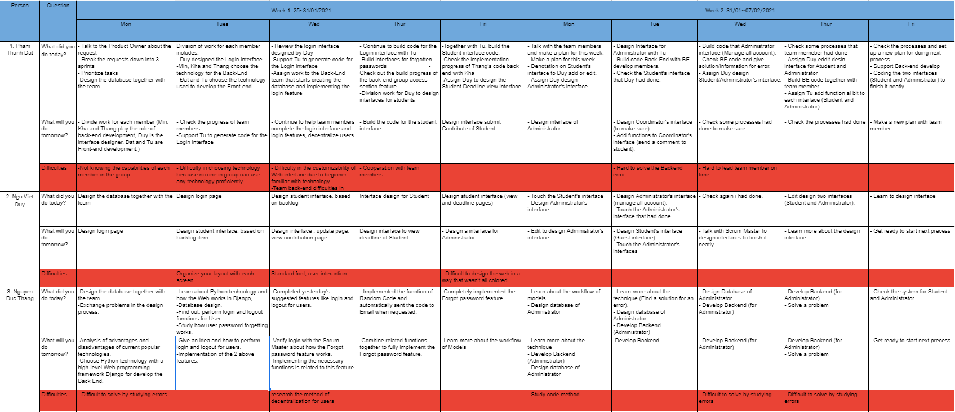

Figure 6. Daily Sprint 1-1

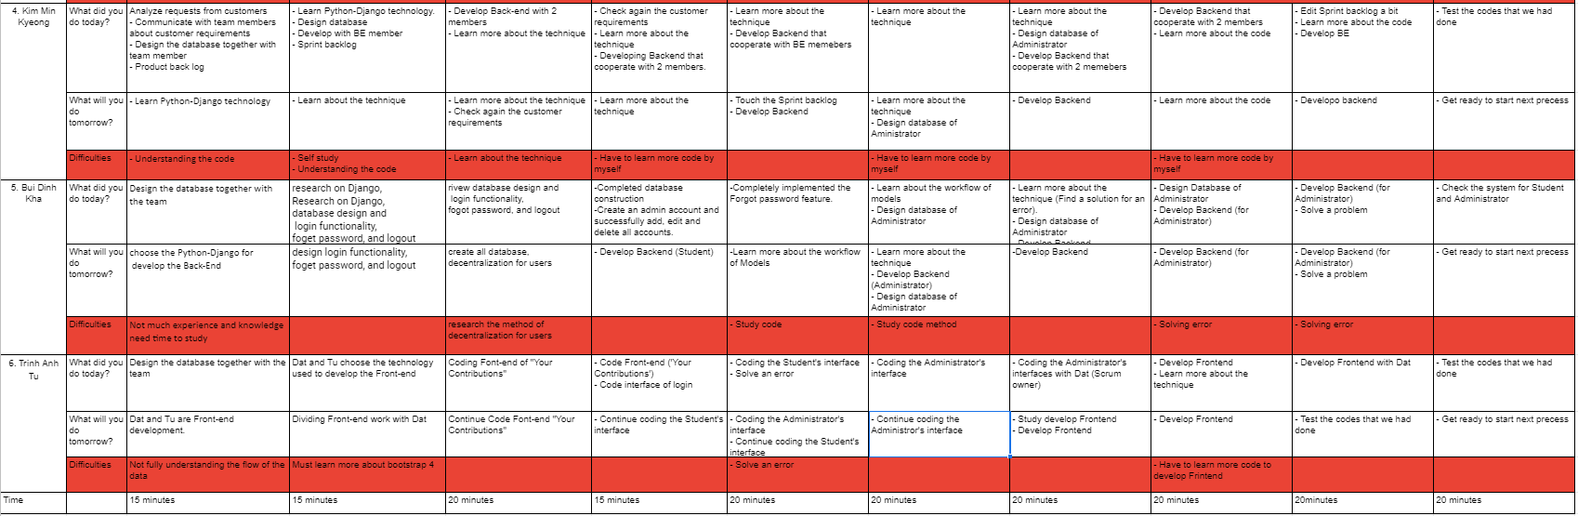

Figure 7.Daily Sprint 1-2

The Scrum Master and Project Owner discussed user requests each week before starting work. Based on this, the Scrum Master set up a reasonable planner with his teammates. However, we always checked the status of the team members to keep them from falling behind. The development team consists of an interface designer, 3 backend developers, and 2 interface developers, and the development team operates as directed by the Scrum Master. In Daily Scrum 1, we have developed some systems for students, 'You can submit contributions, you can interact with your faculty's coordinator, and you can update your contributions before the last deadline.' In addition, we have developed an Administrator system, 'Manage all accounts using the system'.

* Daily Sprint 2

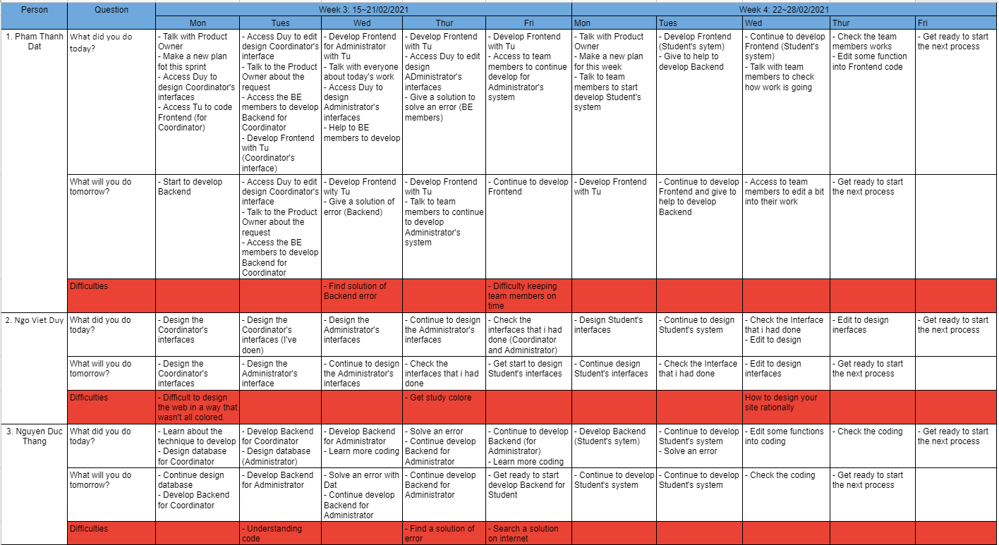

Figure 8. Daily Sprint 2-1

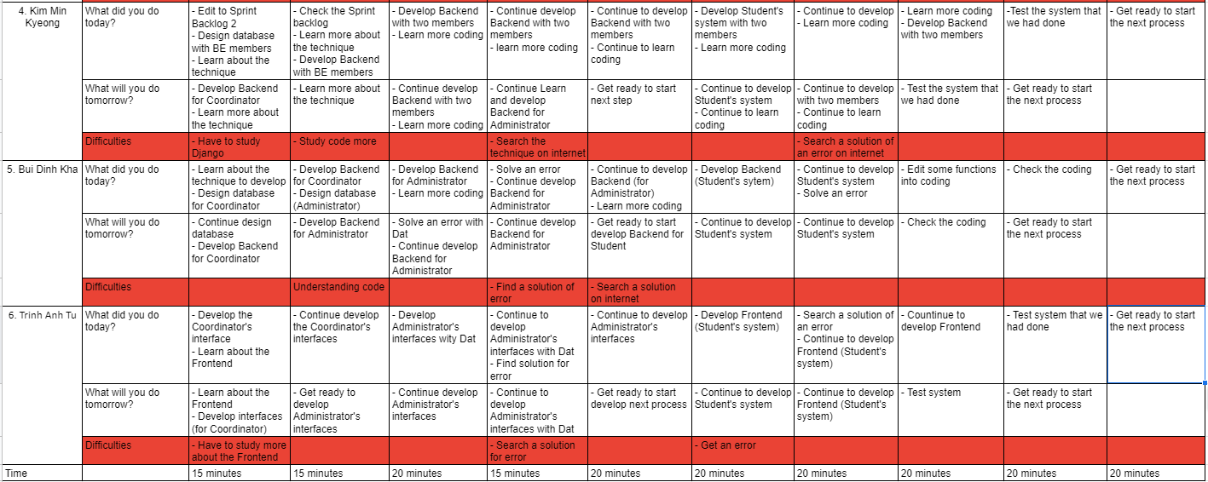

Figure 9. Daily Sprint 2-2

In Daily Scrum 2, we dealt with coordinators, administrators, and some of the students' system breakouts. 'You can see the contributions of your own students' in some systems of the coordinator. Developed. We developed 'Manage data such as student information and deadlines by accessing the database' of some systems of the Administrator. Finally, you can update your contributions during '14 on some of the students' systems. In addition, it was developed for 'You can interact with the coordinator of your faculty'.

* Daily Sprint 3

xdd

* Daily Scrum 4

### Burn down chart

# Evaluation

## Evaluation of system

## Reflection and team contribution

# References