

Software Requirements Specification

for

SHOPPING WEBSITE-Mom and Kid

Version 1.0 approved

Prepared by Team 5

FPT University

27/09/2018

**SIGNATURE PAGE**

**ORIGINATOR:** Phan Anh Tuan – SE05594

**TEAM MEMBER:** Dao Quang Toan – SE05372

Hoang Luong Dung – SE05529

Cao Linh Nhat – SE05871

Pham Viet Hoang – SE06061

**REVIEWERS:** Pham Ngoc Tho

Table of Contents iv

Revision History v

1. Introduction 1

1.1 Purpose 1

1.2 System Purpose 1

1.3 Definitions, Acronyms and Abbreviations 2

1.4 Document Conventions 2

1.5 Intended Audience and Reading Suggestions 2

1.6 Project Scope 2

1.7 References 2

2. Overall Description 3

2.1 Product/System Perspective 3

2.2 System/Product Features 3

2.3 User requirements 4

2.4 User Classes and Characteristics 4

2.5 Operating Environment 4

2.6 Design and Implementation Constraints 5

2.7 User Documentation 5

2.8 Assumptions and Dependencies 5

3. Specific Requirements 6

3.1 Functional Requirements Specification 6

3.1.1 Registration 7

3.1.2 Login 8

3.1.3 Change information 10

3.1.4 Create an order 12

3.1.5 Add/modify a product 14

3.1.6 See information of user 15

3.1.7 Delete a user 16

3.1.8 See information of order 18

3.1.9 Accept/reject an order 20

3.1.10 See report 21

3.2 Non-Functional Requirements Specification 23

3.2.1 External Interface Requirements 23

3.2.2 Other Nonfunctional Requirements 30

4. Other Requirements 32

Appendix A: Database diagram 32

Appendix B: Database entity 33

Revision History

|  |  |  |  |
| --- | --- | --- | --- |
| **Name** | **Date** | **Reason For Changes** | **Version** |
| The whole document | 27/09/2018 | Initiate version for Mom and Kid Website | 1.0 |
|  |  |  |  |

1. Introduction

## Purpose

This document gives information about Shopping system website named Mom and Kid. All functions, information of its, how it be coded, how it works, and all software component will be shown. This document also has a lot of useful for next team developer if another version be developed in the future, support for tester if need fix bug.

## System Purpose

|  |  |
| --- | --- |
| Software | Version |
| Microsoft Windows Server | 2003 SP2 |
| Microsoft SQL Server | 2008 |
| Microsoft .NET Framework | 4.0 |
| Microsoft Visual Studio | 2015 |
| Google Chrome | 69.0.3497.100 |
| Mozilla Firefox | 62.0.2 |
| Opera | 55.0.2994.61 |
| Safari | 12.0 |

## Definitions, Acronyms and Abbreviations

|  |  |  |
| --- | --- | --- |
| ID | Acronyms | Definition |
| 1 | SRS | Software Requirement Specification |
| 2 | DB | Database |
| 3 | GUI | Graphic User Interface |
| 4 | OS | Operating system |
| 5 | M&K | Mom and Kid website |
| 6 | N/A | Not applicable, not available |
| 7 | GB | Gigabyte |

## Document Conventions

This document used Template System Requirement Specification IEEE830 version 1.3. Form-based specifications will be used a lot to describe each of function, input, output, where they come, where they out, information needed, action be taken, pre, post conditions, side effect (if any) of the function.

## Intended Audience and Reading Suggestions

Developer, tester should read document before update coding or fix bugs of previous version.

## Project Scope

Name of this project is Mom and Kid. It is a website for Mom and Kid store that sells products for mother and kid about 1-3 years old. This website focuses on manage importing product, manage selling, manage reporting and manage users.

## References

* Software requirement specification form.
* Software engineering – Ninth Edition (by Ian Sommerville)
* Designing with Web Standards (2nd Edition)
* Model - View - Controller pattern(<https://en.wikipedia.org/wiki/Model–view–controller>)

1. Overall Description

## Product/System Perspective

* Mom and Kid focus on users who:
  + Want to buy product from Mom and Kid shop online
  + Do not have time come to shop and buy product
* On store side, they can:
  + Manage their users: registration, login
  + Manage product in shop: import, sell, …
  + See report: users, product, revenue
  + Manage import product
* Mom and Kid is a website. It run on any operating system has web browser and Internet connection available.

## System/Product Features

* Manage importing product:
  + Add new product
  + Update quantity of product
  + Create report/bill
* Manage shopping:
  + Search a product
  + See detail of product
  + Order
  + Check status of order
  + Accept order
  + Pay
* Create report:
  + Number of products
  + Revenue
  + Number of orders
  + Number of user access
* Manage users:
  + Login
  + Registration
  + Update information

## User requirements

User need a device in any operating system has web browser and Internet connection. Then user must create an account in Mom and Kid website to use full features of website.

Mom and Kid shop will have admin account to use another feature.

## User Classes and Characteristics

Based on analysis, number of babies were born increase year by year. Number of products selling for mom and kid are increasing too. Mom and Kid is a shop which realize that, so they increase limit of selling their products. 2018 is preparation year for 4.0 revolution, they think that a website will help they sell more product instead selling for a limit number of people. They want to sell product for people not only live in near shop, but also from anywhere.

## Operating Environment

* Main programming language: C# with ASP.NET.
* Display: HTML, CSS.
* IDE:
  + Microsoft visual studio 2015
  + .NET framework 3.5
  + Sublime Text version 3.1.1
  + Visual studio code version 1.23
* Database: manage in Microsoft Azure, query use Microsoft SQL Server Management Studio version 17.
* Project workspace, source code: Github.

## Design and Implementation Constraints

* Coding used Model-View-Controller architectural model.
* Variables used camel case (words are joined without spaces and are lowercase with first letter)
* Methods, functions must be commented to support maintenance programmers (comment before functions, before loop, before long code) to understand easily code.
* Code must be coded by convention Java code convention of Oracle.
* Html, Css must be coded by convention Designing with Web Standards (read about they in reference).

## User Documentation

The user documentation will be able as a function of a website, it will use screen captures of website to describe all features.

## Assumptions and Dependencies

Nothing assumptions and dependencies in M&K website version 1.0.

1. Specific Requirements

## Functional Requirements Specification

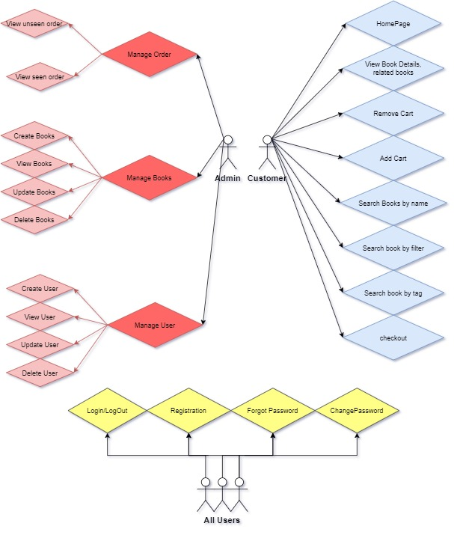

### Registration

|  |  |  |  |
| --- | --- | --- | --- |
| Use Case ID: | OBS01 | | |
| **Use Case Name:** | Sign up for user | | |
| **Created By:** | AnhPD | **Last Updated By:** | AnhPD |
| **Date Created:** | Oct 07, 2021 | **Date Last Updated:** | Oct 07, 2021 |
| **Actors:** | User | | |
| **Triggers** | User clicks on sign-up at the bottom of sign-in form | | |
| **Description:** | Registration for a new user | | |
| **Pre-conditions:** | **OBS01_PRE_1**. User is in website OBS | | |
| **Post-conditions:** | Email, username, password will be added to database with Customer role | | |
| **Normal Flow:** | OBS01_NF_1. User clicks on sign-up at the bottom of sign-in form  OBS01_NF_2. Website display form registration: email, username, password, re-password, sign-up button  **OBS01_NF_3.** User fills up, clicks on submit button  **OBS01_NF_4.** Website validates email, passwords and show “Registration successful” | | |
| **Alternative Flows:** | **OBS01_AT_1.** At step OBS01_NF_4, if email is existed in database, show error “email if existed, enter another email”.  **OBS01_AT_2.** At step OBS01_NF_3, if re-password is different password, ask user enter re-password again.  **OBS01_AT_3.** At step OBS01_NF_3, if password length < 8, ask user re-enter password. | | |
| **Exceptions:** | N/A | | |
| **Priority:** | Normal | | |
| **Other information:** | Email must be valid email  Password is greater or equal 8 character  User can discard value entered by click [Back] instead of [Create new Account] button. | | |
| **Frequency of Use:** | Usually | | |
| **Business Rules:** | N/A | | |
| **Assumptions:** | N/A | | |

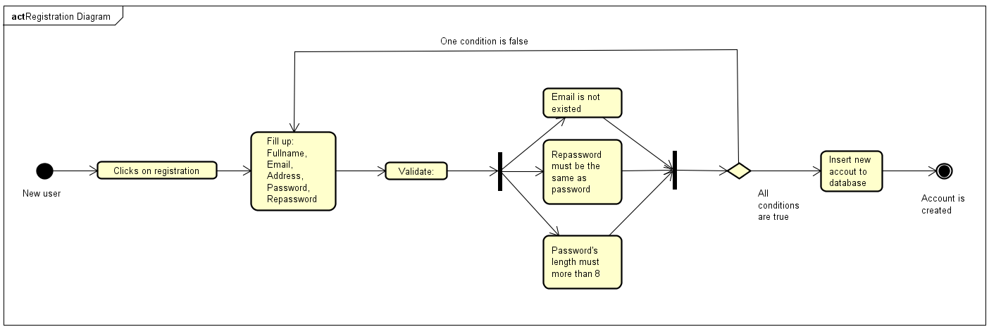

### Login

|  |  |  |  |
| --- | --- | --- | --- |
| Use Case ID: | OBS02 | | |
| **Use Case Name:** | Login for user | | |
| **Created By:** | AnhPD | **Last Updated By:** | AnhPD |
| **Date Created:** | Oct 07, 2021 | **Date Last Updated:** | Oct 07, 2021 |
| **Actors:** | User, Admin | | |
| **Triggers** | User clicks on sign-in on the header of website | | |
| **Description:** | Login for users | | |
| **Pre-conditions:** | **OBS02_PRE_1**. User is in website OBS | | |
| **Post-conditions:** | User login to use feature in website OBS | | |
| **Normal Flow:** | OBS02_NF_1. User clicks on Sign-in in the header of OBS website  OBS02_NF_2. Website display sign-in form: email, password, submit button  **OBS02_NF_3.** User fills up, clicks on sign-in button  **OBS02_NF_4.** Website validates email, passwords and show “Login successful”  **OBS02_NF_5.** If user forgot password, click Forget password and fill up mail. | | |
| **Alternative Flows:** | **OBS02_AF_1.** At step OBS02_NF_4, if username is existed but password is not correct in database, show error: “Email or password incorrect.”  **OBS02_AF_2.** At step OBS02_NF_4, if username is not found in database, show error: “Email or password incorrect.” | | |
| **Exceptions:** | N/A | | |
| **Priority:** | Normal | | |
| **Other information:** | User access to different homepage via their role | | |
| **Frequency of Use:** | Usually | | |
| **Business Rules:** | N/A | | |
| **Assumptions:** | N/A | | |

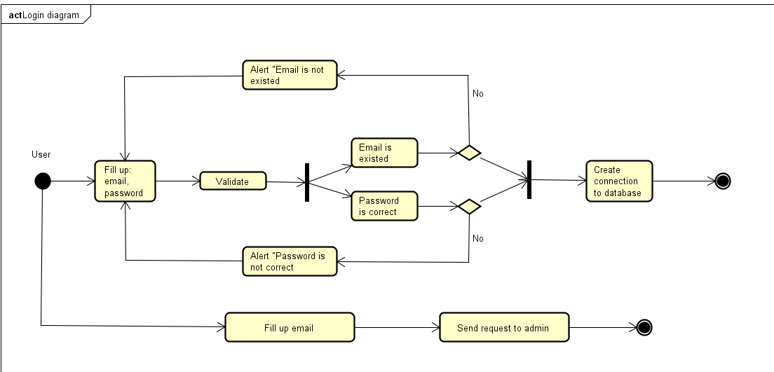

### Change information

|  |  |  |  |
| --- | --- | --- | --- |
| Use Case ID: | OBS03 | | |
| **Use Case Name:** | Change information for user | | |
| **Created By:** | AnhPD | **Last Updated By:** | AnhPD |
| **Date Created:** | Oct 07, 2021 | **Date Last Updated:** | Oct 07, 2021 |
| **Actors:** | User, Admin | | |
| **Triggers** | User clicks on change information after click on their icon on the header of website | | |
| **Description:** | User changes information: password, username, avatar | | |
| **Pre-conditions:** | **OBS03_PRE_1**. User is login website OBS  **OBS03_PRE_2.** User clicks on their avatar in header of website  **OBS03_PRE_3.** User clicks on change information | | |
| **Post-conditions:** | Information of user may be changed and update again to database | | |
| **Normal Flow:** | OBS03_NF_1. User fills up text box password and re-password if want to change password  OBS03_NF_2. User fills up text box username if want to change username  **OBS03_NF_3.** User clicks browse button if want to change avatar  **OBS03_NF_4.** User click update button | | |
| **Alternative Flows:** | **OBS03_AF_1.** At step MK02_NF_1, if password length < 8 alert: “Password must equal or greater than 8 character. | | |
| **Exceptions:** | N/A | | |
| **Priority:** | Normal | | |
| **Other information:** | Password is greater or equal 8 character | | |
| **Frequency of Use:** | Usually | | |
| **Business Rules:** | N/A | | |
| **Assumptions:** | N/A | | |

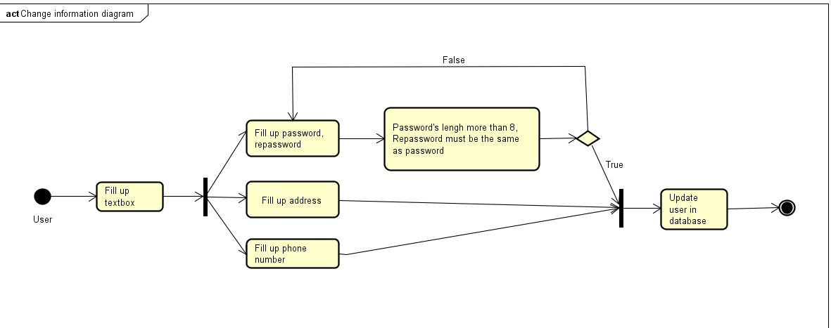

### Search book by genre

|  |  |  |  |
| --- | --- | --- | --- |
| Use Case ID: | OBS04 | | |
| **Use Case Name:** | Search book by genre | | |
| **Created By:** | AnhPD | **Last Updated By:** | AnhPD |
| **Date Created:** | Oct 07, 2021 | **Date Last Updated:** | Oct 07, 2021 |
| **Actors:** | User | | |
| **Triggers** | User clicks on one category on navigation bar below the header | | |
| **Description:** | User view list of book by genre | | |
| **Pre-conditions:** | **OBS04_PRE_1**. User is login website OBS  **OBS04_PRE_2.** User clicks on 1 category on navigation bar below the header. | | |
| **Post-conditions:** | N/A | | |
| **Normal Flow:** | OBS04_NF_1. User is logged in OBS website  OBS04_NF_2. User click on 1 category on navigation bar below the header. | | |
| **Alternative Flows:** | N/A | | |
| **Exceptions:** | N/A | | |
| **Priority:** | Normal | | |
| **Other information:** | N/A | | |
| **Frequency of Use:** | Usually | | |
| **Business Rules:** | N/A | | |
| **Assumptions:** | N/A | | |



### Filter books by multiple genre

|  |  |  |  |
| --- | --- | --- | --- |
| Use Case ID: | OBS05 | | |
| **Use Case Name:** | User filter books by genre(s) | | |
| **Created By:** | AnhPD | **Last Updated By:** | AnhPD |
| **Date Created:** | Oct 07, 2021 | **Date Last Updated:** | Oct 07, 2021 |
| **Actors:** | User | | |
| **Triggers** | Admin ticks genre checkbox on the left-side and clicks filter button. | | |
| **Description:** | Website displays books with checked genre(s) | | |
| **Pre-conditions:** | **OBS05_PRE_1**. User is login website OBS  **OBS05_PRE_2**. User clicks one category on navigation bar below the header.  **OBS05_PRE_3.** User checks genre(s) checkbox on the left-side.  **OBS05_PRE_4**. User clicks filter button. | | |
| **Post-conditions:** | N/A | | |
| **Normal Flow:** | OBS05_NF_1. User checks genre(s) checkbox.  OBS05_NF_2. User clicks on filter button. | | |
| **Alternative Flows:** | **N/A** | | |
| **Exceptions:** | N/A | | |
| **Priority:** | Normal | | |
| **Other information:** | If user doesn’t check any checkbox but still clicks filter button, website display all books. | | |
| **Frequency of Use:** | Usually | | |
| **Business Rules:** | N/A | | |
| **Assumptions:** | N/A | | |

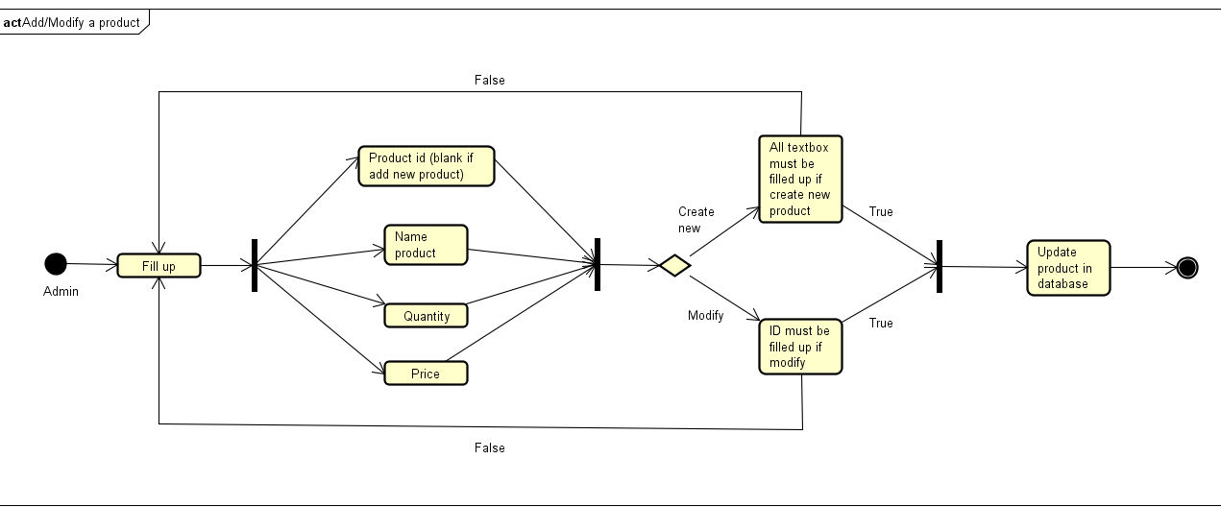

### User view book detail

|  |  |  |  |
| --- | --- | --- | --- |
| Use Case ID: | OBS06 | | |
| **Use Case Name:** | User view book detail | | |
| **Created By:** | AnhPD | **Last Updated By:** | AnhPD |
| **Date Created:** | Oct 07, 2021 | **Date Last Updated:** | Oct 07, 2021 |
| **Actors:** | User | | |
| **Triggers** | User click on a book name. | | |
| **Description:** | Website display book image, name, status (in stock/out stock), price, description, author, related books. | | |
| **Pre-conditions:** | **OBS06_PRE_1**. User logged in website OBS | | |
| **Post-conditions:** | Website show book detail. | | |
| **Normal Flow:** | OBS06_NF_1. User clicks on book name. | | |
| **Alternative Flows:** | N/A | | |
| **Exceptions:** | N/A | | |
| **Priority:** | Normal | | |
| **Other information:** | N/A | | |
| **Frequency of Use:** | Usually | | |
| **Business Rules:** | N/A | | |
| **Assumptions:** | N/A | | |

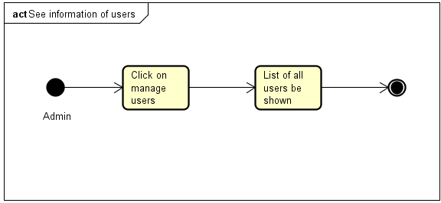

### User add book to Cart

|  |  |  |  |
| --- | --- | --- | --- |
| Use Case ID: | OBS07 | | |
| **Use Case Name:** | User add book to Cart | | |
| **Created By:** | AnhPD | **Last Updated By:** | AnhPD |
| **Date Created:** | Oct 07, 2021 | **Date Last Updated:** | Oct 07, 2021 |
| **Actors:** | User | | |
| **Triggers** | User clicks add to cart button when hover book image | | |
| **Description:** | 1xBook add to Cart | | |
| **Pre-conditions:** | **OBS07_PRE_1**. Admin is login website M&K by admin account  **OBS07_PRE_2**. Admin is click on manage user on menu | | |
| **Post-conditions:** | N/A | | |
| **Normal Flow:** | OBS07_NF_1. User logged in OBS website  OBS07_NF_2. User clicks add to cart button when hover book image. | | |
| **Alternative Flows:** | N/A | | |
| **Exceptions:** | N/A | | |
| **Priority:** | Normal | | |
| **Other information:** | N/A | | |
| **Frequency of Use:** | Usually | | |
| **Business Rules:** | N/A | | |
| **Assumptions:** | N/A | | |

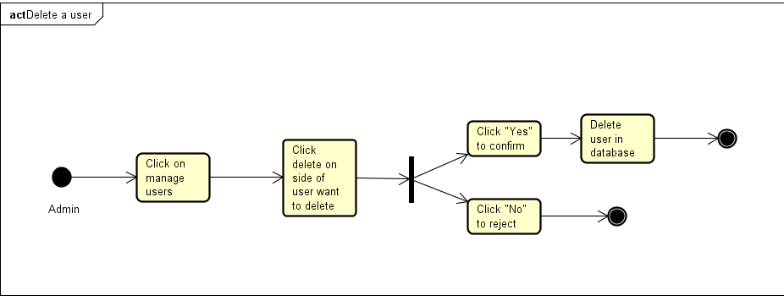

### User remove book out of Cart

|  |  |  |  |
| --- | --- | --- | --- |
| Use Case ID: | OBS08 | | |
| **Use Case Name:** | Remove book out of cart | | |
| **Created By:** | AnhPD | **Last Updated By:** | AnhPD |
| **Date Created:** | Oct 07, 2021 | **Date Last Updated:** | Oct 07, 2021 |
| **Actors:** | User | | |
| **Triggers** | User clicks on x button on the top-left of book image after clicks Cart button | | |
| **Description:** | Remove book out of Cart | | |
| **Pre-conditions:** | **OBS08_PRE_1**. User logged into website OBS  **OBS08_PRE_2**. User added book(s) to Cart  **OBS08_PRE_3**. User clicks x button after clicks Cart | | |
| **Post-conditions:** | N/A | | |
| **Normal Flow:** | MK10_NF_1. User clicks Cart button.  **MK10_NF_2**. User click x button on the left-side of 1 book | | |
| **Alternative Flows:** | N/A | | |
| **Exceptions:** | N/A | | |
| **Priority:** | Normal | | |
| **Other information:** | N/A | | |
| **Frequency of Use:** | Usually | | |
| **Business Rules:** | N/A | | |
| **Assumptions:** | N/A | | |

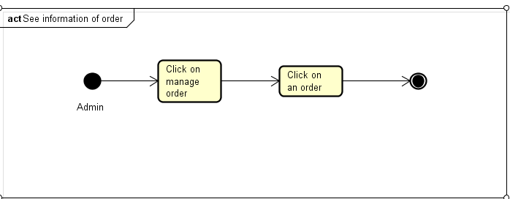

### User checkout

|  |  |  |  |
| --- | --- | --- | --- |
| Use Case ID: | OBS09 | | |
| **Use Case Name:** | Checkout an order | | |
| **Created By:** | AnhPD | **Last Updated By:** | AnhPD |
| **Date Created:** | Oct 07, 2021 | **Date Last Updated:** | Oct 07, 2021 |
| **Actors:** | User | | |
| **Triggers** | User clicks checkout button on the bottom of cart | | |
| **Description:** | Website display form for user fill up address, telephone, payment method. Website display list of ordered books, shipping fee and total. | | |
| **Pre-conditions:** | **OBS09_PRE_1**. User logged in website OBS  **OBS09_PRE_2**. User added book(s) to Cart | | |
| **Post-conditions:** | Order will be updated into database | | |
| **Normal Flow:** | OBS09_NF_1. User clicks on checkout button after clicks cart button.  **OBS09_NF_2**. User fills up address, telephone and payment method.  **OBS09_NF_3**. User clicks place order button. | | |
| **Alternative Flows:** | **OBS09_AF_1**. At **OBS09_NF_2** if User input invalid telephone (has un-digit character) show message “Please input valid telephone number” | | |
| **Exceptions:** | N/A | | |
| **Priority:** | Normal | | |
| **Other information:** | User can shopping again with present Cart if clicks back button.  After clicking place order button, Cart will be emptied. | | |
| **Frequency of Use:** | Usually | | |
| **Business Rules:** | N/A | | |
| **Assumptions:** | N/A | | |

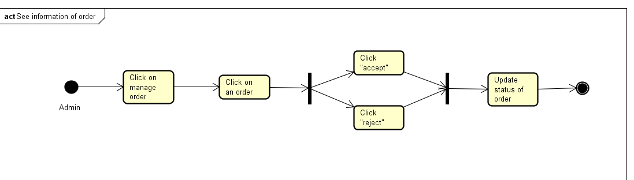

### Admin see list of users

|  |  |  |  |
| --- | --- | --- | --- |
| Use Case ID: | OBS10 | | |
| **Use Case Name:** | See user list | | |
| **Created By:** | AnhPD | **Last Updated By:** | AnhPD |
| **Date Created:** | Oct 07, 2021 | **Date Last Updated:** | Oct 07, 2021 |
| **Actors:** | Admin | | |
| **Triggers** | Admin logged in website OBS by admin account | | |
| **Description:** | Website display list of user with information like email, password, username with option to delete, edit/view, add user | | |
| **Pre-conditions:** | **OBS10_PRE_1**. Admin logged in website OBS by admin account | | |
| **Post-conditions:** | N/A | | |
| **Normal Flow:** | **OBS10_NF_1.** Admin logged in website OBS by admin account | | |
| **Alternative Flows:** | N/A | | |
| **Exceptions:** | N/A | | |
| **Priority:** | Normal | | |
| **Other information:** | N/A | | |
| **Frequency of Use:** | Usually | | |
| **Business Rules:** | N/A | | |
| **Assumptions:** | N/A | | |

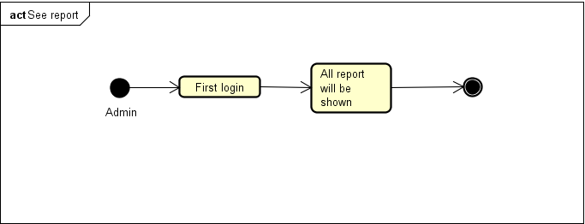

### Admin delete an user

|  |  |  |  |
| --- | --- | --- | --- |
| Use Case ID: | OBS11 | | |
| **Use Case Name:** | See user list | | |
| **Created By:** | AnhPD | **Last Updated By:** | AnhPD |
| **Date Created:** | Oct 07, 2021 | **Date Last Updated:** | Oct 07, 2021 |
| **Actors:** | Admin | | |
| **Triggers** | Admin clicks on delete button on a row of user information. | | |
| **Description:** | Delete an user | | |
| **Pre-conditions:** | **OBS11_PRE_1**. Admin logged in website OBS by admin account | | |
| **Post-conditions:** | N/A | | |
| **Normal Flow:** | **OBS11_NF_1.** Admin clicks on delete button on a row of user information.  **OBS11_NF_2.** Admin clicks on confirm button when website alert message “Do you really want to delete User: email: xxx username: xxx” | | |
| **Alternative Flows:** | N/A | | |
| **Exceptions:** | N/A | | |
| **Priority:** | Normal | | |
| **Other information:** | Admin can cancel deletion by clicking cancel button at the alert. | | |
| **Frequency of Use:** | Usually | | |
| **Business Rules:** | N/A | | |
| **Assumptions:** | N/A | | |

### Admin edit/view an user

|  |  |  |  |
| --- | --- | --- | --- |
| Use Case ID: | OBS12 | | |
| **Use Case Name:** | Update/View user detail | | |
| **Created By:** | AnhPD | **Last Updated By:** | AnhPD |
| **Date Created:** | Oct 07, 2021 | **Date Last Updated:** | Oct 07, 2021 |
| **Actors:** | Admin | | |
| **Triggers** | Admin clicks on Edit button on a row of user information. | | |
| **Description:** | Edit/View an user | | |
| **Pre-conditions:** | **OBS12_PRE_1**. Admin logged in website OBS by admin account | | |
| **Post-conditions:** | New updated information will be updated into database. | | |
| **Normal Flow:** | **OBS12_NF_1.** Admin clicks on Edit button on a row of user information.  **OBS12_NF_2.** Admin edit user information: username, password, avatar, role.  **OBS12_NF_3.** Admin clicks on Update user button at the bottom of website. | | |
| **Alternative Flows:** | **OBS12_AF_1.** At **OBS12_NF_2** if admin fill up an invalid password (have length<8 character) show alert message. | | |
| **Exceptions:** | N/A | | |
| **Priority:** | Normal | | |
| **Other information:** | Admin can view but not edit user information. | | |
| **Frequency of Use:** | Usually | | |
| **Business Rules:** | N/A | | |
| **Assumptions:** | N/A | | |

### Admin add an user

|  |  |  |  |
| --- | --- | --- | --- |
| Use Case ID: | OBS13 | | |
| **Use Case Name:** | Add an user | | |
| **Created By:** | AnhPD | **Last Updated By:** | AnhPD |
| **Date Created:** | Oct 07, 2021 | **Date Last Updated:** | Oct 07, 2021 |
| **Actors:** | Admin | | |
| **Triggers** | Admin clicks on Add an User button. | | |
| **Description:** | Add an user | | |
| **Pre-conditions:** | **OBS13_PRE_1**. Admin logged in website OBS by admin account | | |
| **Post-conditions:** | New Account of user will be inserted into database. | | |
| **Normal Flow:** | **OBS13_NF_1.** Admin clicks on Add user button.  **OBS13_NF_2.** Admin fill up user information: email, username, password, role.  **OBS13_NF_3.** Admin clicks on add user button at the bottom of website. | | |
| **Alternative Flows:** | **OBS13_AF_1.** At **OBS13_NF_2** if admin fill up an invalid password (have length<8 character) show alert message.  **OBS13_AF_1.** At **OBS13_NF_2** if admin fill up an invalid email (have wrong format or existed in database) show alert message. | | |
| **Exceptions:** | N/A | | |
| **Priority:** | Normal | | |
| **Other information:** | Password to log in to OBS website will be send to registered email. | | |
| **Frequency of Use:** | Usually | | |
| **Business Rules:** | N/A | | |
| **Assumptions:** | N/A | | |

### Admin view list of book

|  |  |  |  |
| --- | --- | --- | --- |
| Use Case ID: | OBS14 | | |
| **Use Case Name:** | View list of book in stock | | |
| **Created By:** | AnhPD | **Last Updated By:** | AnhPD |
| **Date Created:** | Oct 07, 2021 | **Date Last Updated:** | Oct 07, 2021 |
| **Actors:** | Admin | | |
| **Triggers** | Admin clicks on List of book on navigation bar | | |
| **Description:** | View list of book | | |
| **Pre-conditions:** | **OBS14_PRE_1**. Admin logged in website OBS by admin account | | |
| **Post-conditions:** | Website displays list of book including id, title, author, price, option to delete, edit/view. | | |
| **Normal Flow:** | **OBS14_NF_1.** Admin clicks on List of book. | | |
| **Alternative Flows:** | N/A | | |
| **Exceptions:** | N/A | | |
| **Priority:** | Normal | | |
| **Other information:** | N/A | | |
| **Frequency of Use:** | Usually | | |
| **Business Rules:** | N/A | | |
| **Assumptions:** | N/A | | |

### Admin delete an book

|  |  |  |  |
| --- | --- | --- | --- |
| Use Case ID: | OBS15 | | |
| **Use Case Name:** | See user list | | |
| **Created By:** | AnhPD | **Last Updated By:** | AnhPD |
| **Date Created:** | Oct 07, 2021 | **Date Last Updated:** | Oct 07, 2021 |
| **Actors:** | Admin | | |
| **Triggers** | Admin clicks on delete button on a row of book information. | | |
| **Description:** | Delete a book | | |
| **Pre-conditions:** | **OBS15_PRE_1**. Admin logged in website OBS by admin account | | |
| **Post-conditions:** | Book information will be deleted from database. | | |
| **Normal Flow:** | **OBS15_NF_1.** Admin clicks on delete button on a row of book information.  **OBS15_NF_2.** Admin clicks on confirm button when website alert message “Do you really want to delete Book: title: xxx” | | |
| **Alternative Flows:** | N/A | | |
| **Exceptions:** | N/A | | |
| **Priority:** | Normal | | |
| **Other information:** | Admin can cancel deletion by clicking cancel button at the alert. | | |
| **Frequency of Use:** | Usually | | |
| **Business Rules:** | N/A | | |
| **Assumptions:** | N/A | | |

### Admin edit/view an book

|  |  |  |  |
| --- | --- | --- | --- |
| Use Case ID: | OBS16 | | |
| **Use Case Name:** | Update/View book detail | | |
| **Created By:** | AnhPD | **Last Updated By:** | AnhPD |
| **Date Created:** | Oct 07, 2021 | **Date Last Updated:** | Oct 07, 2021 |
| **Actors:** | Admin | | |
| **Triggers** | Admin clicks on Edit button on a row of book information. | | |
| **Description:** | Edit/View an book | | |
| **Pre-conditions:** | **OBS16_PRE_1**. Admin logged in website OBS by admin account | | |
| **Post-conditions:** | New updated information will be updated into database. | | |
| **Normal Flow:** | **OBS16_NF_1.** Admin clicks on Edit button on a row of book information.  **OBS16_NF_2.** Admin edit book information: title, author, description, price.  **OBS16_NF_3.** Admin clicks on Update book button at the bottom of website. | | |
| **Alternative Flows:** | N/A | | |
| **Exceptions:** | N/A | | |
| **Priority:** | Normal | | |
| **Other information:** | Admin can view but not edit book information. | | |
| **Frequency of Use:** | Usually | | |
| **Business Rules:** | N/A | | |
| **Assumptions:** | N/A | | |

### Admin add an book

|  |  |  |  |
| --- | --- | --- | --- |
| Use Case ID: | OBS17 | | |
| **Use Case Name:** | Add an book | | |
| **Created By:** | AnhPD | **Last Updated By:** | AnhPD |
| **Date Created:** | Oct 07, 2021 | **Date Last Updated:** | Oct 07, 2021 |
| **Actors:** | Admin | | |
| **Triggers** | Admin clicks on Add a Book button. | | |
| **Description:** | Add an book | | |
| **Pre-conditions:** | **OBS17_PRE_1**. Admin logged in website OBS by admin account | | |
| **Post-conditions:** | New book will be inserted into database. | | |
| **Normal Flow:** | **OBS17_NF_1.** Admin clicks on Add book button.  **OBS17_NF_2.** Admin fill up user information: title, author, description, price.  **OBS17_NF_3.** Admin clicks on add book button at the bottom of website. | | |
| **Alternative Flows:** | N/A | | |
| **Exceptions:** | N/A | | |
| **Priority:** | Normal | | |
| **Other information:** | N/A | | |
| **Frequency of Use:** | Usually | | |
| **Business Rules:** | N/A | | |
| **Assumptions:** | N/A | | |

### Admin view list of seen order

|  |  |  |  |
| --- | --- | --- | --- |
| Use Case ID: | OBS18 | | |
| **Use Case Name:** | View list off seen order | | |
| **Created By:** | AnhPD | **Last Updated By:** | AnhPD |
| **Date Created:** | Oct 07, 2021 | **Date Last Updated:** | Oct 07, 2021 |
| **Actors:** | Admin | | |
| **Triggers** | Admin clicks on list of Order on navigation bar. | | |
| **Description:** | Website displays list of order including information: date, user, address, telephone, payment method, total, status. | | |
| **Pre-conditions:** | **OBS18_PRE_1**. Admin logged in website OBS by admin account | | |
| **Post-conditions:** | N/A | | |
| **Normal Flow:** | **OBS18_NF_1.** Admin clicks on list of Order on navigation bar. | | |
| **Alternative Flows:** | N/A | | |
| **Exceptions:** | N/A | | |
| **Priority:** | Normal | | |
| **Other information:** | N/A | | |
| **Frequency of Use:** | Usually | | |
| **Business Rules:** | N/A | | |
| **Assumptions:** | N/A | | |

### Admin view list of unseen order

|  |  |  |  |
| --- | --- | --- | --- |
| Use Case ID: | OBS19 | | |
| **Use Case Name:** | View list of unseen order | | |
| **Created By:** | AnhPD | **Last Updated By:** | AnhPD |
| **Date Created:** | Oct 07, 2021 | **Date Last Updated:** | Oct 07, 2021 |
| **Actors:** | Admin | | |
| **Triggers** | Admin clicks on new Order on navigation bar. | | |
| **Description:** | Website displays list of order including information: date, user, address, telephone, payment method, total. | | |
| **Pre-conditions:** | **OBS19_PRE_1**. Admin logged in website OBS by admin account | | |
| **Post-conditions:** | N/A | | |
| **Normal Flow:** | **OBS19_NF_1.** Admin clicks on new Order on navigation bar. | | |
| **Alternative Flows:** | N/A | | |
| **Exceptions:** | N/A | | |
| **Priority:** | Normal | | |
| **Other information:** | N/A | | |
| **Frequency of Use:** | Usually | | |
| **Business Rules:** | N/A | | |
| **Assumptions:** | N/A | | |

## Non-Functional Requirements Specification

### External Interface Requirements

#### User Interfaces

Screen 1: user accesses OBS website

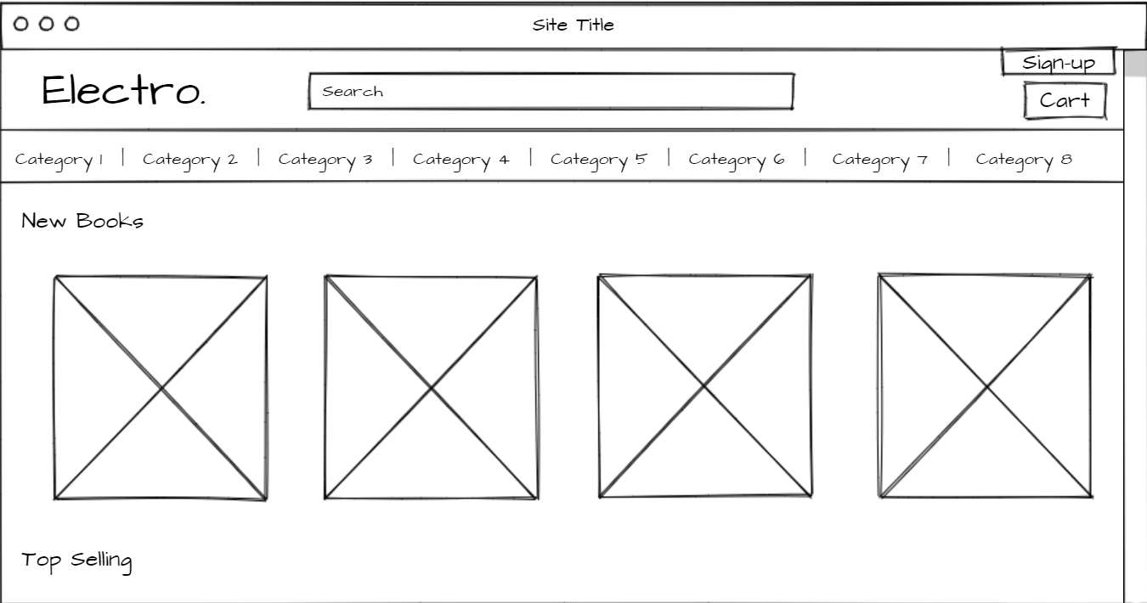

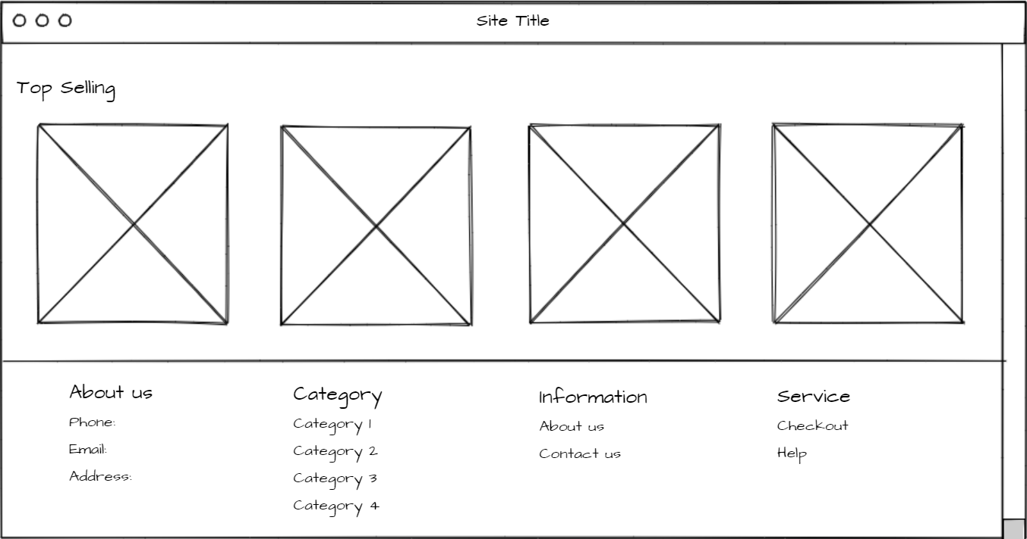

Screen 2: user clicks on sign-in button

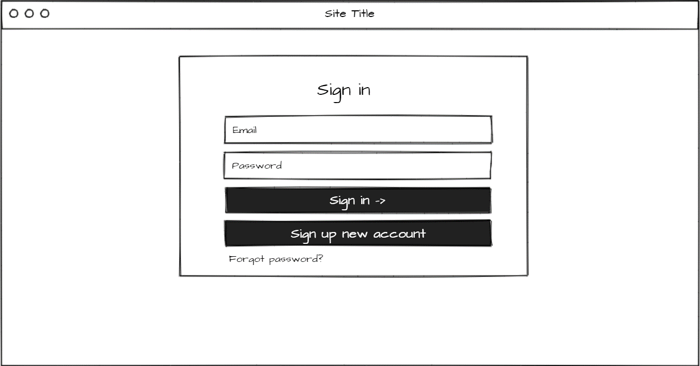

Screen 3: user clicks on sign up new account

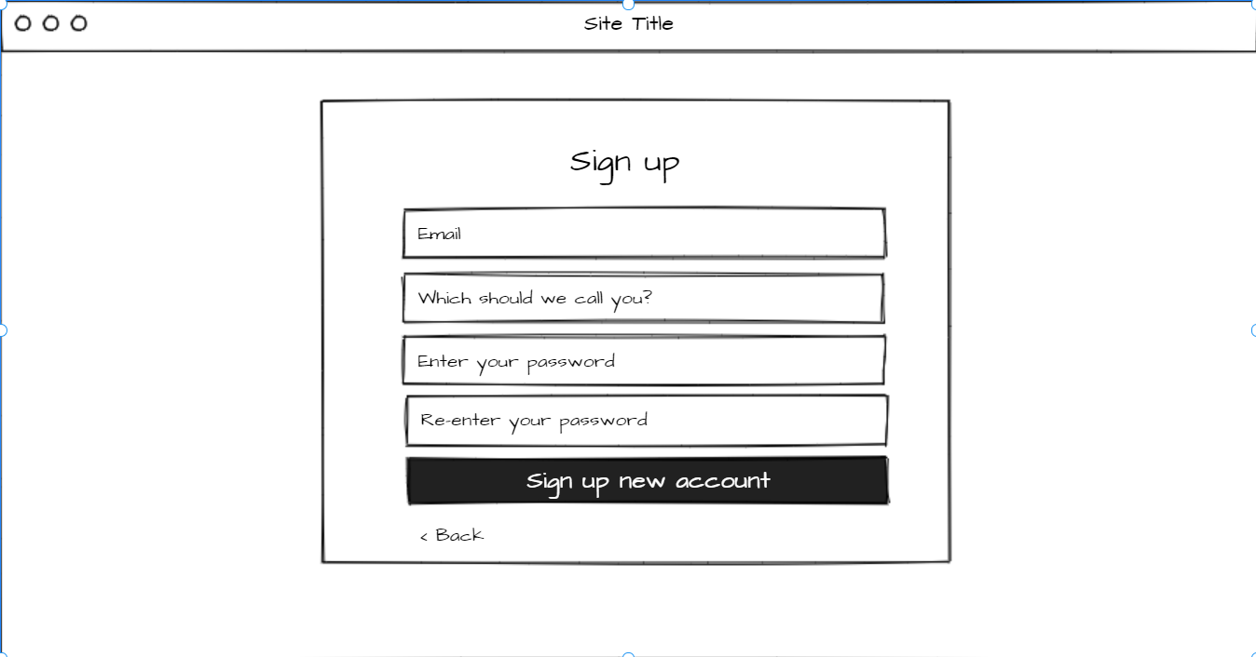

Screen 4: user clicks on forgot password

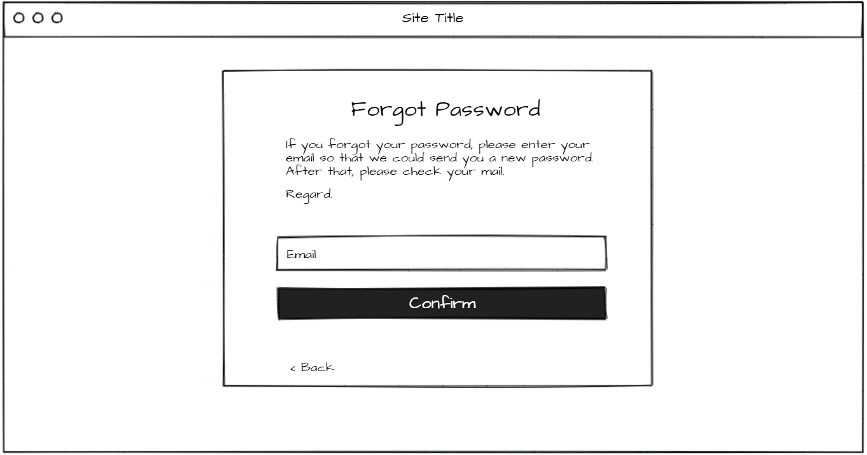

Screen 5: user clicks on category navigation bar

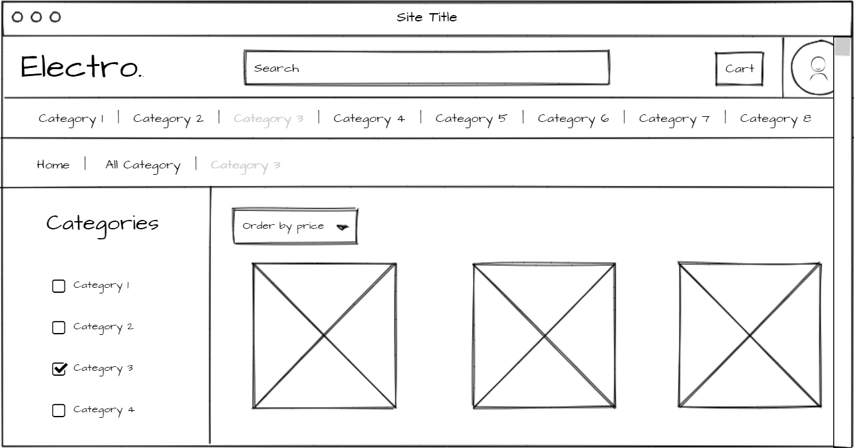

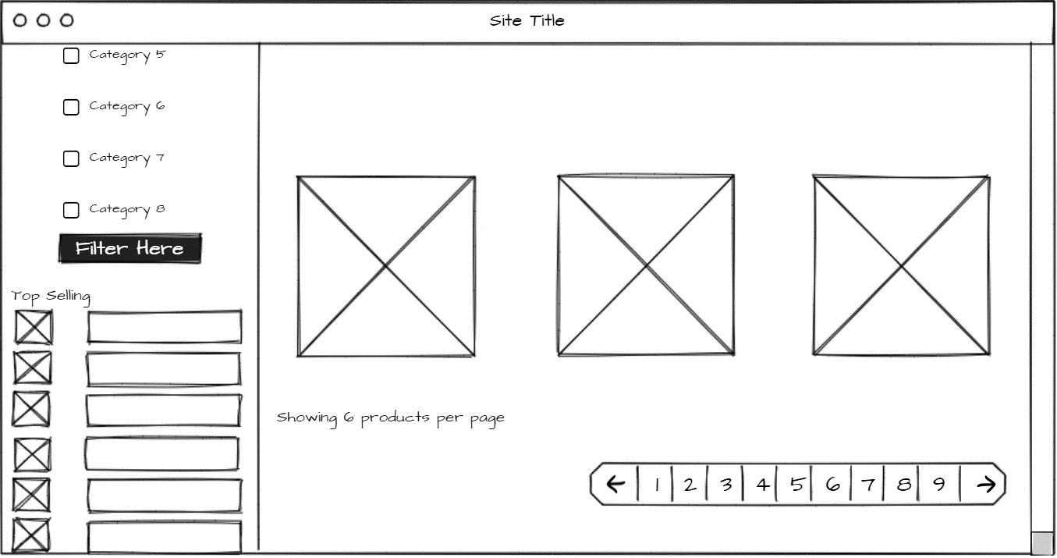

Screen 6: user clicks on Cart

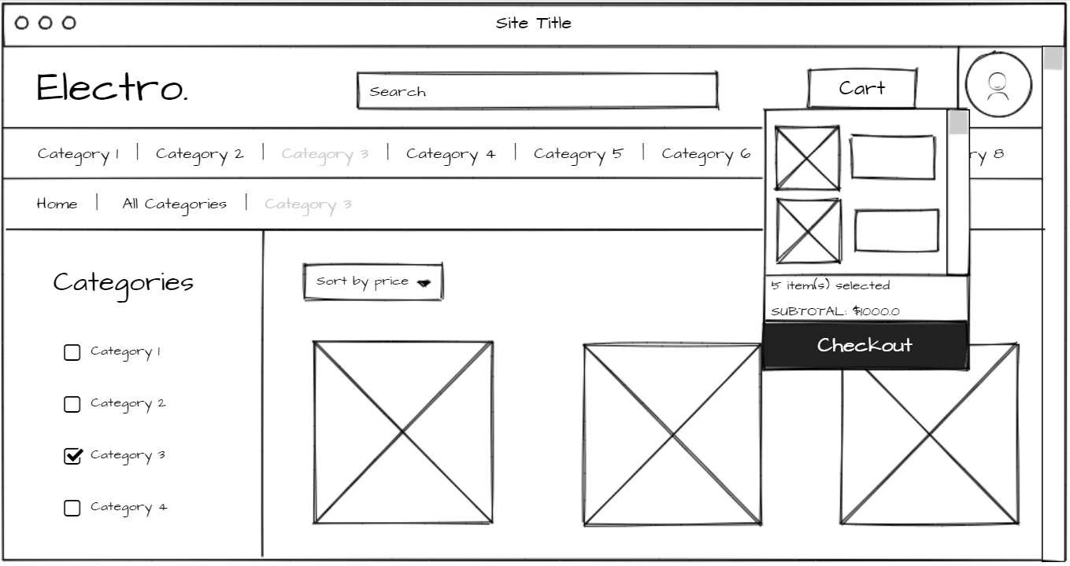

Screen 7: admin clicks on product (product details)

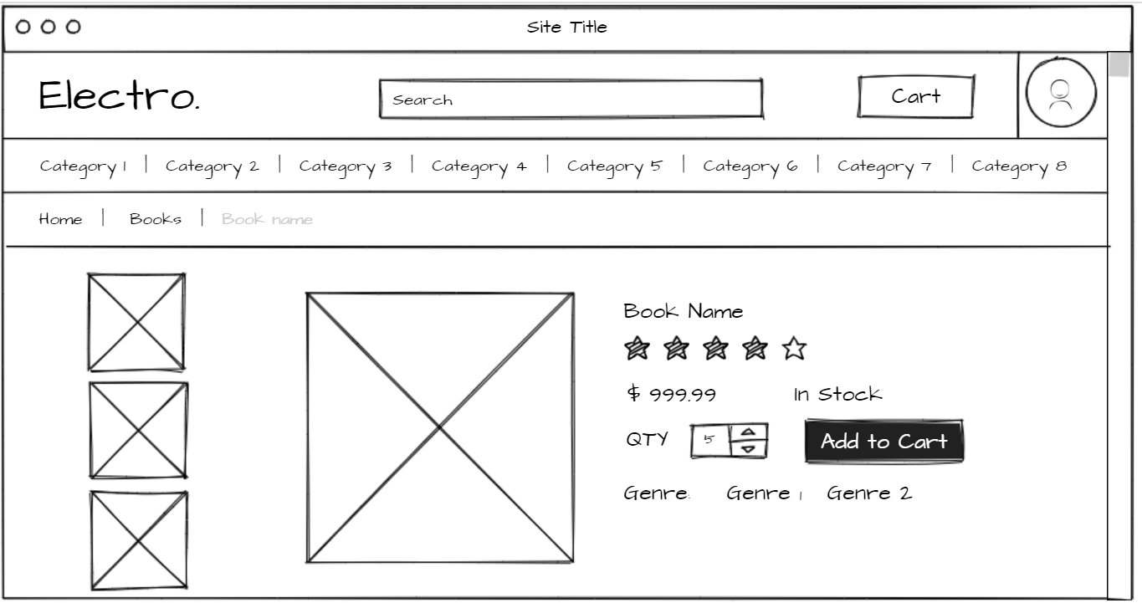

Screen 8: user clicks on checkout

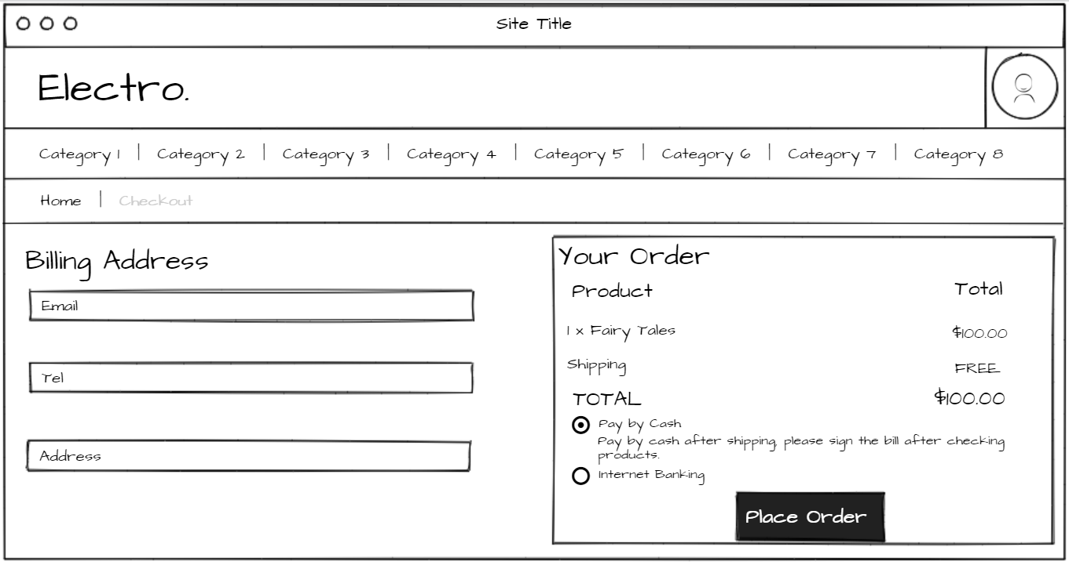

Screen 9: Admin homepage

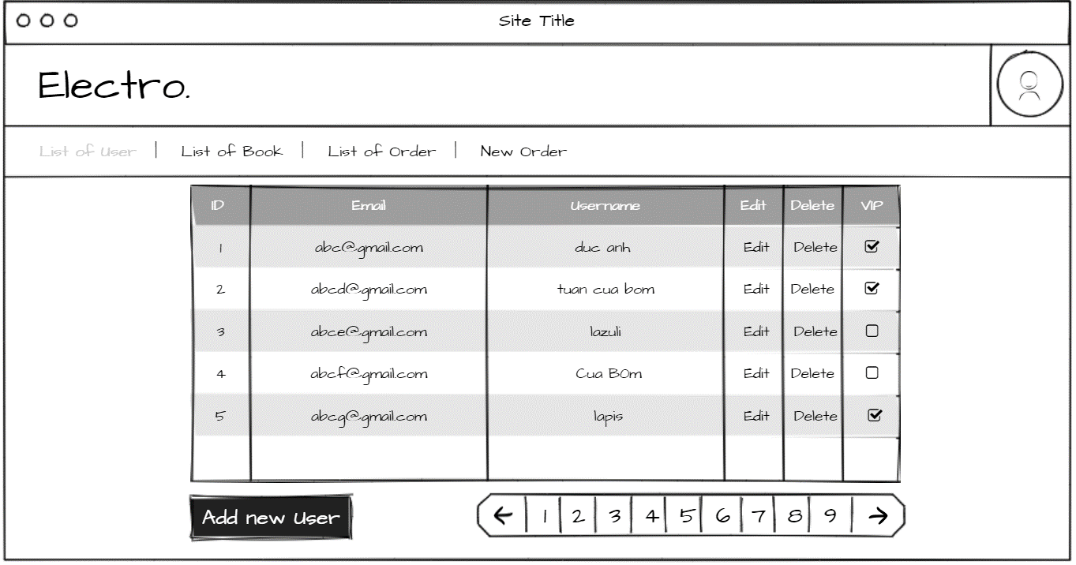

Screen 10: Admin clicks on List of Book

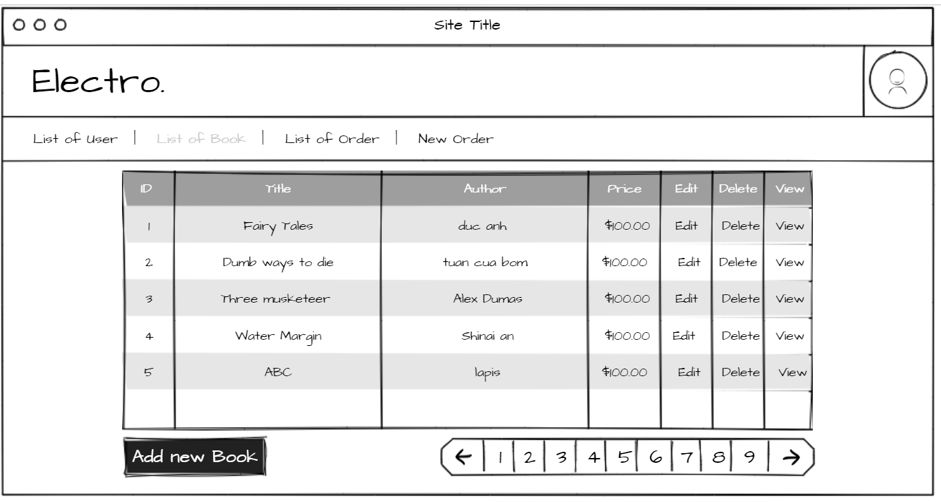

Screen 11: Admin clicks on List of Order

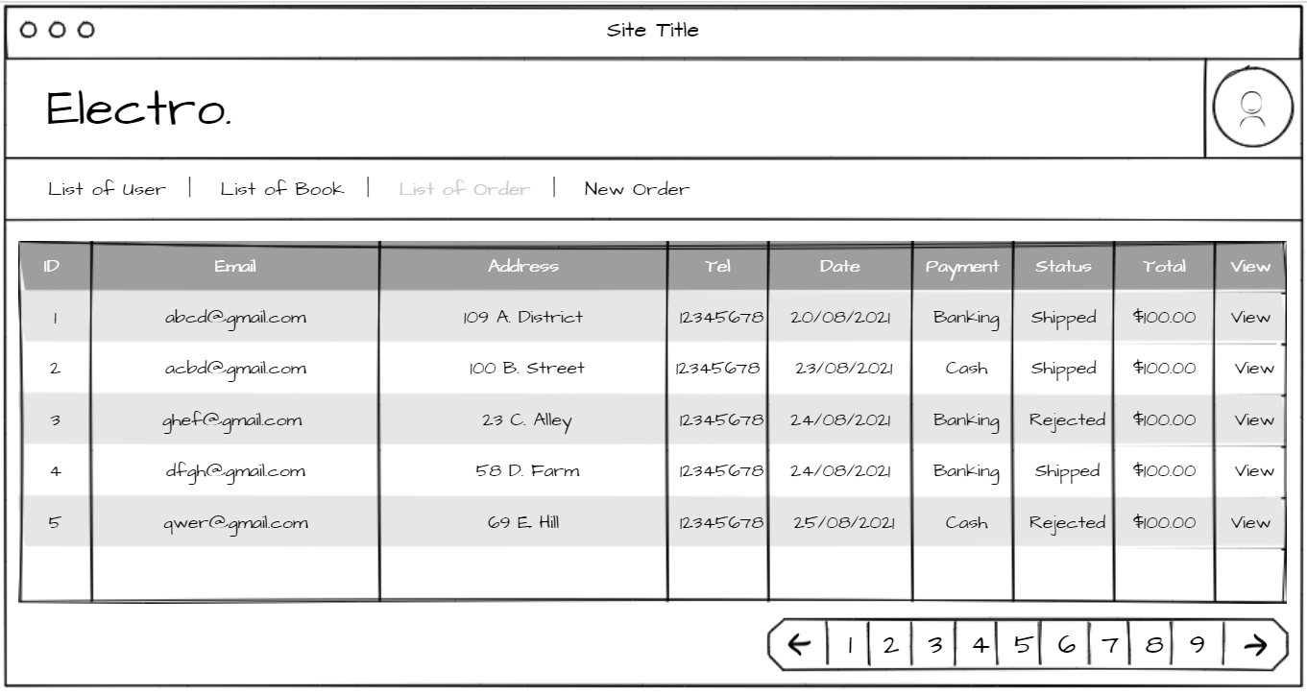

Screen 12: Admin clicks on New Order

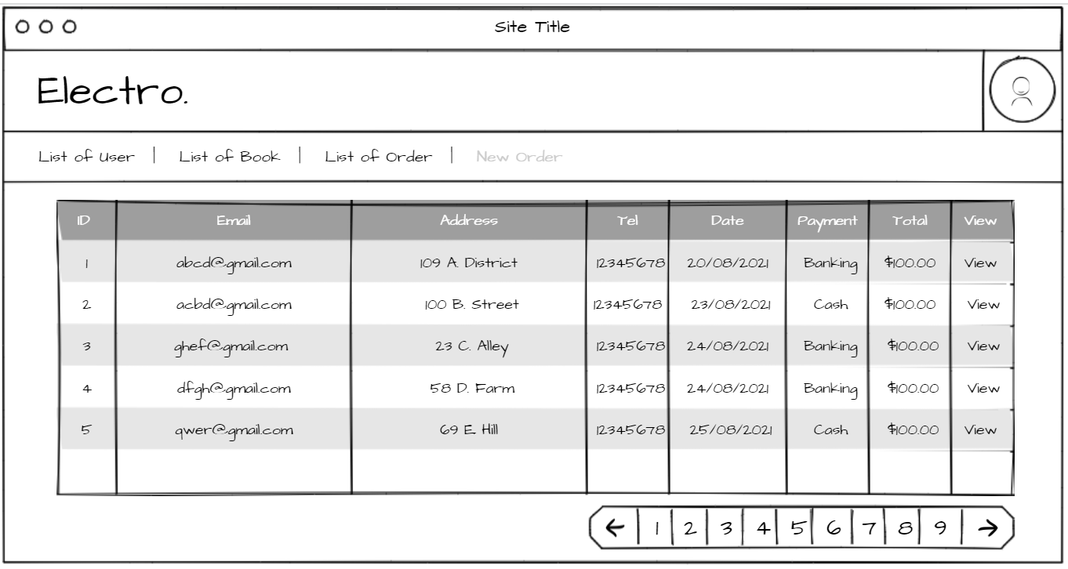

Screen 13: Admin clicks on Add new user

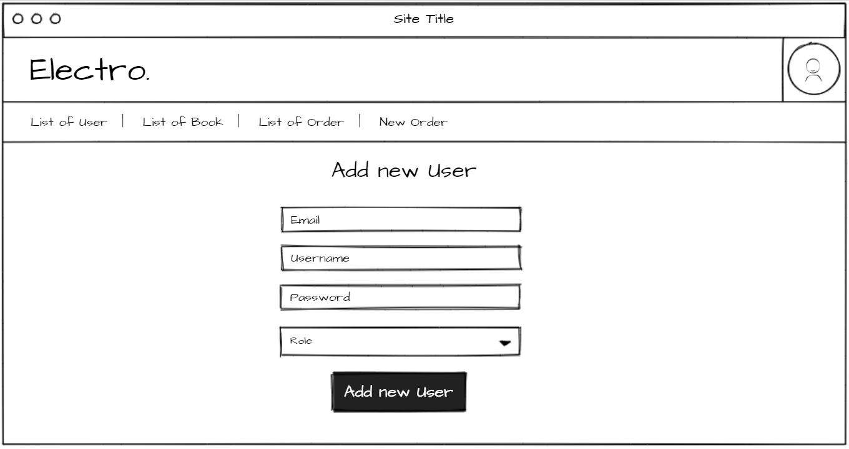

Screen 14: Admin clicks on Add new Book

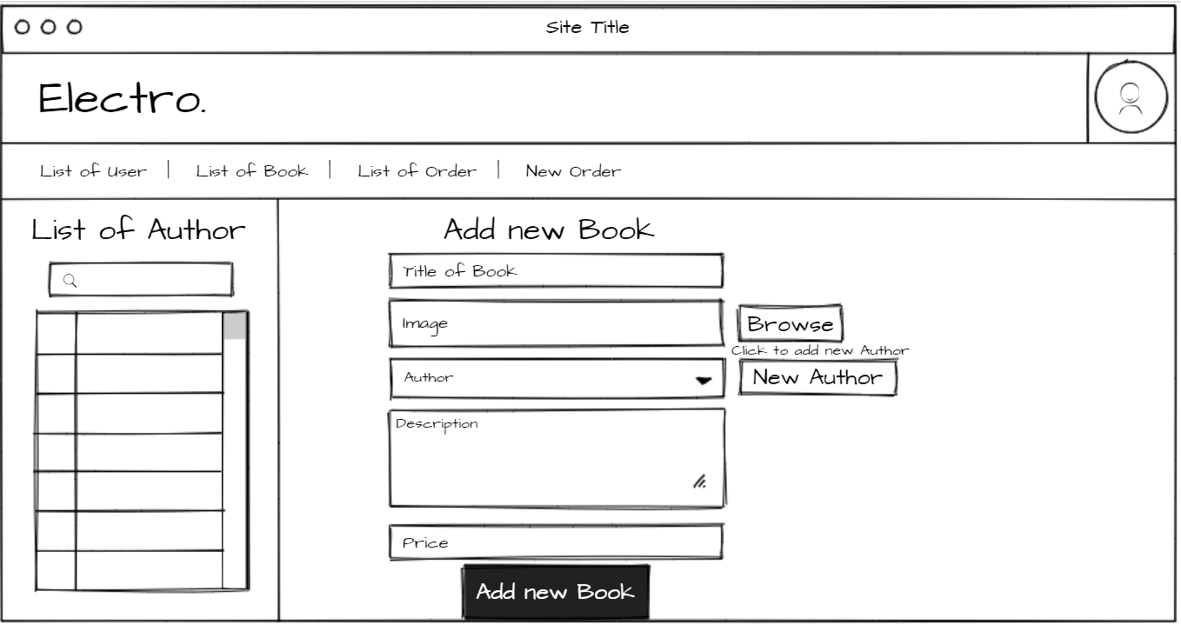

Screen 15: Admin clicks on Edit User

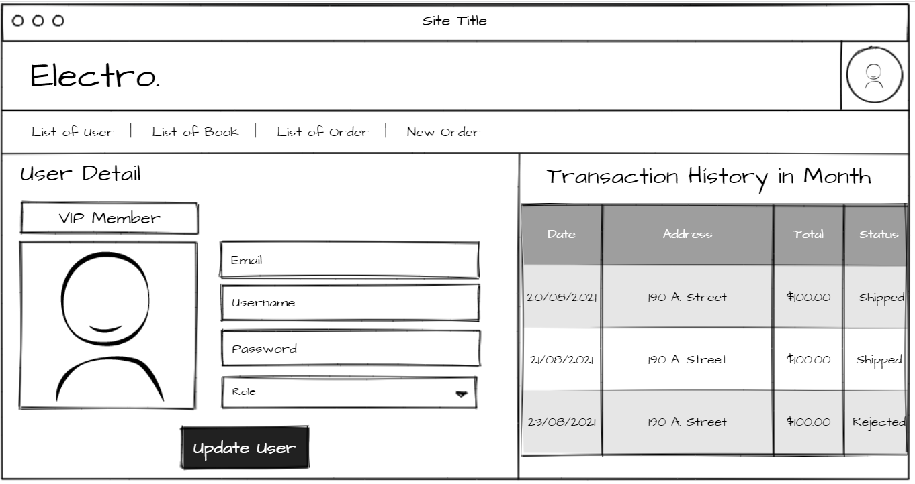

Screen 16: Admin clicks on View new Order

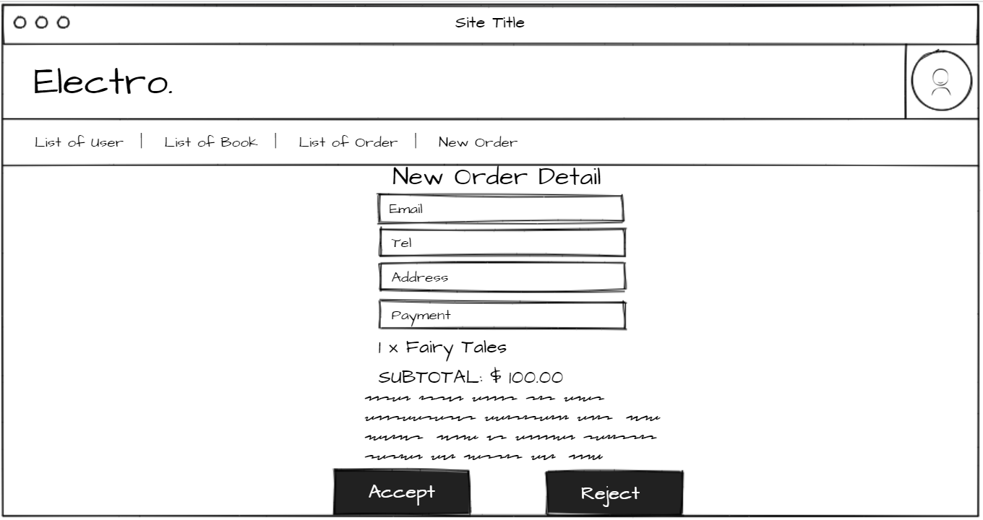

#### Hardware Interfaces

It strongly recommended that user use a desktop device instead of mobile device because some feature may be not work well in mobile in version 1.0 of OBS website. Don’t forget that you must have an internet connection like WAN – LAN.

Recommend that user should use new version of Chrome, Firefox, Safari. Internet Explorer may be not fully supported this website.

#### Software Interfaces

As it has already been started, OBS run on almost browser with internet on any OS on client side. With server side, all most functions depend on database. See information of database in Appendix.

#### Communications Interfaces

OBS use HTTP for communication over the internet.

### Other Nonfunctional Requirements

#### Performance Requirements

First version 1.0 of OBS website does not require powerful processor, more ram or need card graphic. It will run fast all most feature.

#### Design constraints

Coding design constraints uses Model-View-Controller pattern.

#### Safety Requirements

If developers are not careful, data in database can be loss. You must remember to save backup data to rollback if something wrong happened. OBS website version 1.0 doesn’t have more feature for admin because if admin lost account administrator, it’s very difficult to rollback data when database is deleted.

#### Security Requirements

Admin can see another account password. System back-end servers is only accessible by administrator, all database is encrypted.

#### Software Quality Attributes

OBS website has quite easy GUI with all features can be access from homepage. User can easy accesses to some feature from header of website.

1. Other Requirements

Appendix A: Database diagram

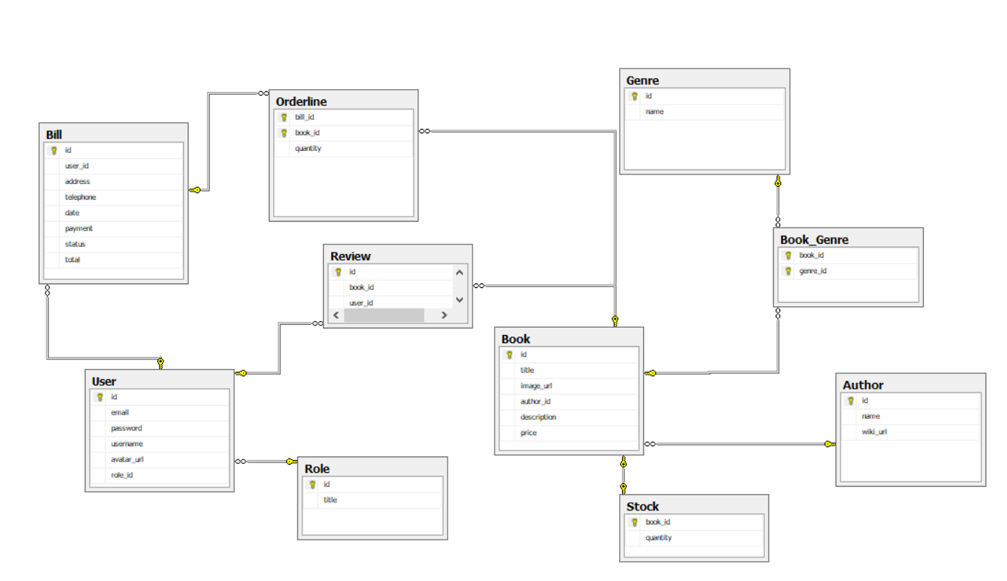

Appendix B: Database entity

1. User

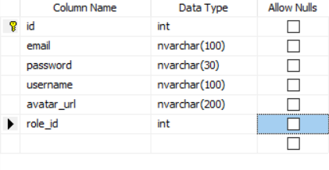

* Save information of user
* Include fields: id, email, password, username, avatar_url, role_id
* Avatar_url set to a default image url when set blank.

1. Stock

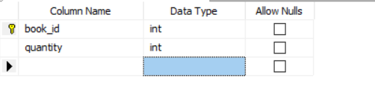

* Save the stock categories of book
* Include fields: book_id, quantity

1. Book

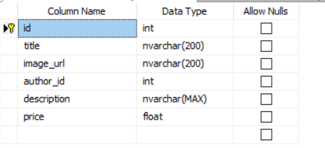

Save information of all the books

* Include fields: id, tittle, image_url, author_id, description, price;

1. Book_Genre

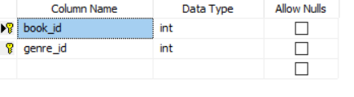

* Save information of books by genreID
* Include fields: book_id, genre_id;

1. Genre

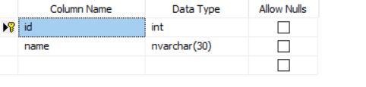

* Save information of all genre
* Include fields: id,name;

1. Author

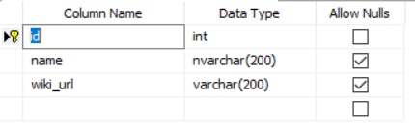

* Save information of all the authors whose books are available
* Include fields: id, name, wiki_url

1. Orderline

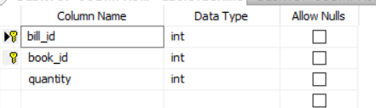

Save all the order by the user

* - Include fields: bill_id(from Bill),book_id(from Book)

1. Bill

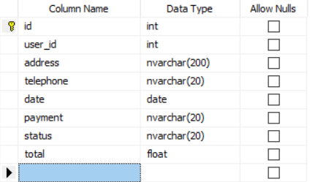

Save all the bill of the current user in charge.

-Include fields: id, user_id , address, telephone , date , payment , status , total.

1. Review

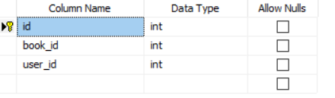

Save all the reviews of users about the books.

Include fields: id, book_id,user_id;

1. Role

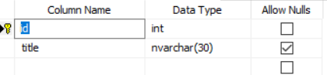

Save all the type of user

* Include fields: id, title;