

Requirement & Design Specification

**Sherah Warehouse System (SWS)**

**Version: 1.0**

– Hanoi, May 2024 –

# Record of Changes

| **Version** | **Date** | **A* M, D** | **In charge** | **Change Description** |
| --- | --- | --- | --- | --- |
| V1.0 | 12/2025 | A |  |  |
|  |  |  |  |  |
|  |  |  |  |  |
|  |  |  |  |  |
|  |  |  |  |  |
|  |  |  |  |  |
|  |  |  |  |  |
|  |  |  |  |  |
|  |  |  |  |  |
|  |  |  |  |  |
|  |  |  |  |  |
|  |  |  |  |  |

*A - Added M - Modified D - Deleted

SE1846_Group1

Contents

**Record of Changes 2**

**I. Overview 8**

1. User Requirements 8

1.1 Actors 8

1.2 Use Cases 8

2. Overall Functionalities 13

[2.1 Screens Flow  
-Screens Flow Manager 13](#_heading=h.3dy6vkm)

-Screens Flow Storage Staff 14

-Screens Flow Purchase Staff 15

-Screens Flow Admin 15

2.2 Screen Descriptions 16

2.3 Screen Authorization 21

3. System High Level Design 23

3.1 Database Design 23

a. Database Schema 23

b. Table Descriptions 23

3.2 Code Packages 25

**II. Requirement Specifications 26**

1. Login/Logout 26

1.1 Login 26

a. UC Specifications 26

1.2 Logout 26

a. UC Specifications 26

1.3 Reset Password 27

a. UC Specifications 27

2. Account Management 27

2.1 View Account 27

a. UC Specifications 27

2.2 Add Account 28

a. UC Specifications 28

2.3 Edit Account 28

a. UC Specifications 28

2.4 Delete Account 29

a. UC Specifications 29

3. Employee Management 29

3.1 View Employee 29

a. UC Specifications 29

3.2 Add Employee 30

a. UC Specifications 30

3.3 Edit Employee 30

a. UC Specifications 30

3.4 Delete employee 31

a. UC Specifications 31

4. Category and Product 31

4.1 Add Category 31

a. UC Specifications 31

4.2 Delete Category 32

a. UC Specifications 32

4.3 Edit Category 32

a. UC Specifications 32

4.4 View Category 33

a. UC Specifications 33

4.5 View Product List 33

a. UC Specifications 33

4.6 Add new product 34

a. UC Specifications 34

4.7 Delete product 35

a. UC Specifications 35

4.8 Update product 35

a. UC Specifications 35

4.9 Recover product 36

a. UC Specifications 36

5. User Profile 37

5.1 View Profile 37

a. UC Specifications 37

5.2 Edit Profile 37

a. UC Specifications 37

5.3 Change password 38

a. UC Specifications 38

6. Supplier Management 38

6.1 View supplier 38

a. UC Specifications 38

6.2 Add supplier 39

a. UC Specifications 39

6.3 Edit supplier 39

a. UC Specifications 39

6.4 Delete supplier 40

a. UC Specifications 40

7. Transfer Order 40

7.1 View list Transfer Order 40

a. UC Specifications 40

7.2 Create Transfer Order 41

a. UC Specifications 41

7.3 Update Transfer Order 41

a. UC Specifications 41

8. Product Detail Management 42

8.1 View list Product Detail 42

a. UC Specifications 42

8.2 View list Product Detail of a product 42

a. UC Specifications 42

8.3 Create new Product Detail of a product 43

a. UC Specifications 43

8.4 Delete Product Detail 43

a. UC Specifications 43

8.5 Recover Product Detail 44

a. UC Specifications 44

8.6 Update Product Detail 45

a. UC Specifications 45

9. Section Type Management 46

9.1 View list Section Type 46

a. UC Specifications 46

10. Section Management 46

10.1 Create new section 46

a. UC Specifications 46

10.2 View section list 47

a. UC Specifications 47

10.3 Update section 47

a. UC Specifications 47

10.4 Delete section 48

a. UC Specifications 48

11. Bin Management 49

11.1 View Bin List 49

a. UC Specifications 49

11.2 Add New Bin 49

a. UC Specifications 49

11.3 Delete Bin 50

a. UC Specifications 50

12. Bin Detail Management 50

12.1 Delete bin detail(product) in bin 50

a. UC Specifications 50

12.2 View list bin details 51

a. UC Specifications 51

13. Inventory Doc Management 52

13.1 View Inventory Doc List 52

a. UC Specifications 52

13.2 Create Inventory Doc 52

a. UC Specifications 52

13.3 Checking Inventory 53

a. UC Specifications 53

13.4 Confirm Inventory 53

a. UC Specifications 53

13.5 View Detail Inventory 54

a. UC Specifications 54

14. Purchase Order Management 55

14.1 Create Purchase Order 55

a. UC Specifications 55

14.2 View Purchase order list 55

a. UC Specifications 55

View Purchase order list 55

14.3 View Purchase Order Detail 56

a. UC Specifications 56

View Purchase Order Detail 56

14.4 Update Purchase Order 56

a. UC Specifications 56

Update Purchase Order 56

14.5 Delete Purchase Order 57

a. UC Specifications 57

Delete Purchase Order 57

14.6 Search Purchase Order 57

a. UC Specifications 57

Search Purchase Order 57

15. Import Management 58

15.1 Create Import Good 58

a. UC Specifications 58

16. DashBoard 58

16.1 DashBoard 58

a. UC Specifications 58

**III. Code Designs 59**

1. Structure Diagrams 59

**IV. Appendix 59**

1. Assumptions & Dependencies 59

2. Business Rules 59

# I. Overview

## 1. User Requirements

### 1.1 Actors

| **#** | **Actor** | **Description** |
| --- | --- | --- |
| 1 | Manager | Who manage employees, view statistics and review purchase orders and inventory. |
| 2 | Purchase Staff | Who creates purchase orders in the system. |
| 3 | Storage Staff | Who perform inventory procedures in the system |
| 4 | Admin | Who manages the account of the employee and role of employee. |

### 1.2 Use Cases

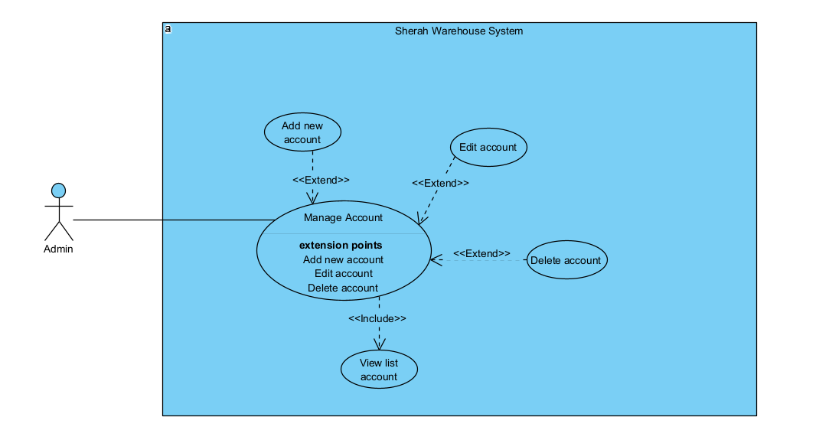

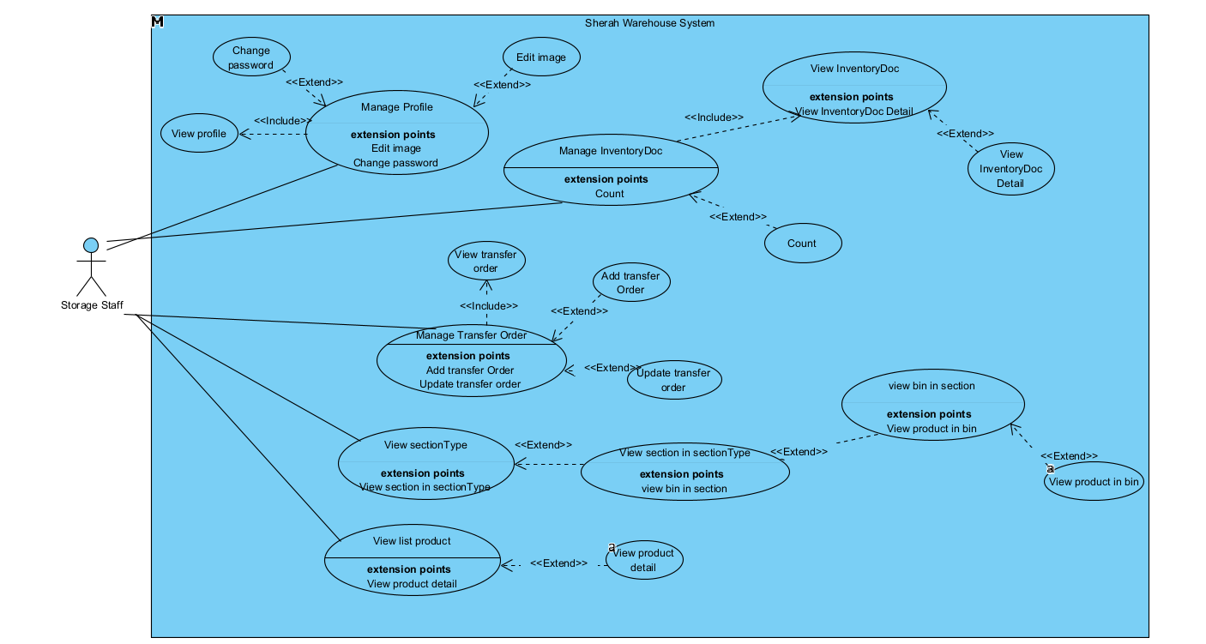

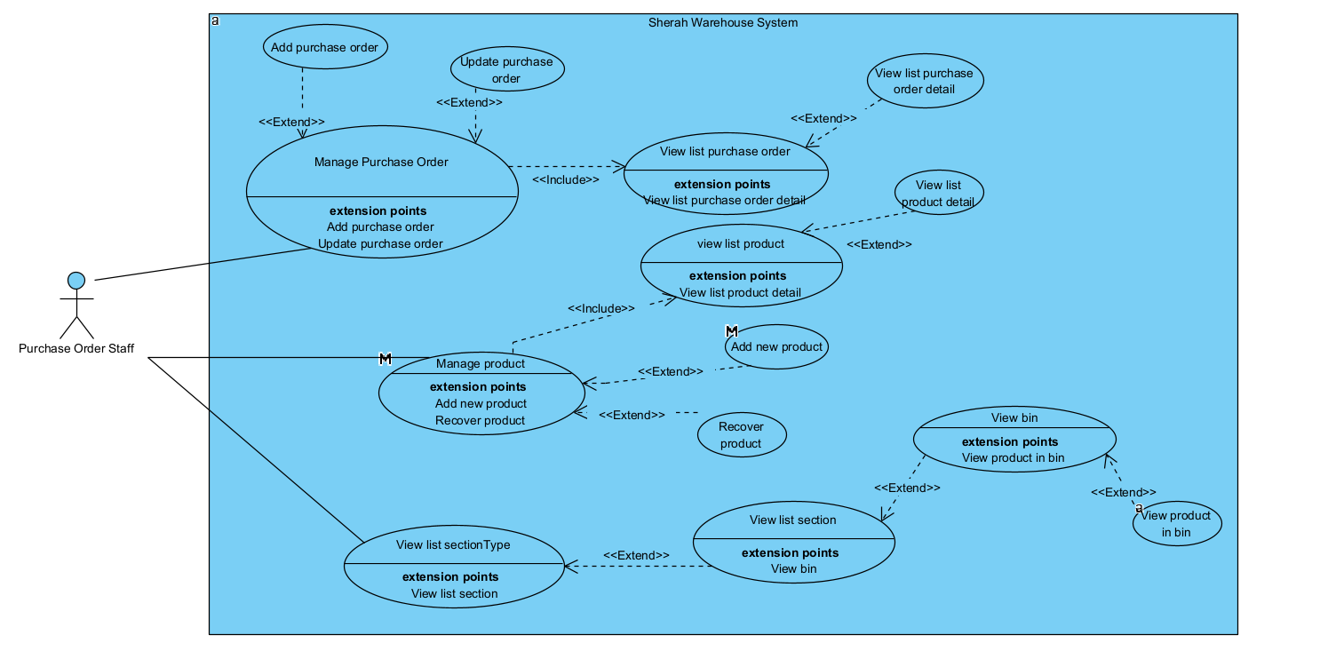

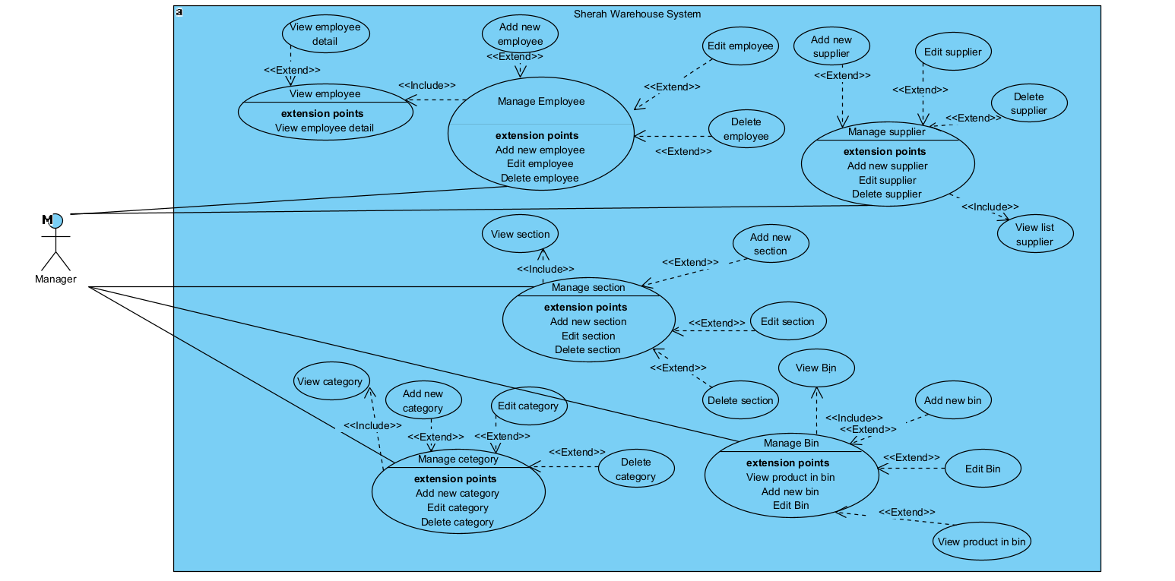

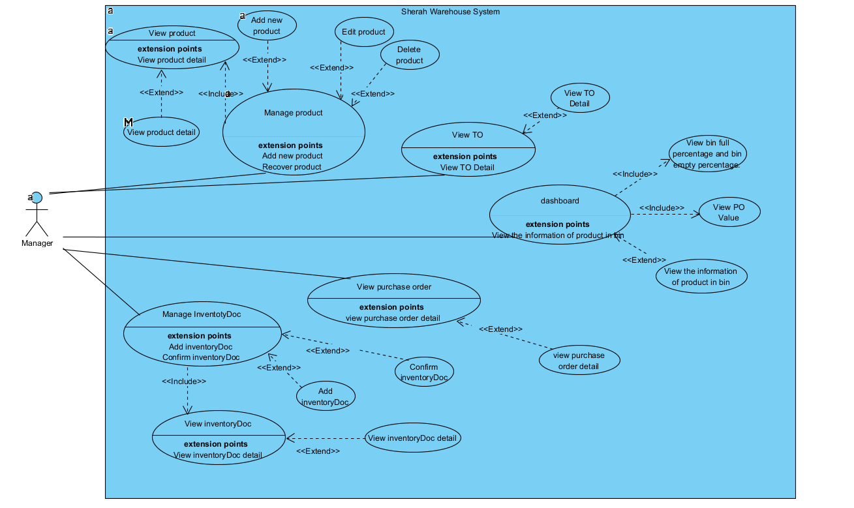

b. Descriptions

| **ID** | **Feature** | **Use Case** | **Use Case Description** |
| --- | --- | --- | --- |
| 01 | Authentication | Login | Allow users to login into the system. |
| 02 | Authentication | Logout | Allow users to log out into the system. |
| 03 | Authentication | Reset Password | Allow users to reset password to login into the system. |
| 04 | Manage Account | View account | Allows the admin to view all account of staff, except the manager |
| 05 | Manage Account | Add account | Allows the admin create a account for staff, can’t create a staff have role “manager” |
| 06 | Manage Account | Edit account | Allows the admin edit role or password of staff, can’t update a staff have role “manager” |
| 07 | Manage Account | Delete account | Allows the admin update account inactive. |
| 08 | Manage Employee | View employee | Allow the manager to view the information of the employee. |
| 09 | Manage Employee | Add employee | Allows the manager to create a new employee in the system. |
| 10 | Manage Employee | Edit employee | Allow the manager to edit the information of the employee, except employeeId. |
| 11 | Manage Employee | Delete employee | Allows the manager to update the status of employees who become inactive. |
| 12 | Manage Supplier | View supplier | Allow the manager to view a list of suppliers working with the system. |
| 13 | Manage Supplier | Add supplier | Allow the manager to add a new supplier. |
| 14 | Manage Supplier | Edit supplier | Allow the manager to edit a supplier. |
| 15 | Manage Supplier | Delete supplier | Allow the manager to update the status of a supplier and become inactive. |
| 16 | View bin inventory | View bin inventory | Allow the Storage Staff to view the quantity of a product in a bin and total quantity of a product in all bin. |
| 17 | Manage product | View list products | Allow users to view every product and it’s information in the system |
| 18 | Manage product | Create product | Allow Manager or Purchase Staff to create a new product . |
| 19 | Manage product | Delete product | Allow Manager to delete a product. |
| 20 | Manage product | Recover product | Allow Manager or Purchase Staff to recover a deleted product. |
| 21 | Manage product | Update product | Allow Manager or Purchase Staff to update a product’s detailed information. |
| 22 | Manage product detail | View list product details | Allow Manager or Purchase Staff or Storage Staff to view every product details in the system. |
| 23 | Manage product detail | View list product details of a product | Allow Manager or Purchase Staff or Storage Staff to view every product detail that belongs to a specific product. |
| 24 | Manage product detail | Create new product detail | Allow Manager or Purchase Staff to create a new product detail. |
| 25 | Manage product detail | Delete product detail | Allow Manager to delete a product detail. |
| 26 | Manage product detail | Recover product detail | Allow Manager or Purchase Staff to recover a deleted product detail. |
| 27 | Manage product detail | Update product detail | Allow Manager or Purchase Staff to update product detail information. |
| 28 | Manage section type | View list section type | Allow Manager or Purchase Staff or Storage Staff to view all section types in the system. |
| 29 | Manage section | View list section of a section type | Allow Manager or Purchase Staff or Storage Staff to view all sections that belong to a specific section type. |
| 30 | Manage section | Add new section | Allow Manager to add a new section that belongs to a specific section type. |
| 31 | Manage section | Edit a section | Allow Manager to edit a section that belongs to a specific section type. |
| 32 | Manage section | Delete a section | Allow Manager to delete a section that belongs to a specific section type. |
| 33 | Manage bin | View list bin of a section | Allow the Manager or Purchase Staff or Storage Staff to view all bins that belong to a specific section. |
| 34 | Manage bin | View product in bin | Allow the Manager or Purchase Staff and Storage Staff to view products that belong to a specific bin. |
| 35 | Manage bin | Add new bin | Allow the Manager to add a new bin that belongs to a specific section. |
| 36 | Manage bin | Edit bin | Allow the Manager to edit a bin that belongs to a specific section. |
| 37 | Manage bin | Delete bin | Allow the Manager to delete a bin that belongs to a specific section. |
| 38 | Manage bin detail | View list bin detail of a bin | Allow the Manager or Purchase Staff or Storage Staff to view all bin details that belong to a specific bin. |
| 39 | User management | View and edit profile | Allow users to edit profiles.(only image) |
| 40 | Manage purchase order | View purchase order | Allow the Manager or Purchase Staff or Storage Staff to view all purchase orders. |
| 41 | Manage purchase order | View purchase order detail | Allow the Manager or Purchase Staff or Storage Staff to view a purchase order detail. |
| 42 | Manage purchase order | Add a purchase order | Allow Purchase Staff to add a new purchase order. |
| 43 | Manage purchase order | Edit a purchase order | Allow Purchase Staff to edit a purchase order. |
| 44 | Manage purchase order | Delete a purchase order | Allow Purchase Staff to delete a purchase order. |
| 45 | Manage delivery order | View list delivery order | Allow the Manager or Purchase Staff or Storage Staff to view all delivery orders. |
| 46 | Manage delivery order | Add delivery order | Allow the Manager or Purchase Staff to add a new delivery order. |
| 47 | Transfer Order Management | View list transfer order | Allow the Manager or Purchase Staff or Storage Staff to view all transfer orders. |
| 48 | Transfer Order Management | Add a new transfer order | Allow the Storage Staff to add a new transfer order. |
| 49 | Transfer Order Management | Edit transfer order | Allow the Storage Staff to edit a transfer order. |
| 50 | Transfer Order Management | Delete transfer order | Allow the Storage Staff to delete a transfer order. |
| 51 | InventoryDoc Management | View list inventoryDoc | Allow the Manager or Storage Staff to view all list inventoryDoc. |
| 52 | InventoryDoc Management | Add new inventoryDoc | Allow the Manager to add a new InventoryDoc. |
| 53 | InventoryDoc Management | Check inventoryDoc | Allow the Storage Staff to update the quantity of an InventoryDoc. |
| 54 | InventoryDoc Management | Confirm inventoryDoc | Allow the Manager to confirm an InventoryDoc. |
| 55 | Category Management | View list category | Allow the Manager to view all list categories. |
| 56 | Category Management | Add a new category | Allow the Manager to add a new category. |
| 57 | Category Management | Edit a category | Allow the Manager to edit a category. |
| 58 | Category Management | Delete a category | Allow the Manager to delete a category. |
| 59 | DashBoard | Statistical | Allow the Manager to view the information of bin, view product in bin, view PO value, view total Order, view total supplier. |

## 2. Overall Functionalities

### 2.1 Screens Flow -Screens Flow Manager

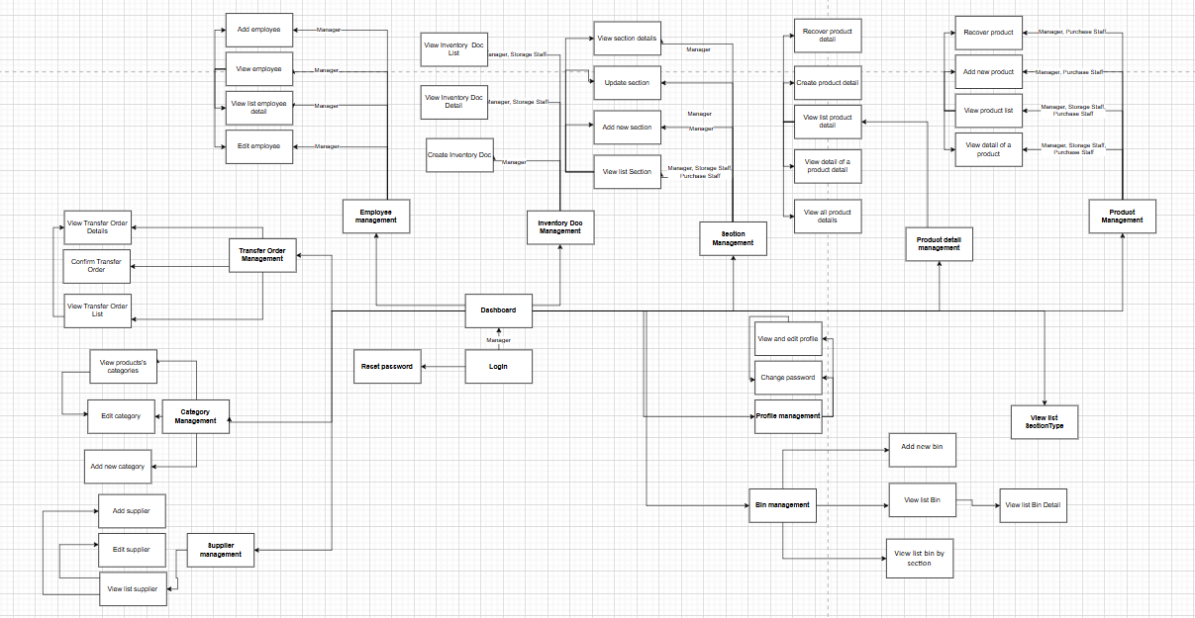

### -Screens Flow Storage Staff

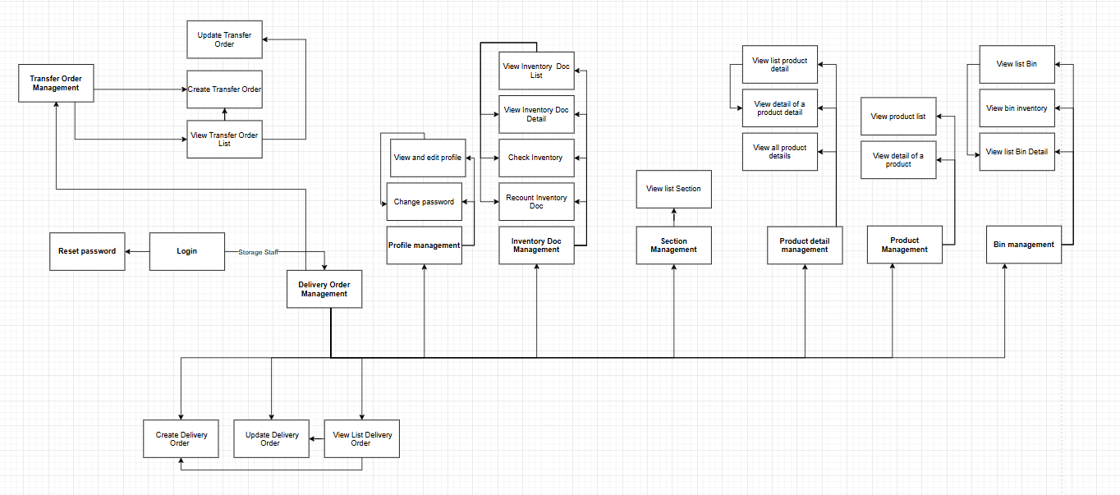

### -Screens Flow Purchase Staff

### -Screens Flow Admin

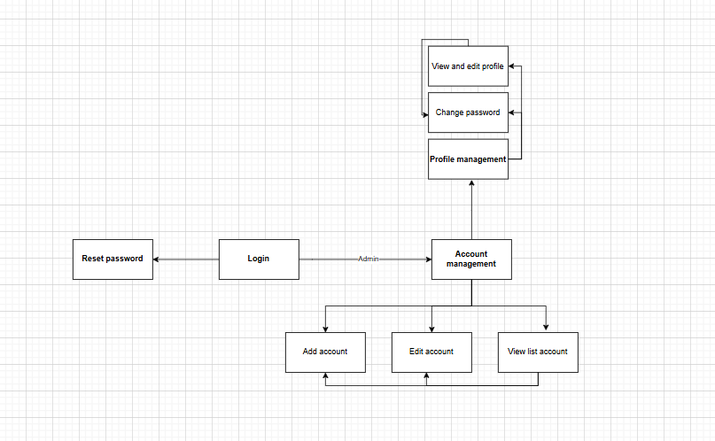

### 

### 2.2 Screen Descriptions

| **#** | **Screen / Function** | **Feature** | **Description** |
| --- | --- | --- | --- |
| 1 | Add account | Account management | Show section details along with bin list (bin id, bin name, status)  - Pagination  - Filter by status  - Search |
| 2 | Edit account | Account management | Allows administrators to edit employee accounts. Accounts include: email (not editable), role, password, status. |
| 3 | View list account | Account management | Allows the administrator to view all active employee accounts. An account consists of: accountId, employeeId, email, role, account status.  An input search based on: employeeId, email." |
| 4 | Login | Authentication | - Allows users to enter password and email to log into the system, remember to remember information when logging in |
| 5 | Reset password | Authentication | - Allows users to reset their password by entering their email  - If the email is in the system, a 6-digit random code will be sent to the email and then enter the code. If the code is entered correctly, it can be redirected to the password update page. When the password is updated, it will be redirected to the login page |
| 6 | View list bin by section | Bin Management | Display list of bins belonging to 1 section; Pagination; Search bin based on binId and binName |
| 7 | Add new bin | Bin Management | Allow user to add bin to section (bin id, bin name, status, max capacity, section id)  - Bin ID is auto generated and displayed in create form  - Validate Bin name must not exist  - Validate bin name must not be blank, at least 5 characters long, not contain only space  - Status of newly created bin will be set to locked  - Max capacity is assumed to be auto 100kg |
| 8 | Update bin | Bin Management | Allow user to update bin (bin id, bin name, status, section id)  - Bin ID is auto generated and displayed in create form if section is changed  - Validate Bin name must not exist  - Validate bin name cannot be blank, at least 5 characters long, not contain only space character |
| 9 | View section details | Bin Management | Show section details along with bin list (bin id, bin name, status)  - Pagination (in progress)  - Filter by status (in progress)  - Search (in progress) |
| 10 | View bin inventory | Bin management | There are 7 fields in total: binId, product detailS, image, color, size, quantity of product in bin, bin activity status. |
| 11 | View list Bin Detail | BinDetail Management | Display a list of products stored in a warehouse; Pagination; Search for products based on productDetailId, binDetailId, size, color; |
| 12 | Add new category | Category Management | Create a new Category with the fields CategoryName.  - If the Category already exists, display the message |
| 13 | Edit category | Category Management | Change Category Name |
| 14 | View products's categories | Category Management | Show Category list with CategoryName, Created By and Update Date fields  - Has Filter fields  - Has Delete button with corresponding Categories and cannot delete Category if there is product |
| 15 | Create Delivery Order | Import Good Management | -Create import good including Product, Supplier, Section and Bin information to import to warehouse, with Status = "Processing" and default section is Storage Received (only contains new goods) |
| 16 | View and edit profile | Employee management | The profile screen displays 10 employee information fields, including image, employeeName, role, email, phoneNumber, address, gender, date of birth, status and warehouse name.  - Allow image update  - Validate image must be in correct format  - Button to Save changes |
| 19 | Change password | Employee management | The screen displays 3 fields: old password, new password, confirm new password.  - Allows users to update password  - Password is encrypted before saving to database  - Check old password  - Validate new password and confirm new password must be the same |
| 20 | Add employee | Employee management | Allows the manager to create a new employee. New employee: employeeId(automatic), employee name, photo, email, phone, address, gender, date of birth, warehouse name and status. |
| 21 | Edit employee | Employee management | Allows the manager to edit employees. Employee information: employeeId(automatic), employee name, photo, email, phone, address, gender, date of birth, warehouse name and status. |
| 22 | View employee | Employee management | "Displays a list of active employees including: employeeId, employee name, email, address and status.  Search input based on: employeeId, email, phone and name." |
| 23 | View list employee detail | Employee management | Display detailed information of an employee including: employeeId, employee name, photo, email, phone, address, gender, date of birth, work location and status. |
| 24 | View Inventory Doc List | Inventory Doc Management | -- Allows users to view the InventoryDoc list |
| 25 | View Inventory Doc Detail | Inventory Doc Management | - Allows users to view the list of products that InventoryDoc needs to check. |
| 26 | Confirm InventoryDoc | Inventory Doc Management | There are three main actions Clear Difference, Cancel and Recount  - Clear Difference will change the status of InventoryDoc to Confirmed and Bin to open  - Cancel will change the status of InventoryDoc to Cancel and Bin to open  - If Recount is selected, the Recount task must be assigned on that screen, and Recount can only be done once |
| 27 | Create Inventory Doc | Inventory Doc Management | Allows Manager to create a new inventoryDoc with fields of interest such as Binid and assign tasks to an employee  -Cannot create inventoryDoc of a bin that is in locked state |
| 28 | Check Inventory | Inventory Doc Management | Allow Storage Staff to import inventory numbers from an inventoryDoc  -Quantity cannot be entered that exceeds the Maxcapacity limit of a bin  -Negative numbers cannot be entered. If the difference is more than 20%, a warning will be issued. |
| 29 | View all product details | Product detail management | Display a list of all productDetails in the system; Pagination available; Search productDetail based on productDetailId, size, color; |
| 30 | View list product detail | Product detail management | Displays a list of all productDetails belonging to a certain product; Has pagination; Searches productDetails based on productDetailId, size, color; Can delete (when the number of products = 0 and its status is 1) and recover (when its status is 0) via the "Delete" and Recover buttons |
| 31 | Create product detail | Product detail management | There are 4 fields, duplicate checked; Uploaded image must have the extension JPG, PNG, GIF and the image size must not exceed 2MB; Weight must be greater than 0; Color cannot be empty, and only contains letters; |
| 32 | Update product detail | Product detail management | Display detailed information of a productDetail and let users update the weight and re-upload the image; weight must be greater than 0 and max is 10.0; Image must have the extension JPG, PNG, GIF and not exceed 2MB; |
| 33 | View product list | Product Management | Displays a list of all products currently on the system; Pagination; Supports searching based on productId, productName, seasons. Can delete (when totalQuantity sp = 0 and its status is 1) and recover (when its status is 0) via the "Delete" and Recover buttons |
| 34 | Add new product | Product Management | There are 10 fields; Check for duplicates; productName is not empty, does not contain all spaces, does not contain special characters; price >= 10,000 and <= 10,000,000; Material is not empty, does not contain all spaces, only contains letters, numbers, "%" and spaces; minQuantity >= 0 b=and <= 1000; If madeIn is entered, madeIn does not contain all spaces, only contains letters and spaces; |
| 35 | Update product | Product Management | Displays detailed information of a Product and can edit information; Checked for duplicates; productName is not empty, does not contain all spaces, does not contain special characters; price >= 10,000 and <= 10,000,000; Material is not empty, does not contain all spaces, only contains letters, numbers, "%" and spaces; minQuantity >= 0 b=and <= 1000; If madeIn is entered, madeIn does not contain all spaces, only contains letters and spaces; |
| 36 | Create Purchase Order | Purchase Order Management | -Allow Purchase Staff to create purchase orders, including selecting Suppliers, and select Product, can enter product price and quantity, default PO status is "Pending" |
| 37 | Update Purchase Order | Purchase Order Management | - Update supplier and product information if PO status is Pending, Confirmed |
| 38 | View Purchase Order Detail | Purchase Order Management | - View Order details, can view Information Other(Actor Name, Actor Email, Actor Phone ,Create Date PO) and Supplier Information(Name, Address, Email, Phone), List Product PO(information product, price po, quantity) |
| 39 | View Purchase order list | Purchase Order Management | - View the Purchase Order list including information fields: PoID, Crated Date, SupplierID, CreateBy, Status, TotalPrice |
| 40 | View list Section | Section Management | Display a list of sections belonging to a sectiontype; Pagination; Search for sections based on sectionId and sectionName |
| 41 | Add new section | Section Management | Allows users to create new sections (section id, section name, section type, description)  - Section ID is auto generated and displayed when created  - "Cancel" button to return to Section List.  - "Save" button to save new Section information. |
| 42 | Update section | Section Management | Allow users to update section (section name, section type and description)  - Do not update Section ID  - "Update" button to save updated information  - Only allow updates if the bins in the section do not contain products. |
| 43 | View list SectionType | Section Type Management | Displays a list of sectionTypes in the system; Pagination; Search based on sectionName and description |
| 44 | Dashboard | Statistical | The dashboard screen will include: total value of completed PO orders, total number of PO orders, total number of employees, total number of suppliers. 1 chart of total value of PO orders by month of the year, 1 chart of number of orders and total value of orders for each supplier. 1 table including 9 fields: productId, product name, binId containing product, sectionId containing binId, color, size, total quantity of product, number of products that can be shipped, number of products that are blocked. 1 table calculating % of full volume of bin, % of volume that bin can hold, section that bin belongs to. |
| 45 | Add supplier | Supplier management | Allows manager to create new supplier including SupplierId (automatic), supplier name, email, phone, address, status (active). |
| 46 | Edit supplier | Supplier management | Allows the administrator to edit suppliers including supplier name, email, phone, address and status (active). |
| 47 | View list supplier | Supplier management | Display list of all Products; Pagination; Search based on |
| 48 | Create Transfer Order | Transfer Order Management | - Allows Storage staff to create transfer orders to transfer products from one bin to another.  - The form includes the fields: original section, origin bin, final section, final bin, product and quantity.  - Search box to search for products and show search suggestion  - The transfer order code (TO ID) is automatically generated and displayed. The status of the transfer order will be automatically set to "Pending" when created.  - Validate the destination bin does not overlap the transfer bin  - Validate the quantity of goods transferred does not exceed the quantity of goods in the transfer bin |
| 49 | Update Transfer Order | Transfer Order Management | - Allows user to update transfer order with status "Pending"  - User can update: final section, final bin  - Validate destination bin does not duplicate transfer bin  - Validate whether remaining capacity of destination bin is enough to transfer to |
| 50 | View Transfer Order List | Transfer Order Management | - Allows users to view a list of all transfer orders (Transfer order code, Creator, Status, Creation date).  - "Edit" button: takes users to the "Update transfer order" page.  - "Processing" button: confirms taking goods from the source warehouse (minus the source warehouse quantity)  <Validate rechecks available quantity in origin bin.>  - "Complete" button: confirms goods have arrived at the destination warehouse (adds quantity to the destination warehouse)  - "Cancelled" button: changes status from Pending to Cancelled  - When clicking on the Transfer Order Code (TO ID), the system will display Transfer Order Details.  - Supports pagination.  - Supports searching by keyword.  - Supports filtering by status, creator, time period. |
| 51 | View Transfer Order Details | Transfer Order Management | -Allows users to view detailed information of a transfer order (Transfer order code, Creator, Status, Creation date) along with the transferred product (product detail id, productName, quantity, weight) |

### 2.3 Screen Authorization

| **Screen/Function** | **Manager** | **Purchase Staff** | **Storage Staff** | **Admin** |
| --- | --- | --- | --- | --- |
| Add account |  |  |  | x |
| Edit account |  |  |  | x |
| View list account |  |  |  | x |
| Login | x | x | x | x |
| Reset password | x | x | x | x |
| View list bin by section | x | x | x |  |
| Add new bin | x |  | x |  |
| Update bin | x |  | x |  |
| View section details | x |  | x |  |
| View bin inventory | x |  |  |  |
| View list Bin Detail | x | x | x |  |
| Add new category | x |  |  |  |
| Edit category | x |  |  |  |
| View products's categories | x |  |  |  |
| Create Import good |  |  | x |  |
| View and edit profile | x | x | x | x |
| Change password | x | x | x | x |
| Add employee | x |  |  |  |
| Edit employee | x |  |  |  |
| View employee | x |  |  |  |
| View list employee detail | x |  |  |  |
| View Inventory Doc List | x |  | x |  |
| View Inventory Doc Detail | x |  | x |  |
| Confirm InventoryDoc | x |  |  |  |
| Create Inventory Doc | x |  |  |  |
| Check Inventory |  |  | x |  |
| View all product details | x | x | x |  |
| View list product detail | x | x | x |  |
| Create product detail | x | x |  |  |
| Update product detail | x |  |  |  |
| View product list | x | x | x |  |
| Add new product | x | x |  |  |
| Update product | x |  |  |  |
| Create Purchase Order |  | x |  |  |
| Update Purchase Order |  |  |  |  |
| View Purchase Order Detail | x | x |  |  |
| View Purchase order list | x | x |  |  |
| View list Section | x | x | x |  |
| Add new section | x |  |  |  |
| Update section | x |  |  |  |
| View list SectionType | x |  |  |  |
| Dashboard | x |  |  |  |
| Add supplier | x |  |  |  |
| Edit supplier | x |  |  |  |
| View list supplier | x |  |  |  |
| Create Transfer Order |  |  | x |  |
| Update Transfer Order |  |  | x |  |
| View Transfer Order List | x |  | x |  |
| View Transfer Order Details | x |  | x |  |

## 3. System High Level Design

### 3.1 Database Design

#### a. Database Schema

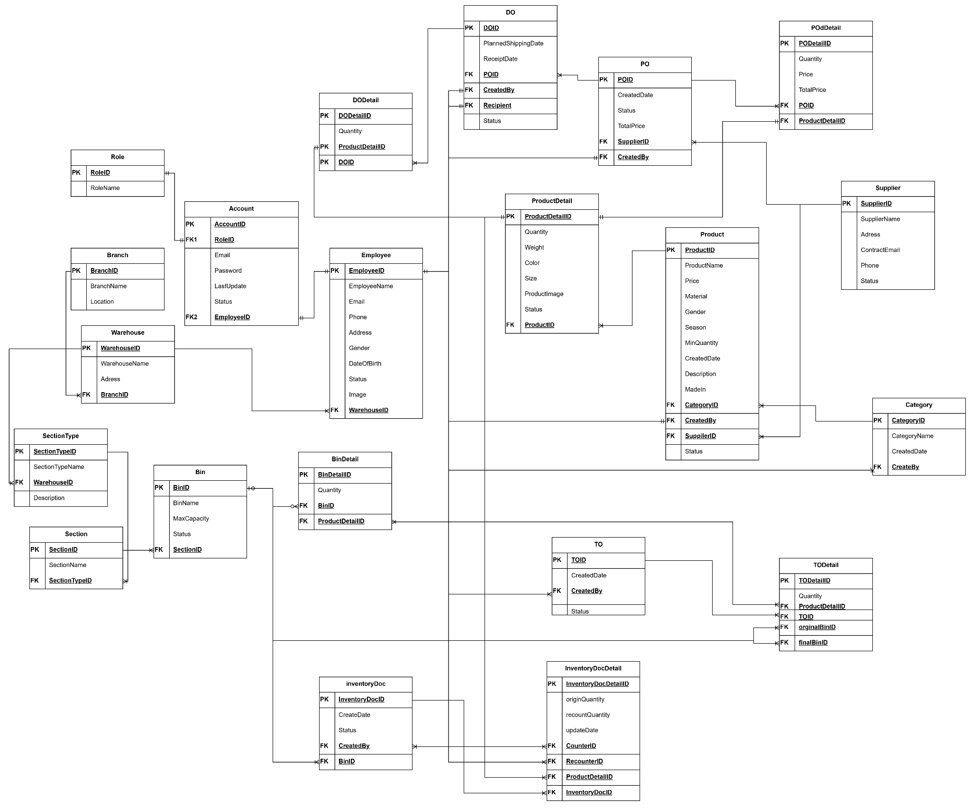

#### b. Table Descriptions

| **No** | **Table** | **Description** |
| --- | --- | --- |
| 01 | Product | Table for product  - Primary keys: Product ID  - Foreign keys: CategoryID, CreatedBy, SupplierID |
| 02 | Product Detail | Table for Product Detail  - Primary keys: ProductDetailID  - Foreign keys: ProductID |
| 03 | Category | Table of Category  - Primary keys: CategoryID  - Foreign keys: CreateBy |
| 04 | DO | Table of Delivery Order  - Primary keys:DOID  - Foreign keys:CreatedBy, Recipient |
| 05 | DODetail | Table for Delivery Order Detail  - Primary keys: DODetailID  - Foreign keys: ProductDetailID, DOID |
| 06 | InventoryDoc | Table for InventoryDoc  - Primary keys: InventoryDocID  - Foreign keys: CreatedBy, BinID |
| 07 | InventoryDoc Detail | Table for Inventory Doc Detail  - Primary keys: InventoryDocDetailID  - Foreign keys: ProductDetailID, CounterID, ReCounterID, InventoryDocID |
| 08 | Purchase Order | Table for Purchase Order  - Primary keys: POID  - Foreign keys: SupplierID,CreatedBy |
| 09 | Purchase Order Detail | Table for Purchase Order Detail  - Primary keys: POdetailID  - Foreign keys: POID, ProductDetailID |
| 10 | Role | Table forRole  - Primary keys: RoleID |
| 11 | Section | Table for Section  - Primary keys: SectionID  - Foreign keys: SectionTypeID |
| 12 | SectionType | Table for SectionType  - Primary keys: SectionTypeID  - Foreign keys: WarehouseID |
| 13 | Supplier | Table for Supplier  - Primary keys: SupplierID |
| 14 | TO | Table for Transfer Order  - Primary keys: TOID  - Foreign keys: CreatedBy |
| 15 | TODetail | Table for Transfer Order Detail  - Primary keys: TODetailID  - Foreign keys:ProductDetailID, TOID ,OriginBinId, FinalBinId |
| 16 | Warehouse | Table for Warehouse  - Primary keys: WarehouseID  - Foreign keys :BranchID |
| 17 | Account | Table for Account  - Primary keys: AccountID  - Foreign keys :RoleID,EmployeeID |
| 18 | Bin | Table for BinID  - Primary keys: BinID  - Foreign keys : SectionID |
| 19 | BinDetail | Table for BinDetail  - Primary keys: BinDetailID  - Foreign keys :BinID,ProductDetailID |
| 20 | Branch | Table for Branch  - Primary keys: BranchID |
| 21 | Employee | Table for Employee  - Primary keys: EmployeeID  - Foreign keys :WarehouseID |

### 3.2 Code Packages

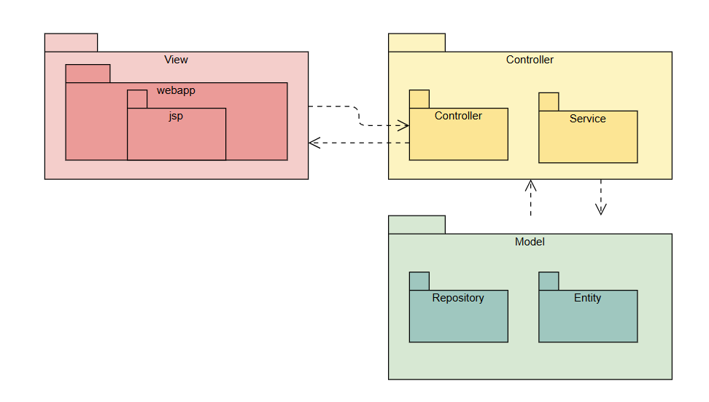

***Package descriptions***

| **No** | **Package** | **Description** |
| --- | --- | --- |
| 01 | Web App | Contains all the JSP files that present the UI to the user. |
| 02 | Controller | Handles user requests, invoking services, and returning views. |
| 03 | Service | Contains business logic, processing data between controller & model. |
| 04 | Repository | Interfaces with the database using DAO to fetch or persist data. |
| 05 | Entity | Represents the data structure in the database. |

# II. Requirement Specifications

## 1. Login/Logout

### 1.1 Login

#### a. UC Specifications

| UC Name: | Login | | |
| --- | --- | --- | --- |
| Primary Actor: | Manager, Staff | Secondary Actors: | None |
| Trigger: | -When the user clicks on the “Login” button | | |
| Description: | -When a customer provides their username and password and clicks on the “Login” button, the system authenticates the credentials. If valid, the customer is logged into their account. | | |
| Preconditions: | -The login page must be accessible. | | |
| Postconditions: | -The user has successfully logged in and is redirected to the page corresponding to the role.  -The session is created for the logged-in user. | | |
| Normal Flow: | 1. User navigates to the login page. 2. User enters an email and password. 3. User clicks on the “Login” button. 4. System verifies credentials. 5. If the login information is valid, the user will be logged in and redirected to the corresponding page. | | |
| Alternative Flows: | none | | |
| Exceptions: | If the credentials are invalid, the system displays an error message indicating incorrect email or password. | | |
| Business Rules: | -Email in exits in system, Account is Active | | |

### 1.2 Logout

#### a. UC Specifications

| UC Name: | Logout | | |
| --- | --- | --- | --- |
| Primary Actor: | Manager, Staff | Secondary Actors: | None |
| Trigger: | -When the user clicks on the “Logout” button | | |
| Description: | -When the user clicks on the “Logout” button, the system terminates the user session and redirects the user to the login page. | | |
| Preconditions: | -The user must be logged in. | | |
| Postconditions: | -The user is logged out, and the session is terminated.  -The user is redirected to the login page. | | |
| Normal Flow: | 1. Customer clicks on the “Logout” button. 2. System terminates the user session. 3. User is redirected to the login page. | | |
| Alternative Flows: | None | | |
| Exceptions: | None | | |
| Business Rules: | The session should expire automatically after a period of inactivity. | | |

### 1.3 Reset Password

#### a. UC Specifications

| UC Name: | Reset Password | | |
| --- | --- | --- | --- |
| Primary Actor: | Manager, Staff | Secondary Actors: | None |
| Trigger: | When the user clicks on the “Forgot Password” button in Login page | | |
| Description: | -Allow users to reset their password by entering an email  -If the email is in the system, random code is sent to the email and then entered. If the code is entered correctly, it can be transferred to the password update page. When the password is updated, it will be transferred to the login page. | | |
| Preconditions: | -Email exists in the system | | |
| Postconditions: | -The user is logged out, and the session is terminated.  -The user is redirected to the login page. | | |
| Normal Flow: | 1. Customer clicks on the “Forgot Password” button. 2. User enters email 3. User enters code random 4. User enters new password 5. The user will be redirected to the Login page. | | |
| Alternative Flows: | None | | |
| Exceptions: | Display a message if email does not exist in the system  Display a message if random code is entered incorrectly  Display a message if confirm password is entered incorrectly | | |
| Business Rules: | -Password must have at least 8 characters, including one uppercase letter, one number, and one special character." -Email exist in system | | |

## 2. Account Management

### 2.1 View Account

#### a. UC Specifications

| UC Name: | View Account | | |
| --- | --- | --- | --- |
| Primary Actor: | Admin | Secondary Actors: | None |
| Trigger: | When the admin click on the the word "Account" at the sidebar | | |
| Description: | Display list of employee accounts in the system. | | |
| Preconditions: | Users have to login with role admin to use this function. | | |
| Postconditions: | None | | |
| Normal Flow: | 1. Already logged in Admin click on the the word "Account" 2. List of employee accounts displayed on the screen | | |
| Alternative Flows: | 1. Already logged in Admin click on the the word "Account" 2. Displayed list of employee accounts on the screen 3. Input email or employeeId of account admin want to search 4. The system will be shown the account admin wants to search for and will be displayed accordingly. | | |
| Exceptions: | When “search” if value empty will show all accounts, if no information each corresponding won’t show anything. | | |
| Business Rules: | “Search” Input of value is EmployeeId, email of employee | | |

### 2.2 Add Account

#### a. UC Specifications

| UC Name: | Add Account | | |
| --- | --- | --- | --- |
| Primary Actor: | Admin | Secondary Actors: | None |
| Trigger: | When the admin clicks on the word “Add account” in the upper left corner of the employee account list. | | |
| Description: | When the admin clicks on the word “Add account”, fills the fields necessary, clicks the “Add” button, a new account will be created. | | |
| Preconditions: | Users have to login with role admin to use this function. | | |
| Postconditions: | A new account will be created and inserted into the database. | | |
| Normal Flow: | 1. Already logged in Admin click on the word “Add account”. 2. The system will pop-up, showing the fields necessary. 3. The admin will choose EmployeeID 4. The system shows the information of the employee. 5. The admin clicks the “Add”. 6. A new account will be created and inserted into the database, then send the information of the account to email for the employee. | | |
| Alternative Flows: | None | | |
| Exceptions: | - Display an “errorPassword” is “Password must be at least 8 characters, including uppercase letters, numbers, and special characters” if the admin entered an incorrect password.  - Display a message saying “Can't update account” if the system cannot update information account. | | |
| Business Rules: | * EmployeeID cannot be empty. | | |

### 2.3 Edit Account

#### a. UC Specifications

| UC Name: | Edit Account | | |
| --- | --- | --- | --- |
| Primary Actor: | Admin | Secondary Actors: | None |
| Trigger: | When the admin click on the “Edit” icon on the list of employee account, right side of each employee account | | |
| Description: | The admin chooses an account needed to edit, fill the fields needed to edit, information will update for account choosed. | | |
| Preconditions: | Users have to login with role admin to use this function. | | |
| Postconditions: | The new information will be updated for the account chosen. | | |
| Normal Flow: | 1. Admin clicks on the “edit” icon of the account admin wants to edit. 2. System shows the information of the account chosen. 3. The admin fills the fields needed to update new information. 4. The admin clicks button “Save”. 5. The system will update new information for the account, then send the information of the account to email for the employee. | | |
| Alternative Flows: | None | | |
| Exceptions: | - Display an “errorPassword” is “Password must be at least 8 characters, including uppercase letters, numbers, and special characters” if the admin entered an incorrect password.  - Display a message saying “Can't update account” if the system cannot update information account. | | |
| Business Rules: | * Roles cannot be empty. * Passwords must be at least 8 characters, including uppercase letters, numbers, and special characters. | | |

### 2.4 Delete Account

#### a. UC Specifications

| UC Name: | Delete account | | |
| --- | --- | --- | --- |
| Primary Actor: | Admin | Secondary Actors: | None |
| Trigger: | When the admin click on the “delete” icon on the list of employee account, right side of each employee account | | |
| Description: | When the admin clicks on the “delete” icon, the account will be removed from the system. | | |
| Preconditions: | Users have to login with role admin to use this function. | | |
| Postconditions: | The account of the employee will be removed and the employee can’t login into the system. | | |
| Normal Flow: | 1. Already logged in Admin click on the the word "Account" 2. Displayed list of employee accounts on the screen 3. Click on the “delete” icon of the account admin want to remove 4. The system will confirm and ask if the admin really wants to delete. 5. The admin clicks “OK” and the account will be removed from the system. | | |
| Alternative Flows: | None | | |
| Exceptions: | Display a message saying “Failed to delete account” when the system can’t delete an account. | | |
| Business Rules: | Account must exist in the system. | | |

## 3. Employee Management

### 3.1 View Employee

#### a. UC Specifications

| UC Name: | View Employee | | |
| --- | --- | --- | --- |
| Primary Actor: | Manager | Secondary Actors: | None |
| Trigger: | When the manager click on the the word "Employee" at the sidebar | | |
| Description: | Display list of employees in the system. | | |
| Preconditions: | Users have to login with the role manager to use this function. | | |
| Postconditions: | None | | |
| Normal Flow: | 1. Already logged in Manager click on the the word "Employee" 2. List of employees will be displayed on the screen | | |
| Alternative Flows: | 1. Already logged in Manager click on the the word "Employee" 2. Displayed list of employees on the screen 3. Input email or employeeId of employee manager want to search 4. The system will be shown the list of employees the manager wants to search for and will be displayed accordingly. | | |
| Exceptions: | When “search” if value empty will show all employees, if no information each corresponding won’t show anything. | | |
| Business Rules: | “Search ” input of value if employeeId, employee name, email, phone of employee. | | |

### 

### 3.2 Add Employee

#### a. UC Specifications

| UC Name: | Add Employee | | |
| --- | --- | --- | --- |
| Primary Actor: | Manager | Secondary Actors: | None |
| Trigger: | When the manager clicks on the word “Add employee” in the upper left corner of the employees list. | | |
| Description: | When the manager clicks on the word “Add employee”, fills the fields necessary, clicks the “Add” button, a new employee will be created. | | |
| Preconditions: | Users have to login with the role manager to use this function. | | |
| Postconditions: | A new employee will be created and inserted into the database. | | |
| Normal Flow: | 1. Already logged in Manager click on the word “Add employee”. 2. The system will show the fields necessary in an “addEmployee” page. 3. The manager will fill in the information necessary for each field and click the “Add” button. 4. A new employee will be created and inserted into the database. | | |
| Alternative Flows: | None | | |
| Exceptions: | Display a message where the manager entered incorrect data. | | |
| Business Rules: | * Employee names cannot be blank, no numbers, no special characters. * Image must be an image file. * Must not be the same as previously registered email, cannot be empty. * Phone number cannot be blank, it must be 10 digits. * Date of birth cannot be blank, must not be under 18 years old. | | |

### 

### 3.3 Edit Employee

#### a. UC Specifications

| UC Name: | Edit employee | | |
| --- | --- | --- | --- |
| Primary Actor: | Manager | Secondary Actors: | None |
| Trigger: | When the manager clicks on the “Edit” icon on the list of employees , the right side of each employee. | | |
| Description: | The manager chooses an employee needed to edit, fill the fields needed to edit, information will update for the employee choosed. | | |
| Preconditions: | Users have to login with the role manager to use this function. | | |
| Postconditions: | The new information will be updated for the employee chosen. | | |
| Normal Flow: | 1. Manager clicks on the “edit” icon of the employee admin wants to edit. 2. System shows the information of the employee chosen. 3. The manager fills the fields needed to update new information. 4. The manager clicks “Save” 5. The system will update new information for the employee. | | |
| Alternative Flows: | None | | |
| Exceptions: | Display a message where the manager entered incorrect data | | |
| Business Rules: | * Employee names cannot be blank, no numbers, no special characters. * Image must be an image file. * Must not be the same as previously registered email, cannot be empty. * Phone number cannot be blank, it must be 10 digits. * Date of birth cannot be blank, must not be under 18 years old. | | |

### 3.4 Delete employee

#### a. UC Specifications

| UC Name: | Delete employee | | |
| --- | --- | --- | --- |
| Primary Actor: | Manager | Secondary Actors: | None |
| Trigger: | When the manager clicks on the “delete” icon on the employees, the right side of each employee. | | |
| Description: | When the manager clicks on the “delete” icon, the employee will be removed from the system. | | |
| Preconditions: | Users have to login with the role manager to use this function. | | |
| Postconditions: | The employee will be removed and the employee can’t login into the system. | | |
| Normal Flow: | 1. Already logged in Manager click on the the word "Employee" 2. Displayed list of employees on the screen 3. Click on the “delete” icon of the employee manager want to remove 4. The system will confirm and ask if the manager really wants to delete. 5. The manager clicks “OK” and the employee will be removed from the system. | | |
| Alternative Flows: | None | | |
| Exceptions: | Display a message when the system can’t delete an employee. | | |
| Business Rules: | The employee must exist in the system. | | |

#### 

## 4. Category and Product

### 4.1 Add Category

#### a. UC Specifications

| UC Name: | Add Category | | |
| --- | --- | --- | --- |
| Primary Actor: | Manager |  |  |
| Trigger: | When the manager clicks on the “add category” icon on the category table | | |
| Description: | When the admin clicks on the “add category” icon | | |
| Preconditions: | Users have to login with the role manager to use this function. | | |
| Postconditions: | The new category will be show in category table list | | |
| Normal Flow: | 1. Already logged in Manager click on the the word "Add Category" 2. Displayed form to enter the name 3. Click on the “add” icon of the add | | |
| Alternative Flows: | None | | |
| Exceptions: | Display a message when the name does not follow business rule | | |
| Business Rules: | -The category name is not longer than 20 characters  -The category name must not contain special character. | | |

### 4.2 Delete Category

#### a. UC Specifications

| UC Name: | Delete Category | | |
| --- | --- | --- | --- |
| Primary Actor: | Manager |  |  |
| Trigger: | When the manager clicks on the “delete” icon on the categories, the right side of each category | | |
| Description: | When the admin clicks on the “delete” icon, the categories will be removed from the system. | | |
| Preconditions: | Users have to login with the role manager to use this function. | | |
| Postconditions: | The category will be removed and the category can’t show into the system. | | |
| Normal Flow: | 1. Already logged in Manager click on the the word " 2. Displayed list of employees on the screen 3. Click on the “delete” icon of the employee manager want to remove 4. The system will confirm and ask if the manager really wants to delete. 5. The manager clicks “OK” and the employee will be removed from the system. | | |
| Alternative Flows: | None | | |
| Exceptions: | Display a message when the system can’t delete an employee. | | |
| Business Rules: | -The category must exist in the system.  -The category which has product available can’t be delete | | |

### 4.3 Edit Category

#### a. UC Specifications

| UC Name: | Edit Category | | |
| --- | --- | --- | --- |
| Primary Actor: | Manager |  |  |
| Trigger: | When the manager clicks on the “edit” icon on the employees, the right side of each category | | |
| Description: | When the admin clicks on the “edit” icon, the category information will be change | | |
| Preconditions: | Users have to login with the role manager to use this function. | | |
| Postconditions: | The category information | | |
| Normal Flow: | 1. Already logged in Manager click on the the word "edit" 2. Displayed category form 3. Enter new information 4. The manager clicks “OK” and the category will be changed from the system. | | |
| Alternative Flows: | None | | |
| Exceptions: | Display a message when the name does not follow business rule | | |
| Business Rules: | -The category must exist in the system.  -The new category name is not longer than 20 characters  -The new category name must capitalize the first letter  -The new category name must not contain special character. | | |

### 4.4 View Category

#### a. UC Specifications

| UC Name: | View Category | | |
| --- | --- | --- | --- |
| Primary Actor: | Manager | Second Actor |  |
| Trigger: | View category list | | |
| Description: | When the admin clicks on the category to show the category list | | |
| Preconditions: | Users have to login to use this function. | | |
| Postconditions: | The user must be login | | |
| Normal Flow: | 1. Already logged in Manager click on the the word "Category" 2. Displayed list of Categories on the screen | | |
| Alternative Flows: | None | | |
| Exceptions: | No exception. | | |
| Business Rules: | No Business rule | | |

### 

### 4.5 View Product List

#### a. UC Specifications

| UC Name: | View Product List | | |
| --- | --- | --- | --- |
| Primary Actor: | Manager, Staff |  |  |
| Trigger: | When users click on the “Product ” option on the side bar. | | |
| Description: | When the user clicks on the "Product" option, the system will display a page showing the list of products available in the inventory. This page will include details like product name, image, price and quantity. | | |
| Preconditions: | Users must be logged in and have appropriate permissions to add new products. | | |
| Postconditions: | The product list page is displayed to the user. | | |
| Normal Flow: | 1. Users log into the system. 2. Users click on the “Products” option on the side bar. 3. The system retrieves the product data from the database. 4. The system displays the list of products on the screen, showing relevant information such as name, price, and availability. | | |
| Alternative Flows: | None | | |
| Exceptions: | Display a message when the the system can not retrieve the data from the database or there is no product | | |
| Business Rules: | * If the total number of products exceeds the predefined limit (e.g., 5 products per page), the system will display the products in a paginated format. * If the total number of products does not exceed the limit, the system will display all products on a single page. | | |

### 4.6 Add new product

#### a. UC Specifications

| UC Name: | Add new product | | |
| --- | --- | --- | --- |
| Primary Actor: | Manager, Staff |  |  |
| Trigger: | User clicks on the "Add New Product" option from the side bar. | | |
| Description: | When the user clicks on the "Add New Product" option, the system will display a form for entering the details of the new product. The user can fill out product details such as name, price, description, category, and availability. After submitting, the system will save the new product to the database and confirm the addition. | | |
| Preconditions: | Users must be logged in and have appropriate permissions to add new products. | | |
| Postconditions: | The new product is added to the system and can be viewed in the product list. | | |
| Normal Flow: | 1. User logs into the system. 2. User clicks on the "Add New Product" button from the product management page. 3. The system displays a form with fields for the product name, price, description, category, and availability. 4. User fills in all required product details. 5. User clicks the "Submit" button. 6. The system validates the input and adds the new product to the database. 7. The system displays a success message confirming the product has been added. | | |
| Alternative Flows: | None | | |
| Exceptions: | 1. If the user fails to fill in required fields, the system will display an error message indicating which fields are missing or incorrect. 2. If the product price is less than 0 and greater than 9,999,999, and the product minimum quantity is greater than 0 and less than 9,999, the system will notify the user of an error and prompt them to try again 3. If there is an issue with the database, the system will display an error message and prompt the user to try again later. | | |
| Business Rules: | 1. None | | |

### 

### 4.7 Delete product

#### a. UC Specifications

| UC Name: | Delete product | | |
| --- | --- | --- | --- |
| Primary Actor: | Manager |  |  |
| Trigger: | User clicks on the "Delete" button next to a product on the product list page. | | |
| Description: | When the user clicks on the "Delete" button next to a product, the system will ask for confirmation to ensure that the user intends to permanently delete the product from the database. If confirmed, the system will change the status of the product and update the product list. | | |
| Preconditions: | Users must be logged in and have appropriate permissions to delete products. | | |
| Postconditions: | The product’s status setted to 0. | | |
| Normal Flow: | 1. User logs into the system. 2. User navigates to the product list page. 3. User clicks on the "Delete" button next to the product they want to remove. 4. The system prompts the user with a confirmation message: "Are you sure you want to delete this product?" 5. User confirms the deletion by clicking the "Confirm" button. 6. The system sets the status of the product to 0 in the database. 7. The system updates the product list. 8. The system displays a success message confirming the product has been deleted. | | |
| Alternative Flows: | None | | |
| Exceptions: | If there is an issue deleting the product (e.g., database error), the system will notify the user and prompt them to try again later. | | |
| Business Rules: | None | | |

### 

### 

### 

### 4.8 Update product

#### a. UC Specifications

| UC Name: | Update product | | |
| --- | --- | --- | --- |
| Primary Actor: | Manager |  |  |
| Trigger: | Users click on “Detail” button on the product list page | | |
| Description: | When the user clicks the "Detail" button next to a product, the system redirects to the product detail page where the user can edit the product's information directly. The user then clicks the "Save" button to update the product information in the system. | | |
| Preconditions: | Users must be logged in and have appropriate permissions to delete products. | | |
| Postconditions: | The product information is successfully updated in the system. | | |
| Normal Flow: | 1. The user clicks on the "Detail" button next to a product. 2. The system navigates to the product detail page. 3. The user edits the product information in the form. 4. The user clicks the "Save" button to update the information. 5. The system updates the product information in the database and reflects the changes in the product list. | | |
| Alternative Flows: | None | | |
| Exceptions: | * If there is an issue updating the product (e.g., database error), the system will notify the user and prompt them to try again later. * If the product price is less than 0 and greater than 9,999,999, and the product minimum quantity is greater than 0 and less than 9,999, the system will notify the user of an error and prompt them to try again | | |
| Business Rules: | None | | |

### 

### 4.9 Recover product

#### a. UC Specifications

| UC Name: | Recover product | | |
| --- | --- | --- | --- |
| Primary Actor: | Manager and Purchase Staff |  |  |
| Trigger: | User clicks on the "Recover" button next to a product on the product list page. | | |
| Description: | When the user clicks on the "Recover" button next to a product, the system will ask for confirmation to ensure that the user intends to permanently delete the product from the database. If confirmed, the system will delete the product and update the product list. | | |
| Preconditions: | Users must be logged in and have appropriate permissions. | | |
| Postconditions: | The product’s status setted to 1. | | |
| Normal Flow: | 1. User logs into the system. 2. User navigates to the product list page. 3. User clicks on the "Recover" button next to the product they want to remove. 4. The system prompts the user with a confirmation message: "Are you sure you want to recover this product?" 5. User confirms the recovery by clicking the "Confirm" button. 6. The system sets the status of the product to 1 in the database. 7. The system updates the product list. 8. The system displays a success message confirming the product has been recovered. | | |
| Alternative Flows: | None | | |
| Exceptions: | * If there is an issue updating the product (e.g., database error), the system will notify the user and prompt them to try again later. * If the product price is less than 0 and greater than 9,999,999, and the product minimum quantity is greater than 0 and less than 9,999, the system will notify the user of an error and prompt them to try again | | |
| Business Rules: | None | | |

### 

## 5. User Profile

### 5.1 View Profile

#### a. UC Specifications

| UC Name: | View Profile | | |
| --- | --- | --- | --- |
| Primary Actor: | Manager, Staff, Admin | Secondary Actors: | None |
| Trigger: | When user click on My Profile button on top right of screen after login | | |
| Description: | When the user clicks on ”My Profile button” on the top right of the screen. It will direct to the user profile page displaying user information details. | | |
| Preconditions: | Users have to be already logged in. | | |
| Postconditions: | None | | |
| Normal Flow: | 1. User has logged in. 2. In main page, user clicks on ”My Profile button” on the top right of the screen 3. Display a page with the user's information details. | | |
| Alternative Flows: | None | | |
| Exceptions: | Direct to login form when user not login | | |
| Business Rules: | None | | |

### 5.2 Edit Profile

#### a. UC Specifications

| UC Name: | Edit Profile | | |
| --- | --- | --- | --- |
| Primary Actor: | Manager, Staff, Admin | Secondary Actors: | None |
| Trigger: | When user edit a field in form and press on “Save” button | | |
| Description: | In the view profile page, if a user edits a field in form and presses on the “Save” button it will update user information and reload on the page instantly. | | |
| Preconditions: | Users have to be already logged in. | | |
| Postconditions: | User information will be updated and display instantly | | |
| Normal Flow: | 1. User has logged in and click on “My profile” 2. User can only update profile picture 3. User click on “Save” button 4. Information will be updated and reloaded on the page instantly with “Update information successfully” success message. | | |
| Alternative Flows: | None | | |
| Exceptions: | If user’s changes not match field validation, error message will be displayed | | |
| Business Rules: |  | | |

### 5.3 Change password

#### a. UC Specifications

| UC Name: | Change password | | |
| --- | --- | --- | --- |
| Primary Actor: | Manager, Staff, Admin | Secondary Actors: | None |
| Trigger: | When user click on “Save” button on Change password tab | | |
| Description: | In the view profile page, choose the Change password tab and enter the old password with the new password. After that click on “Save” button, password will be updated | | |
| Preconditions: | Users have to be already logged in. | | |
| Postconditions: | Password will be updated. | | |
| Normal Flow: | 1. User has logged in and click on “My profile” 2. User edit one or many field in form (exclude email, gender, warehouse name) 3. User click on “Save” button 4. Information will be updated and reloaded on the page instantly with a success message. | | |
| Alternative Flows: | None | | |
| Exceptions: | If user’s changes not match field validation, error message will be displayed | | |
| Business Rules: | * Password must not contain whitespace only * Password must not start or end with whitespaces | | |

## 6. Supplier Management

### 6.1 View supplier

#### a. UC Specifications

| UC Name: | View supplier | | |
| --- | --- | --- | --- |
| Primary Actor: | Manager | Secondary Actors: | None |
| Trigger: | When the manager click on the the word "Supplier" at the sidebar | | |
| Description: | Display list of suppliers in the system. | | |
| Preconditions: | Users have to login with the role manager to use this function. | | |
| Postconditions: | None | | |
| Normal Flow: | 1. Already logged in Manager click on the the word "Supplier" 2. List of suppliers will be displayed on the screen | | |
| Alternative Flows: | 1. Already logged in Manager click on the the word "Supplier" 2. Input value on the input “Search”. 3. The system will display the supplier corresponding to the search value. | | |
| Exceptions: | When “Search” input is empty, the system will show all suppliers, if no information each corresponding won’t show anything. | | |
| Business Rules: | The “Search” input of value is supplier name, contact email, phone, supplierId. | | |

### 

### 6.2 Add supplier

#### a. UC Specifications

| UC Name: | Add Supplier | | |
| --- | --- | --- | --- |
| Primary Actor: | Manager | Secondary Actors: | None |
| Trigger: | When the manager clicks on the word “Add supplier” in the upper left corner of the employees list. | | |
| Description: | When the manager clicks on the word “Add supplier”, fills the fields necessary, clicks the “Add” button, a new supplier will be created. | | |
| Preconditions: | Users have to login with the role manager to use this function. | | |
| Postconditions: | A new employee will be created and inserted into the database. | | |
| Normal Flow: | 1. Already logged in Manager click on the word “Add supplier”. 2. The system will show the fields necessary in an “addSupplier” page. 3. The manager will fill in the information necessary for each field and click the “Add” button. 4. A new supplier will be created and inserted into the database. | | |
| Alternative Flows: | None | | |
| Exceptions: | Display a message where the manager entered incorrect data. | | |
| Business Rules: | * Supplier names cannot be blank. * Must not be the same as previously registered email, cannot be empty. * Phone number cannot be blank, it must be 10 digits. * Address cannot be empty. | | |

### 6.3 Edit supplier

#### a. UC Specifications

| UC Name: | Edit supplier | | |
| --- | --- | --- | --- |
| Primary Actor: | Manager | Secondary Actors: | None |
| Trigger: | When the manager clicks on the “Edit” icon on the list of suppliers, the right side supplier. | | |
| Description: | The admin chooses a supplier needed to edit, fill the fields needed to edit, information will update for the supplier choosed. | | |
| Preconditions: | Users have to login with the role manager to use this function. | | |
| Postconditions: | The new information will be updated for the supplier chosen. | | |
| Normal Flow: | 1. Manager clicks on the “edit” icon of the list supplier manager wants to edit. 2. System shows the information of the supplier chosen. 3. The manager fills the fields needed to update new information. 4. The manager clicks “Save”. 5. The system will update new information for the supplier. | | |
| Alternative Flows: | None | | |
| Exceptions: | Display a message where the manager entered incorrect data | | |
| Business Rules: | * Supplier names cannot be blank * Must not be the same as previously registered email, cannot be empty. * Phone number cannot be blank, it must be 10 digits. * Address cannot be empty. | | |

### 6.4 Delete supplier

#### a. UC Specifications

| UC Name: | Delete supplier | | |
| --- | --- | --- | --- |
| Primary Actor: | Manager | Secondary Actors: | None |
| Trigger: | When the manager clicks on the “delete” icon on the suppliers, the right side of each supplier. | | |
| Description: | When the manager clicks on the “delete” icon, the employee will be removed from the system. | | |
| Preconditions: | Users have to login with the role manager to use this function. | | |
| Postconditions: | The supplier will be removed into the system. | | |
| Normal Flow: | 1. Already logged in Manager click on the word "Supplier". 2. The system will display a list of suppliers on the screen. 3. Click on the “delete” icon of the supplier manager you want to remove. 4. The system will confirm and ask if the manager really wants to delete. 5. The manager clicks “OK” and the supplier will be removed from the system. | | |
| Alternative Flows: | None | | |
| Exceptions: | Display a message when the system can’t delete a supplier. | | |
| Business Rules: | The supplier must exist in the system. | | |

## 7. Transfer Order

### 7.1 View list Transfer Order

#### a. UC Specifications

| UC Name: | View List Transfer Order | | |
| --- | --- | --- | --- |
| Primary Actor: | Manager, Storage Staff | Secondary Actors: | None |
| Trigger: | When user click on Transfer Order List on sidebar | | |
| Description: | When the user clicks on ”Transfer Order List” on the left sidebar. It will direct to page where display all Transfer Order information | | |
| Preconditions: | Users have to be already logged in as Manager or Staff. | | |
| Postconditions: | None | | |
| Normal Flow: | 1. User logged in 2. User click on Transfer Order on sidebar, a dropdown display and choose Transfer Order List 3. Direct user to Transfer Order List page where display all Transfer Order general information | | |
| Alternative Flows: | None | | |
| Exceptions: | None | | |
| Business Rules: | None | | |

### 7.2 Create Transfer Order

#### a. UC Specifications

| UC Name: | Create Transfer Order | | |
| --- | --- | --- | --- |
| Primary Actor: | Storage Staff | Secondary Actors: | None |
| Trigger: | When user click on Create Transfer Order on sidebar | | |
| Description: | When the user clicks on ”Create new transfer order” on the left sidebar. It will allow user create new Transfer Order to transfer products to a bin user want | | |
| Preconditions: | Users have to be already logged in as Manager or Staff. | | |
| Postconditions: | None | | |
| Normal Flow: | 1. User logged in 2. User click on Transfer Order on sidebar, a dropdown display and choose “Create new transfer order” 3. User enter all necessary information (original bin id, final bin id, product detail id, quantity) 4. User click on “Create” and a transfer order will be created | | |
| Alternative Flows: | None | | |
| Exceptions: | 3.1. If user enter quantity exceed origin bin have it will display error | | |
| Business Rules: | None | | |

### 7.3 Update Transfer Order

#### a. UC Specifications

| UC Name: | Update Transfer Order | | |
| --- | --- | --- | --- |
| Primary Actor: | Storage Staff | Secondary Actors: | None |
| Trigger: | When user click on Update button in list Transfer Order | | |
| Description: | When the user clicks on the ”Update” button on the Transfer Order which user wants to update in the Transfer Order List table. It will allow user to update that Transfer Order information | | |
| Preconditions: | Users have to be already logged in as Manager or Staff. | | |
| Postconditions: | None | | |
| Normal Flow: | 1. User logged in 2. User click on Transfer Order on sidebar, a dropdown display and choose “Transfer Order List” 3. User clicks on the ”Update” button on the Transfer Order which the user wants to update in the Transfer Order List table. 4. Change information and click on “Save” (Can only update destination location) 5. The transfer order will be saved with changed information | | |
| Alternative Flows: | None | | |
| Exceptions: |  | | |
| Business Rules: | 1. Only transfer order has status = ‘Processing’ is allowed to update | | |

## 

## 8. Product Detail Management

### 8.1 View list Product Detail

#### a. UC Specifications

| UC Name: | View list Product Detail | | |
| --- | --- | --- | --- |
| Primary Actor: | Manager, Staff | Secondary Actors: | None |
| Trigger: | User clicks on the "Product Details" button on the side bar | | |
| Description: | When the user clicks on the "Product Details" button, the system will redirect the user to a screen that displays all the product details currently available in the system. | | |
| Preconditions: | Users have to be already logged in. | | |
| Postconditions: | The system displays a list of all product details in the system. | | |
| Normal Flow: | 1. The user clicks on the "Product Details" button. 2. The system redirects the user to the screen that shows all product details in the system. 3. The system displays a list of all product details. | | |
| Alternative Flows: | None | | |
| Exceptions: | If there is an issue displaying the product details (e.g., database error), the system will notify the user and prompt them to try again later. | | |
| Business Rules: | None | | |

### 8.2 View list Product Detail of a product

#### a. UC Specifications

| UC Name: | View list Product Detail of a product | | |
| --- | --- | --- | --- |
| Primary Actor: | Manager, Staff | Secondary Actors: | None |
| Trigger: | User clicks on the "Detail” button on a product. | | |
| Description: | When the user clicks on the "Detail" button, the system will redirect the user to a screen that displays all the detail information of that product | | |
| Preconditions: | Users have to be already logged in. | | |
| Postconditions: | The system displays a list of all product details in the system. | | |
| Normal Flow: | 1. User logs in to the system. 2. User navigates to the product list page. 3. User clicks the **"Detail"** button for a specific product. 4. The system redirects the user to the product detail page and displays all the relevant information about that product (e.g., product name, price, description, etc.). 5. User clicks the “View product detail”. 6. The system redirects the user to a page that shows every product details that belongs to that product | | |
| Alternative Flows: | None | | |
| Exceptions: | If there is an issue displaying the product details (e.g., database error), the system will notify the user and prompt them to try again later. | | |
| Business Rules: | None | | |

### 8.3 Create new Product Detail of a product

#### a. UC Specifications

| UC Name: | Create new Product Detail of a product | | |
| --- | --- | --- | --- |
| Primary Actor: | Manager, Staff | Secondary Actors: | None |
| Trigger: | In the view list product screen, the user clicks on the "Add Product Detail” button on a product. | | |
| Description: | When the user clicks on the "Add Product Detail" button, the system will redirect the user to a screen for users to input the information. | | |
| Preconditions: | Users have to be already logged in. | | |
| Postconditions: | The system displays a list of all product details in the system. | | |
| Normal Flow: | 1. User logs into the system. 2. User navigates to the "Product Management" section. 3. User clicks the **"Add Product Detail"** button for the product they want to add details for. 4. The system redirects the user to the product detail input screen. 5. The user enters all required product details (e.g., product name, description, price, etc.). 6. The user clicks **"Save"** to submit the product details. 7. The system saves the new product details and redirects the user back to the product list page. 8. The system displays the updated list of all product details, including the newly added product. | | |
| Alternative Flows: | None | | |
| Exceptions: | If there is an issue creating new product details (e.g., database error), the system will notify the user and prompt them to try again later. | | |
| Business Rules: | If a user try to create a new product detail which is already existed in the system, the system will cancel it and notify to the user and prompt them to try again later. | | |

### 8.4 Delete Product Detail

#### a. UC Specifications

| UC Name: | Delete Product Detail | | |
| --- | --- | --- | --- |
| Primary Actor: | Manager | Secondary Actors: | None |
| Trigger: | User clicks on the "Delete" button for a product detail | | |
| Description: | When the user clicks on the "Delete" button for a product detail, the system will set the status of that product from 1 (active) to 0 (inactive). | | |
| Preconditions: | * Users must be logged in and have the appropriate permissions to delete product details. * The quantity of that product detail must be 0 so that it can be deleted * The status must be 1 | | |
| Postconditions: | The product's status is updated from 1 to 0, marking it as inactive in the system. | | |
| Normal Flow: | 1. The user clicks on the "Delete" button for a specific product detail. 2. The system prompts the user to confirm the deletion action. 3. The user confirms the deletion. 4. The system changes the status of the product from 1 (active) to 0 (inactive). 5. The system updates the product detail in the database, marking it as inactive. | | |
| Alternative Flows: | None | | |
| Exceptions: | If there is an issue updating the product status (e.g., database error), the system will notify the user and prompt them to try again later. | | |
| Business Rules: | None | | |

### 

### 8.5 Recover Product Detail

#### a. UC Specifications

| UC Name: | Recover Product Detail | | |
| --- | --- | --- | --- |
| Primary Actor: | Manager, Staff | Secondary Actors: | None |
| Trigger: | User clicks on the "Recovery" button for a product detail | | |
| Description: | When the user clicks on the "Recovery" button for a product detail, the system will set the status of that product from 0 (inactive) to 1 (active). | | |
| Preconditions: | * Users must be logged in and have the appropriate permissions to delete product details. * The quantity of that product detail must be 0 so that it can be deleted * The status must be 1 | | |
| Postconditions: | The product's status is updated from 0 to 1, marking it as active in the system. | | |
| Normal Flow: | 1. The user clicks on the "Recovery" button for a specific product detail. 2. The system prompts the user to confirm the recovery action. 3. The user confirms the recovery. 4. The system changes the status of the product from 0 (inactive) to 1 (active). 5. The system updates the product detail in the database, marking it as active. | | |
| Alternative Flows: | None | | |
| Exceptions: | * Users must be logged in and have the appropriate permissions to delete product details. * The status must be 0 | | |
| Business Rules: | None | | |

### 

### 8.6 Update Product Detail

#### a. UC Specifications

| UC Name: | Update product detail | | |
| --- | --- | --- | --- |
| Primary Actor: | Manager, Staff | Secondary Actors: | None |
| Trigger: | User clicks on the "Add Product Detail” button on a product. | | |
| Description: | When the user clicks on the "Add Product Detail" button, the system will redirect the user to a screen for users to input the information. | | |
| Preconditions: | Users have to be already logged in. | | |
| Postconditions: | The system displays a list of all product details in the system. | | |
| Normal Flow: | 1. **User logs in** to the system. 2. **User navigates** to the "List product detail" screen. 3. **User clicks** on the **"Add Product Detail"** button for the product they want to update. 4. The system redirects the user to the product detail screen for the selected product. 5. The system displays the current product details, pre-filled with existing data. 6. **User updates** the necessary product details (e.g., name, description, price, etc.). 7. **User clicks** **"Save"** to submit the updated details. 8. The system validates the updated data.    1. If the data is valid, the system proceeds to step 9.    2. If the data is invalid, the system displays an error message and prompts the user to correct the input. 9. The system saves the updated product details in the database. 10. The system confirms the update and displays a success message. 11. The system redirects the user back to the product detail list page. 12. The system displays the updated list of all product details, including the modified product. | | |
| Alternative Flows: | None | | |
| Exceptions: | If there is an issue with updating product details (e.g., database error), the system will notify the user and prompt them to try again later. | | |
| Business Rules: | If information from the user is duplicate with another product detail, the system will notify the user and prompt them to try again later. | | |

### 

### 

## 

## 9. Section Type Management

### 9.1 View list Section Type

#### a. UC Specifications

| UC Name: | View list Section Type | | |
| --- | --- | --- | --- |
| Primary Actor: | Manager, Staff | Secondary Actors: | None |
| Trigger: | User clicks on the "View Section Types" button on the side bar | | |
| Description: | When the user clicks on the "View Section Types" button, the system will navigate the user to the screen displaying all the section types currently available in the system. | | |
| Preconditions: | Users have to be already logged in. | | |
| Postconditions: | The system displays a list of all section types currently in the system. | | |
| Normal Flow: | 1. The user clicks on the "View Section Types" button. 2. The system navigates to the page that displays all section types in the system. 3. The system shows a list of all section types. | | |
| Alternative Flows: | None | | |
| Exceptions: | If there is an issue displaying the section types (e.g., database error), the system will notify the user and prompt them to try again later. | | |
| Business Rules: | None | | |

## 

## 10. Section Management

### 10.1 Create new section

#### a. UC Specifications

| UC Name: | Create new section | | |
| --- | --- | --- | --- |
| Primary Actor: | Manager | Secondary Actors: | None |
| Trigger: | When user click on “Section Management” in sidebar, a dropdown display, select “Add New Section ” | | |
| Description: | When the user clicks on ”Add New Section” on the left sidebar. It will direct user to a form to insert all necessary information to add a new section | | |
| Preconditions: | Users have to be already logged in as Manager. | | |
| Postconditions: | None | | |
| Normal Flow: | 1. User logged in as Manager 2. User click on “Section Management” on sidebar, a dropdown display and choose “Add new section” 3. Direct user to Add New Section screen which has a form to add a new section. 4. User enter all necessary field (section name, section type) 5. User click on “Add” button 6. Redirect back to Section List with a success message | | |
| Alternative Flows: | None | | |
| Exceptions: | None | | |
| Business Rules: | None | | |

### 10.2 View section list

#### a. UC Specifications

| UC Name: | View section list | | |
| --- | --- | --- | --- |
| Primary Actor: | Manager | Secondary Actors: | None |
| Trigger: | When user click on “Section Management” in sidebar, a dropdown display, select “Section List” | | |
| Description: | When the user clicks on ”Section List” on the left sidebar. It will direct the user to a page where all sections exist in the system. | | |
| Preconditions: | Users have to be already logged in as Manager. | | |
| Postconditions: | None | | |
| Normal Flow: | 1. User logged in as Manager 2. User click on “Section Management” on sidebar, a dropdown display and choose “Section List” 3. Redirect user to Section List page, showing all existed section in the warehouse system | | |
| Alternative Flows: | None | | |
| Exceptions: | None | | |
| Business Rules: | None | | |

### 10.3 Update section

#### a. UC Specifications

| UC Name: | Update section | | |
| --- | --- | --- | --- |
| Primary Actor: | Manager | Secondary Actors: | None |
| Trigger: | When the user clicks on “Section Management” in the sidebar, a dropdown display, select “Section List”, Click the "Update" button in the "Action" column next to the section you want to update. | | |
| Description: | When the user clicks on ”Update” on the view section list page. It will direct the user to that section's update screen. | | |
| Preconditions: | Users have to be already logged in as Manager. | | |
| Postconditions: | None | | |
| Normal Flow: | 1. User logged in as Manager 2. User click on “Section Management” on sidebar, a dropdown display and choose “Section List” 3. Click the "Update" button in the "Action" column next to the section you want to update 4. Direct user to update section screen 5. User change one section name or section type and click on “Update” 6. Redirect back to “View List Section” screen with a success message | | |
| Alternative Flows: | None | | |
| Exceptions: | None | | |
| Business Rules: | None | | |

### 

### 

### 10.4 Delete section

#### a. UC Specifications

| UC Name: | Delete section | | |
| --- | --- | --- | --- |
| Primary Actor: | Manager | Secondary Actors: | None |
| Trigger: | When the user clicks on “Section Management” in the sidebar, a dropdown display, select “Section List”, Click the "Delete" button in the "Action" column next to the section you want to delete. | | |
| Description: | When the user clicks on ”Delete” on the view section list page. A pop up display confirms the section’s deletion. | | |
| Preconditions: | Users have to be already logged in as Manager. | | |
| Postconditions: | None | | |
| Normal Flow: | 1. User logged in as Manager 2. User click on “Section Management” on sidebar, a dropdown display and choose “Section List” 3. Click the "Delete" button in the "Action" column next to the section you want to delete 4. A pop up display confirms the section’s deletion. 5. Users click on “OK”. 6. Section will be deleted from system | | |
| Alternative Flows: | None | | |
| Exceptions: | If in section still bin active then the system will show the message “In section still bin active”. | | |
| Business Rules: | 1. There must be no bin having the section that user intend to delete | | |

### 

## 11. Bin Management

### 11.1 View Bin List

#### a. UC Specifications

| UC Name: | View bin list | | |
| --- | --- | --- | --- |
| Primary Actor: | Manager | Secondary Actors: | None |
| Trigger: | When the user clicks on “Bin Management” in the sidebar, a dropdown display, select “View Bin List”, it will direct the user to the “View Bin List” screen displaying all existing bin with related information . | | |
| Description: | When the user clicks on ”View Bin List” on the sidebar. Direct to the “View Bin List” screen displaying all existing bin with related information . | | |
| Preconditions: | Users have to be already logged in as Manager. | | |
| Postconditions: | None | | |
| Normal Flow: | 1. User logged in as Manager 2. User click on “Bin Management” on sidebar, a dropdown display and choose “View Bin List” 3. Redirect to the “View Bin List” screen displaying all existing bin with related information | | |
| Alternative Flows: | None | | |
| Exceptions: | None | | |
| Business Rules: | None | | |

### 11.2 Add New Bin

#### a. UC Specifications

| UC Name: | Add new bin | | |
| --- | --- | --- | --- |
| Primary Actor: | Manager | Secondary Actors: | None |
| Trigger: | When the user clicks on “Bin Management” in the sidebar, a dropdown display, select “Add new bin”, it will direct the user to the “Add new bin” screen to create a new bin . | | |
| Description: | When the user clicks on ”Add new bin” on the sidebar. Direct to the “Add new bin” screen allows the user to create a new bin . | | |
| Preconditions: | Users have to be already logged in as Manager. | | |
| Postconditions: | None | | |
| Normal Flow: | 1. User logged in as Manager 2. User click on “Bin Management” on sidebar, a dropdown display and choose “Add new bin” 3. Direct to the “Add new bin” screen displaying a form to enter new bin information 4. Click on “Add” button 5. Redirect to “View bin list” screen with a success message | | |
| Alternative Flows: | None | | |
| Exceptions: | None | | |
| Business Rules: |  | | |

### 

### 11.3 Delete Bin

#### a. UC Specifications

| UC Name: | Delete bin | | |
| --- | --- | --- | --- |
| Primary Actor: | Manager, purchase staff, storage staff | Secondary Actors: | None |
| Trigger: | User clicks on the "View SectionType" button on the side bar -> Click on “Detail ” to show all section of the that section type-> Click “Detail” to show all bin in that section -> Click “Detail” show all bindetail in that bin. | | |
| Description: | When the user clicks on the "Delete", the product will be deleted from the bin. | | |
| Preconditions: | * Users must be logged in and have the appropriate permissions to delete product details. | | |
| Postconditions: | The product will be deleted from the bin. | | |
| Normal Flow: | 1. User clicks on the ”View SectionType” button on the side bar 2. System redirect to the screen that show all section type 3. Users clicks on “Detail” 4. System redirect to the screen that show all section of that section type 5. Users clicks on “Detail” 6. System redirect to the screen that show all bin of that section 7. Users clicks on “Detail” 8. System redirect to the screen that show all bin detail of that bin | | |
| Alternative Flows: | None | | |
| Exceptions: | If there is an issue displaying the section types (e.g., database error), the system will notify the user and prompt them to try again later. | | |
| Business Rules: |  | | |

### 

### 11.3 Update Bin

#### a. UC Specifications

| UC Name: | Delete bin | | |
| --- | --- | --- | --- |
| Primary Actor: | Manager, purchase staff, storage staff | Secondary Actors: | None |
| Trigger: | User clicks on the "View SectionType" button on the side bar -> Click on “Detail ” to show all section of the that section type-> Click “Detail” to show all bin in that section -> Click “Update” to update bin information. | | |
| Description: | When the user clicks on the "Delete", the product will be deleted from the bin. | | |
| Preconditions: | * Users must be logged in and have the appropriate permissions to delete product details. | | |
| Postconditions: | The product will be updated. | | |
| Normal Flow: | 1. User clicks on the ”View SectionType” button on the side bar 2. System redirect to the screen that show all section type 3. Users clicks on “Detail” 4. System redirect to the screen that show all section of that section type 5. Users clicks on “Detail” 6. System redirect to the screen that show all bin of that section 7. Users clicks on “Update” 8. User can change bin name and status. | | |
| Alternative Flows: | None | | |
| Exceptions: | If there is an issue displaying the section types (e.g., database error), the system will notify the user and prompt them to try again later. | | |
| Business Rules: | None | | |

### 

## 12. Bin Detail Management

### 12.1 Delete bin detail(product) in bin

#### a. UC Specifications

| UC Name: | Delete Product In bin | | |
| --- | --- | --- | --- |
| Primary Actor: | Manager | Secondary Actors: | None |
| Trigger: | User clicks on the "View Section" button on the side bar -> Click on “Detail ” to show all bin of the section -> Click “Detail” to show all product in bin -> Click “Detail” to show all the information off product | | |
| Description: | When the user clicks on the "Delete", the product will be deleted from the bin. | | |
| Preconditions: | * Users must be logged in and have the appropriate permissions to delete product details. | | |
| Postconditions: | The product will be deleted from the bin. | | |
| Normal Flow: | 1. The user clicks on the "Delete" for a specific product detail. 2. The system prompts the user to confirm the deletion action. 3. The manager confirms the deletion. 4. The system will be deleted from the bin. | | |
| Alternative Flows: | None | | |
| Exceptions: | If the product in the bin has a quantity of product > 0 then show the message “The product is still in bin”. | | |
| Business Rules: | None | | |

### 

### 12.2 View list bin details

#### a. UC Specifications

| UC Name: | View list bin detail | | |
| --- | --- | --- | --- |
| Primary Actor: | Manager, purchase staff, storage staff | Secondary Actors: | None |
| Trigger: | User clicks on the "View SectionType" button on the side bar -> Click on “Detail ” to show all section of the that section type-> Click “Detail” to show all bin in that section -> Click “Detail” show all bindetail in that bin. | | |
| Description: | When the user clicks on the "Delete", the product will be deleted from the bin. | | |
| Preconditions: | * Users must be logged in and have the appropriate permissions to delete product details. | | |
| Postconditions: | The product will be deleted from the bin. | | |
| Normal Flow: | 1. User clicks on the ”View SectionType” button on the side bar 2. System redirect to the screen that show all section type 3. Users clicks on “Detail” 4. System redirect to the screen that show all section of that section type 5. Users clicks on “Detail” 6. System redirect to the screen that show all bin of that section 7. Users clicks on “Detail” 8. System redirect to the screen that show all bin detail of that bin | | |
| Alternative Flows: | None | | |
| Exceptions: | If there is an issue displaying the section types (e.g., database error), the system will notify the user and prompt them to try again later. | | |
| Business Rules: | None | | |

### 

## 13. Inventory Doc Management

### 13.1 View Inventory Doc List

#### a. UC Specifications

| UC Name: | View list InventoryDoc | | |
| --- | --- | --- | --- |
| Primary Actor: | Manager, Storage Staff | Secondary Actors: | None |
| Trigger: | User clicks on the "Inventory" button on the side bar | | |
| Description: | When the user clicks on the "Inventory" button, the system will navigate the user to the screen displaying all the Inventory Docs in the system. | | |
| Preconditions: | Users have to be already logged in and has role is Manager or Storage Staff | | |
| Postconditions: | The system displays a list of all Inventory Doc currently in the system. | | |
| Normal Flow: | The user clicks on the "Inventory" button.  The system navigates to the page that displays all Inventory Docs in the system.  The system shows a list of all Inventory Docs. | | |
| Alternative Flows: | None | | |
| Exceptions: |  | | |
| Business Rules: | None | | |

## 

### 13.2 Create Inventory Doc

#### a. UC Specifications

| UC Name: | Create InventoryDoc | | |
| --- | --- | --- | --- |
| Primary Actor: | Manager | Secondary Actors: | None |
| Trigger: | User clicks on the " Add New Inventory" button on the top of the table list | | |
| Description: | When the user clicks on the "Add Inventory" button, the system will navigate the user to the screen displaying the form to create Inventory Doc in the system. | | |
| Preconditions: | Users have to be already logged in and has role is Manager and in View List Inventory Doc List | | |
| Postconditions: | The new InventoryDoc has been add into InventoryDoc list with pending status | | |
| Normal Flow: | The user clicks on the "Add New Inventory" button.  The system navigates to the page that displays form create Inventory Docs in the system.  The system shows form Create Inventory Docs.  User enter BinID need to check and EmployeeID who check the bin  User Click Submit | | |
| Alternative Flows: | None | | |
| Exceptions: |  | | |
| Business Rules: | * The Selected Bin must not empty * The Selected Bin must not have status lock * The Selected Employee must be Storage Staff | | |

## 

### 13.3 Checking Inventory

#### a. UC Specifications

#### 

| UC Name: | Checking Inventory | | |
| --- | --- | --- | --- |
| Primary Actor: | Storage Staff | Secondary Actors: | None |
| Trigger: | User clicks on the ">>" button in the action column with corresponding inventoryDoc | | |
| Description: | When the user clicks on the "Count" button, the system will navigate the user to the screen displaying the form to check Inventory Doc in the system. | | |
| Preconditions: | * Users have to be already logged in and has role is Storage Staff * The Inventory Doc must has status “Pending”, “Recount” * The user who does not be assigned for count or recount can not enter | | |
| Postconditions: | The Select InventoryDoc has been change status into “Counted” | | |
| Normal Flow: | The user clicks on the "Count" button.  The system navigates to the page that displays form check Inventory Docs in the system.  The system shows form Check Inventory Docs.  User enter RealQuantity need to check for each product  User Click Submit | | |
| Alternative Flows: | None | | |
| Exceptions: |  | | |
| Business Rules: | * The Real Quantity must been entered * The Real Quantity must not negative number * The total weight must not greater than maxcapacity | | |

## 

### 13.4 Confirm Inventory

#### a. UC Specifications

#### 

| UC Name: | ConfirmInventory | | |
| --- | --- | --- | --- |
| Primary Actor: | Manager | Secondary Actors: | None |
| Trigger: | User clicks on the ">>" button in the action column with corresponding inventoryDoc | | |
| Description: | When the user clicks on the "Confirm" button, the system will navigate the user to the screen displaying the form to confirm Inventory Doc in the system. | | |
| Preconditions: | * Users have to be already logged in and has role is Manager * The Inventory Doc must has status “Counted” * The user must be Manger | | |
| Postconditions: | * The Select InventoryDoc has been change status into “Confirm” * The Quantity In Bin detail for each product detail has been Update * The Quantity in Product Detail has been Update | | |
| Normal Flow: | The user clicks on the "Confirm" button.  The system navigates to the page that displays form check Inventory Docs in the system.  The system shows form Check Inventory Docs.  User Choose Action “Clear Difference” | | |
| Alternative Flows: | AF1:   * The user Choose Action ” Cancel “ * The System Update Inventory Doc Status is “Cancel”   AF2:   * The User Choose Action “Recount” * The system Display Employee Field * The User choose Employe to “Recount” | | |
| Exceptions: |  | | |
| Business Rules: | * The recount employee must not count employee | | |

## 

### 13.5 View Detail Inventory

#### a. UC Specifications

#### 

| UC Name: | View Detail Inventory | | |
| --- | --- | --- | --- |
| Primary Actor: | Storage Staff, Manager | Secondary Actors: | None |
| Trigger: | User clicks on the "Detail" button in the action column with corresponding inventoryDoc | | |
| Description: | When the user clicks on the "Detail" button, the system will navigate the user to the screen displaying the form to detail Inventory Doc in the system. | | |
| Preconditions: | * Users have to be already logged in and has role is Storage Staff and Manager | | |
| Postconditions: | none | | |
| Normal Flow: | The user clicks on the "Detail" button.  The system navigates to the page that displays form detailInventory Docs in the system.  The system shows a list product of Inventory Docs. | | |
| Alternative Flows: | None | | |
| Exceptions: |  | | |
| Business Rules: | * If the Recount Quantity has not been enter the RecountQuantity and Difference will be not display | | |

## 14. Purchase Order Management

### 14.1 Create Purchase Order

#### a. UC Specifications

| UC Name: | Create Purchase Order | | |
| --- | --- | --- | --- |
| Primary Actor: | Purchase Staff | Secondary Actors: | None |
| Trigger: | When Purchase Staff click Button “Add Purchase Order” in screen Purchase Order List | | |
| Description: | -Allow Purchase Staff to create purchase orders, including selecting Suppliers, and items belonging to the selected supplier, can enter price and quantity of imported products, default PO status is "Pending" | | |
| Preconditions: | - Users have to login with role Purchase Staff to use this function. | | |
| Postconditions: | -The user has successfully add PO and is redirected to the page PO List | | |
| Normal Flow: | 1. Click button “Add PO” in screen Purchase Order List 2. Select Supplier, Product 3. Input price, quantity 4. Click button “Create PO” | | |
| Alternative Flows: | None | | |
| Exceptions: | If Supplier select and Supplier Product choose are not the same, an error message will be displayed | | |
| Business Rules: | -Product is active and when add quantity of 1 product < 1000 | | |

### 14.2 View Purchase order list

#### a. UC Specifications

| UC Name: | View Purchase order list | | |
| --- | --- | --- | --- |
| Primary Actor: | Purchase Staff | Secondary Actors: | None |
| Trigger: | - When Purchasing Staff login go to View PO list / When users click on the “ View PO list ” option on the side bar. | | |
| Description: | - View the Purchase Order list including information fields: PoID, Crated Date, SupplierID, CreateBy, Status, TotalPrice | | |
| Preconditions: | - Users have to login with role Purchase Staff to use this function. | | |
| Postconditions: | -none | | |
| Normal Flow: | 1. Login 2. System display List PO | | |
| Alternative Flows: | None | | |
| Exceptions: | None | | |
| Business Rules: | None | | |

### 14.3 View Purchase Order Detail

#### a. UC Specifications

| UC Name: | View Purchase Order Detail | | |
| --- | --- | --- | --- |
| Primary Actor: | Purchase Staff | Secondary Actors: | None |
| Trigger: | -Click PoID/ Status button | | |
| Description: | - View Purchase Order details, can view Information Other(Actor Name, Actor Email, Actor Phone ,Create Date PO) and Supplier Information(Name, Address, Email, Phone), And List Product PO(information product, price po, quantity) | | |
| Preconditions: | - Users have to login with role Purchase Staff to use this function. | | |
| Postconditions: | none | | |
| Normal Flow: | 1. View List PO 2. click PoID/ Status button 3. System show View PO Detail | | |
| Alternative Flows: | None | | |
| Exceptions: | None | | |
| Business Rules: | None | | |

### 14.4 Update Purchase Order

#### a. UC Specifications

| UC Name: | Update Purchase Order | | |
| --- | --- | --- | --- |
| Primary Actor: | Purchase Staff | Secondary Actors: | None |
| Trigger: | -Click PoId/ Status Button | | |
| Description: | - Update Status, Supplier and Product Information if PO status is Pending, Confirm | | |
| Preconditions: | - Users have to login with role Purchase Staff to use this function. - Status of PO must Pending and Confirm And the purchase order must be created by that person. | | |
| Postconditions: | - After update product success go to Po List | | |
| Normal Flow: | 1. Click PoId/ Status Button in 2. Click Update button / Select Status 3. Select Producr, Supllier 4. Input Price, Quantity 5. Click “Update” button | | |
| Alternative Flows: | None | | |
| Exceptions: | None | | |
| Business Rules: | -Product is active and when add quantity of 1 product < 1000 | | |

### 14.5 Delete Purchase Order

#### a. UC Specifications

| UC Name: | Delete Purchase Order | | |
| --- | --- | --- | --- |
| Primary Actor: | Purchase Staff | Secondary Actors: | None |
| Trigger: | -Click select Status and Click button “Update Status” | | |
| Description: | - Delete PO by editing the order to "Cancel" status | | |
| Preconditions: | - Users have to login with role Purchase Staff to use this function. -Status of PO is Confirm, Pending | | |
| Postconditions: | None | | |
| Normal Flow: | 1. Click PoId/ Status Button in 2. Select Status “Cancel” 3. Click “Update Status” button | | |
| Alternative Flows: | None | | |
| Exceptions: | None | | |
| Business Rules: | None | | |

### 14.6 Search Purchase Order

#### a. UC Specifications

| UC Name: | Search Purchase Order | | |
| --- | --- | --- | --- |
| Primary Actor: | Purchase Staff | Secondary Actors: | None |
| Trigger: | -Input information to search and click “Search” button | | |
| Description: | - Search for PO orders by POID, Created Date, SupplierID, CreateBy, Status.,TotalPrice fields and return a list of corresponding PO | | |
| Preconditions: | - Users have to login with role Purchase Staff to use this function. | | |
| Postconditions: | -Display list PO by information search | | |
| Normal Flow: | 1. Input Information to Search 2. Click “Search” button | | |
| Alternative Flows: | None | | |
| Exceptions: | None | | |
| Business Rules: | None | | |

## 15. Import Management

### 15.1 Create Import Good

#### a. UC Specifications

| UC Name: | Create Import Good | | |
| --- | --- | --- | --- |
| Primary Actor: | Storage Staff | Secondary Actors: | None |
| Trigger: | Select Section, and select bin | | |
| Description: | -Create a Import good including Product, Supplier, Section and Bin information to import to the warehouse,PO have Status = "Processing" and default section is Storage Received | | |
| Preconditions: | - Users have to login with role Storage Staff to use this function. -Status = "Processing" | | |
| Postconditions: | -Update Status of Po Processing to Done and Display messege success in screen PO list | | |
| Normal Flow: | 1. Select Section 2. Select Bin 3. Click “import goods” 4. Display Notification Success | | |
| Alternative Flows: | None | | |
| Exceptions: | None | | |
| Business Rules: | None | | |

#### 

|  |  | | |
| --- | --- | --- | --- |
|  |  |  |  |
|  |  | | |
|  |  | | |
|  |  | | |
|  |  | | |
|  |  | | |
|  |  | | |
|  |  | | |
|  |  | | |

### 

## 16. DashBoard

### 16.1 DashBoard

#### a. UC Specifications

| UC Name: | DashBoard | | |
| --- | --- | --- | --- |
| Primary Actor: | Manager | Secondary Actors: | None |
| Trigger: | When the manager clicks on the word “Dash Board” in the sidebar. | | |
| Description: | When the manager clicks on the word “DashBoard”, the product and bin parameters will be shown. | | |
| Preconditions: | Users have to login with the role manager to use this function. | | |
| Postconditions: | The manager input productdetailId, the list of product information about which bin the product is stored in and how many are in stock will be shown. | | |
| Normal Flow: | 1. Already logged in Manager role 2. Click on the word “Dashboard” on the sidebar. | | |
| Alternative Flows: | 1. Already logged in Manager role 2. Click on the word “Dashboard” on the sidebar. 3. The manager input productdetailId. 4. The system will show information about products in the bin. | | |
| Exceptions: | Display a message “No product available” | | |
| Business Rules: | None | | |

### 

# III. Code Designs

## 1. Structure Diagrams

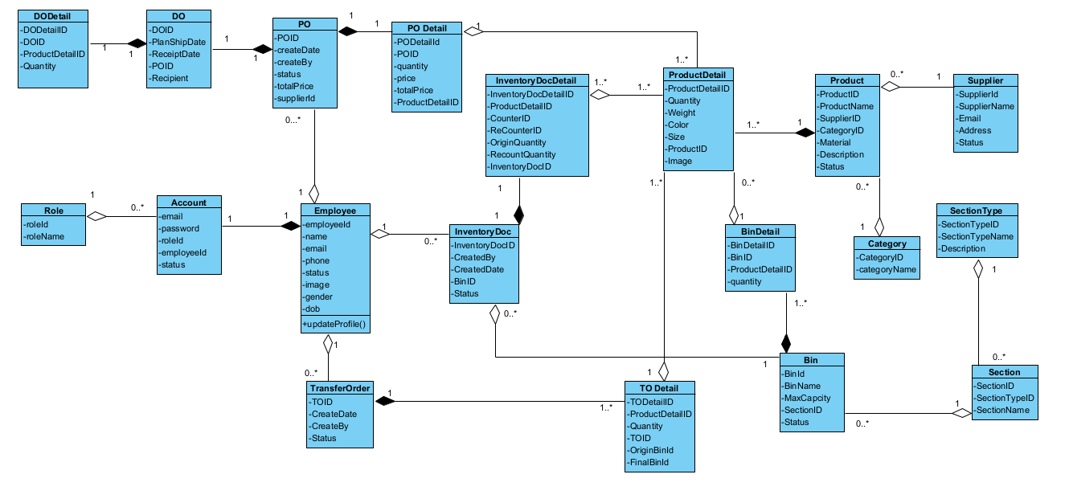

## 

# IV. Appendix

## 1. Assumptions & Dependencies

* AS-1: 1 PO order has only 1 DO order, which means that all goods can be received only once.
* AS-2: Inventory order can be counted twice by 2 different warehouse staff.
* AS-3: 1 Inventory Doc order can only be created to count all goods in 1 bin
* AS-4: Only 1 Inventory Doc can be created at a time
* AS-5: A supplier can only deliver products provided by that supplier.
* AS-6: One Section can hold max 1000kg
* AS-7: There are 3 kinds of bin: 50, 100 and 150 kg
* AS-8: 1 Inventory Doc can be recount for one time
* AS-9: System can hold max 25000 kg
* AS-10: A section type has maximum 5 sections

## 2. Business Rules

| **ID** | **Category** | **Rule Definition** |
| --- | --- | --- |
| BR-01 | Constraints | -The total product weight must not exceed 100 kg/1 bin |
| BR-02 | Constraints | - Devices must be connected to the internet and server. |
|  |  |  |
|  |  |  |

## 