

<<Project name>>
Software Design Specification

–Da Nang, November 2025–

Record of changeS
Date | A*  M, D | In charge | Change Description
*A - Added M - Modified D - Deleted

Contents
I. Overview 5
1. Code Packages 5
2. Database Design 6
a. Database Schema 6
b. Table Description 8
II. Code Designs 9
1. Authentication & Authorization 9
2. Point of Sale (POS) / Cashier System 11
a. Class Diagram 13
b. Class Specifications 13
c. Sequence Diagram(s) 13
d. Database Queries 13
4. Inventory Management 13
a. Class Diagram 13
b. Class Specifications 14
c. Sequence Diagram(s) 14
d. Database Queries 15
5. Employee & HR Management 15
a. Class Diagram 15
b. Class Specifications 15
c. Sequence Diagram(s) 16
d. Database Queries 16
6. Procurement System 16
a. Class Diagram 16
b. Class Specifications 16
c. Sequence Diagram(s) 17
d. Database Queries 17
7. Sales & Reporting 18
a. Class Diagram 18
b. Class Specifications 18
c. Sequence Diagram(s) 18
d. Database Queries 18
8. Alert System 19
a. Class Diagram 19
b. Class Specifications 19
c. Sequence Diagram(s) 19
d. Database Queries 20

I. Overview

1. Code Packages
The LiteFlow system is organized following a layered architecture with the following main packages:
Package descriptions
No | Package | Description
01 | com.liteflow.controller | Package containing Servlet classes that handle HTTP requests from clients. Includes sub-packages: auth (authentication), cashier (POS), inventory (inventory management), employee (employee management), procurement (procurement), schedule (work schedule), timesheet (time tracking), report (reporting), sales (sales), alert (alerts), dashboard (dashboard), api (REST API endpoints), admin (administration), notice (notifications).
02 | com.liteflow.dao | Package containing Data Access Objects (DAO) that perform database operations. Includes: BaseDAO (abstract base class), GenericDAO (generic CRUD operations), and specific DAOs for each module: inventory, employee, procurement, timesheet, alert, analytics, payroll, sales, report, notice.
03 | com.liteflow.model | Package containing Entity classes (JPA entities) representing database tables. Includes sub-packages: auth (User, Role, UserSession, OtpToken, AuditLog, Employee), inventory (Product, ProductVariant, ProductStock, Order, OrderDetail, Reservation, Table, Room), procurement (Supplier, PurchaseOrder, GoodsReceipt, Invoice), timesheet (EmployeeAttendance, LeaveRequest, PersonalSchedule), payroll (PayrollEntry, EmployeeCompensation), alert (AlertConfiguration, AlertHistory, NotificationChannel), notice (Notice), external (HolidayCalendar, ExchangeRate).
04 | com.liteflow.service | Package containing Service classes that contain business logic of the system. Includes sub-packages: auth (AuthService, UserService, OtpService, AuditService), inventory (ProductService, OrderService, ReservationService, ProductInventoryService), employee (EmployeeService, CompensationService), procurement (ProcurementService, InvoiceMatchingService), timesheet (TimesheetService, AttendanceService), alert (AlertService, NotificationService), analytics (DemandForecastService), report (RevenueReportService), notice (NoticeService), ai (GPTService).
05 | com.liteflow.filter | Package containing Filter classes that handle authentication and authorization. Includes: AuthenticationFilter (validates JWT token and session), LoginFilter (handles login requests), LogoutFilter (handles logout requests), CommonFilter (handles encoding and logging), BaseFilter (base class for filters).
06 | com.liteflow.security | Package containing utility classes for security. Includes: JwtUtil (JWT token generation and validation), TotpUtil (TOTP 2FA generation and verification), AuthUtils (authentication utilities), AuthControllerHelper (helper methods for authentication controllers).
07 | com.liteflow.util | Package containing utility helper classes. Includes: PasswordUtil (BCrypt password hashing), MailUtil (email sending), HashGenerator (hash generation), OrderDataUtil (order data processing), Utils (general utilities).
07 | com.liteflow.util | Package containing utility helper classes. Includes: PasswordUtil (BCrypt password hashing), MailUtil (email sending), HashGenerator (hash generation), OrderDataUtil (order data processing), Utils (general utilities).
08 | com.liteflow.job | Package containing scheduled job classes. Includes: ProcurementAlertJob (procurement order alerts), ReservationOverdueJob (handles overdue reservations).
09 | com.liteflow.listener | Package containing listener classes. Includes: AlertSchedulerListener (initializes scheduler for alert system).

Naming Conventions:

- Controller classes: Names end with "Servlet" (e.g., LoginServlet, CashierServlet)
- DAO classes: Names end with "DAO" (e.g., UserDAO, ProductDAO)
- Service classes: Names end with "Service" (e.g., AuthService, OrderService)
- Model classes: Names follow entity name (e.g., User, Product, Order)
- Filter classes: Names end with "Filter" (e.g., AuthenticationFilter)
- Util classes: Names end with "Util" (e.g., JwtUtil, PasswordUtil)

2. Database Design

a. Database Schema
The system uses Microsoft SQL Server as the primary database with the database name LiteFlowDBO. The database is organized into the following main modules:

1. Authentication & Authorization Module:
- Users ↔ UserRoles ↔ Roles (Many-to-Many relationship)
- Users ↔ UserSessions (One-to-Many relationship)
- Users ↔ OtpTokens (One-to-Many relationship)
- Users ↔ AuditLogs (One-to-Many relationship)
2. Product & Inventory Module:
- Products ↔ ProductVariant (One-to-Many relationship)
- Products ↔ ProductsCategories ↔ Categories (Many-to-Many relationship)
- ProductVariant ↔ ProductStock ↔ Inventory (Many-to-Many relationship)
- ProductVariant ↔ InventoryLogs (One-to-Many relationship)
3. Room & Table Management:
- Rooms ↔ Tables (One-to-Many relationship)
- Tables ↔ TableSessions (One-to-Many relationship)
- Tables ↔ Reservations (One-to-Many relationship)
- Reservations ↔ ReservationItems ↔ Products (Many-to-Many relationship)
4. Order Management:
- TableSessions ↔ Orders (One-to-Many relationship)
- Orders ↔ OrderDetails ↔ ProductVariant (Many-to-Many relationship)
- Orders ↔ OrderStatusHistory (One-to-Many relationship)
- Orders ↔ PaymentTransactions (One-to-Many relationship)
5. Employee & HR Module:
- Users ↔ Employees (One-to-One relationship)
- Employees ↔ EmployeeShifts (One-to-Many relationship)
- Employees ↔ EmployeeShiftAssignments ↔ ShiftTemplates (Many-to-Many relationship)
- Employees ↔ EmployeeAttendance (One-to-Many relationship)
- Employees ↔ EmployeeShiftTimesheets (One-to-Many relationship)
- Employees ↔ PersonalSchedules (One-to-Many relationship)
- Employees ↔ LeaveRequests (One-to-Many relationship)
- Employees ↔ ForgotClockRequests (One-to-Many relationship)
6. Payroll Module:
- Employees ↔ PayrollEntries ↔ PayrollRuns (Many-to-Many relationship)
- Employees ↔ EmployeeCompensation (One-to-Many relationship)
- PayPeriods ↔ PayrollRuns (One-to-Many relationship)
- PayPolicies ↔ EmployeeCompensation (One-to-Many relationship)
- ShiftPayRules ↔ EmployeeCompensation (One-to-Many relationship)
7. Procurement Module:
- Suppliers ↔ SupplierSLA (One-to-One relationship)
- Suppliers ↔ PurchaseOrders (One-to-Many relationship)
- PurchaseOrders ↔ PurchaseOrderItems (One-to-Many relationship)
- PurchaseOrders ↔ GoodsReceipts (One-to-Many relationship)
- GoodsReceipts ↔ GoodsReceiptItems ↔ PurchaseOrderItems (Many-to-Many relationship)
- PurchaseOrders ↔ Invoices (One-to-Many relationship)
- Invoices ↔ InvoiceItems ↔ PurchaseOrderItems (Many-to-Many relationship)
8. Alert System Module:
- AlertConfigurations ↔ AlertHistory (One-to-Many relationship)
- AlertConfigurations ↔ NotificationChannels (Many-to-Many relationship)
- Users ↔ UserAlertPreferences (One-to-Many relationship)
- AlertHistory ↔ GPTInteractions (One-to-Many relationship)
9. Notice Module:
- Notices ↔ NoticeReads ↔ Users (Many-to-Many relationship)
10. External Data:
- HolidayCalendar (standalone table)
- ExchangeRates (standalone table)

b. Table Description
No | Table | Description
01 | Users | Stores system user information: email, password hash, 2FA secret, display name, active status, metadata JSON.
02 | Roles | Stores system roles: Admin, Manager, Cashier, Kitchen Staff, Employee.
03 | UserRoles | Junction table between Users and Roles (Many-to-Many), stores role assignments for users, assigner, assignment time.
04 | UserSessions | Stores user session information: JWT token, device info, IP address, creation and expiration time, revoked status, 2FA verification status.
05 | OtpTokens | Stores OTP codes for 2FA authentication and password recovery: OTP code, expiration time, used status, IP address.
06 | AuditLogs | Stores logs of user actions in the system: action type, object type, object ID, details, IP address, timestamp.
07 | Categories | Stores product categories: category name, description.
08 | Products | Stores product information: name, description, image, product type, status, unit of measure.
09 | ProductVariant | Stores product variants: size, original price, selling price, discount price, discount expiration time.
10 | ProductsCategories | Junction table between Products and Categories (Many-to-Many).
11 | Inventory | Stores warehouse information: warehouse name, location.
12 | ProductStock | Stores stock quantity for each ProductVariant in each Inventory: current quantity.
13 | InventoryLogs | Stores inventory change history: operation type (IN/OUT), quantity changed, execution date, warehouse location.
14 | Rooms | Stores room information: room name, description, table count, total capacity.
15 | Tables | Stores table information: table number, table name, room assignment, capacity, status (Available/Occupied/Reserved/Maintenance).
16 | Reservations | Stores reservation information: reservation code, customer name, phone number, email, arrival time, number of guests, table/room, status (PENDING/CONFIRMED/SEATED/CANCELLED/NO_SHOW/CLOSED).
17 | ReservationItems | Stores pre-ordered items in reservations: product, quantity, notes.
18 | TableSessions | Stores table session information: table, customer name, start/end time, status, total amount.
19 | Orders | Stores order information: table session, creator, creation time, status (PENDING/PREPARING/READY/SERVED/CANCELLED), total amount, notes.
20 | OrderDetails | Stores order details: product variant, quantity, price, total amount, notes.
21 | OrderStatusHistory | Stores order status change history: old status, new status, changer, timestamp, notes.
22 | PaymentTransactions | Stores payment transactions: order, payment method, amount, status, transaction code, timestamp.
23 | UserInteractions | Stores user interactions with the system: interaction type, object, details, timestamp.
24 | Employees | Stores employee information: user ID, employee code, department, position, base salary, start date, status.
25 | EmployeeShifts | Stores work shifts: shift name, start/end time, shift type (Regular/Overtime/Holiday).
26 | ShiftTemplates | Stores shift templates: template name, start/end time, day of week.
27 | EmployeeShiftAssignments | Junction table between Employees and ShiftTemplates, stores shift schedules for employees.
28 | EmployeeAttendance | Stores employee attendance: employee, date, clock in/out time, status (Present/Absent/Late/Early Leave), notes.
29 | EmployeeShiftTimesheets | Stores detailed timesheet by shift: employee, work shift, date, actual clock in/out time, work hours, status.
30 | PersonalSchedules | Stores employee personal schedules: employee, date, type (Work/Leave/Off), description.
31 | LeaveRequests | Stores leave requests: employee, leave type, start/end date, reason, status (PENDING/APPROVED/REJECTED), approver.
32 | ForgotClockRequests | Stores forgot clock-in/out requests: employee, date, clock in/out time, reason, status (PENDING/APPROVED/REJECTED).
33 | PayPeriods | Stores pay periods: period name, start/end date, status (Open/Closed).
34 | PayrollRuns | Stores payroll runs: pay period, run date, status (Draft/Finalized), total amount.
35 | PayrollEntries | Stores employee payroll details: employee, payroll run, base salary, allowances, deductions, total salary.
36 | PayrollAdjustments | Stores payroll adjustments: payroll entry, adjustment type, amount, reason.
37 | PayPolicies | Stores pay policies: policy name, description, type (Base/Allowance/Deduction), value.
38 | EmployeeCompensation | Stores employee compensation information: employee, pay policy, value, effective date.
39 | ShiftPayRules | Stores shift pay calculation rules: shift type, pay multiplier, description.
40 | HolidayCalendar | Stores holiday calendar: holiday name, date, type (National/Company), description.
41 | ExchangeRates | Stores exchange rates: currency type, exchange rate, effective date.
42 | EmployeeCompEvents | Stores compensation events: employee, event type, amount, date, description.
43 | Suppliers | Stores supplier information: name, contact, email, phone, address, rating, on-time delivery rate, defect rate.
44 | SupplierSLA | Stores supplier SLA: total orders, on-time deliveries, average delay days, last evaluation date.
45 | PurchaseOrders | Stores purchase orders: supplier, creator, approver, creation date, expected delivery date, total amount, status (PENDING/APPROVED/REJECTED/RECEIVED), approval level.
46 | PurchaseOrderItems | Stores purchase order details: product name, quantity, unit price, total amount.
47 | GoodsReceipts | Stores goods receipts: purchase order, receiver, receipt date, notes, status (PARTIAL/FULL).
48 | GoodsReceiptItems | Stores goods receipt details: purchase order item, ordered quantity, received quantity, unit price, discrepancy, discrepancy reason, quality status (OK/DEFECTIVE/DAMAGED/EXPIRED), defective quantity.
49 | Invoices | Stores invoices: purchase order, supplier, invoice date, total amount, matching status (PENDING/MATCHED/MISMATCHED/PARTIAL_MATCH), matcher, matching date.
50 | InvoiceItems | Stores invoice details: purchase order item, product name, quantity, unit price, total amount, matching status, amount/quantity discrepancy.
51 | AlertConfigurations | Stores alert configurations: alert type (PO_PENDING/LOW_INVENTORY/REVENUE_DROP/DAILY_SUMMARY), name, description, trigger conditions (JSON), notification channels (Slack/Telegram/Email/InApp), recipients, GPT usage, schedule (Cron), priority level.
52 | NotificationChannels | Stores notification channel configurations: channel type (SLACK/TELEGRAM/EMAIL/SMS), connection info (webhook URL, bot token, chat ID, email recipients), active status.
53 | AlertHistory | Stores alert history: alert configuration, title, content, priority level, send status, channel, trigger time, send time.
54 | GPTInteractions | Stores GPT interactions: alert history, sent prompt, received response, timestamp.
55 | UserAlertPreferences | Stores user alert preferences: user, alert type, preferred notification channel, enabled/disabled status.
56 | Notices | Stores notices: title, content, type, priority level, creator, creation time, expiration time.
57 | NoticeReads | Junction table between Notices and Users, stores read status for users: user, notice, read time.
58 | POAlertNotifications | Stores purchase order alert notifications: purchase order, alert type, title, content, status, timestamp.
59 | StockAlertNotifications | Stores low stock alert notifications: product variant, current stock level, alert threshold, status, timestamp.

II. Code Designs

1. Authentication & Authorization
[Provide the detailed design for the Authentication & Authorization function. It includes Class Diagram, Class Specifications, and Sequence Diagram(s)]
a. Class Diagram
The Authentication & Authorization module consists of LoginServlet, AuthService, UserService, OtpService, AuthenticationFilter, JwtUtil, and related model classes (User, UserSession, Role, OtpToken).
b. Class Specifications
LoginServlet Class
No | Method | Description
01 | doGet() | Displays login page and handles CSRF token generation.
02 | doPost() | Processes login request: validates credentials, generates OTP if required, creates session and JWT token.
AuthService Class
No | Method | Description
01 | findByEmail(String email) | Finds user by email (case-insensitive).
02 | checkPassword(User user, String rawPassword) | Validates password using BCrypt.
03 | login(User user, String rawPassword, String deviceInfo, String ip) | Authenticates user, creates session and JWT token.
04 | logout(String jwt, User user, String ip) | Revokes session and invalidates JWT token.
05 | refreshToken(String oldJwt, String ip) | Generates new JWT token from refresh token.
06 | is2faRequired(User user, UserSession activeSession) | Checks if 2FA verification is required for user.
07 | mark2faVerified(UserSession session) | Marks session as 2FA verified.
OtpService Class
No | Method | Description
01 | issueOtp(User user, String ip) | Generates OTP code (TOTP-based or random) and stores in database with 5-minute TTL.
02 | verifyOtp(User user, String code, String ip) | Validates OTP code and marks as used.
AuthenticationFilter Class
No | Method | Description
01 | doFilter() | Intercepts requests, validates JWT token and session, redirects to login if unauthorized.
c. Sequence Diagram(s)
Login Flow: 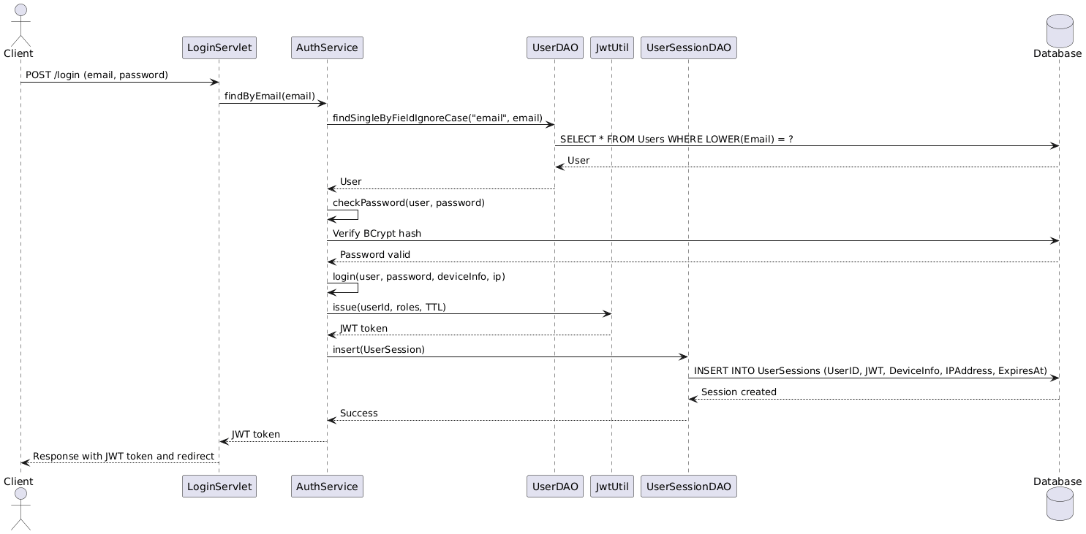
2FA Flow: Client → VerifyOtpServlet → OtpService → UserSession (upgrade) → Access granted.
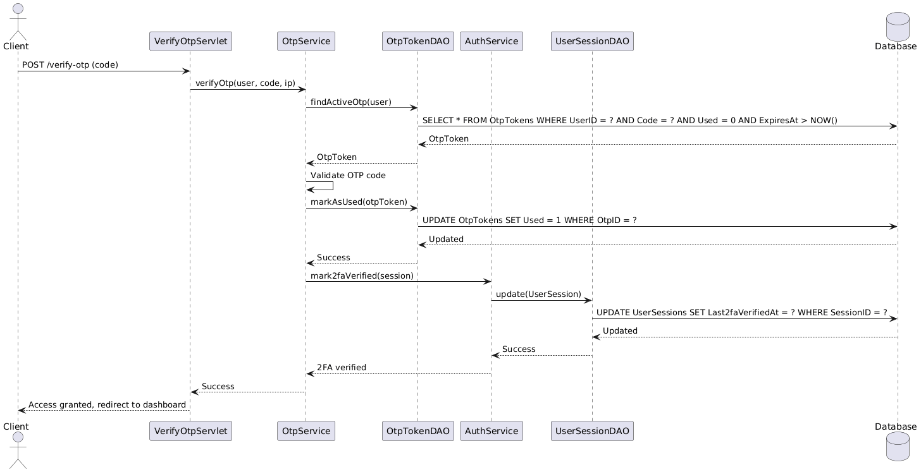
d. Database Queries
SELECT user by email: SELECT * FROM Users WHERE LOWER(Email) = ?; INSERT session: INSERT INTO UserSessions (UserID, JWT, DeviceInfo, IPAddress, ExpiresAt) VALUES (?, ?, ?, ?, ?); INSERT OTP: INSERT INTO OtpTokens (UserID, Code, ExpiresAt, IPAddress) VALUES (?, ?, ?, ?); UPDATE session 2FA: UPDATE UserSessions SET Last2faVerifiedAt = ? WHERE SessionID = ?; SELECT roles: SELECT r.* FROM Roles r JOIN UserRoles ur ON r.RoleID = ur.RoleID WHERE ur.UserID = ?.

2. Point of Sale (POS) / Cashier System
[Provide the detailed design for the POS/Cashier System function. It includes Class Diagram, Class Specifications, and Sequence Diagram(s)]
a. Class Diagram
The POS/Cashier System consists of CashierServlet, CashierAPIServlet, OrderService, ReservationService, OrderDAO, and related model classes (Order, OrderDetail, TableSession, Reservation).
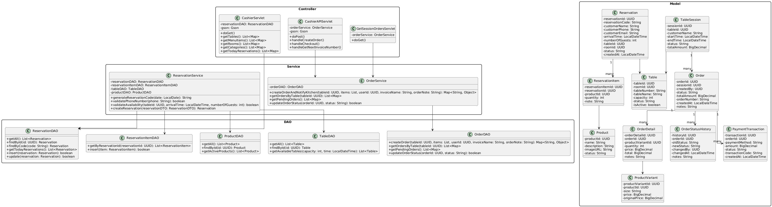
b. Class Specifications
CashierServlet Class
No | Method | Description
01 | doGet() | Displays cashier page with tables, products, categories, and reservations data.
02 | getTables() | Retrieves list of tables with status and capacity.
03 | getMenuItems() | Retrieves products with variants and stock information.
04 | getRooms() | Retrieves list of rooms.
05 | getCategories() | Retrieves product categories.
06 | getTodayReservations() | Retrieves reservations for current date.
CashierAPIServlet Class
No | Method | Description
01 | doPost() | Handles order creation and checkout requests.
02 | handleCreateOrder() | Creates new order, validates stock, calculates total, notifies kitchen.
03 | handleCheckout() | Processes payment, closes table session, generates invoice.
04 | handleGetNextInvoiceNumber() | Returns next invoice number for table session.
OrderService Class
No | Method | Description
01 | createOrderAndNotifyKitchen() | Creates order, validates stock, deducts inventory, notifies kitchen.
02 | getOrdersByTable() | Retrieves all orders for a specific table.
03 | getPendingOrders() | Retrieves orders with PENDING status.
04 | updateOrderStatus() | Updates order status and creates status history record.
c. Sequence Diagram(s)
Create Order Flow: Client → CashierAPIServlet → OrderService → OrderDAO → ProductStockDAO (validate stock) → InventoryDAO (deduct) → Kitchen notification → Response.
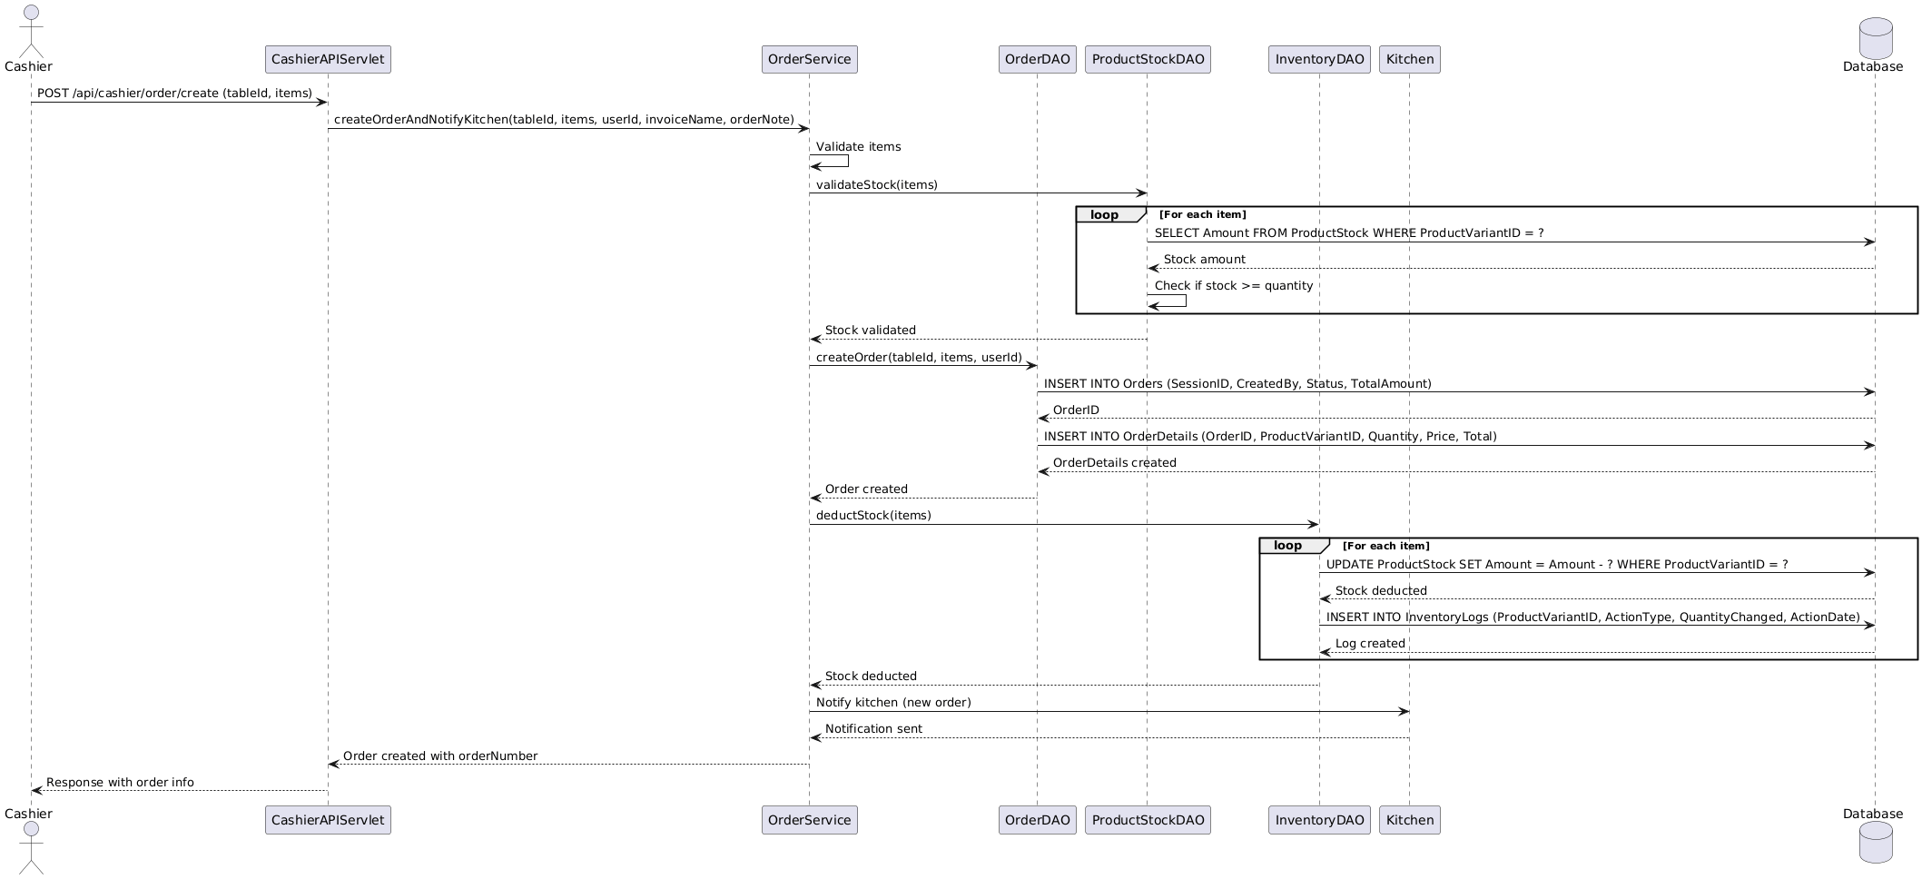
Payment Flow: Client → CashierAPIServlet → PaymentTransactionDAO → TableSessionDAO (close) → Invoice generation → Response.
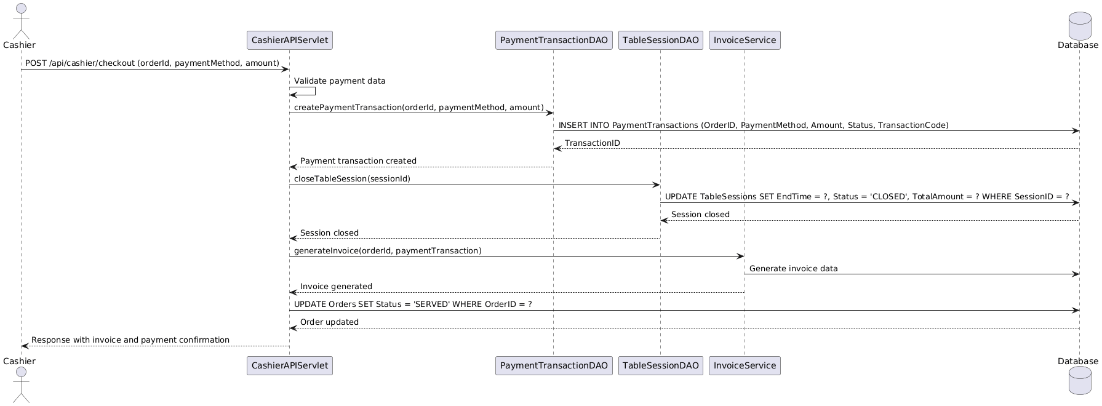
d. Database Queries
INSERT order: INSERT INTO Orders (SessionID, CreatedBy, Status, TotalAmount) VALUES (?, ?, ?, ?); INSERT order details: INSERT INTO OrderDetails (OrderID, ProductVariantID, Quantity, Price, Total) VALUES (?, ?, ?, ?, ?); UPDATE stock: UPDATE ProductStock SET Amount = Amount - ? WHERE ProductVariantID = ? AND InventoryID = ?; SELECT orders by table: SELECT * FROM Orders WHERE SessionID IN (SELECT SessionID FROM TableSessions WHERE TableID = ?); INSERT payment: INSERT INTO PaymentTransactions (OrderID, PaymentMethod, Amount, Status) VALUES (?, ?, ?, ?).
3. Kitchen Management[Provide the detailed design for the Kitchen Management function. It includes Class Diagram, Class Specifications, and Sequence Diagram(s)]

a. Class Diagram
The Kitchen Management module consists of KitchenServlet, UpdateOrderStatusServlet, OrderService, OrderDAO, and related model classes (Order, OrderDetail, OrderStatusHistory).
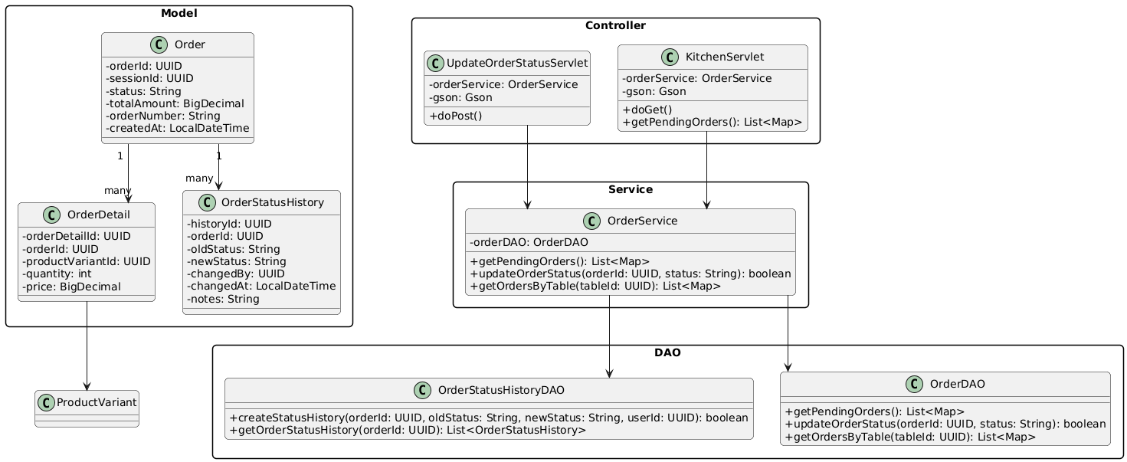

b. Class Specifications

KitchenServlet Class
No | Method | Description
01 | doGet() | Displays kitchen dashboard with pending orders sorted by priority.
02 | getPendingOrders() | Retrieves orders with status PENDING or PREPARING.

UpdateOrderStatusServlet Class
No | Method | Description
01 | doPost() | Updates order status (PENDING → PREPARING → READY → SERVED) and creates status history.

c. Sequence Diagram(s)
Order Status Update Flow: Kitchen → UpdateOrderStatusServlet → OrderService → OrderDAO (update status) → OrderStatusHistoryDAO (insert record) → Notification to cashier → Response.
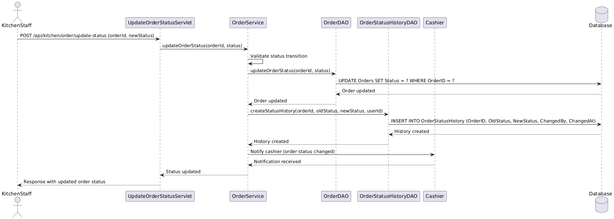

d. Database Queries
SELECT pending orders: SELECT * FROM Orders WHERE Status IN ('PENDING', 'PREPARING') ORDER BY CreatedAt ASC; UPDATE order status: UPDATE Orders SET Status = ? WHERE OrderID = ?; INSERT status history: INSERT INTO OrderStatusHistory (OrderID, OldStatus, NewStatus, ChangedBy, ChangedAt) VALUES (?, ?, ?, ?, ?).

4. Inventory Management
[Provide the detailed design for the Inventory Management function. It includes Class Diagram, Class Specifications, and Sequence Diagram(s)]

a. Class Diagram
The Inventory Management module consists of ProductServlet, RoomTableServlet, ProductService, ProductInventoryService, ProductDAO, ProductStockDAO, and related model classes (Product, ProductVariant, ProductStock, Inventory). 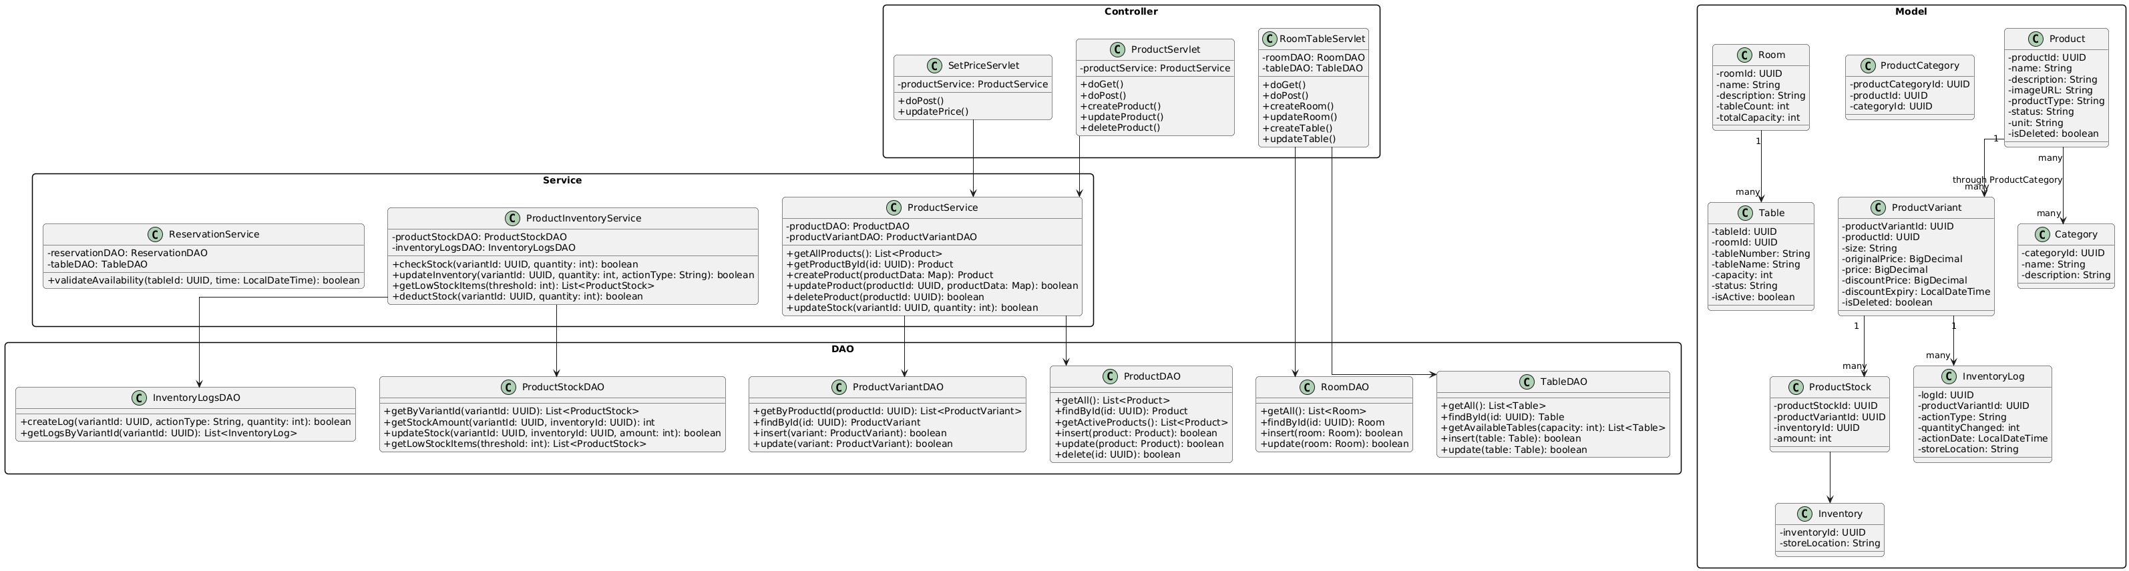

b. Class Specifications

ProductServlet Class
No | Method | Description
01 | doGet() | Displays product list page with categories and filters.
02 | doPost() | Handles product creation, update, and deletion.
03 | createProduct() | Creates new product with variants and initial stock.
04 | updateProduct() | Updates product information and variants.
05 | deleteProduct() | Soft deletes product (sets IsDeleted flag).

ProductService Class
No | Method | Description
01 | getAllProducts() | Retrieves all active products with variants and stock.
02 | getProductById() | Retrieves product by ID with full details.
03 | updateStock() | Updates product stock quantity and creates inventory log.

ProductInventoryService Class
No | Method | Description
01 | checkStock() | Checks if product variant has sufficient stock.
02 | updateInventory() | Updates inventory quantity and logs the change.
03 | getLowStockItems() | Retrieves products with stock below threshold.

c. Sequence Diagram(s)
Product Creation Flow: Client → ProductServlet → ProductService → ProductDAO → ProductVariantDAO → ProductStockDAO → InventoryLogsDAO → Response.
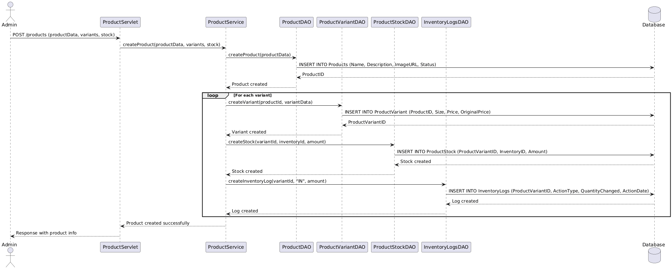
Stock Update Flow: Client → ProductInventoryService → ProductStockDAO (update) → InventoryLogsDAO (insert log) → Check low stock threshold → Alert if needed.
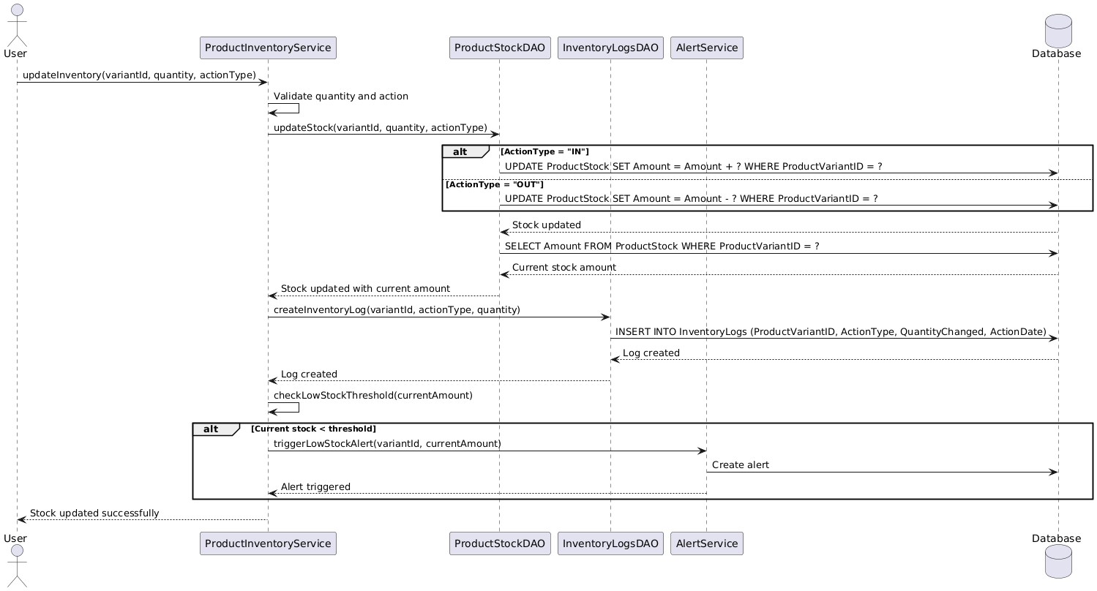

d. Database Queries
INSERT product: INSERT INTO Products (Name, Description, ImageURL, Status) VALUES (?, ?, ?, ?); INSERT variant: INSERT INTO ProductVariant (ProductID, Size, Price, OriginalPrice) VALUES (?, ?, ?, ?); INSERT stock: INSERT INTO ProductStock (ProductVariantID, InventoryID, Amount) VALUES (?, ?, ?); UPDATE stock: UPDATE ProductStock SET Amount = ? WHERE ProductStockID = ?; INSERT inventory log: INSERT INTO InventoryLogs (ProductVariantID, ActionType, QuantityChanged, ActionDate) VALUES (?, ?, ?, ?); SELECT low stock: SELECT * FROM ProductStock WHERE Amount < ?.

5. Employee & HR Management
[Provide the detailed design for the Employee & HR Management function. It includes Class Diagram, Class Specifications, and Sequence Diagram(s)]

a. Class Diagram
The Employee & HR Management module consists of EmployeeServlet, SetupEmployeeServlet, EmployeeService, CompensationService, EmployeeDAO, and related model classes (Employee, EmployeeShift, EmployeeAttendance, EmployeeCompensation).
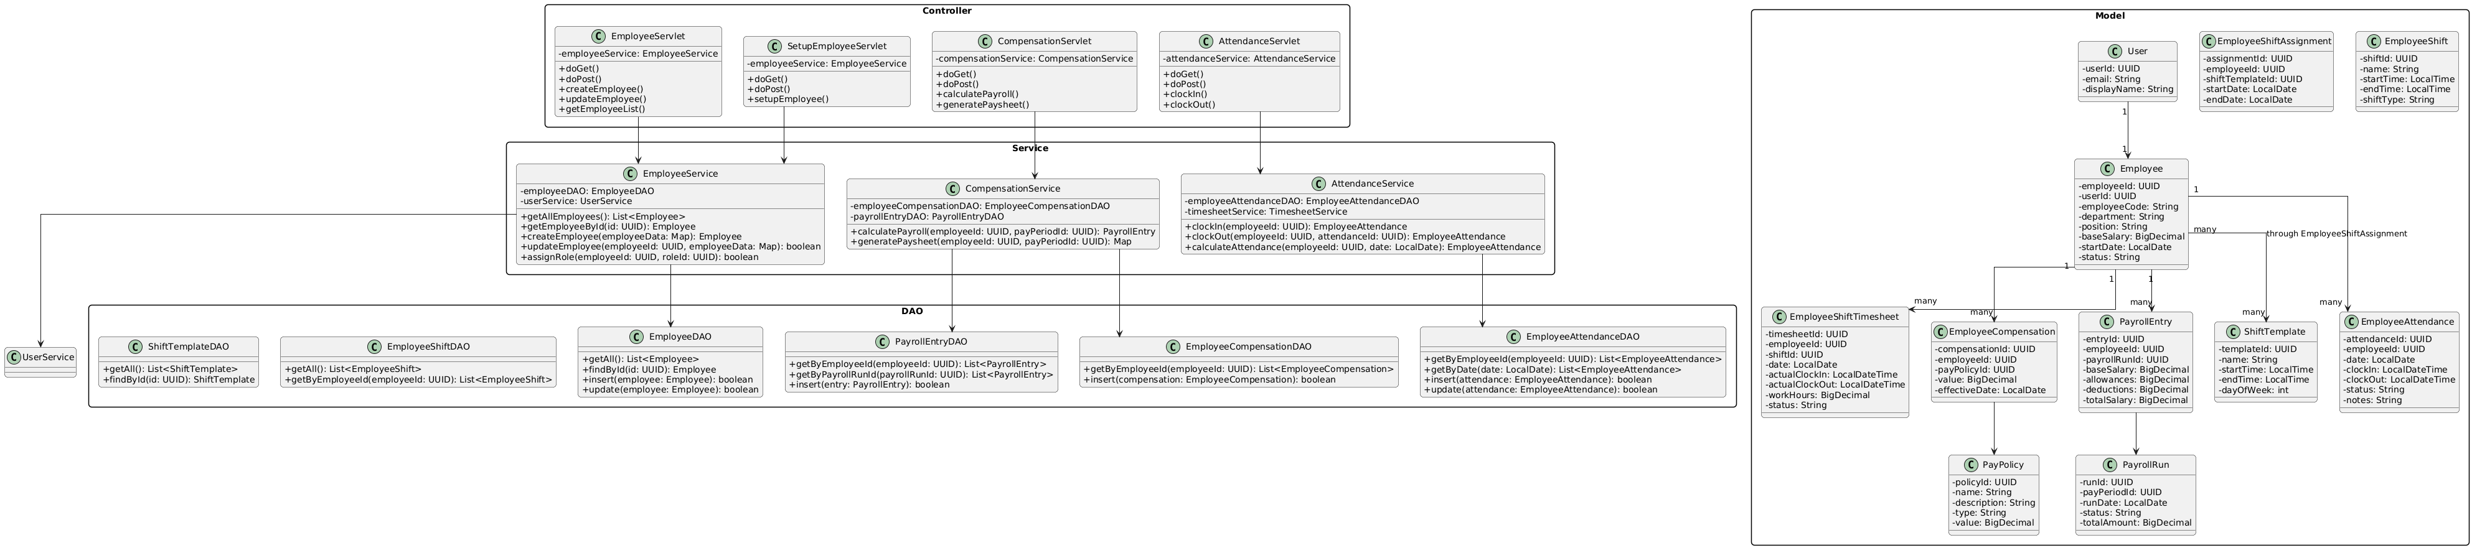

b. Class Specifications

EmployeeServlet Class
No | Method | Description
01 | doGet() | Displays employee list page with filters and search.
02 | doPost() | Handles employee creation and update requests.
03 | createEmployee() | Creates new employee record and assigns roles.
04 | updateEmployee() | Updates employee information and role assignments.

EmployeeService Class
No | Method | Description
01 | getAllEmployees() | Retrieves all employees with user and role information.
02 | getEmployeeById() | Retrieves employee by ID with full details.
03 | assignRole() | Assigns role to employee via UserRoles table.
04 | calculateAttendance() | Calculates attendance records for employee.

CompensationService Class
No | Method | Description
01 | calculatePayroll() | Calculates payroll for employee based on shifts and policies.
02 | generatePaysheet() | Generates paysheet with salary breakdown.

c. Sequence Diagram(s)
Employee Creation Flow: Client → EmployeeServlet → EmployeeService → EmployeeDAO → UserDAO → UserRolesDAO → Response.
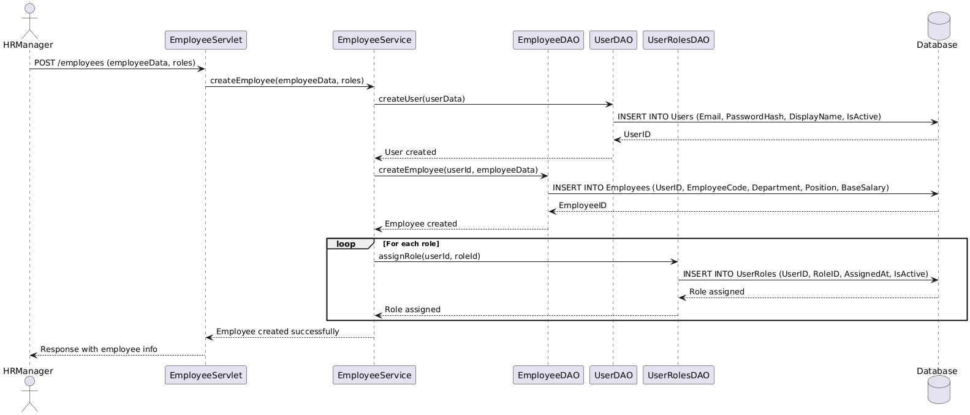
Attendance Flow: Client → AttendanceServlet → EmployeeAttendanceDAO → Calculate hours → Update timesheet → Response.
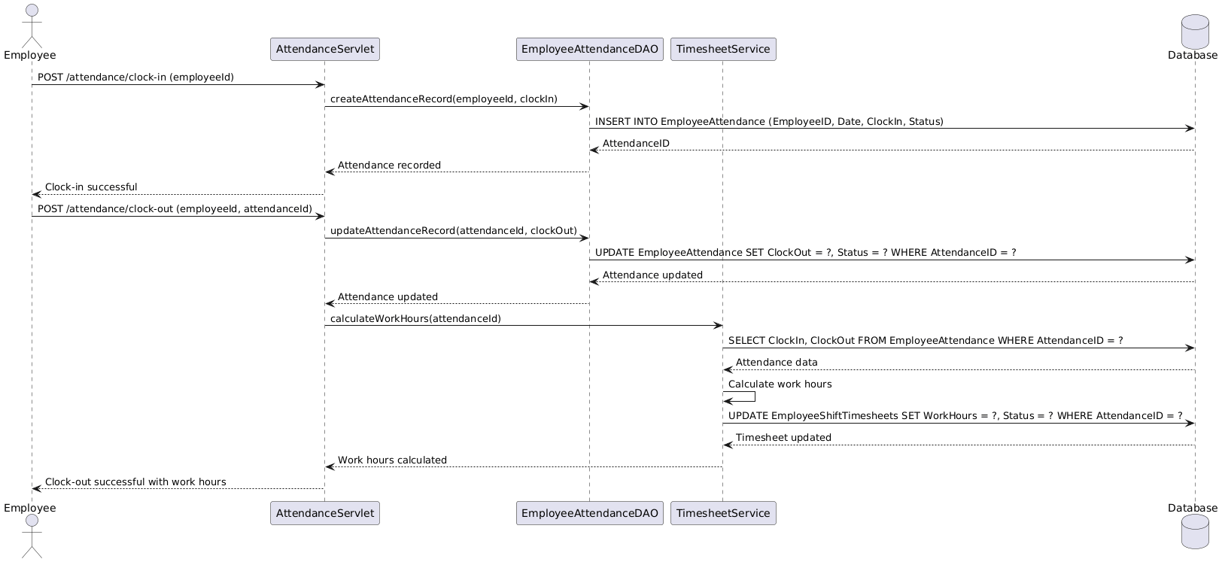

d. Database Queries
INSERT employee: INSERT INTO Employees (UserID, EmployeeCode, Department, Position, BaseSalary) VALUES (?, ?, ?, ?, ?); SELECT employees: SELECT * FROM Employees e JOIN Users u ON e.UserID = u.UserID; INSERT attendance: INSERT INTO EmployeeAttendance (EmployeeID, Date, ClockIn, ClockOut, Status) VALUES (?, ?, ?, ?, ?); SELECT shifts: SELECT * FROM EmployeeShiftAssignments esa JOIN ShiftTemplates st ON esa.ShiftTemplateID = st.ShiftTemplateID WHERE esa.EmployeeID = ?.

6. Procurement System
[Provide the detailed design for the Procurement System function. It includes Class Diagram, Class Specifications, and Sequence Diagram(s)]

a. Class Diagram
The Procurement System consists of PurchaseOrderServlet, SupplierServlet, GoodsReceiptServlet, ProcurementService, InvoiceMatchingService, and related model classes (Supplier, PurchaseOrder, GoodsReceipt, Invoice). 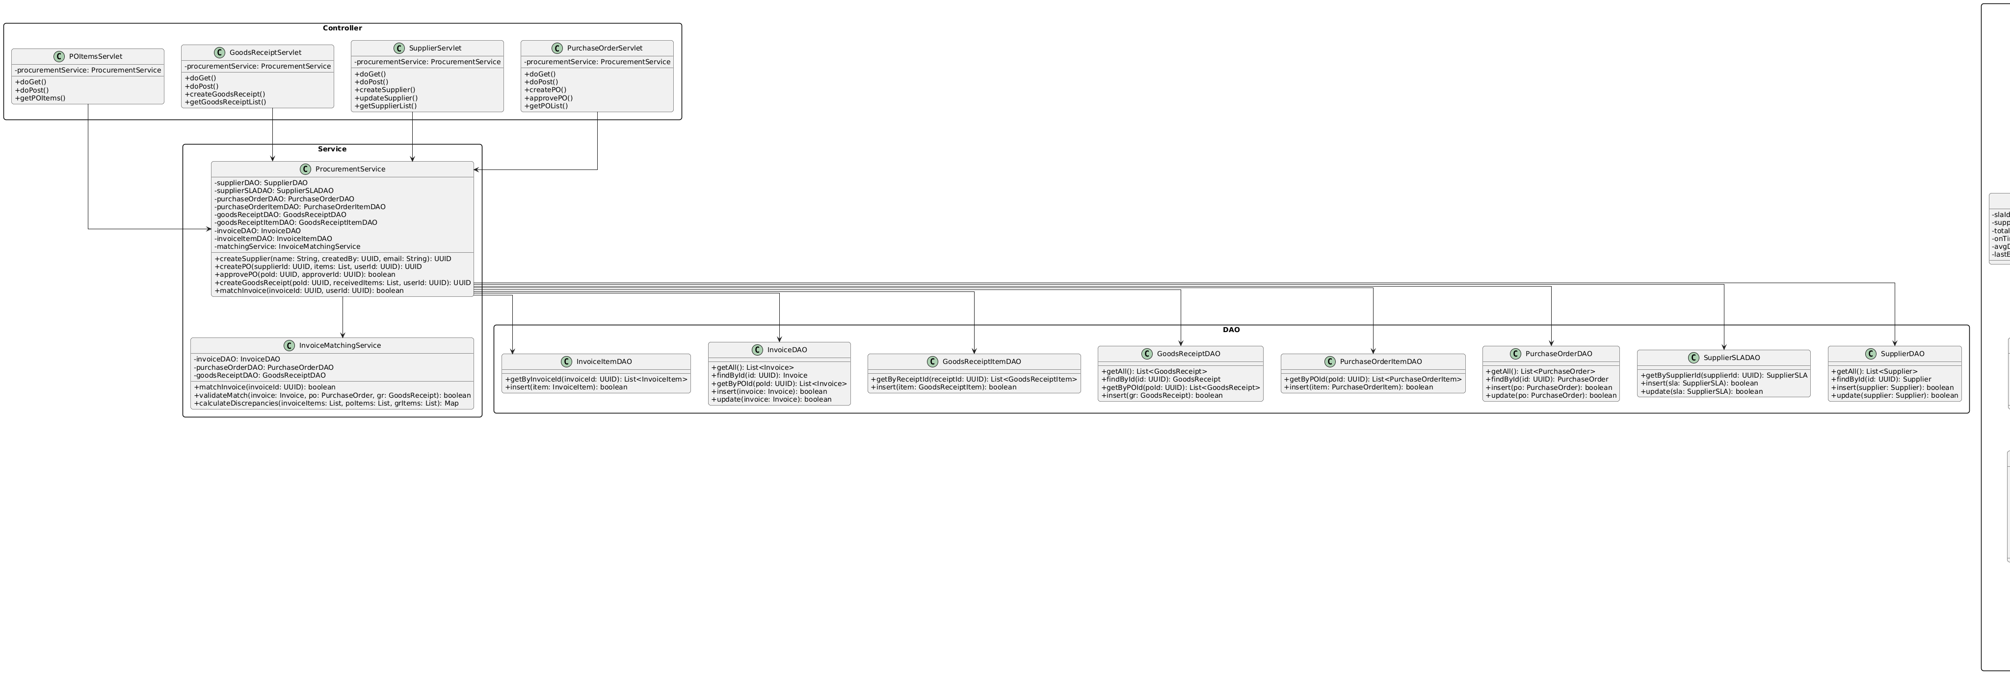

b. Class Specifications

PurchaseOrderServlet Class
No | Method | Description
01 | doGet() | Displays purchase order list with filters and status.
02 | doPost() | Handles purchase order creation and approval.
03 | createPO() | Creates new purchase order with items.
04 | approvePO() | Approves purchase order and updates status.

ProcurementService Class
No | Method | Description
01 | createSupplier() | Creates new supplier and initializes SLA record.
02 | createPO() | Creates purchase order with items and calculates total.
03 | createGoodsReceipt() | Creates goods receipt, validates quantities, updates inventory.
04 | matchInvoice() | Matches invoice with purchase order and goods receipt.

InvoiceMatchingService Class
No | Method | Description
01 | matchInvoice() | Compares invoice items with PO and GR, calculates discrepancies.
02 | validateMatch() | Validates invoice matching criteria and updates status.

c. Sequence Diagram(s)
PO Creation Flow: Client → PurchaseOrderServlet → ProcurementService → PurchaseOrderDAO → PurchaseOrderItemDAO → SupplierSLADAO (update) → Response.
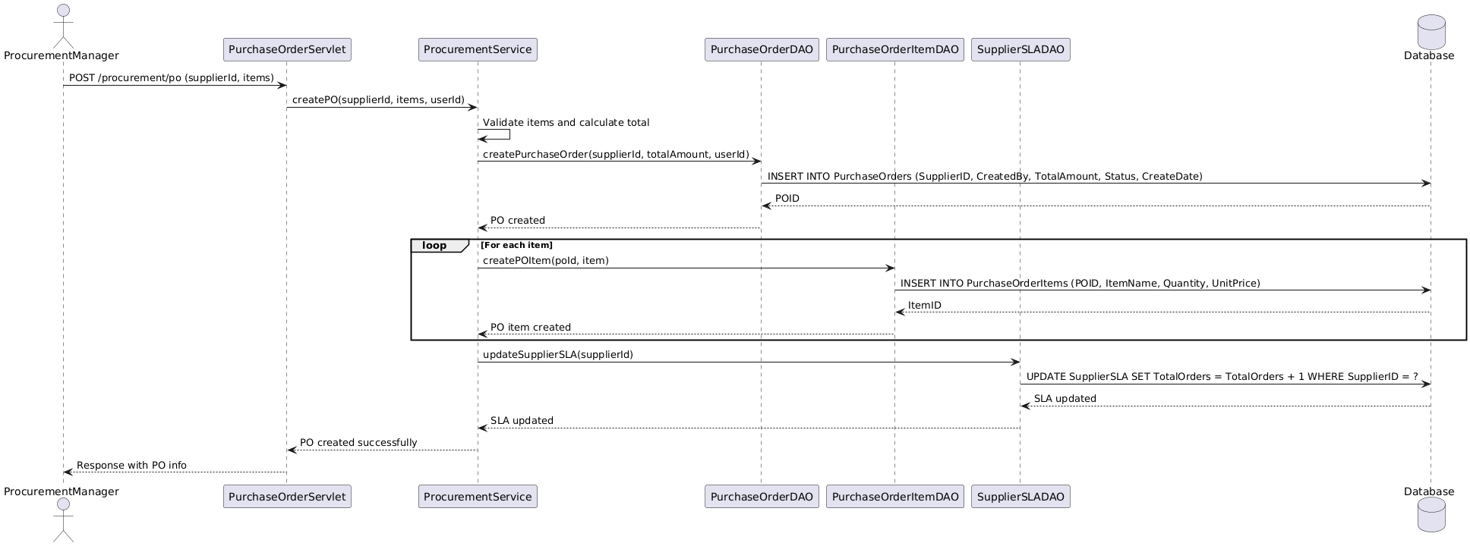
Goods Receipt Flow: Client → GoodsReceiptServlet → ProcurementService → GoodsReceiptDAO → GoodsReceiptItemDAO → ProductStockDAO (update inventory) → Response.
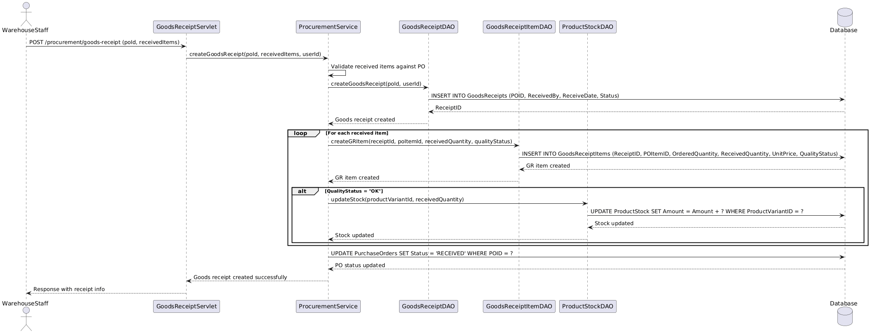
Invoice Matching Flow: Client → InvoiceServlet → InvoiceMatchingService → Compare invoice items with PO and GR → Calculate discrepancies → Update invoice status → Response
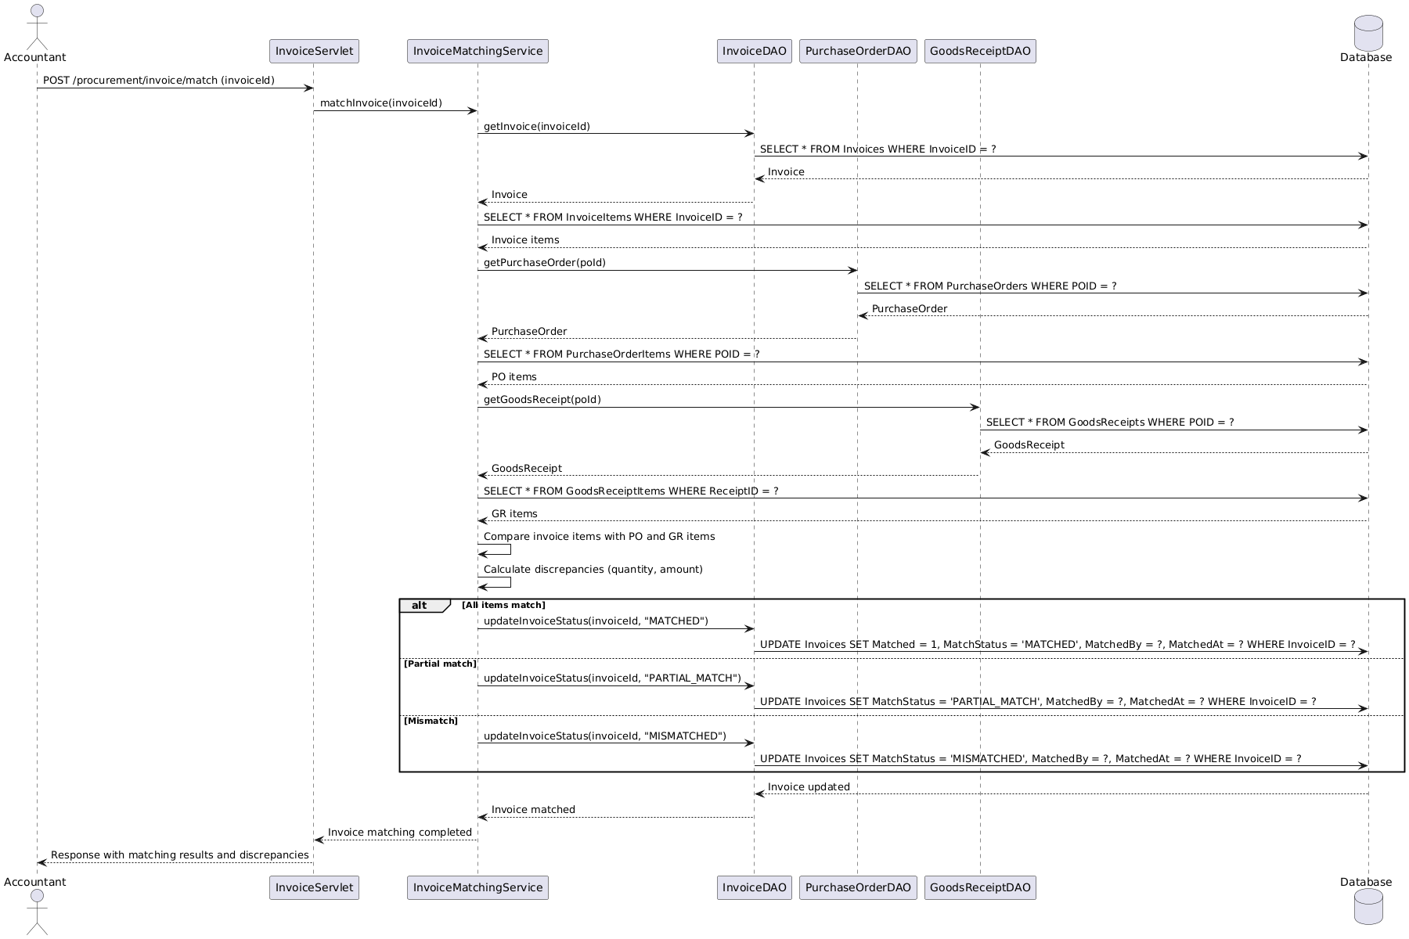

d. Database Queries
INSERT PO: INSERT INTO PurchaseOrders (SupplierID, CreatedBy, TotalAmount, Status) VALUES (?, ?, ?, ?); INSERT PO items: INSERT INTO PurchaseOrderItems (POID, ItemName, Quantity, UnitPrice) VALUES (?, ?, ?, ?); INSERT goods receipt: INSERT INTO GoodsReceipts (POID, ReceivedBy, ReceiveDate, Status) VALUES (?, ?, ?, ?); INSERT GR items: INSERT INTO GoodsReceiptItems (ReceiptID, POItemID, OrderedQuantity, ReceivedQuantity, UnitPrice) VALUES (?, ?, ?, ?, ?); INSERT invoice: INSERT INTO Invoices (POID, SupplierID, TotalAmount, MatchStatus) VALUES (?, ?, ?, ?); UPDATE invoice match: UPDATE Invoices SET Matched = 1, MatchStatus = ?, MatchedBy = ?, MatchedAt = ? WHERE InvoiceID = ?.

7. Sales & Reporting
[Provide the detailed design for the Sales & Reporting function. It includes Class Diagram, Class Specifications, and Sequence Diagram(s)]

a. Class Diagram
The Sales & Reporting module consists of RevenueReportServlet, SalesInvoiceServlet, RevenueReportService, RevenueReportDAO, and related model classes (PaymentTransaction, Order).

b. Class Specifications

RevenueReportServlet Class
No | Method | Description
01 | doGet() | Displays revenue report page with date filters.
02 | generateDailyReport() | Generates daily revenue report with sales summary.
03 | generateMonthlyReport() | Generates monthly revenue report with trends.

RevenueReportService Class
No | Method | Description
01 | getDailyRevenue() | Calculates daily revenue from payment transactions.
02 | getTopProducts() | Retrieves top selling products by quantity and revenue.
03 | getSalesSummary() | Generates sales summary with totals and averages.

c. Sequence Diagram(s)
Report Generation Flow: Client → RevenueReportServlet → RevenueReportService → RevenueReportDAO → Aggregate data from PaymentTransactions and Orders → Generate report → Response with JSON/HTML.
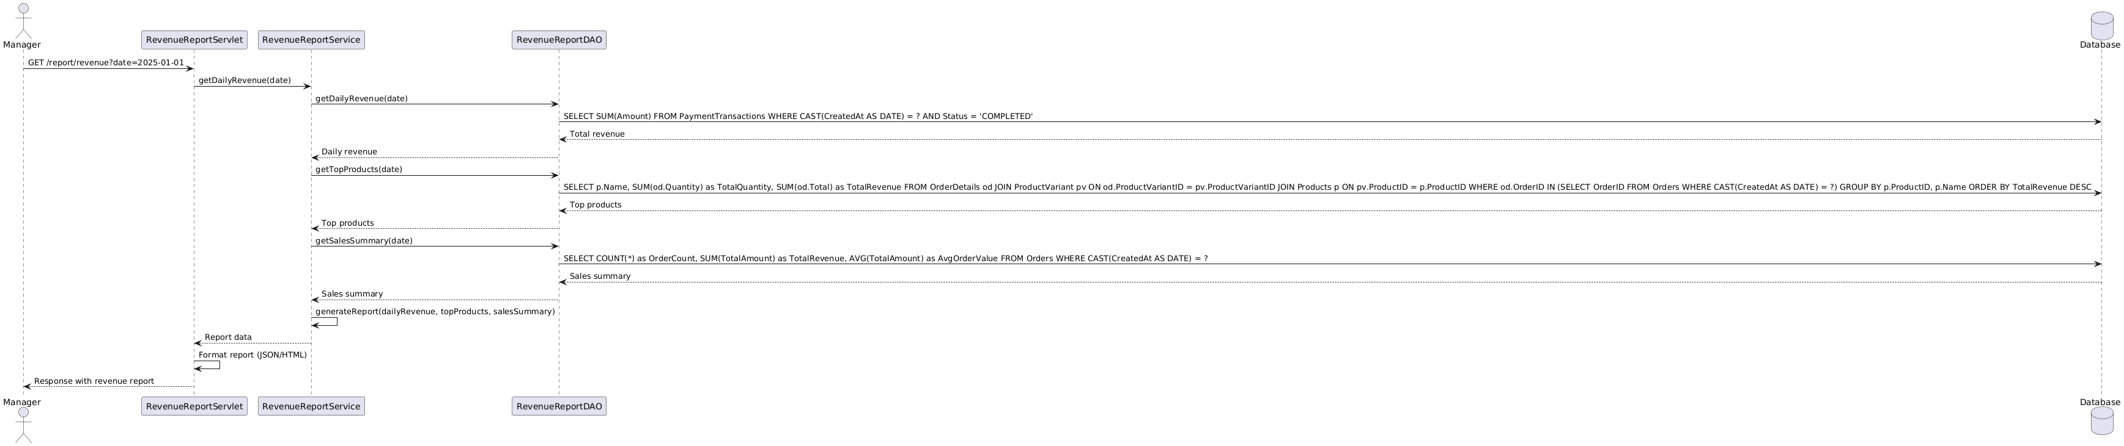

d. Database Queries
SELECT daily revenue: SELECT SUM(Amount) FROM PaymentTransactions WHERE CAST(CreatedAt AS DATE) = ? AND Status = 'COMPLETED'; SELECT top products: SELECT p.Name, SUM(od.Quantity) as TotalQuantity, SUM(od.Total) as TotalRevenue FROM OrderDetails od JOIN ProductVariant pv ON od.ProductVariantID = pv.ProductVariantID JOIN Products p ON pv.ProductID = p.ProductID WHERE od.OrderID IN (SELECT OrderID FROM Orders WHERE CAST(CreatedAt AS DATE) = ?) GROUP BY p.ProductID, p.Name ORDER BY TotalRevenue DESC; SELECT sales summary: SELECT COUNT(*) as OrderCount, SUM(TotalAmount) as TotalRevenue, AVG(TotalAmount) as AvgOrderValue FROM Orders WHERE CAST(CreatedAt AS DATE) = ?.

8. Alert System
[Provide the detailed design for the Alert System function. It includes Class Diagram, Class Specifications, and Sequence Diagram(s)]

a. Class Diagram
The Alert System consists of AlertServlet, SendNotificationServlet, AlertService, NotificationService, GPTService, and related model classes (AlertConfiguration, AlertHistory, NotificationChannel). 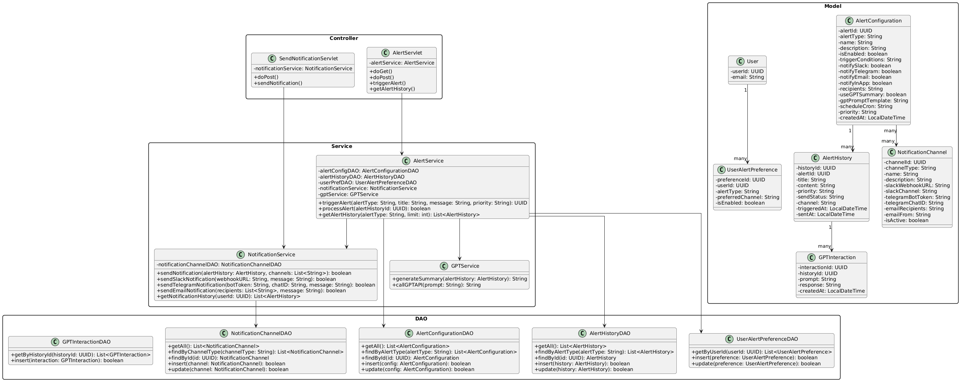

b. Class Specifications

AlertService Class
No | Method | Description
01 | triggerAlert() | Triggers alert based on configuration, creates alert history record.
02 | processAlert() | Processes alert, generates notification content, sends via channels.

NotificationService Class
No | Method | Description
01 | sendNotification() | Sends notification via configured channels (Slack, Telegram, Email, InApp).
02 | getNotificationHistory() | Retrieves notification history for user.

GPTService Class
No | Method | Description
01 | generateSummary() | Generates AI summary for alert using GPT API.

c. Sequence Diagram(s)
Alert Triggering Flow: Scheduled Job/Event → AlertService → Check trigger conditions → Create AlertHistory → NotificationService → Send via channels (Slack/Telegram/Email) → GPTService (if enabled) → Update AlertHistory status.
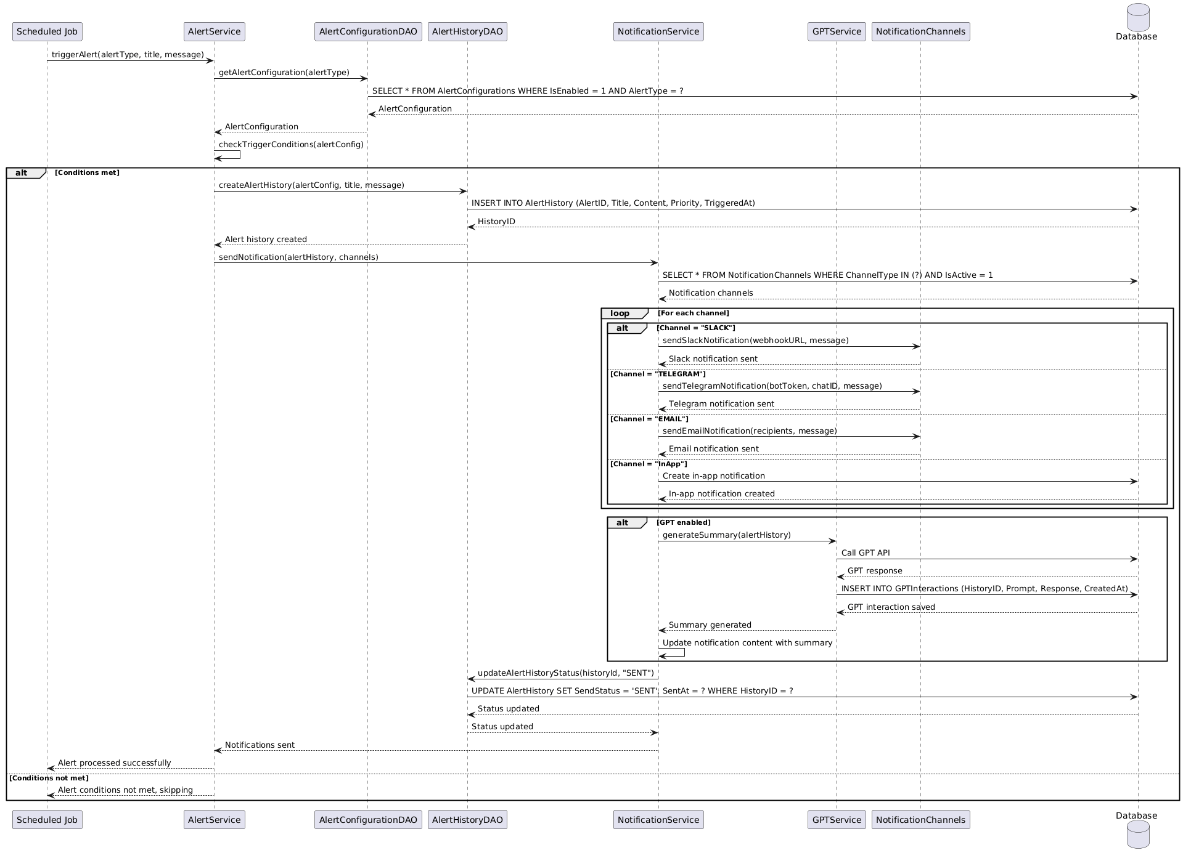

d. Database Queries
SELECT alert configs: SELECT * FROM AlertConfigurations WHERE IsEnabled = 1 AND AlertType = ?; INSERT alert history: INSERT INTO AlertHistory (AlertID, Title, Content, Priority, TriggeredAt) VALUES (?, ?, ?, ?, ?); SELECT notification channels: SELECT * FROM NotificationChannels WHERE ChannelType = ? AND IsActive = 1; UPDATE alert history: UPDATE AlertHistory SET SendStatus = ?, SentAt = ? WHERE HistoryID = ?; INSERT GPT interaction: INSERT INTO GPTInteractions (HistoryID, Prompt, Response, CreatedAt) VALUES (?, ?, ?, ?).

