Ví dụ :

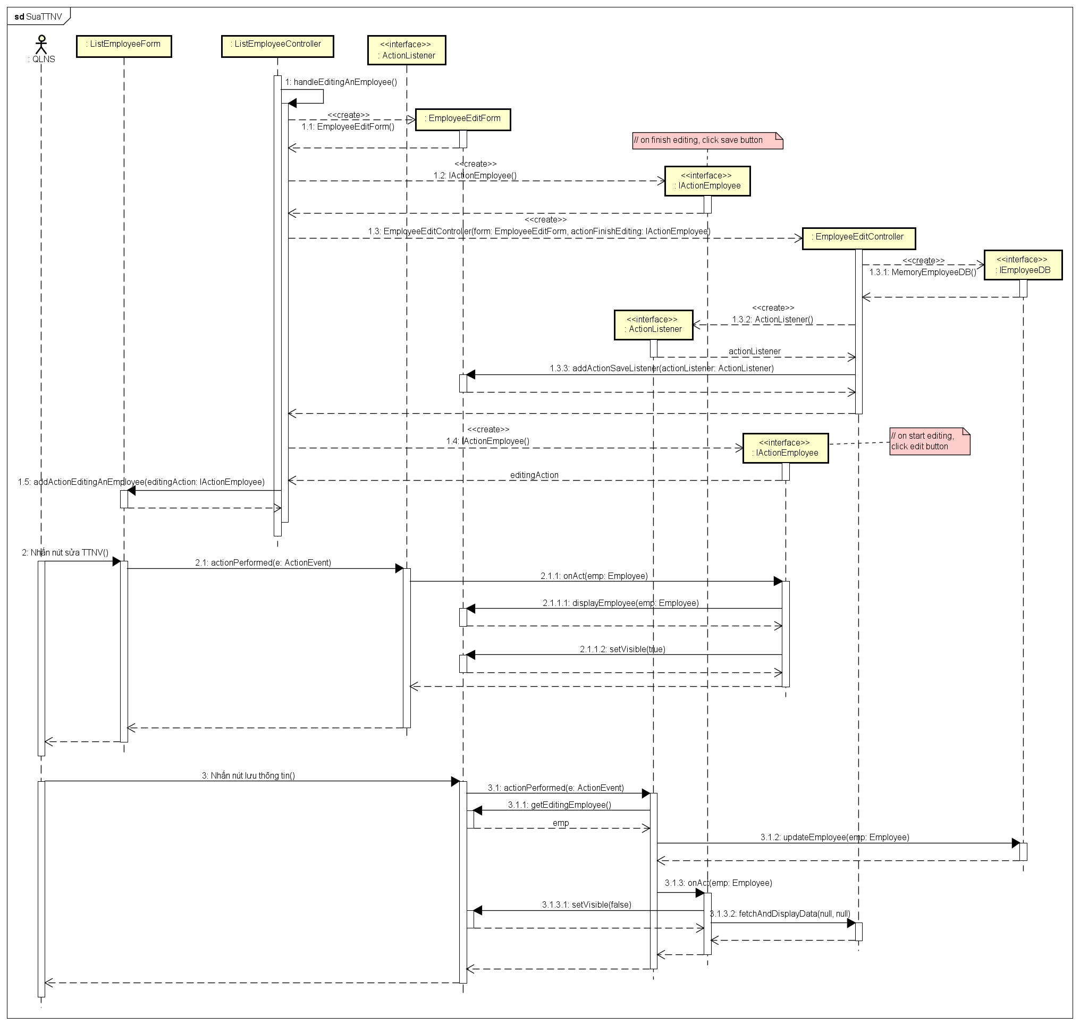

UC : Xem báo cáo chấm công đơn vị

