**Xpress Money Transfer**

Table of Contents

2 Preface 2-3

2.1 Recipient Groups 2-3

2.2 Readability Instructions 2-3

2.3 Acknowledgements 2-3

3 Project Establishment 3-3

3.1 Problem Definition 3-4

3.1.1 What we had to be aware of 3-4

3.2 Project Scope 3-4

3.2.1 Out of Scope 3-5

3.3 Project Management 3-5

3.3.1 Who we are 3-5

3.3.2 Signing Contract 3-6

3.3.3 Draft Contract 3-7

3.3.4 Strengths 3-7

3.3.5 **Weaknesses** 3-8

3.4 Conventions and Workspaces 3-9

3.4.1 Artifacts 3-10

3.4.2 Documentation 3-10

3.4.3 Implementation 3-11

3.4.4 Old Project 3-11

3.4.5 Pictures 3-11

3.4.6 Methodologies 3-11

3.5 Estimate project Timeline 3-11

3.6 Risk list 3-12

3.7 Conclusion 3-12

**3.7.1** Iteration plan for business analysis 3-12

4 Business Analysis 4-12

4.1 Introduction 4-12

4.1.1 Why is business analysis a phase in itself? 4-13

4.2 Market Level/Industry 4-13

4.2.1 Supplier Power 4-13

4.2.2 Buyer Power 4-13

4.2.3 Threat of Subtitution 4-13

4.2.4 Threat of New Entry 4-13

4.3 Customers 4-13

4.4 Competitors 4-13

4.5 Offering Level 4-14

4.5.1 Porters Generic Strategy 4-14

Porter 5 Forces 4-14

4.6 Activities and Organization 4-14

4.6.1 Value Chain Analysis 4-14

4.6.2 Organizational Structure 4-14

4.6.3 6 Keys Element 4-15

4.7 Resources Level 4-16

4.7.1 Suppliers 4-16

4.7.2 SWOT Analysis 4-16

4.8 Conclusion 4-18

4.9 Risk Assessment 4-18

4.10 Iteration plan for Inception 4-18

5 Inception 5-18

5.1 Introduction 5-18

5.2 Business Case 5-18

5.2.1 Problem Statement 5-18

5.2.2 Business Impact 5-18

5.2.3 Technology Migration 5-18

5.3 Vision 5-18

5.3.1 Product Position Statement 5-18

5.3.2 Problem Statement 5-18

5.3.3 Product Competition 5-18

5.3.4 Stakeholder Descriptions 5-18

5.3.5 User Level Goals 5-18

5.3.6 Summary of System Features 5-18

5.3.7 Other Requirements and Constraints 5-18

5.4 Use-Case Modeling 5-18

5.4.1 Brainstorm 5-18

5.4.2 Use – Case Testing 5-18

5.4.3 Use – Case Diagram 5-18

5.4.4 Identifying Key Use-Cases 5-18

5.4.5 Manage Claims Use-Case 5-18

5.5 Conclusion 5-18

5.6 Risk Assessment 5-18

5.7 Project Plan Revisited 5-18

5.8 Iteration plan for E1 5-18

6 Elaboration – 1st Iteration 6-18

6.1 Introduction 6-18

6.2 Design Modeling 6-18

6.2.1 Design Class Diagram 6-18

6.2.2 Domain Model 6-18

6.2.3 Modeling “Create ” 6-19

6.2.4 Modeling “Forward Claim” 6-19

6.2.5 Modeling “Close ” 6-19

6.2.6 Modeling “Edit ” 6-19

6.3 Implementing Model 6-19

6.3.1 Testing 6-19

6.3.2 Database Configuration 6-19

7 Conclusion 7-19

7.1 If only we’d had more time 7-19

8 Appendix 8-19

8.1 Glossary 8-19

8.2 Data Dictionary 8-20

8.3 Supplementary Specifications 8-20

8.3.1 Functionality 8-20

8.3.2 Usability 8-20

8.3.3 Reliability 8-20

8.3.4 Performance 8-20

8.3.5 Supportability 8-20

8.4 Code 8-20

8.5 SQLDUMP DDL 8-20

# Preface

## Recipient Groups

## Readability Instructions

## Acknowledgements

# Project Establishment

In our Team we decided to develop the **Xpress Money Online Transfer System** more user friendly.

****We’re going to make a system that can make a transaction of the money from one office to another, one bank to another, one country to another and a secure, fast and reliable money online transfer. Can give service to the customers within 5 minutes. Can offer the best exchange rate in dollars that can attract a lot of customers.

It can be payout anywhere in the world from any convenient Xpress Money Agent location within the country they reside in.

We’re going to get a commission on every transaction we made in each customer. We have different range of payment depends on the money they send.

## Problem Definition

As a basis for the project, we been choosing to make an IT system for Xpress Money.

|  |
| --- |
| **“How can the unified process (UP), java programming and relational database be used for development and implementation of a minor single user IT System?”** |

### What we had to be aware of

## Project Scope

It is important that we restrict ourselves by a so called project scope, It can help us evaluate whether a project is doing what it should no more and no less, and whether the budget and other aspects make it worthwhile. It can also help to prevent a project from expanding. Within a clear scope statement we know what’s within scope. There is always a major risk of getting sidetracked along the development process. This starts to happen if we uncontrollably “grow” the features of the system.

It is required of us that we apply the UP methodology from Craig Larmans book “Applying UML and Patterns”. This methodology is also further extended by the UPEDO Organization. We are required to construct the system using the Java programming language, using the Netbeans IDE or Eclipse, and implement a relational database.

From the UP methodology it is required that the project goes through 5 phases

* Project Establishment
* Inception
* Elaboration (Iteration#1, Iteration #2)
* Construction
* Evaluation and Conclusion

Of course we haven’t forgotten to make a detailed business Analysis of our stakeholder’s company. It is important for establishing the relationship between our project and their demands.

Enforcing these restrictions requires rigorous management of each individual group member.

### Out of Scope

This section is a good place to document assumptions about what is outside the boundaries of our project.

## Project Management

It can help us to find out what problem are we trying to solve how are we going to solve the problem, knowing our plan, Identifying the work to be done in detail, how long the work takes, the resources we need and how much it cost. Clearly defining objectives and requirements. Through the help of project Management we can find out easily what worked well what didn’t and why? How could work have been done better and etc. We also find out that through Project Management we can improve the likelihood of success for our project and the one we work in the future.

### Who we are

We consist of 4 people in our Team and we called it as ***TEAM COMSCI***.

|  |  |
| --- | --- |
| Phamela Hoffmann | A Project Manager in our Team, she have knowledge in technical skills specific in project management like what goes into a project plan, how to build and fine tune a project schedule, how to measure progress with tools like earned value analysis, business expertise, interpersonal skills and have a strong leader ship.  Presently working at the Xpress Money  Email: [phamela@boh.dk](mailto:phamela@boh.dk)  Mobile:53680090 |

|  |  |
| --- | --- |
| Tobias Ewoldt Grell Mouer | He is the Assistant Manager and our programmer expert. Have a wide understanding in coding, and very helpful to fellow students in terms of programming part for our project. He is a quiet achiever and always have a reserve input during discussions about the said project.  Skills: Programmer (expert) and Theory  Email: [webdota@hotmail.com](mailto:webdota@hotmail.com)  Mobile:40145112 |

|  |  |
| --- | --- |
| Bo Mu | She isour secretary, always active and helpful in designing part. She has knowledge using Microsoft office. Good in writing report and  Skills: Theory / programmer  Email: [mubo0714@gmail.com](mailto:mubo0714@gmail.com)  Mobile:53670601 |

|  |  |
| --- | --- |
| Bikram Rimal | He is friendly and very active in our group.  Skills: Theory / programmer  Email: [rimalbikram@gmail.com](mailto:rimalbikram@gmail.com)  Mobile:71601402 |

Before we acknowledge each member in the Team, we discussed first about the dos and don’ts stated in our Team Contract. When both parties are agreed and want to participate in the team we ask them to signed the contract and we take picture together and signed on it.

After signing the contract we can feel the responsibility that we accept and now we focus to the determination and commitments on the project that were going to do.

### Signing Contract

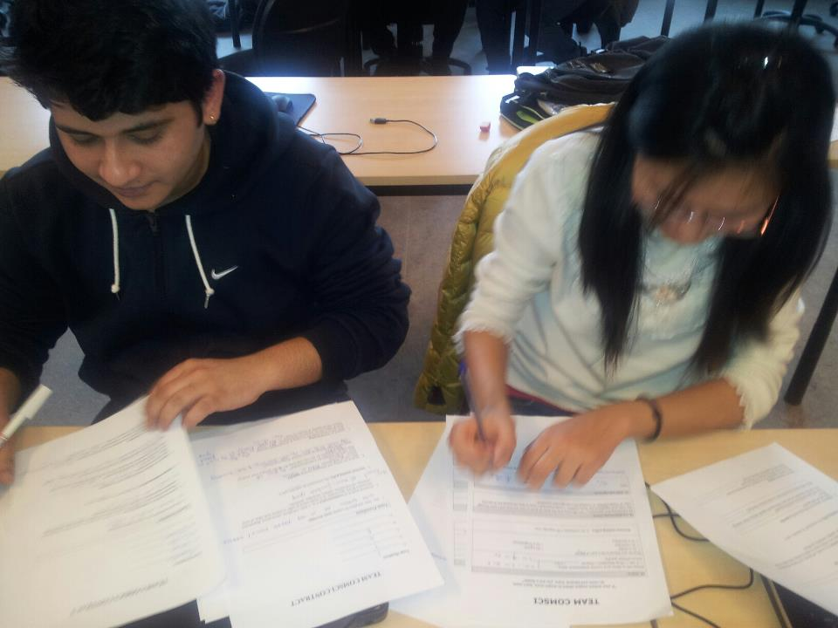A contract is important for us because it sets the rules and procedures which will guide us to work as a team; it creates the environment which can feels us necessary to achieve our common goals.

Signing a team contracts is, of course, not legally binding. It has however a symbolic value. By signing it, team members acknowledge that they know the contents and agree with them. We entered into a commitment towards each other.

### Draft Contract

|  |
| --- |
| pics |

### Strengths

|  |  |
| --- | --- |
| **Open Communication** | We have a very open communication in our team, we encourage our members to speak up and express their thoughts and ideas clearly, directly, honestly and with respect for others and for the work of the team. |
| **Good Listener** | We are good listeners too, were trying to give way to other members to express their point of views, ideas and concept for the project. |
| **Active** | Every members participates actively, they are fully engaged in the work, they have initiative to help make things happen and they volunteer for assignments. I was also surprise that they are willing to share information, knowledge and experience, our project is a good topic for international students because we experienced how to send and received money. |
| **Cooperative** | In our team every member was very cooperative we are acting together to accomplish the job. Despite of differences concerning style and perspective, we figure out ways to work together to solve problems and get work done. We are responding to request for assistance and take the initiative to offer help if one of the member cannot understand the project. We are looking forward that we can finish the project in a right time. |
| **Curiosity** | We are very open to new ideas, We constantly seek out new information, We ask questions, do follow up reading, or make my own enquiries to learn more. |
| **Order** | We are very well- organized. Everything has its place, and my team mean that we are able to be as effective as possible in things we do. We know what to do when and why something is important. |
| **Adventure** | We relish the risk of the unusual or the untired. We look forward to experiences things that are on the edge of, or outside our comfort zone. We like to somewhat push the boundaries and see what a situation will throw on us. |
| **Innovation**  **Catalyst** | We are driven by the desire to want to design and create things that are better than before. We have the ability to look at things from a different perspective to others, to think laterally and out of the box our ideas and inventions help move things forward.  We are the type of person who loves to mobilize and inspire other people to take part in a range of activities and projects. We especially enjoy getting new projects off the ground and putting ideas into action by involving others. We get people excited about new projects and motivate them to work on things that otherwise they might never have done. |

|  |
| --- |
| ***“We believe that we are PROBLEM SOLVER, not problem dwellers, problem-blamers or problem-avoiders. We are ready to find solutions and form action plans for the project in the 2nd semester. “*** |

### Weaknesses

|  |  |
| --- | --- |
| **Lack of some skills:** | This projectwere going to do is totally new for us, we don’t have the requisite skills for this project. This one of the greatest disadvantages. |
| **Sensitive person:** | Taking things to heart and getting too disappointed when things are done in the wrong way. |
| **Lack of programming skills:** | Not all members are good in programming so there will be a disadvantages for us on this part. |
| **Lack of understanding:** |  |
| **Conflicts of each members:** | In every discussion we cannot avoid to debate on the topic that ends up into conflict. |

## Conventions and Workspaces

In order to work as a Team we decided to download on each of our computer all the latest version of Microsoft Office pack in order to the member to participate in making our project. There’s no excuses during the meeting and hands on training for every member.

We had already knowledge the importance of a repository system for storing and retrieving work output. It had to be easily accessible to both of us, through majority vote we decided to choose the following:

|  |  |
| --- | --- |
| **GitHub:** | It is flexible discussion tools, where we can review change, comments on lines of code, report issues and planning the future of our project. (Our group has been learning an online video from [www.lynda.com](http://www.lynda.com) |
| **Dropbox:** | A free site where we can keep all our save documents [www.dropbox.com](http://www.dropbox.com) |
| **Facebook Group:** | A network that accessible for all of us anywhere we called it [ComsciTeam@groups.facebook.com](mailto:ComsciTeam@groups.facebook.com) |
| **Microsoft Word 2013:** | To write our report. On our team we tried to download the latest version of Microsoft word 2013, we also watch the video at Lynda.com for more training how to make a good project using this latest version. |
| **Visio 2013** | To design. |
| **Photoshop CS6:** | resizing pictures and designing for our website |
| **White Folder:** | We keep our valuable documents on this folder especially our daily conversation and meetings about our project. |
| **PowerPoint storyboarding:** | We used this to draw an ideas for our projects. |

We have 3 particular features to back up our files if the system will crash. They are:

* GitHub
* Dropbox
* SkyDrive

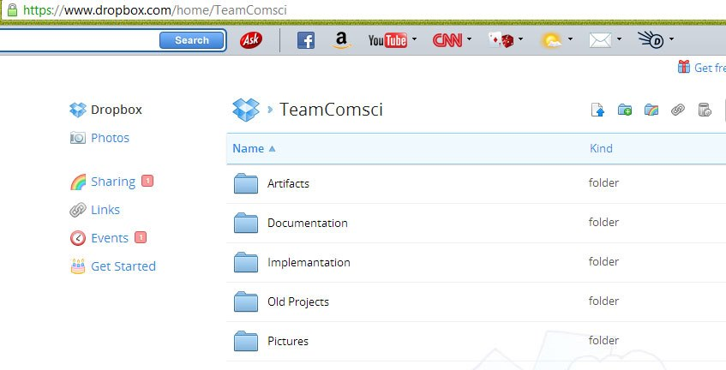

Team ComSci was our root directory, containing 5 sub-directories; “artifacts”, “documentation”, “Implementation” and “old project” and “pictures”.

### Artifacts

### Documentation

For the documentation, we agreed to use the following:

Theme – Office

Color Palette --

Font­ Style – Calibri Light

Font size – 12 (for written text)

Topic – Header 1

Subtopic – Header 2

Section – Header 3

Subsection – Header 4

Font -- ***Calibri*** font at size 12 for written text. Topic and

### Implementation

### Old Project

This is very useful for us and we keep on using this as our references for our present project. It helps us nourish our mind and guiding us in the right way how to work with our present project. We used this as our inspiration and gives better understanding on the project.

### Pictures

Our project was composed of documentation and design so we decided to make a Pictures folder where we can save all our pictures. We work a lot in photoshop CS6 so it is very good idea that we have one folder wit all the pictures we need for the project.

### Methodologies

## Estimate project Timeline

In our project we have 3 months period time to gather our resources. We had a lot of time to plan what to do, analyzing and implementing the code we need for our IT system. In order not to waste time on the project we tried to make a project plan where you can see the schedule we’ve done on each phases.

**Project Plan**

|  |
| --- |
|  |

Meeting Record (Shot Photo )

|  |
| --- |
|  |

## Risk list

Making a human risk list is the tool we use to plan for the risks we might encounter, through this we already decided how to respond when risks become reality, so we are ready to make informed and prudent decisions.

|  |  |
| --- | --- |
| **Lack of Communication:** | It can happen that we can have a lack of communication if one of the member is always absent or not attending a meeting. |
| **Lack of tools:** | Only one person in our team have a tools in designing it can be hard for us to finish the project faster. |
| **Absences:** | It cannot avoid that one of the members got sick so they cannot manage to go to school. |
| **Different languages**  **And cultures** | As an International students it cannot avoid sometimes that there will be a miscommunication due to different languages or cultural differences. |
|  |  |
|  |  |

## Conclusion

During the Project Establishment, we identified and mitigated key risk that would have an impact on our development.

### Iteration plan for business analysis

# Business Analysis

## Introduction

The purpose of the analysis we made is to understand the process that are going to be automated. This ensures a good fit between the process and the selected technology, an indicates how that technology should be configured. It is very important for us to dedicate some time to understanding the current processes, because the exercise helps to clarify the “language” used by the business to describe its processes, and provides the basis from which improvement can be evaluated.

The business analysis influenced our vision for the system we were going to make. Vision, in turn helped us identifying use-cases, requirements that fit into Xpress Money’s business model.

During the business analysis we tried to understand the functionality of the Xpress money transfer and its purpose or “mission” and relate this to the organization’s current business processes. We identify and analyze the collection of process and activities currently operational within the organization, and ascertain how far they achieve the business objectives.

### Why is business analysis a phase in itself?

## Market Level/Industry

At the market/industry we attempted to find what customers Express Money catered to, and who competed with them. Analysis of their consumer base heavily provides input for defining the offering level of the business analysis, where we tried to understand what exactly it is that they offer.

Xpress Money remittance operates on partnership basis with other bank worldwide. This collaboration will provide their customers with more channels to transfer and receive money across the globe quickly and securely.

With the support of several, prestigious banking and non-banking organizations we have a presence in many corners of the world. Xpress Money is also one of the few non-banking entities with a SWIFT membership (EXEMGB2L) which gives us the credibility and reach that is unparalleled across the globe.

Remittances are playing an increasingly large role in the economies of many countries, contributing to economic growth and to the livelihoods of less prosperous people (though generally not the poorest of the poor).

### Supplier Power

### Buyer Power

### Threat of Subtitution

### Threat of New Entry

## Customers

Money transfer is in demand to foreigners all over the world. This is the way where they can send money to their love ones, family and relatives.

Money sent home by migrants constitutes the second largest financial inflow too many developing countries, exceeding international aid.

Remittances contribute to economic growth and to the livelihoods of people worldwide moreover, remittance transfers can also promote access to [financial services](http://en.wikipedia.org/wiki/Financial_service) for the sender and recipient, thereby increasing financial and social inclusion.

There’s a lot of *agent* who work for Xpress money where they can get commissions on every transaction they made for each customer.

## Competitors

Express money director told us that they were leading company in the industry especially in Denmark. After inquiring and research in the internet we find out that there are another online website who offer a low payment in transferring money but lower $rate. We study their websites and we tried to compare their business to Xpress money and we find out that Xpress money is still leading in $rate basis compare to other remittances.

## Offering Level

### Porters Generic Strategy

## Porter 5 Forces

## Activities and Organization

### Value Chain Analysis

### Organizational Structure

Having somebody in our group working in the Xpress Money it was been a big help for us to access on their organizational structure. We have access internally in the company. Due to the help of the Director of Xpress Money we got all the answers we need for the project, besides we been visiting their websites to gather more information about the business flow.

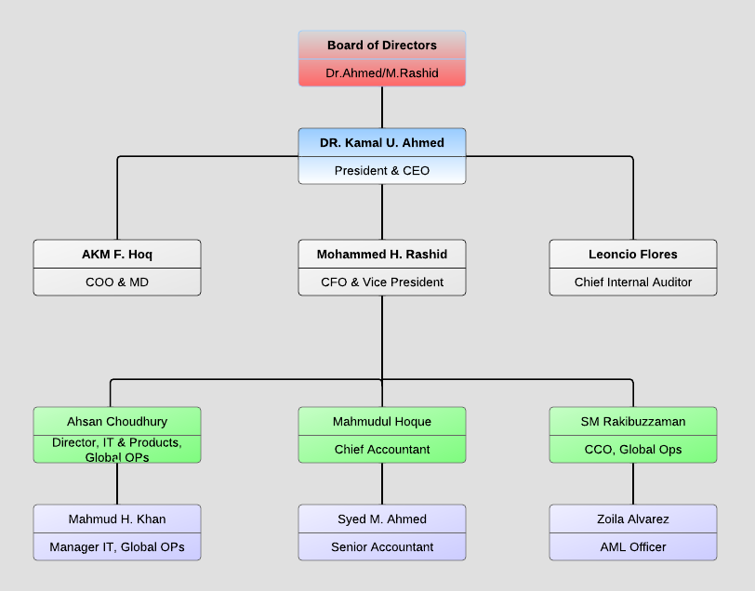

The company structure is based around a very simple functional structure which allows social structure to form on basis of delegated responsibilities. They have a constructive and collaborative work structure for each of their employees.

It can be access to the net and

We tried to apply the following relevant theories that we needed in the Business model. Here is the

### 6 Keys Element

* Work Specialization :

In our system it is ensured that each employee has a set of specific duties they're expected to perform based on their work experience, education and skills. It prevents employees from being expected to perform tasks for which they have no previous experience or training. For instance we have Board of Directors, senior accountant, chief accountant, CEO, IT officers and so on who have their own specialized work.

* Departmentalization :

In our money transfer system, departments are created based on the types of jobs employees perform, the products or brands they're assigned to or customer needs.

* Chain of Command :

In a company, each employee is expected to report to one manager, rather than to several. Mangers are responsible for assigning tasks, informing employees of expectations and deadlines and offering motivation. Managers are also available to answer job-related questions from employees and handle conflicts within their departments. Employees are responsible for completing duties assigned to them by their manager accurately and in a timely fashion. In our system, Board of director look after President and CEO.CEO looks after MD, vice president and chief internal auditor. This is how chain of command flows in our system.

* Span of control :

This element of organizational structure outlines the number of mangers an organization needs, which is typically determined based on the number of employees and departments a company has.

* Centralization and Decentralization :

Our system is centralized organization. All decisions are made by President and CEO and is finalize by Board of director.

* Formalization :

Formalization is the element that outlines employee roles within a workplace, as defined by the rules and guidelines developed by board of director. Formalization determines whether employees have to sign in and out upon arriving and exiting the office, frequency and length of breaks, computer usage and dress code.

## Resources Level

### Suppliers

The main task of our project include transfer cash, calculate tax, the customer maybe come from different countries using different currency. So we need to unify money and then transfer it.

So Xpress Money Online Transfer System will going to transfer of the money, it will unify money and then transfer money. Throw our program you could transfer money all over the world.

### SWOT Analysis

|  |  |
| --- | --- |
| Strenght | Weaknesses |
| Oppurtunity | Threats |

## Conclusion

## Risk Assessment

## Iteration plan for Inception

# Inception

## Introduction

## Business Case

### Problem Statement

### Business Impact

### Technology Migration

## Vision

### Product Position Statement

### Problem Statement

### Product Competition

### Stakeholder Descriptions

### User Level Goals

### Summary of System Features

### Other Requirements and Constraints

## Use-Case Modeling

### Brainstorm

### Use – Case Testing

### Use – Case Diagram

### Identifying Key Use-Cases

### Manage Claims Use-Case

## Conclusion

## Risk Assessment

## Project Plan Revisited

## Iteration plan for E1

# Elaboration – 1st Iteration

## Introduction

## Design Modeling

### Design Class Diagram

### Domain Model

### Modeling “Create ”

#### System Sequence Diagram

#### Operation Contract

#### Sequence Diagrams

#### Data Model

### Modeling “Forward Claim”

#### System Sequence Diagram

#### Operation Contract

### Modeling “Close ”

#### ¨System Sequence Diagram

#### Operation Contract

#### Sequence Diagram

### Modeling “Edit ”

#### System Sequence Diagram

#### Operation Contract

#### Sequence Diagram

## Implementing Model

### Testing

### Database Configuration

# Conclusion

## If only we’d had more time

# Appendix

## Glossary

## Data Dictionary

## Supplementary Specifications

### Functionality

### Usability

### Reliability

### Performance

### Supportability

## Code

## SQLDUMP DDL