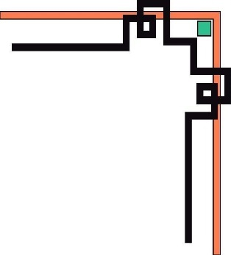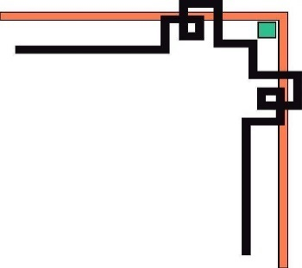

**Ho Chi Minh City University of Technology and Education**

**FACUTLY OF INTERNATIONAL EDUCATION**

**INFORMATION TECHNOLOGY**

**🕯✡🕮🕮✡🕯**



**PROJECT REPORT ON DATABASE MANAGEMENT SYSTEM**

***TOPIC:* RESTAURANT MANAGEMENT**

***GVHD****: ThS. Lê Thị Minh Châu*

*MEMBERS:*

1. Tô Đức An21110002
2. Phạm Nguyễn Gia Kiệt21110051
3. Trần Đại Dương 21110011
4. Trần Phi Tường 21110108

***TP. Hồ Chí Minh, 5/2023***

|  |  |  |  |
| --- | --- | --- | --- |
| Assignment | | | |
| **Student name** | **Student id** | **Stack** | **Finish** |
| Phạm Nguyễn Gia Kiệt | 21110051 | create 6 procedure:  UpdateAccount  AddTable  DeleteTable  USP_ThemNhanVien1  DeleteEmploy  USP_EmployeeWorking  ,  Create 4 trigger :  UpdateBillInfo  UpdateBill CreateSQLAccount DeleteSqlAccount,  create UI on Visual Studio code by c#,write code | 100% |
| Trần Phi Tường | 21110108 | Create table view,  Create 1 procedure:  USP_CaculateWorkingTime,  3 Function:  FN_ListAccount  FN_GetListIncomeByDate  FN_GetMenu  ,do report, write code | 100% |
| Tô Đức An | 21110002 | Create 5 procedure:  ThemDangNhap  GanQuyenNhanVien  USP_XoaDangNhap USP_InsertBill USP_InsertBillInfo,  draw ERD,  write code | 100% |
| Trần Đại Dương | 21110011 | Create 4 procedure:  USP_GetUnCheckTable USP_GetAccountByUserName USP_GetLogin USP_GetTableList  , create UI on Visual Studio code by c# | 100% |

**INDEX**

**PREFACE.** 1

**CHAPTER 1. DESCRIPTION OF SYSTEM REQUIREMENTS** 2

**1.** **System description and authorization:** 2

**a.** **System Description.** 2

**b.** **Function Description.** 2

**2.** **Database Description.** 2

**3.** **Entity association model.** 3

**4.** **ERD relational model** 3

**CHAPTER 2. SYSTEM DESIGN.** 4

**1. Architectural design.** 4

**2. Database Design** 10

**a)** **Description of tables** 10

**b)** **Description of stored procedures** 10

**c)** **Function description** 11

**d)** **Description of trigger** 11

**e)** **Description of the view** 12

**CHAPTER 3. IMPLEMENTATION OF THE SYSTEM** 13

**1. Description of the fields in the table** 13

**2. Write Store Procedure** 16

**3. Writing Function** 22

**4. Write Trigger** 22

**5. View** 24

**CHAPTER 4. CONCLUSION** 26

**1.** **Advantage:** 26

**2.** **Defect** 26

3. **Direction of development and improvement:** 26

**PREFACE**

**Dear lecturers and students, First of all, we would like to thank the lecturer for providing us with the opportunity to conduct this report on restaurant management in the subject of database management. In the current era, the food service industry is growing strongly, especially in the restaurant sector. Effective restaurant management is an important factor to help businesses grow and compete in this fiercely competitive market. This report will cover how to manage data in a restaurant, from storing menu information to managing staff and revenue. We'll introduce the basics of databases and DBMS, and show you how to effectively manage data in a restaurant. In addition, the report will also present common challenges and problems in restaurant data management, including information security, big data processing, and system performance optimization. system. We hope this report will help students gain more knowledge and understanding on how to manage data in a restaurant, thereby helping businesses in the food industry develop sustainably and efficiently. more fruitful. Sincerely thank!**

# **CONTENT**

# **CHAPTER 1. DESCRIPTION OF SYSTEM REQUIREMENTS**

1. **System description and authorization:**
   1. **System Description.**

A restaurant system, whether large or small, must have a central management system. The main divisions include: Account, bill, billinfo, food, foodCategory and TableFood. Those components are called entities. They interact with each other to create a restaurant management system.

The main tasks of the entities are as follows:

- Account includes many employees with different positions. But here we only consider admin and staff as the two main positions.

- Bill is the food bill ordered for each table to pay

- Billinfo contains the Bill related id number of each table to record the items called by each Bill for easy payment.

- Food includes dishes and drinks.

-TableFood is used to control the number of tables and operating status in the restaurant.

- FoodCategory is a warehouse used to classify food.

* 1. **Function Description.**

Admin: Admin has the highest authority, the right to manage the system by adding and deleting employees, accounts, dishes, bills and tables. Also admin can add admin rights for some other accounts.

Staff:

-Have the right to operate on BillInfo, Bill, Table to facilitate ordering and payment.

1. **Database Description.**

Each entity has its own id to store the object's serial number in the system

1. **Food category**

Information on classification of food groups such as Sea Food, Hot Pot ….

1. **Food**

Information of dishes is stored such as name, price and classification in stock

1. **Billinfo**

Information includes the id number of each bill, the id number of each item to be able to provide accurate information for 1 Bill for payment.

1. **Bill**

The bill entity includes the start and end dates of a table, and the number of tables. There is also the status of paid or not to change the status of the table to in use or empty.

1. **TableFood**

The TableFood entity consists of the table name and the state of the table.

1. **Account**

The Account entity will store the user's information, position, working status.

1. **Entity association model.**

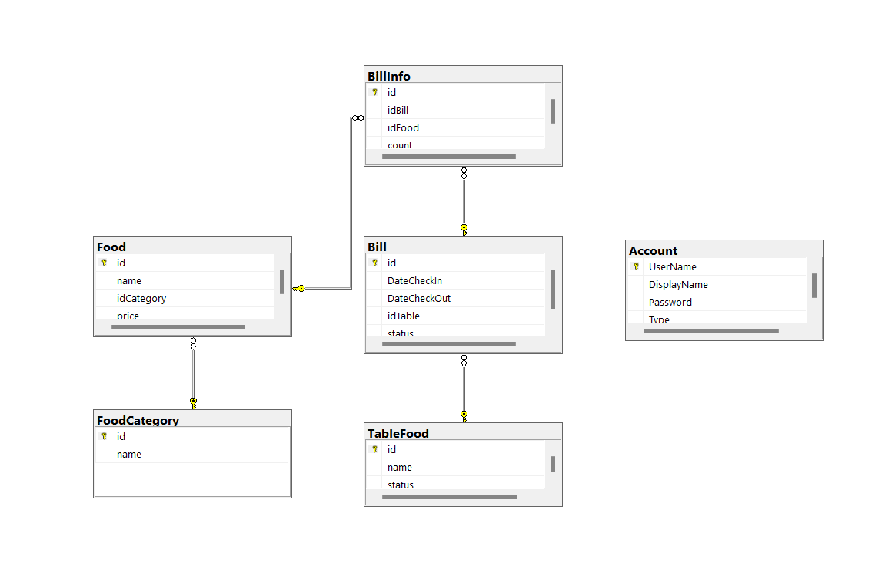

1. **ERD relational model**

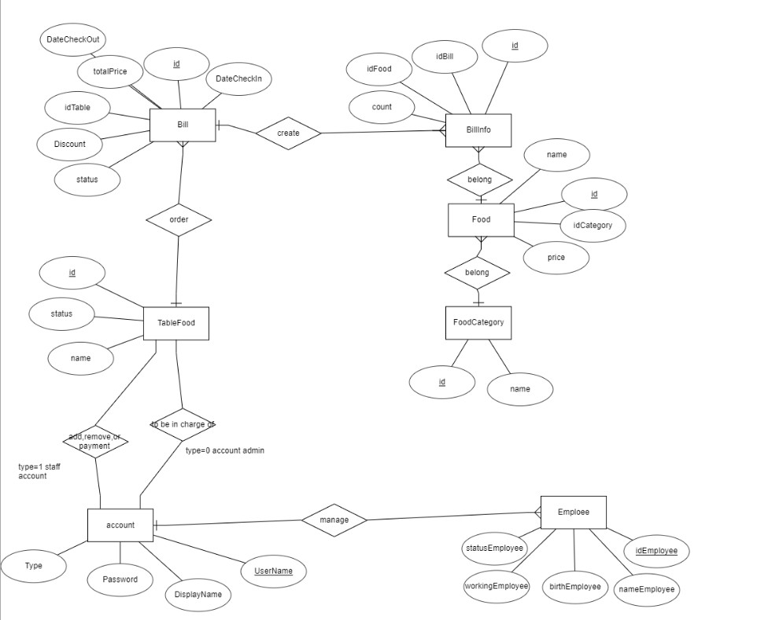

*Figure 4.2. ERD relational model.*

**CHAPTER 2. SYSTEM DESIGN.**

1. **Architectural design.**

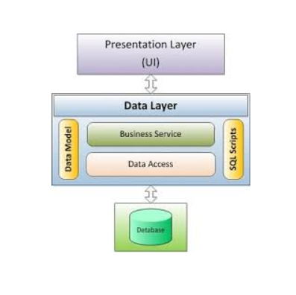 3-layer design

The 3-layer model consists of three main parts:

- Presentation Layer (GUI): This layer has the main task of communicating with the user. It includes interface components (win form, web form, ...) and performs tasks such as inputting data, displaying data, checking data correctness before calling the Business Logic Layer (BLL).

- Business Logic Layer (BLL): This layer is divided into 2 tasks:

• This is the place to meet the data manipulation requirements of the GUI layer, process the data source from the Presentation Layer before transmitting to the Data Access Layer and saving it to the DBMS.

• This is also a place to check constraints, data integrity and validity, perform calculations and process business requirements, before returning the results to Presentation Layer.

- Data Access Layer (DAL): This layer has the function of communicating with the DBMS such as performing tasks related to data storage and query (search, add, delete, edit, ...).

* **Advantages:**
* The division into classes makes the code more transparent. Thanks to the division of classes to take on different and separate functions such as interfaces, processing, queries instead of leaving them all in one place. To reduce adhesion.

- Ease of maintenance when divided, a component of the system will be easy to change. This change can be isolated to a single layer, or affect the nearest layer without affecting the entire program.

- Ease of development, reuse: when we want to add a certain function, it is easier to program according to a model because we already have a standard to follow. And the reuse when there is a change between the two environments ( Winform to Webfrom ) then just change the GUI layer again.

- Easy to hand over. If everyone follows a predetermined standard, the handover and interaction work will be easier and save a lot of time.

- Easy to distribute workload. Each group, a department will receive a task in the 3-layer model. Such a clear division will help programmers control their workload.

**2. Interface Design**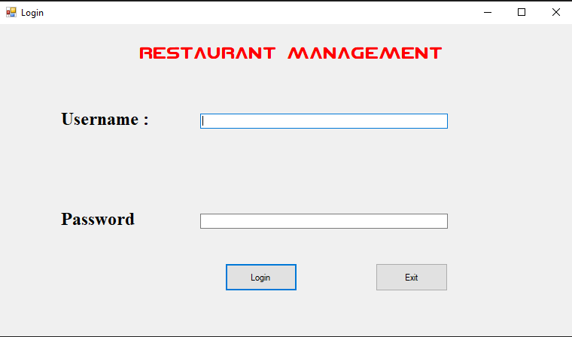

*Figure 3.1. Login interface*

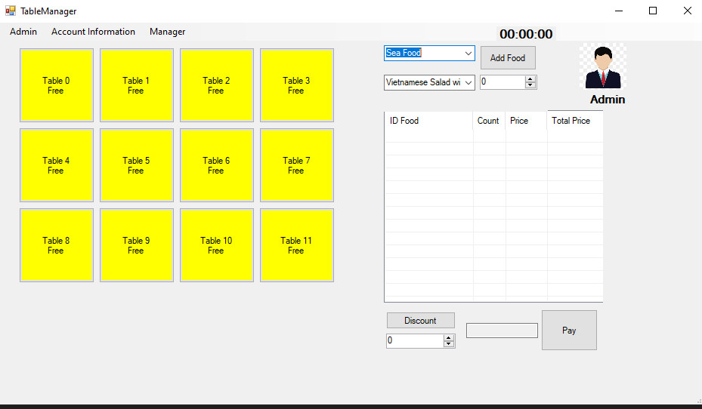

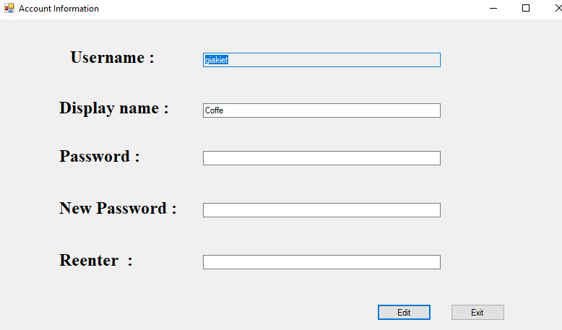*Figure 3.2. Admin main interface after logFigure*

*3.3. Login information interface*

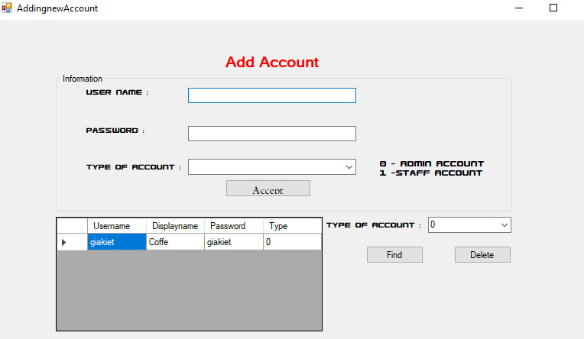

*Figure 3.4. Interface for creating login information*

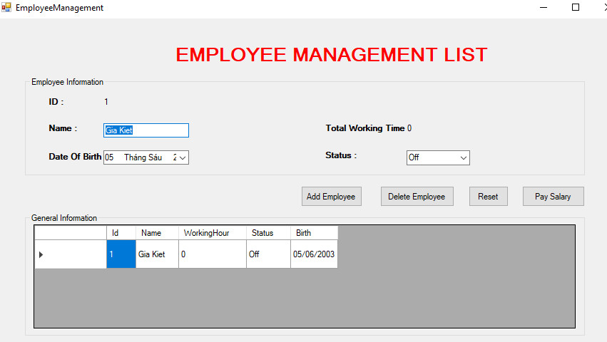

*Figure 3.5. Employee CURD interface*

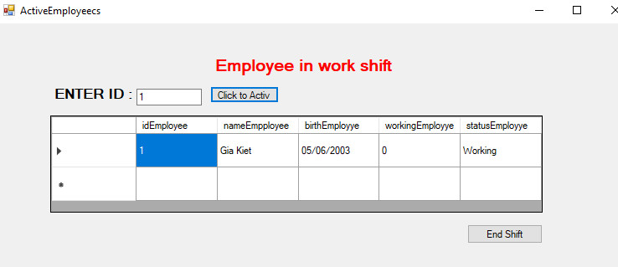

*Figure 3.6. Employee CURD interface*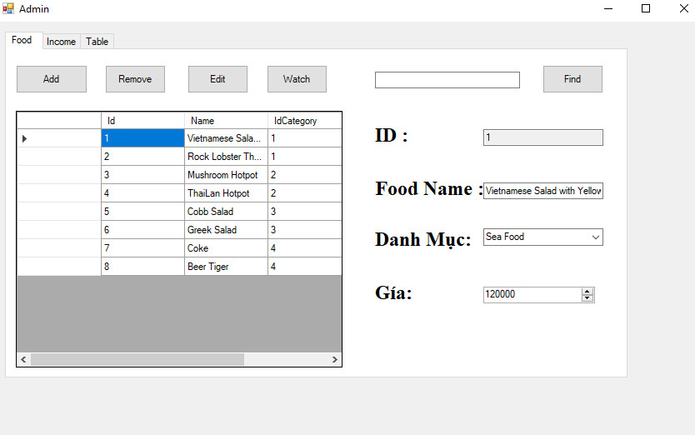

*Figure 3.7. CURD Food interface*

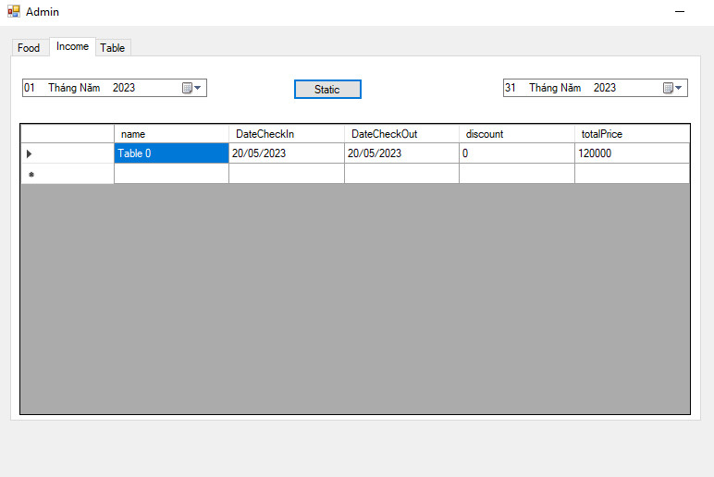*Figure 3.8. CURD Bill interface*

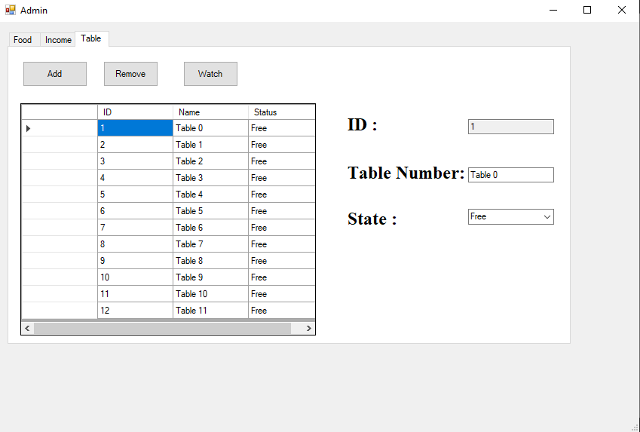

*Figure 3.8. CURD Table interface*

1. **Database Design**
   1. **Description of tables**

|  |  |  |
| --- | --- | --- |
| **TT** | **NAME** | **PURPOSE** |
| 1 | FoodCatefory | Save information of food category |
| 2 | Food | Save information of food and unit price |
| 3 | Billinfo | Store invoice data |
| 4 | Bill | Save invoice information |
| 5 | TableFood | Save table information |
| 6 | Account | Save user information |

* 1. ***Description of the stored procedure***

|  |  |  |
| --- | --- | --- |
| **TT** | Name of Store Procedure | **PURPOSE** |
| 1 | USP_GetUnCheckTable | List of available tables |
| 2 | USP_GetAccountByUserName | List accounts with the same username |
| 3 | USP_GetLogin | List any accounts with the same username and password provided |
| 4 | USP_GetTableList | List of Table Food |
| 5 | USP_InsertBill | Add Bill to 1 Table |
| 6 | USP_InsertBillInfo | Update the amount of food with the Bill that already exists or add the food with the Bill that doesn't exist |
| 7 | UpdateAccount | Update account information |
| 8 | AddTable | Add Tables |
| 9 | DeleteTable | Delete Tables |
| 10 | USP_ThemNhanVien1 | Add staffs |
| 11 | DeleteEmploy | Delete staffs |
| 12 | USP_EmployeeWorking | Update employee status |
| 13 | USP_CaculateWorkingTime | Calculate working hours |
| 14 | ThemDangNhap | Add account login |
| 15 | GanQuyenNhanVien | Assign permissions to the account |
| 16 | USP_XoaDangNhap | Delete login account |

* 1. ***Description of function***

|  |  |  |
| --- | --- | --- |
| **TT** | **Name of Function** | **PURPOSE** |
| 1 | FN_ListAccount | List accounts with type passed in |
| 2 | FN_GetListIncomeByDate | List Bill's data with time passed in |
| 3 | FN_GetMenu | List Food’s count,price,total Price from 1 table |

* 1. ***Description of* trigger**

|  |  |  |
| --- | --- | --- |
| **TT** | **Name of Trigger** | **PURPOSE** |
| 1 | UpdateBillInfo | Update table from empty state to busy, if 1 Bill id is added |
| 2 | UpdateBill | Update table in busy state to empty, if bill has been paid |
| 3 | CreateSQLAccount | Create a login account for the admin staff on the database (the name is the same as the login name) |
| 4 | DeleteSqlAccount | Delete the login account for the admin staff on the database (the name is the same as the login name) |

* 1. **Description of view**

|  |  |  |
| --- | --- | --- |
| **TT** | **Name of View** | **PURPOSE** |
| 1 | ListAccount | List of accounts |
| 2 | View_EmployeeActiv | List of current employees |

**CHAPTER 3. IMPLEMENTATION OF THE SYSTEM**

1. **Describe the fields in the table**
2. Account

|  |  |  |  |  |
| --- | --- | --- | --- | --- |
| **Entity** | **Propertiy** | **Data Type** | **Describe** | **Example** |
| Account | Username | nvarchar(100), not null | user name | giakiet |
| DisplayName | nvarchar(100), not null | Display name | Kiet |
| Password | nvarchar(1000),  not null | Login password | giakiet |
| Type | Int, not null | Account Type | 0-Admin  1-Staff |

1. TableFood

|  |  |  |  |  |
| --- | --- | --- | --- | --- |
| **Entity** | **Propertiy** | **Data Type** | **Describe** | **Example** |
| TableFood | id | Int, not null | Table number in the system | 1 |
| name | nvarchar(100) | Table name | Table 0 |
| status | nvarchar(100) | Status | -Free  -In using |

1. Bill

|  |  |  |  |  |  |
| --- | --- | --- | --- | --- | --- |
| **Entity** | **Propertiy** | **Data Type** | **Describe** | | **Example** |
| Bill | id | int ,not null | Order number of bill in the system | 1 | |
| DateCheckIn | Date,not null | Day in | 2023-05-18 | |
| DateCheckOut | Date, null | Date out | 2023-05-18 | |
| idTable | Int, not null | Table number | 1 | |
| status | Int, not null | Status | 0-Chưa thanh toán  1-Đã Thanh toán | |

1. BillInfo

|  |  |  |  |  |
| --- | --- | --- | --- | --- |
| **Entity** | **Propertiy** | **Data Type** | **Describe** | **Example** |
| Billnfo | id | int not null | BillInfo's serial number | 1 |
| idbill | int not null | Order number of an invoice | 2 |
| idFood | int not null | Order number of food | 3 |
| Count | int not null | Number of dishes | 4 |

1. Food

|  |  |  |  |  |
| --- | --- | --- | --- | --- |
| **Entity** | **Propertiy** | **Data Type** | **Describe** | **Example** |
| Food | id | int not null | The order number of the item in the system | 1 |
| name | nvarchar(100) not null | Name of dish | Vietnamese Salad with Yellowfin Bream |
| idCategory | Int , not null | The ordinal number the food belongs to | 1-Sea Food  (2-Hot Pot  3-Vegetable  4-Beverage) |
| price | Float null | Price of the dish | 120000 |

1. FoodCategory

|  |  |  |  |  |
| --- | --- | --- | --- | --- |
| **Entity** | **Propertiy** | **Data Type** | **Describe** | **Example** |
| FoodCategory | id | Int, not null | Ordinal number in the system | ‘1’ |
| name | nvarchar(100), null | Category name | Sea Food., Hot Pot |

1. **Write Store procedure**

* *Question 1: Write a proc that lists empty table data* 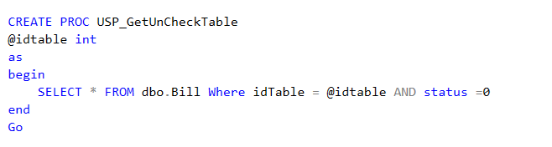
* *Question 2:* [Write](https://dictionary.cambridge.org/vi/dictionary/english-vietnamese/write) proc [list](https://dictionary.cambridge.org/vi/dictionary/english-vietnamese/list) [account](https://dictionary.cambridge.org/vi/dictionary/english-vietnamese/account) checklist [data](https://dictionary.cambridge.org/vi/dictionary/english-vietnamese/data)

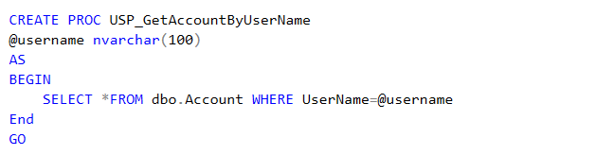

* [Question](https://dictionary.cambridge.org/vi/dictionary/english-vietnamese/question) 3: [Write](https://dictionary.cambridge.org/vi/dictionary/english-vietnamese/write) proc [check](https://dictionary.cambridge.org/vi/dictionary/english-vietnamese/check) login [list](https://dictionary.cambridge.org/vi/dictionary/english-vietnamese/list) [by](https://dictionary.cambridge.org/vi/dictionary/english-vietnamese/by) username [and](https://dictionary.cambridge.org/vi/dictionary/english-vietnamese/and) [password](https://dictionary.cambridge.org/vi/dictionary/english-vietnamese/password)

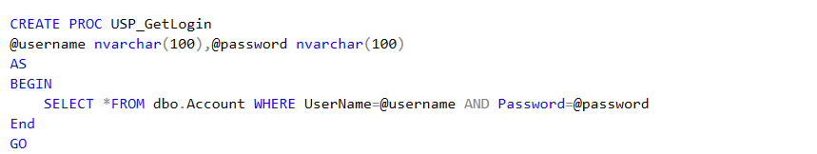

* [Question](https://dictionary.cambridge.org/vi/dictionary/english-vietnamese/question) 4: [Write](https://dictionary.cambridge.org/vi/dictionary/english-vietnamese/write) proc [check](https://dictionary.cambridge.org/vi/dictionary/english-vietnamese/check) [table](https://dictionary.cambridge.org/vi/dictionary/english-vietnamese/table) [list](https://dictionary.cambridge.org/vi/dictionary/english-vietnamese/list)

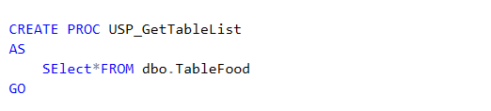

* [Question](https://dictionary.cambridge.org/vi/dictionary/english-vietnamese/question) 5: [Write](https://dictionary.cambridge.org/vi/dictionary/english-vietnamese/write) proc [add](https://dictionary.cambridge.org/vi/dictionary/english-vietnamese/add) [data](https://dictionary.cambridge.org/vi/dictionary/english-vietnamese/data) [to](https://dictionary.cambridge.org/vi/dictionary/english-vietnamese/to) 1 [Bill](https://dictionary.cambridge.org/vi/dictionary/english-vietnamese/bill)

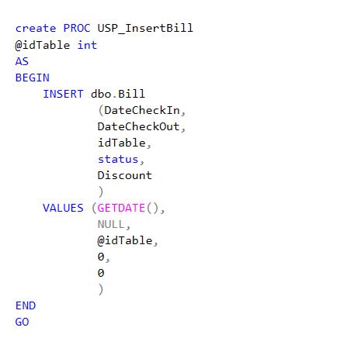

* [Question](https://dictionary.cambridge.org/vi/dictionary/english-vietnamese/question) 6: [Write](https://dictionary.cambridge.org/vi/dictionary/english-vietnamese/write) proc [add](https://dictionary.cambridge.org/vi/dictionary/english-vietnamese/add) [or](https://dictionary.cambridge.org/vi/dictionary/english-vietnamese/or) [update](https://dictionary.cambridge.org/vi/dictionary/english-vietnamese/update) [with](https://dictionary.cambridge.org/vi/dictionary/english-vietnamese/with) [Bill](https://dictionary.cambridge.org/vi/dictionary/english-vietnamese/bill) [that](https://dictionary.cambridge.org/vi/dictionary/english-vietnamese/that) exists [or](https://dictionary.cambridge.org/vi/dictionary/english-vietnamese/or) does [not](https://dictionary.cambridge.org/vi/dictionary/english-vietnamese/not) [exist](https://dictionary.cambridge.org/vi/dictionary/english-vietnamese/exist) [yet](https://dictionary.cambridge.org/vi/dictionary/english-vietnamese/yet)

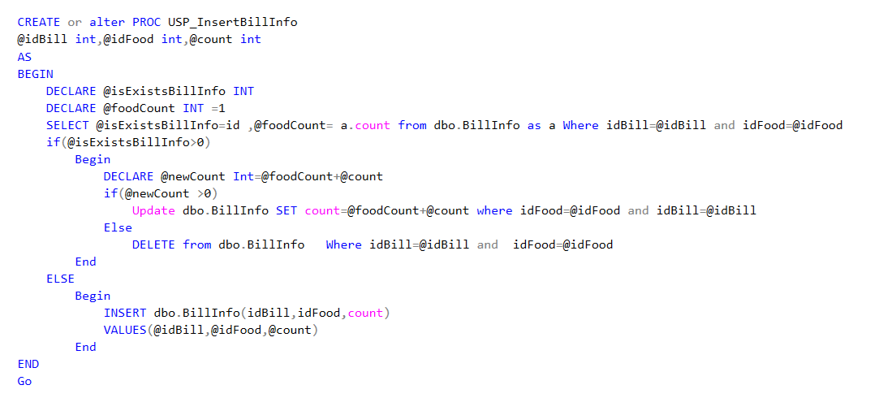

* [Question](https://dictionary.cambridge.org/vi/dictionary/english-vietnamese/question) 7: [Write](https://dictionary.cambridge.org/vi/dictionary/english-vietnamese/write) proc [to](https://dictionary.cambridge.org/vi/dictionary/english-vietnamese/to) [update](https://dictionary.cambridge.org/vi/dictionary/english-vietnamese/update) [account](https://dictionary.cambridge.org/vi/dictionary/english-vietnamese/account) [information](https://dictionary.cambridge.org/vi/dictionary/english-vietnamese/information)

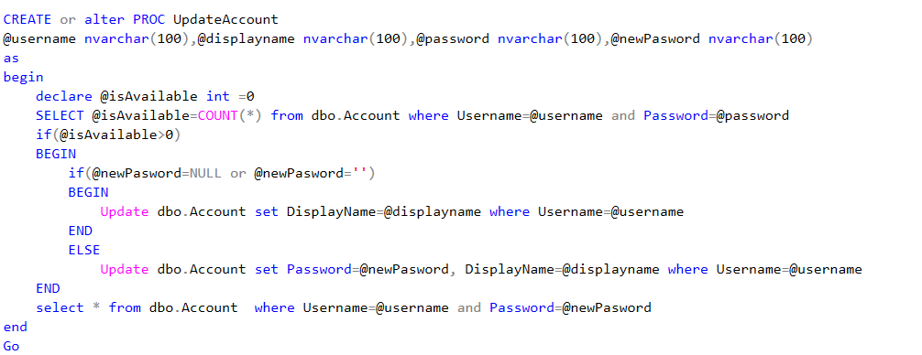

[Question](https://dictionary.cambridge.org/vi/dictionary/english-vietnamese/question) 8: [Write](https://dictionary.cambridge.org/vi/dictionary/english-vietnamese/write) proc [add](https://dictionary.cambridge.org/vi/dictionary/english-vietnamese/add) [table](https://dictionary.cambridge.org/vi/dictionary/english-vietnamese/table) [in](https://dictionary.cambridge.org/vi/dictionary/english-vietnamese/in) [the](https://dictionary.cambridge.org/vi/dictionary/english-vietnamese/the) TableFood [table](https://dictionary.cambridge.org/vi/dictionary/english-vietnamese/table)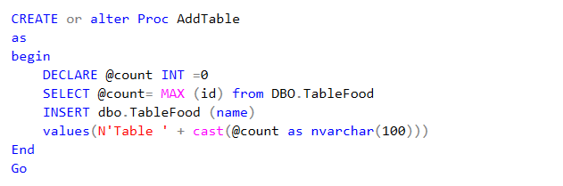

[Question](https://dictionary.cambridge.org/vi/dictionary/english-vietnamese/question) 9: [Write](https://dictionary.cambridge.org/vi/dictionary/english-vietnamese/write) proc [delete](https://dictionary.cambridge.org/vi/dictionary/english-vietnamese/delete) [table](https://dictionary.cambridge.org/vi/dictionary/english-vietnamese/table)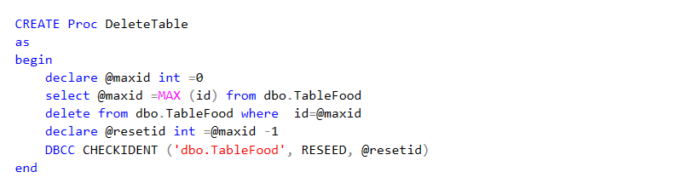

[Question](https://dictionary.cambridge.org/vi/dictionary/english-vietnamese/question) 10: [Write](https://dictionary.cambridge.org/vi/dictionary/english-vietnamese/write) proc [more](https://dictionary.cambridge.org/vi/dictionary/english-vietnamese/more) employees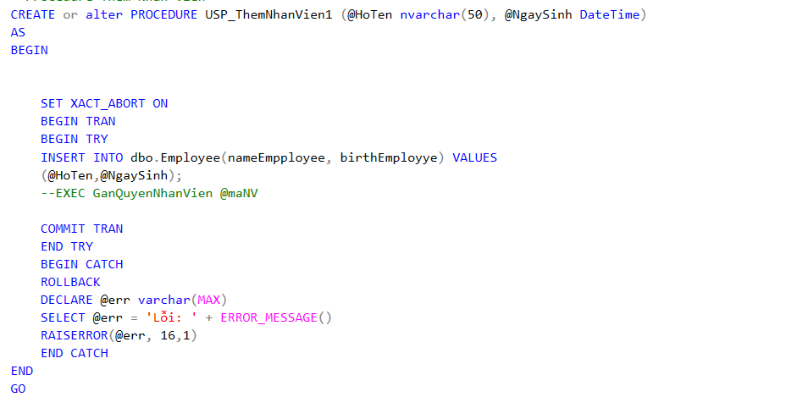

* ➢[Question](https://dictionary.cambridge.org/vi/dictionary/english-vietnamese/question) 11: [Write](https://dictionary.cambridge.org/vi/dictionary/english-vietnamese/write) proc [delete](https://dictionary.cambridge.org/vi/dictionary/english-vietnamese/delete) [employee](https://dictionary.cambridge.org/vi/dictionary/english-vietnamese/employee)

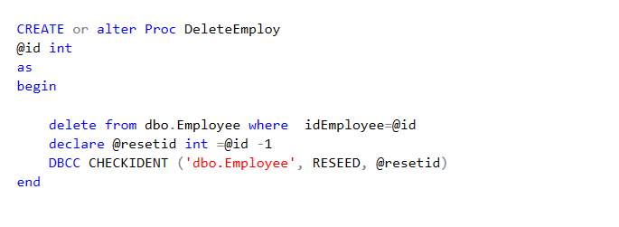

*.*

* ➢[Question](https://dictionary.cambridge.org/vi/dictionary/english-vietnamese/question) 12: [Write](https://dictionary.cambridge.org/vi/dictionary/english-vietnamese/write) proc [check](https://dictionary.cambridge.org/vi/dictionary/english-vietnamese/check) [on](https://dictionary.cambridge.org/vi/dictionary/english-vietnamese/on) working employees

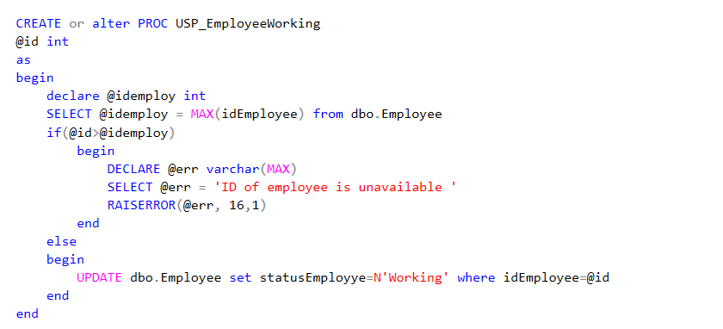

[Question](https://dictionary.cambridge.org/vi/dictionary/english-vietnamese/question) 13: [Write](https://dictionary.cambridge.org/vi/dictionary/english-vietnamese/write) proc [to](https://dictionary.cambridge.org/vi/dictionary/english-vietnamese/to) [calculate](https://dictionary.cambridge.org/vi/dictionary/english-vietnamese/calculate) working [time](https://dictionary.cambridge.org/vi/dictionary/english-vietnamese/time) 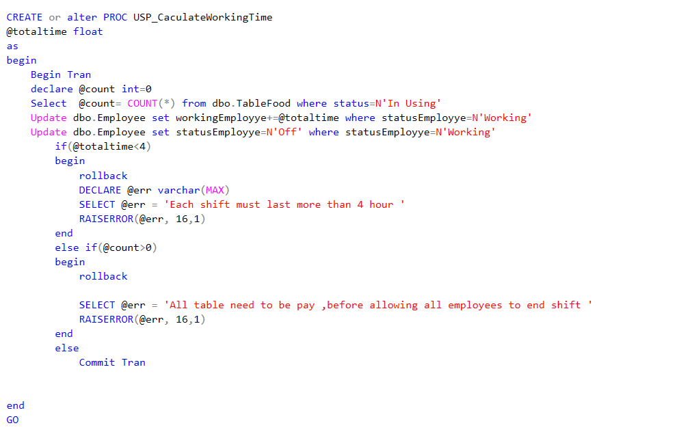

[Question](https://dictionary.cambridge.org/vi/dictionary/english-vietnamese/question) 14: [Write](https://dictionary.cambridge.org/vi/dictionary/english-vietnamese/write) proc [add](https://dictionary.cambridge.org/vi/dictionary/english-vietnamese/add) login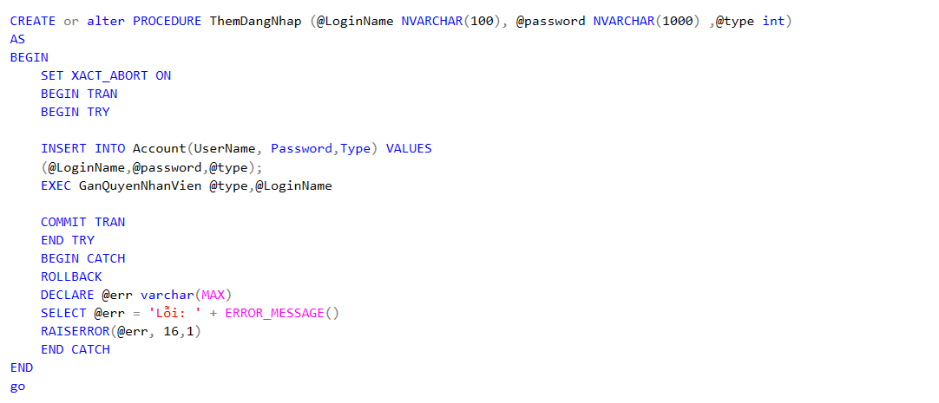

[Question](https://dictionary.cambridge.org/vi/dictionary/english-vietnamese/question) 15: [Write](https://dictionary.cambridge.org/vi/dictionary/english-vietnamese/write) proc [add](https://dictionary.cambridge.org/vi/dictionary/english-vietnamese/add) permissions [to](https://dictionary.cambridge.org/vi/dictionary/english-vietnamese/to) [the](https://dictionary.cambridge.org/vi/dictionary/english-vietnamese/the) [account](https://dictionary.cambridge.org/vi/dictionary/english-vietnamese/account)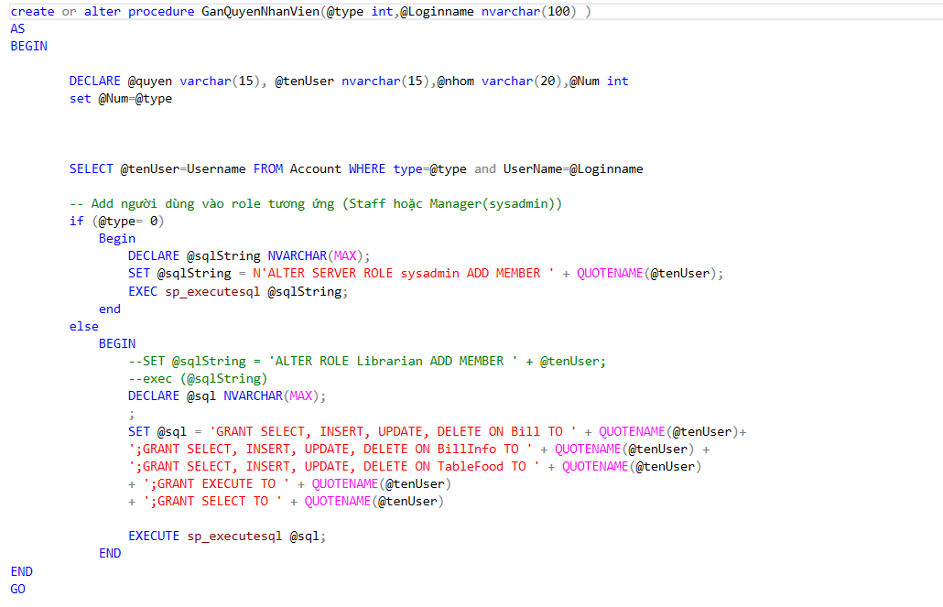

Question 16: [Write](https://dictionary.cambridge.org/vi/dictionary/english-vietnamese/write) proc [delete](https://dictionary.cambridge.org/vi/dictionary/english-vietnamese/delete) login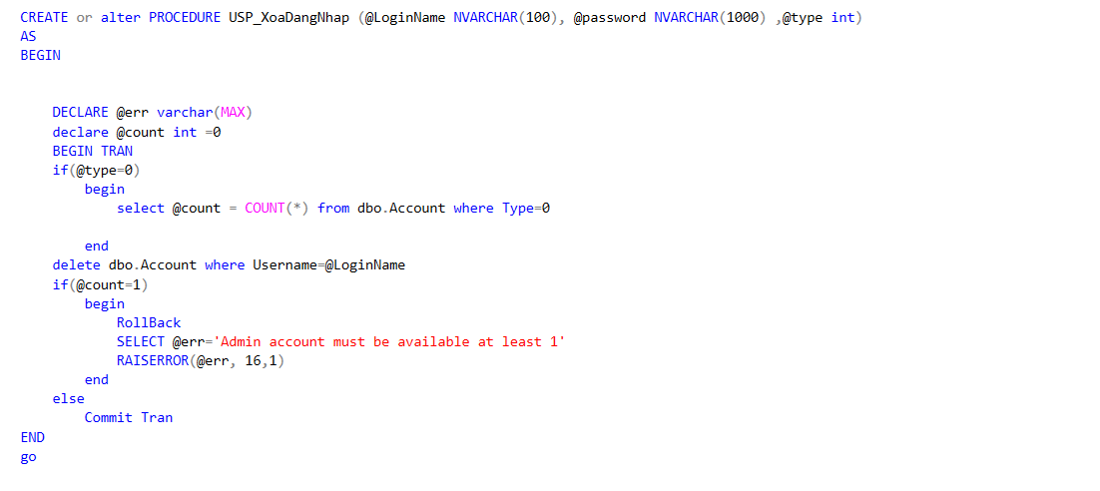

1. **Write Function**

[Question](https://dictionary.cambridge.org/vi/dictionary/english-vietnamese/question) 1: [Write](https://dictionary.cambridge.org/vi/dictionary/english-vietnamese/write) [the](https://dictionary.cambridge.org/vi/dictionary/english-vietnamese/the) [function](https://dictionary.cambridge.org/vi/dictionary/english-vietnamese/function) [to](https://dictionary.cambridge.org/vi/dictionary/english-vietnamese/to) [list](https://dictionary.cambridge.org/vi/dictionary/english-vietnamese/list) [the](https://dictionary.cambridge.org/vi/dictionary/english-vietnamese/the) acount [list](https://dictionary.cambridge.org/vi/dictionary/english-vietnamese/list) [by](https://dictionary.cambridge.org/vi/dictionary/english-vietnamese/by) [type](https://dictionary.cambridge.org/vi/dictionary/english-vietnamese/type)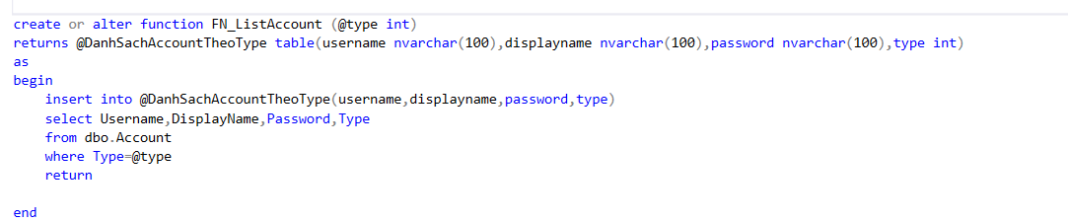

[Question](https://dictionary.cambridge.org/vi/dictionary/english-vietnamese/question" \t "https://dictionary.cambridge.org/vi/translate/_blank" \o "question) 2: [Write](https://dictionary.cambridge.org/vi/dictionary/english-vietnamese/write) [Function](https://dictionary.cambridge.org/vi/dictionary/english-vietnamese/function) [to](https://dictionary.cambridge.org/vi/dictionary/english-vietnamese/to) [list](https://dictionary.cambridge.org/vi/dictionary/english-vietnamese/list) [income](https://dictionary.cambridge.org/vi/dictionary/english-vietnamese/income) [by](https://dictionary.cambridge.org/vi/dictionary/english-vietnamese/by) Checkin [and](https://dictionary.cambridge.org/vi/dictionary/english-vietnamese/and) [check](https://dictionary.cambridge.org/vi/dictionary/english-vietnamese/check) [out](https://dictionary.cambridge.org/vi/dictionary/english-vietnamese/out) [date](https://dictionary.cambridge.org/vi/dictionary/english-vietnamese/date)

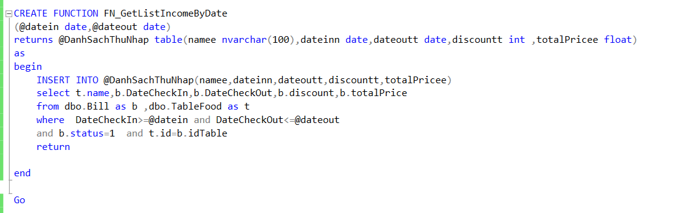

[Question](https://dictionary.cambridge.org/vi/dictionary/english-vietnamese/question) 3: [Write](https://dictionary.cambridge.org/vi/dictionary/english-vietnamese/write) [Function](https://dictionary.cambridge.org/vi/dictionary/english-vietnamese/function) [to](https://dictionary.cambridge.org/vi/dictionary/english-vietnamese/to) [list](https://dictionary.cambridge.org/vi/dictionary/english-vietnamese/list) [Food](https://dictionary.cambridge.org/vi/dictionary/english-vietnamese/income) information from 1 table

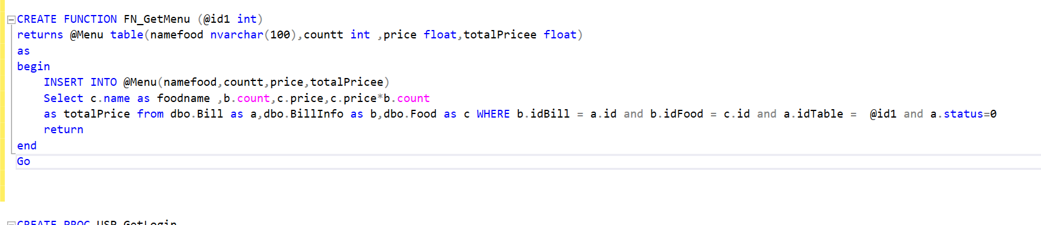

1. **Write Trigger**

➢[Question](https://dictionary.cambridge.org/vi/dictionary/english-vietnamese/question) 1: [Write](https://dictionary.cambridge.org/vi/dictionary/english-vietnamese/write) [a](https://dictionary.cambridge.org/vi/dictionary/english-vietnamese/a) [table](https://dictionary.cambridge.org/vi/dictionary/english-vietnamese/table) [status](https://dictionary.cambridge.org/vi/dictionary/english-vietnamese/status) [update](https://dictionary.cambridge.org/vi/dictionary/english-vietnamese/update) [trigger](https://dictionary.cambridge.org/vi/dictionary/english-vietnamese/trigger) [to](https://dictionary.cambridge.org/vi/dictionary/english-vietnamese/to) [In](https://dictionary.cambridge.org/vi/dictionary/english-vietnamese/in) Using [with](https://dictionary.cambridge.org/vi/dictionary/english-vietnamese/with) [the](https://dictionary.cambridge.org/vi/dictionary/english-vietnamese/the) [newly](https://dictionary.cambridge.org/vi/dictionary/english-vietnamese/newly) [added](https://dictionary.cambridge.org/vi/dictionary/english-vietnamese/added) [Bill](https://dictionary.cambridge.org/vi/dictionary/english-vietnamese/bill) [of](https://dictionary.cambridge.org/vi/dictionary/english-vietnamese/of) 1 [table](https://dictionary.cambridge.org/vi/dictionary/english-vietnamese/table)

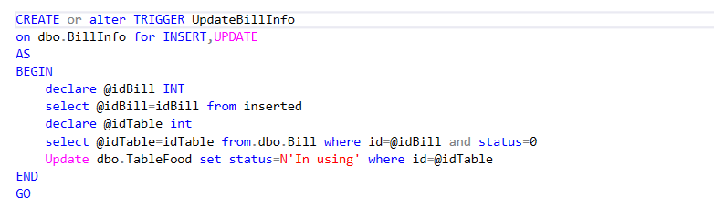

[Question](https://dictionary.cambridge.org/vi/dictionary/english-vietnamese/question) 2: [write](https://dictionary.cambridge.org/vi/dictionary/english-vietnamese/write) [the](https://dictionary.cambridge.org/vi/dictionary/english-vietnamese/the) [trigger](https://dictionary.cambridge.org/vi/dictionary/english-vietnamese/trigger) [to](https://dictionary.cambridge.org/vi/dictionary/english-vietnamese/to) [update](https://dictionary.cambridge.org/vi/dictionary/english-vietnamese/update) [the](https://dictionary.cambridge.org/vi/dictionary/english-vietnamese/the) [status](https://dictionary.cambridge.org/vi/dictionary/english-vietnamese/status) [of](https://dictionary.cambridge.org/vi/dictionary/english-vietnamese/of) [the](https://dictionary.cambridge.org/vi/dictionary/english-vietnamese/the) [table](https://dictionary.cambridge.org/vi/dictionary/english-vietnamese/table) [to](https://dictionary.cambridge.org/vi/dictionary/english-vietnamese/to) [Free](https://dictionary.cambridge.org/vi/dictionary/english-vietnamese/free) [with](https://dictionary.cambridge.org/vi/dictionary/english-vietnamese/with) [Bill](https://dictionary.cambridge.org/vi/dictionary/english-vietnamese/bill) [who](https://dictionary.cambridge.org/vi/dictionary/english-vietnamese/who) has been [paid](https://dictionary.cambridge.org/vi/dictionary/english-vietnamese/pay) [at](https://dictionary.cambridge.org/vi/dictionary/english-vietnamese/at) [that](https://dictionary.cambridge.org/vi/dictionary/english-vietnamese/that) [table](https://dictionary.cambridge.org/vi/dictionary/english-vietnamese/table)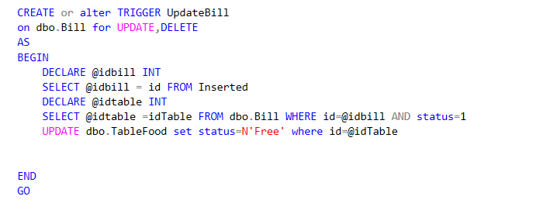

[Question](https://dictionary.cambridge.org/vi/dictionary/english-vietnamese/question) 3: [write](https://dictionary.cambridge.org/vi/dictionary/english-vietnamese/write) [a](https://dictionary.cambridge.org/vi/dictionary/english-vietnamese/a) [trigger](https://dictionary.cambridge.org/vi/dictionary/english-vietnamese/trigger) [to](https://dictionary.cambridge.org/vi/dictionary/english-vietnamese/to) [create](https://dictionary.cambridge.org/vi/dictionary/english-vietnamese/create) [a](https://dictionary.cambridge.org/vi/dictionary/english-vietnamese/a) Login [account](https://dictionary.cambridge.org/vi/dictionary/english-vietnamese/account) [on](https://dictionary.cambridge.org/vi/dictionary/english-vietnamese/on) [the](https://dictionary.cambridge.org/vi/dictionary/english-vietnamese/the) [Database](https://dictionary.cambridge.org/vi/dictionary/english-vietnamese/database)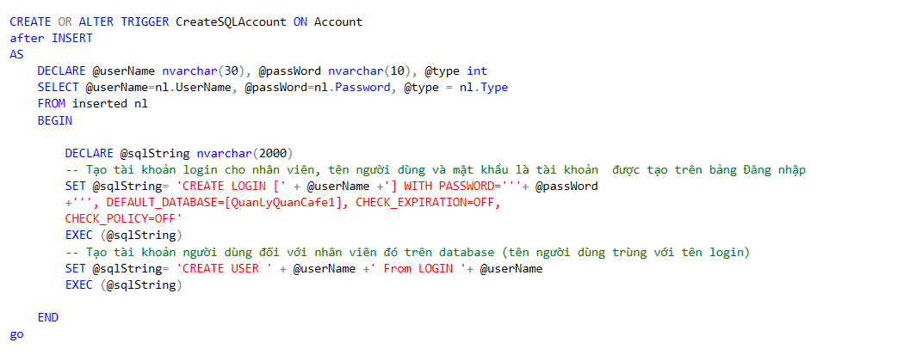

➢[Question](https://dictionary.cambridge.org/vi/dictionary/english-vietnamese/question) 4: [Write](https://dictionary.cambridge.org/vi/dictionary/english-vietnamese/write) [trigger](https://dictionary.cambridge.org/vi/dictionary/english-vietnamese/trigger) [to](https://dictionary.cambridge.org/vi/dictionary/english-vietnamese/to) [delete](https://dictionary.cambridge.org/vi/dictionary/english-vietnamese/delete) Login [account](https://dictionary.cambridge.org/vi/dictionary/english-vietnamese/account) [on](https://dictionary.cambridge.org/vi/dictionary/english-vietnamese/on) [Database](https://dictionary.cambridge.org/vi/dictionary/english-vietnamese/database) 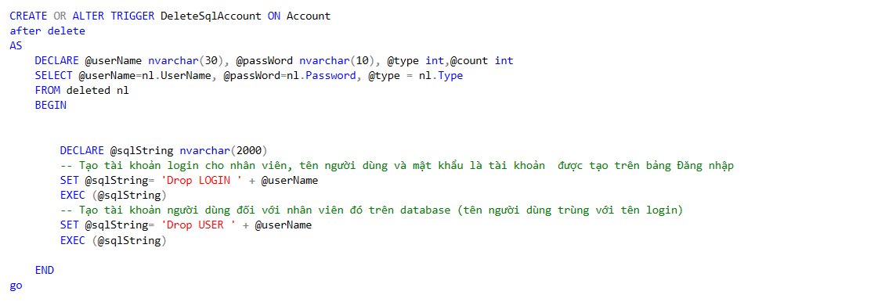

1. **Write View**

* [Question](https://dictionary.cambridge.org/vi/dictionary/english-vietnamese/question) 1: [Write](https://dictionary.cambridge.org/vi/dictionary/english-vietnamese/write) [a](https://dictionary.cambridge.org/vi/dictionary/english-vietnamese/a) [view](https://dictionary.cambridge.org/vi/dictionary/english-vietnamese/view) showing [the](https://dictionary.cambridge.org/vi/dictionary/english-vietnamese/the) [list](https://dictionary.cambridge.org/vi/dictionary/english-vietnamese/list) [of](https://dictionary.cambridge.org/vi/dictionary/english-vietnamese/of) employees working

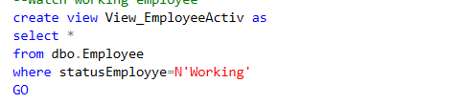

➢[Question](https://dictionary.cambridge.org/vi/dictionary/english-vietnamese/question) 2: [Write](https://dictionary.cambridge.org/vi/dictionary/english-vietnamese/write) [a](https://dictionary.cambridge.org/vi/dictionary/english-vietnamese/a) [view](https://dictionary.cambridge.org/vi/dictionary/english-vietnamese/view) showing [the](https://dictionary.cambridge.org/vi/dictionary/english-vietnamese/the) [list](https://dictionary.cambridge.org/vi/dictionary/english-vietnamese/list) [of](https://dictionary.cambridge.org/vi/dictionary/english-vietnamese/of) accounts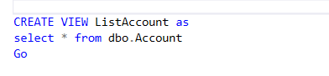

**CHAPTER 4. CONCLUSION**

1. **Advantages:**

* During the survey of the basic restaurant management project, the following tasks have been completed:
* Updating, storing, adding information:
* Employee
* Admin account
* Food
* Food category
* Bill
* Bill info
* Employee account
* Apply stored procedure, function, trigger, view, transaction, index to add, delete, edit, search, display list of entities.

1. **Disadvantages**

The restaurant management program has many limitations. This management problem only applies to small-scale restaurants, due to the characteristics of each restaurant, the management is different. Here, our group only learns about small restaurants, so it only applies to management work in similar restaurants. In the process of building and completing the program, I noticed that the program has many shortcomings such as:

- The database system is not thorough

- Data security is not high

- The program lacks many functions such as: management of Employee’s each month,management of salary for each Employee’s position

- The interface is not optimized for users.

1. **Direction of development and improvement:**

Add more functions to the hub. Show the center's revenue at a certain time. Optimizing the program and building a central information supply system and online booking.

REFERENCES

1. <https://www.c-sharpcorner.com/UploadFile/dacca2/understand-3-tier-architecture-in-C-Sharp-net/>
2. <https://morioh.com/p/b09b8fe98913>
3. <https://www.codeproject.com/Messages/2522344/Add-a-button-to-FlowLayoutPanel-at-a-specified-loc.aspx>
4. <https://hktsoft.com/cach-phan-quyen-cho-nguoi-dung-trong-ms-sql-server/>