**LOCAL**

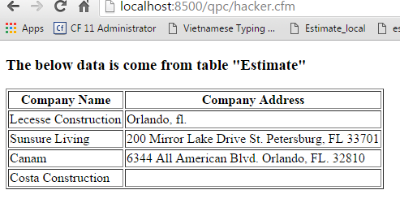

=======================================================================================

**REMOTE**

[**http://qpc.phamhomesite.com/hacker.cfm**](http://qpc.phamhomesite.com/hacker.cfm)

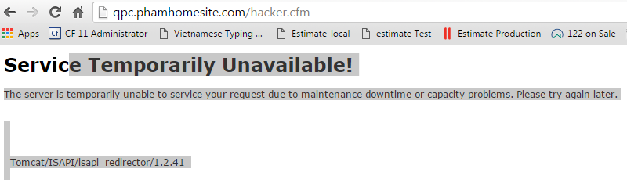

=====================================================================================

**DOMAIN SETTINGS**

