**Activity Diagram**

# Activity diagram “view list user”.

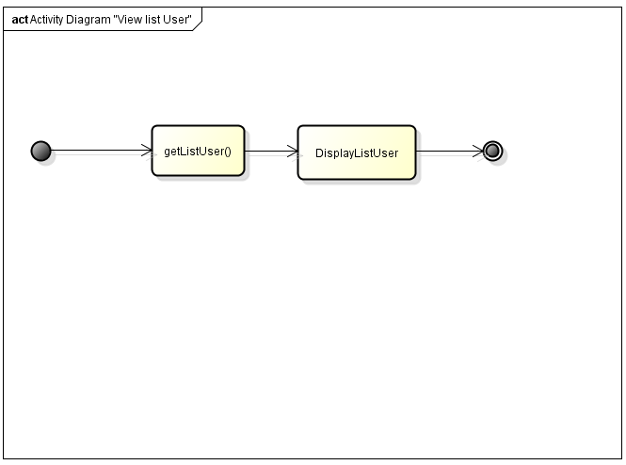

# Activity diagram “Search User”.

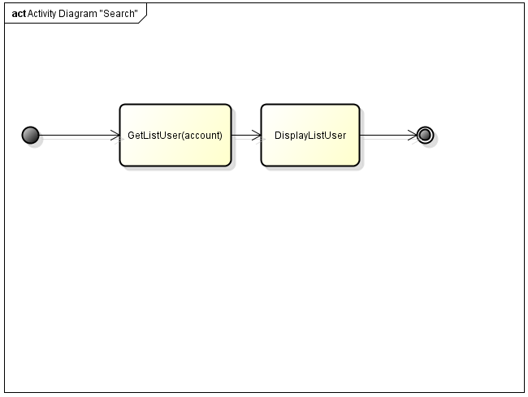

# Activity diagram “Delete user”.

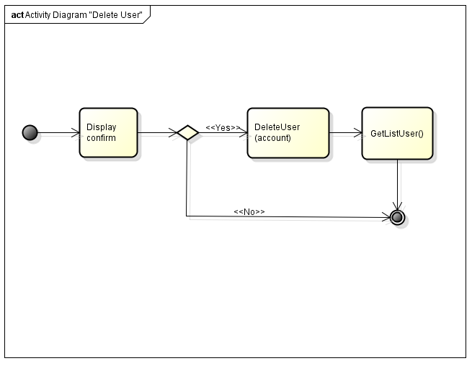

# Activity diagram “Add user”

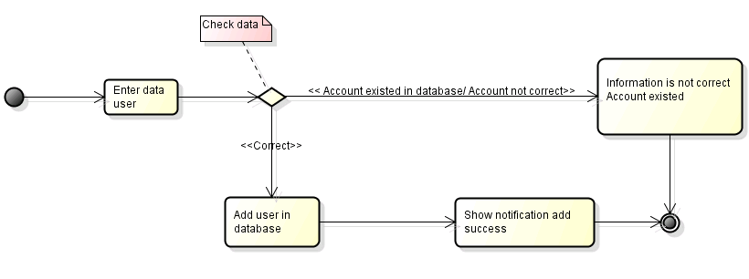

# Activity diagram ”Edit user”

