**ACTIVITY DIAGRAM**

# 1.1 Usecase49 – Login

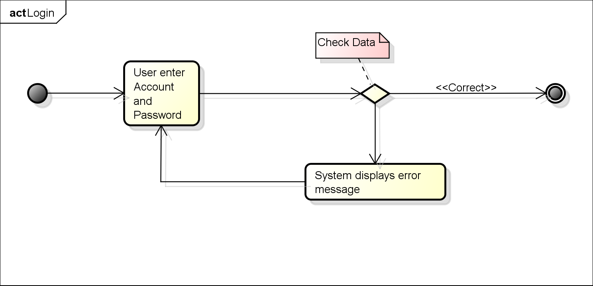

# 1.2 Usecase07 – Search, View Interviewer

