**SEQUENCE DIAGRAM**

# 1.1 Usecase49 - Login

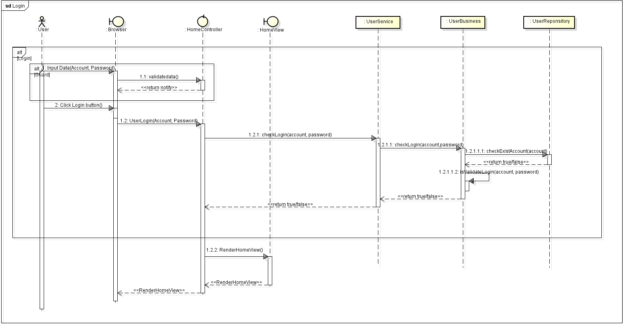

# 1.2 Usecase07 – Search, View Interviewer

