1. **Skill sequence diagram**
   1. 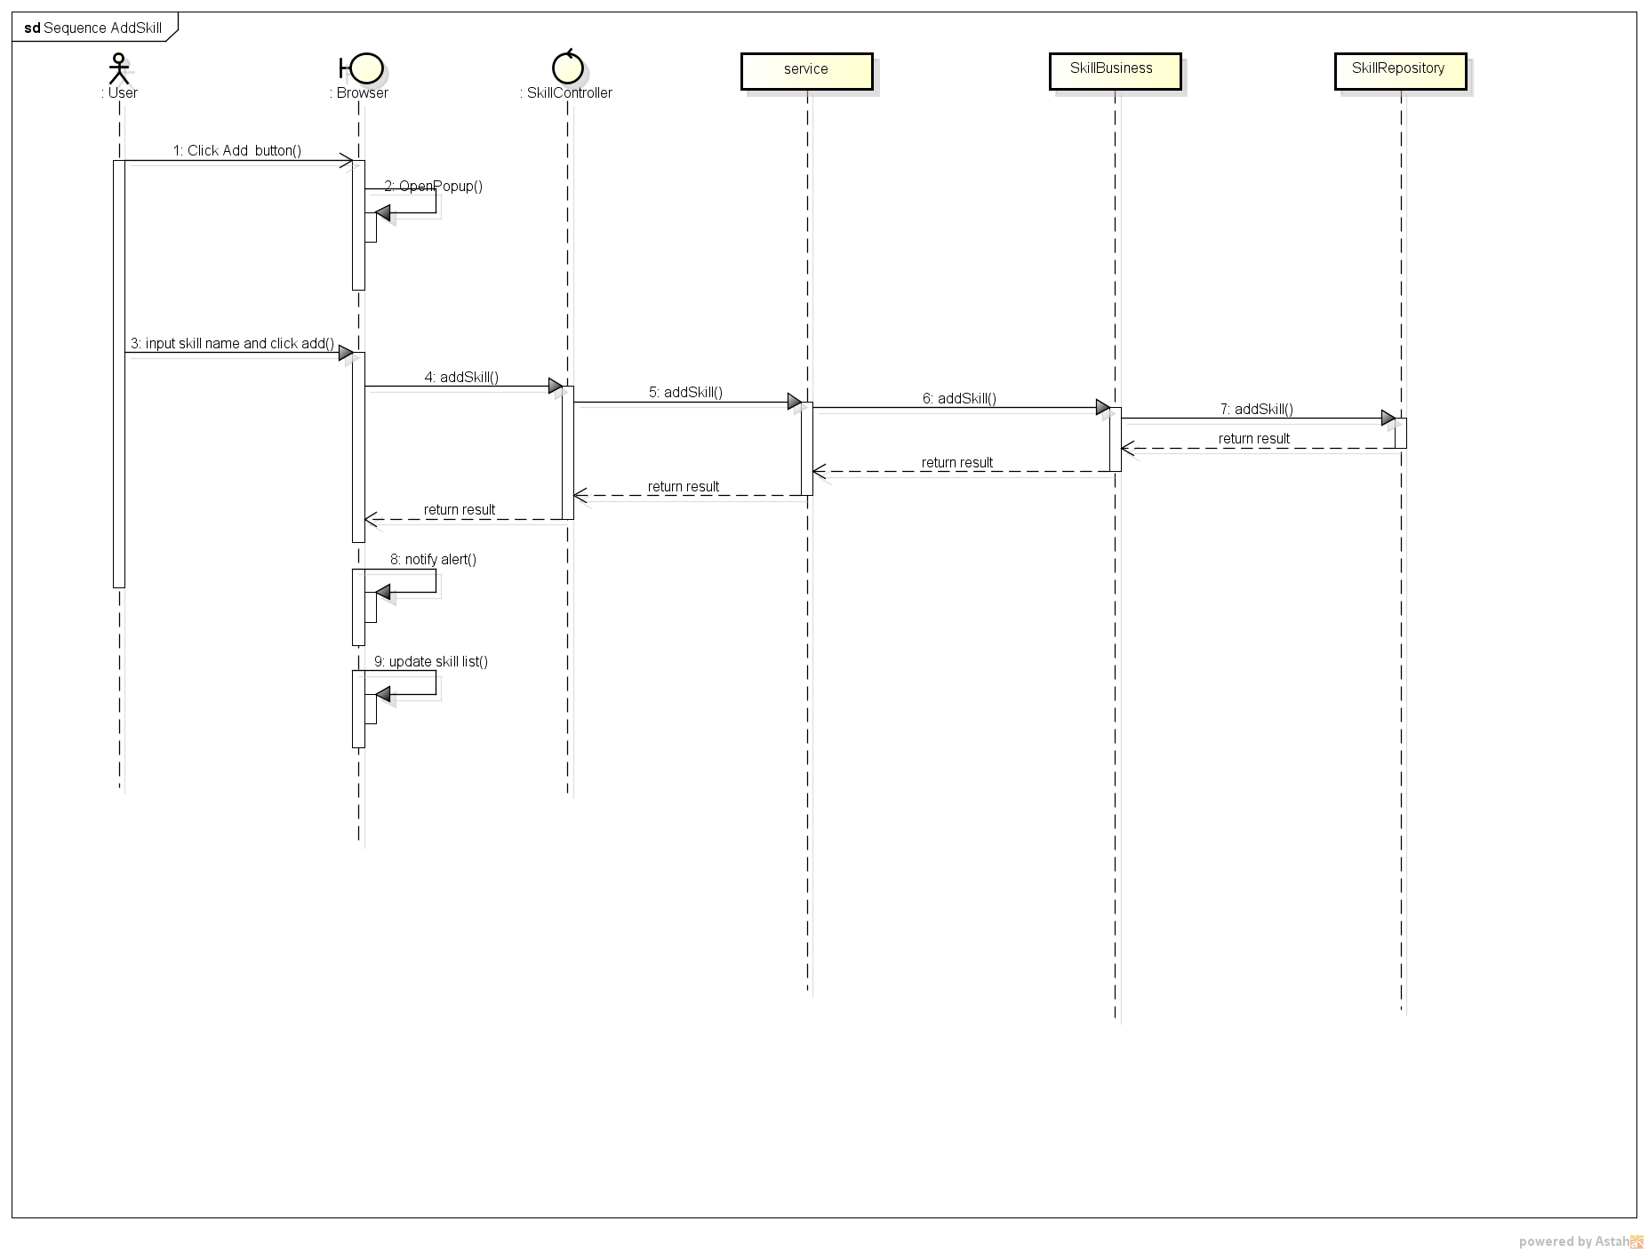***Add skill***
   2. ***Delete skill***

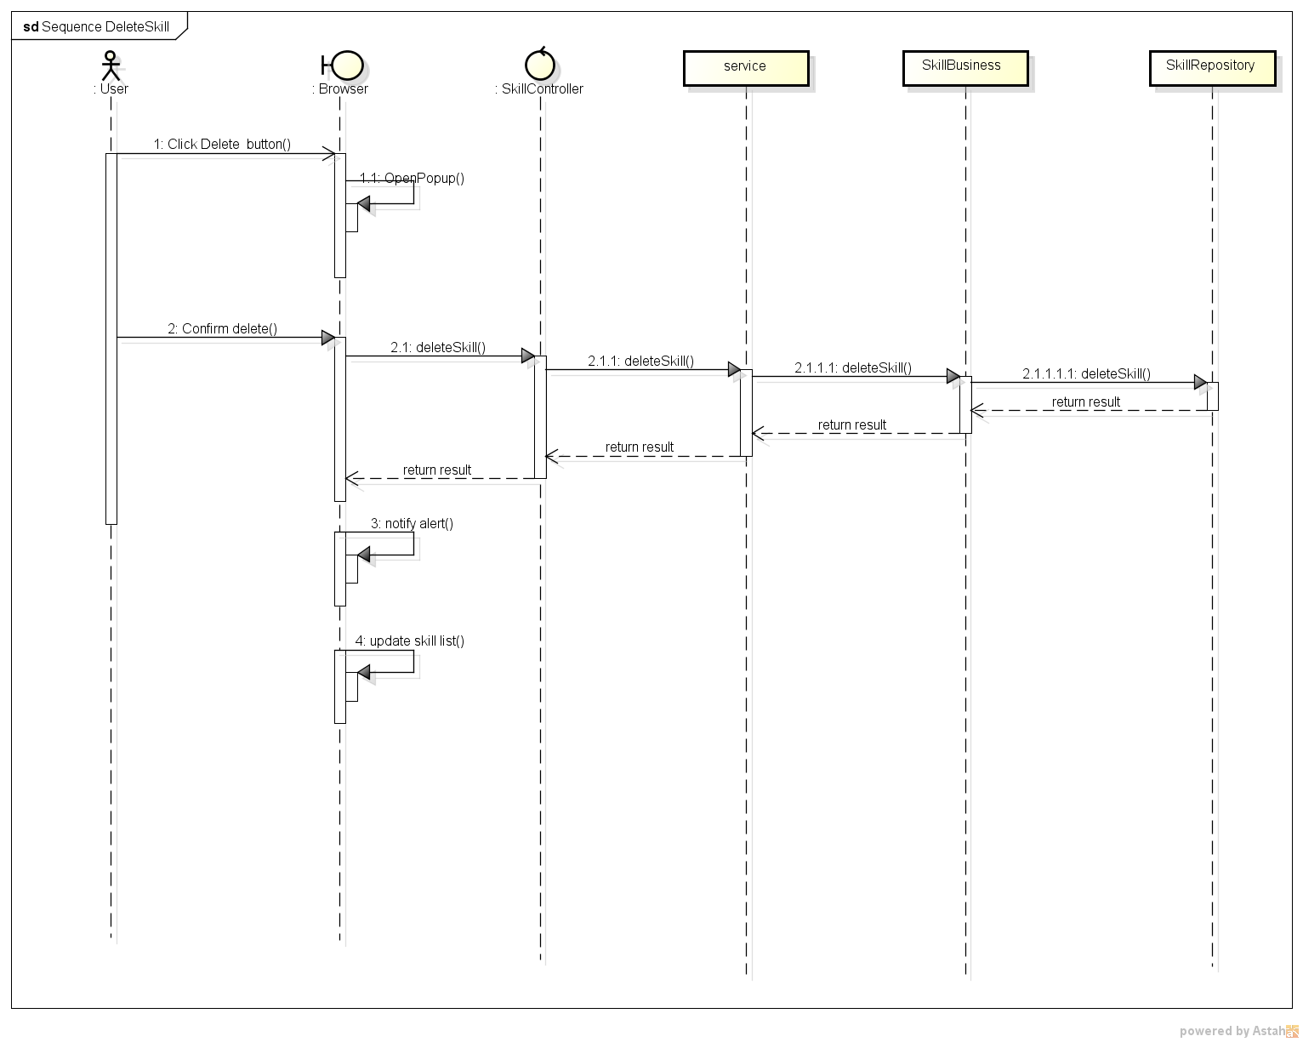

* 1. ***Edit skill***

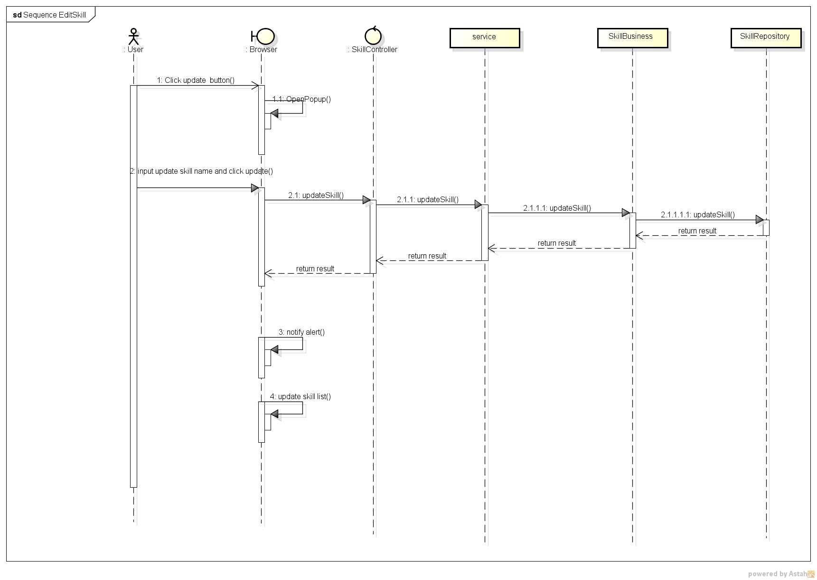

1. **Position sequence diagram**
   1. ***Add position***

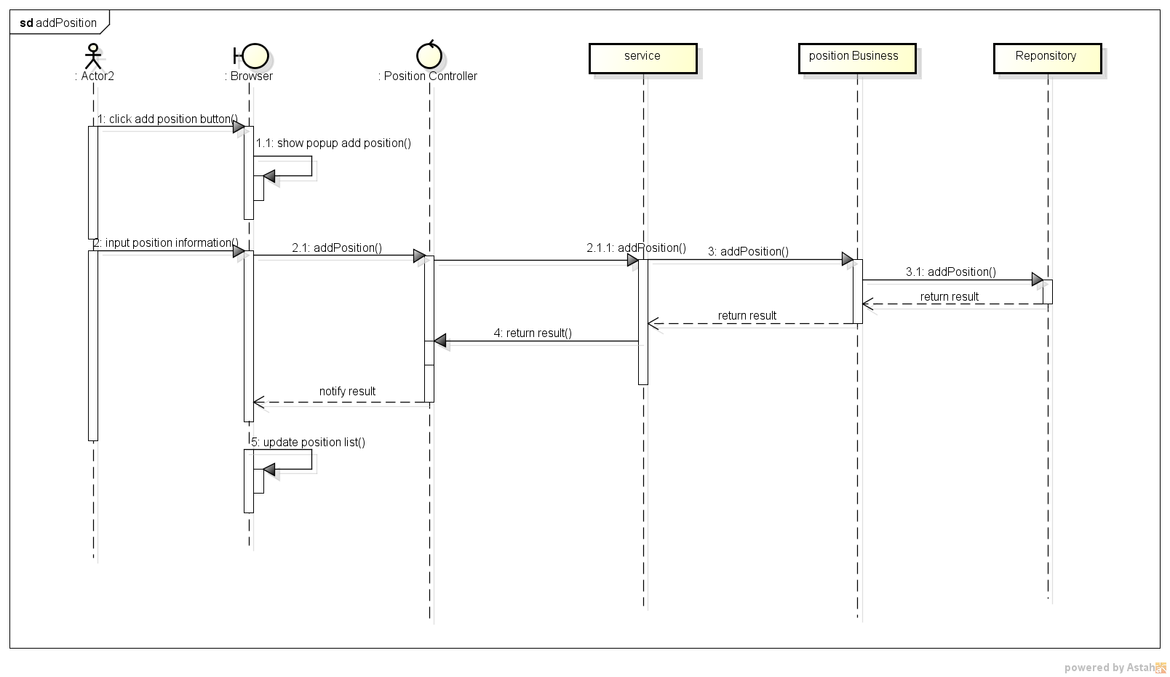

* 1. ***Delete position***

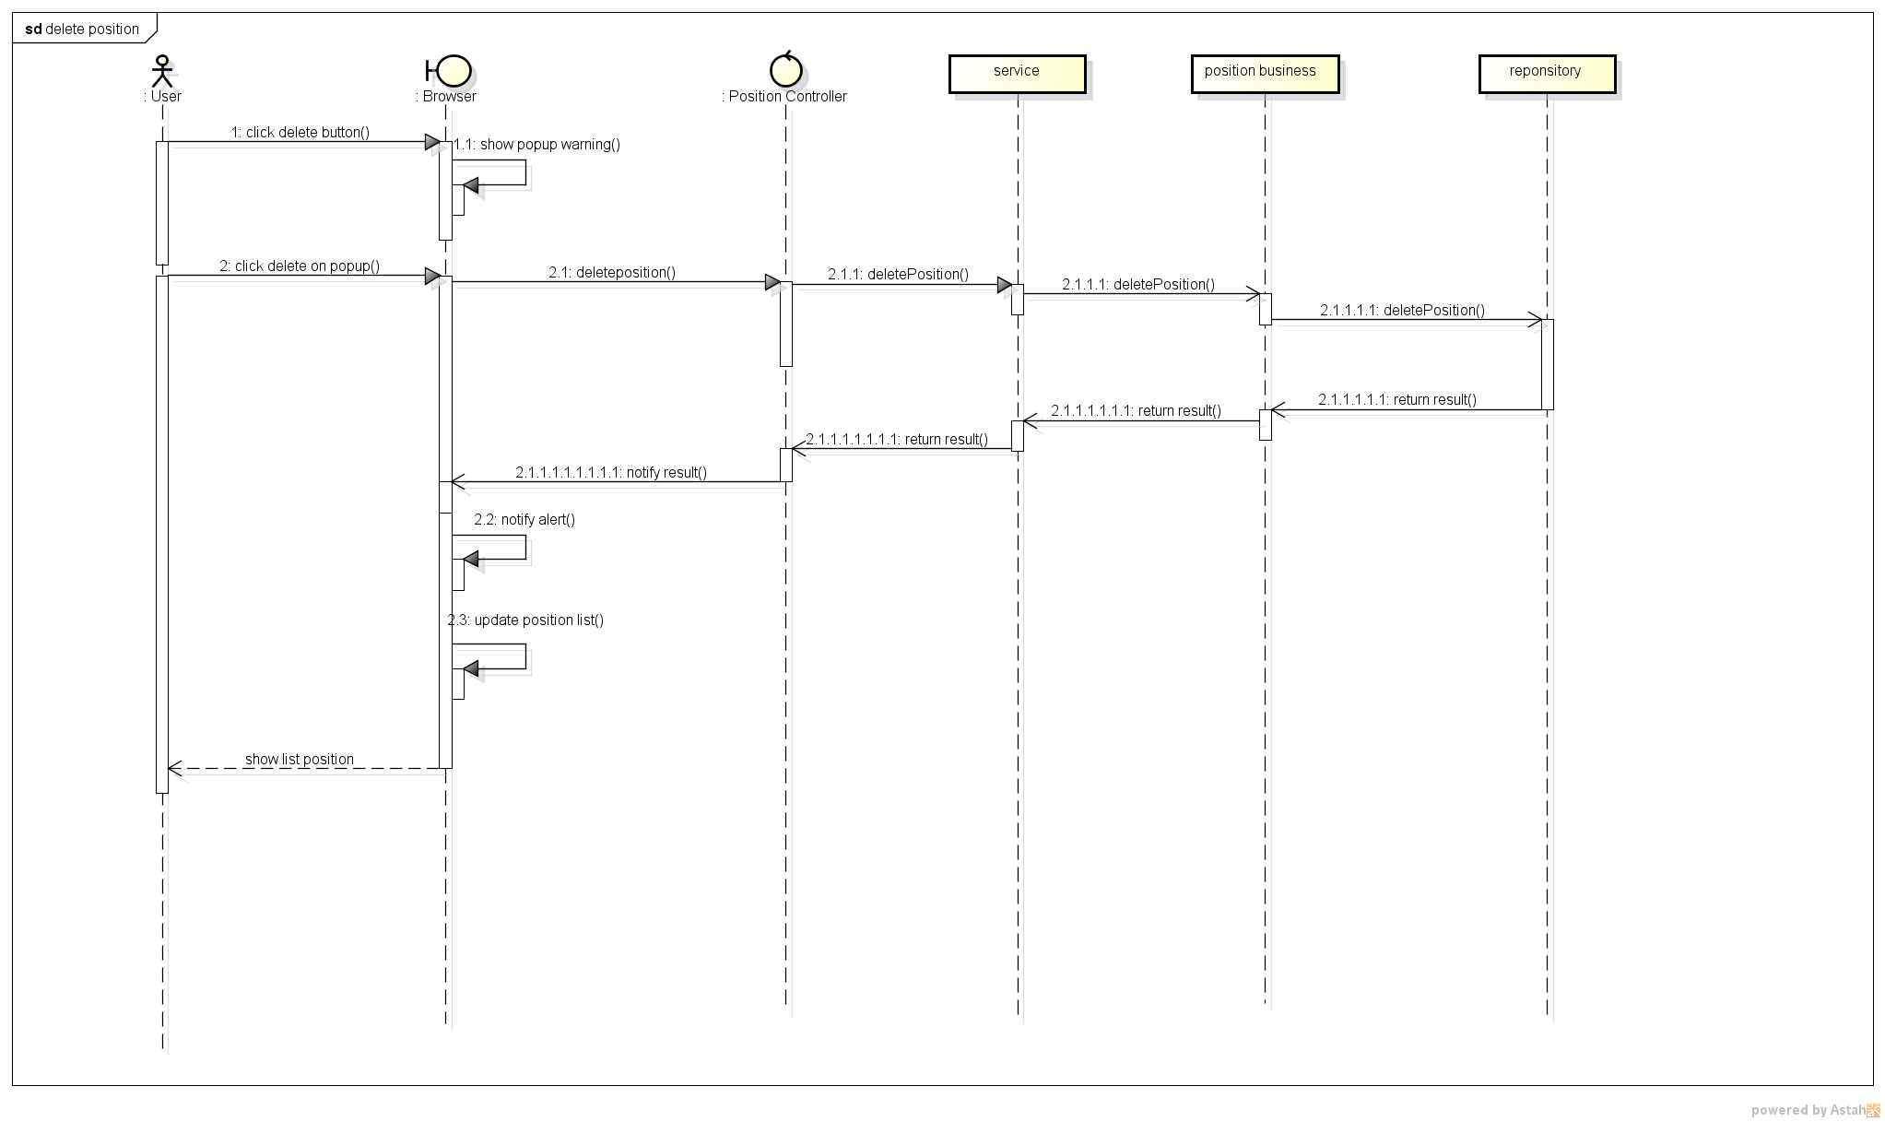

* 1. ***Edit position***

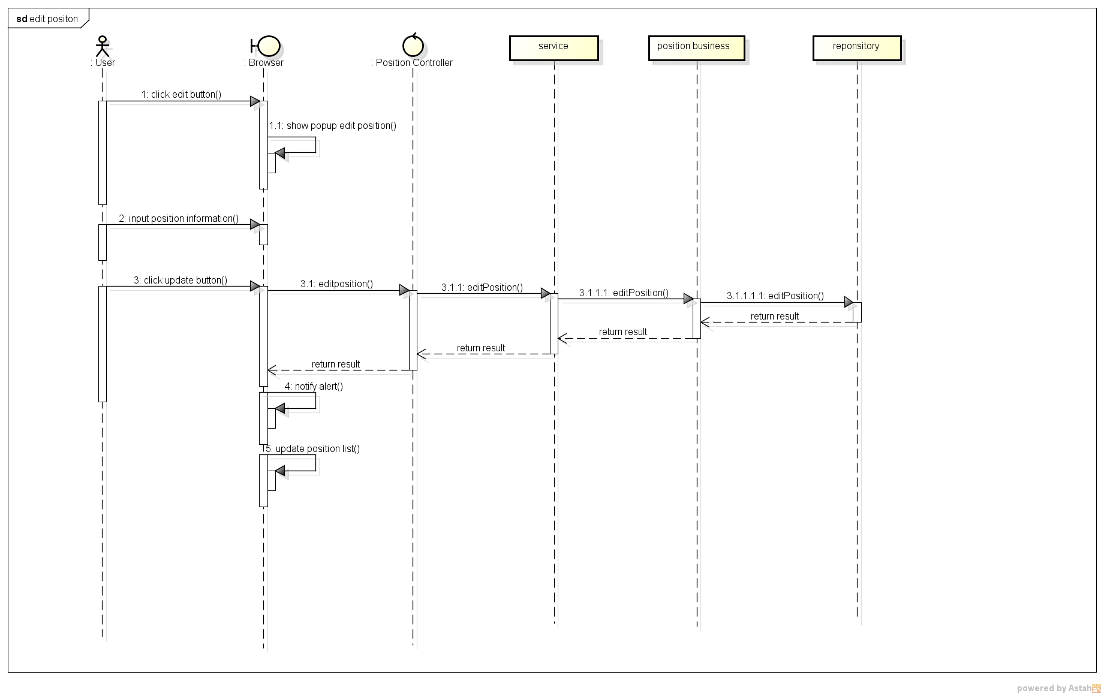

1. **Interview Admin sequence diagram**
   1. ***Transmit candidate***

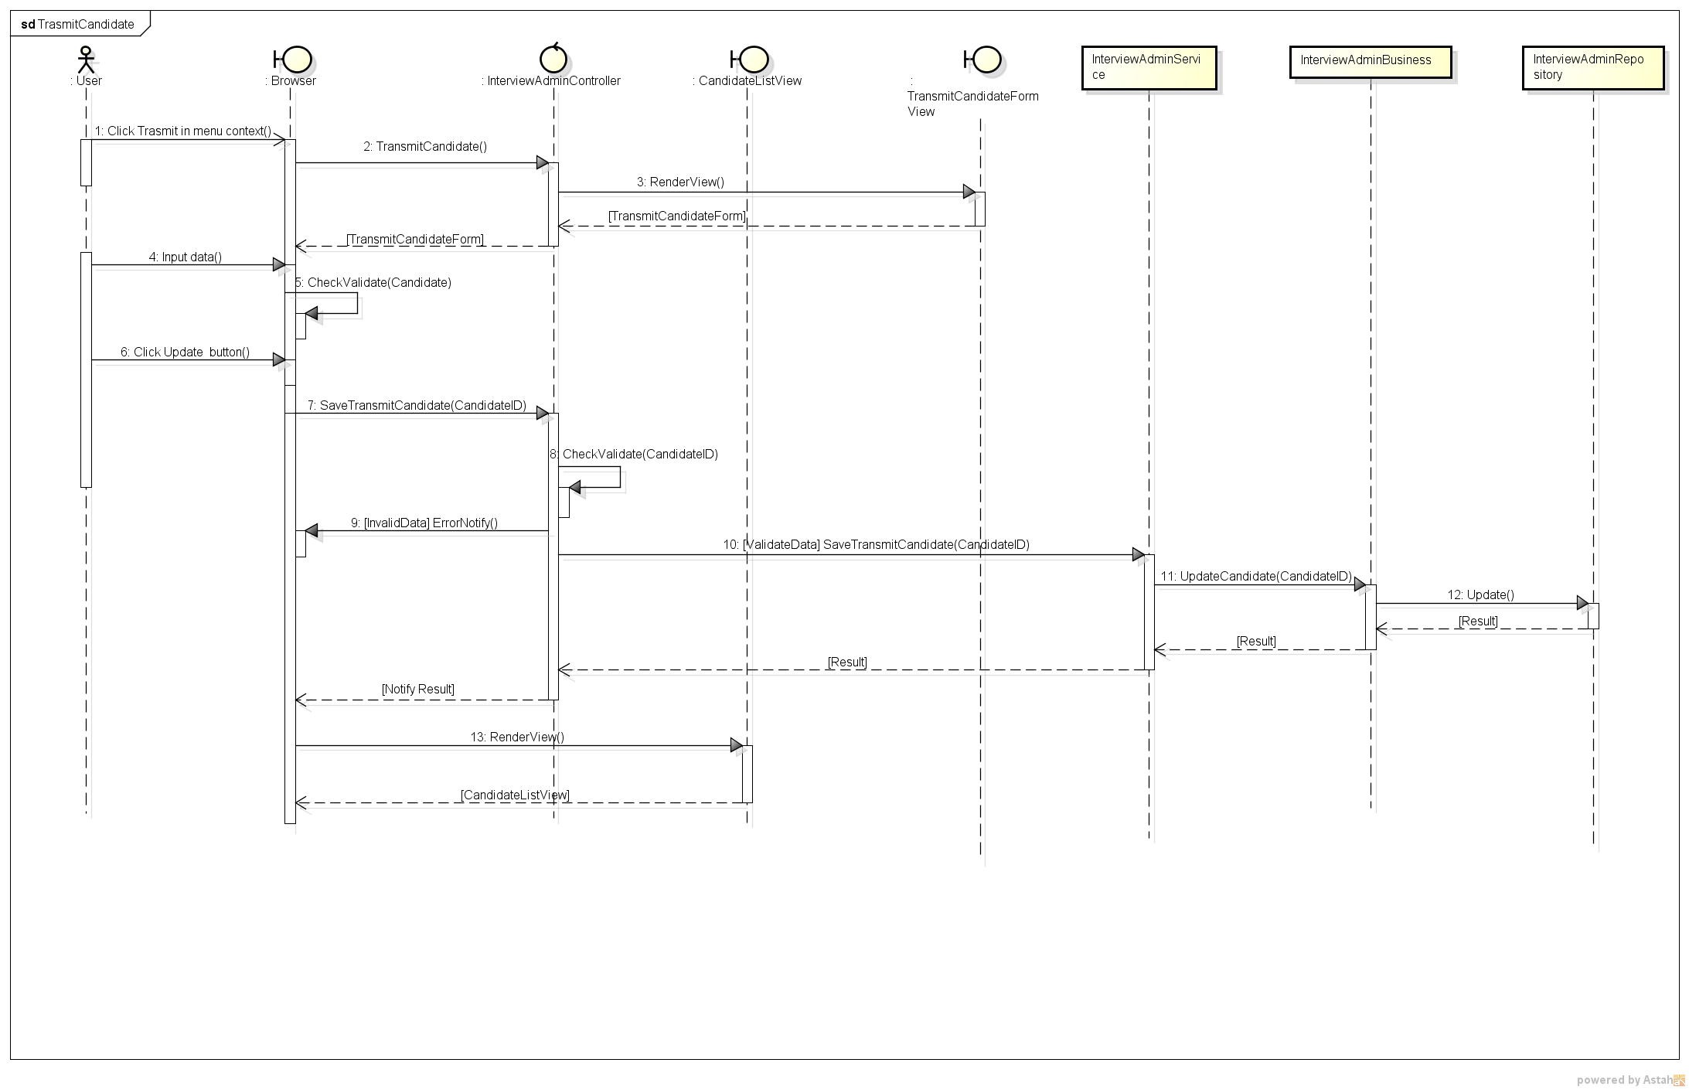

* 1. ***View list interview admin***

