**Thực Hành BigData**

**Buổi 2**

**Lab 6 :** Flajolet-Martin Algorithm

**Code** :

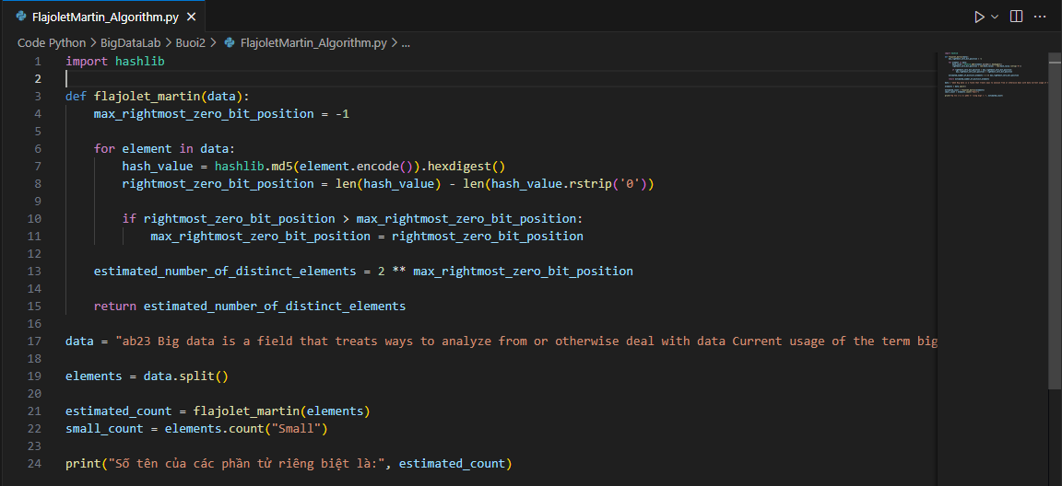

**Result**:



**Lab7**: Install Apache Pig

**Install Pig:** <https://downloads.apache.org/pig/pig-0.17.0/pig-0.17.0.tar.gz>

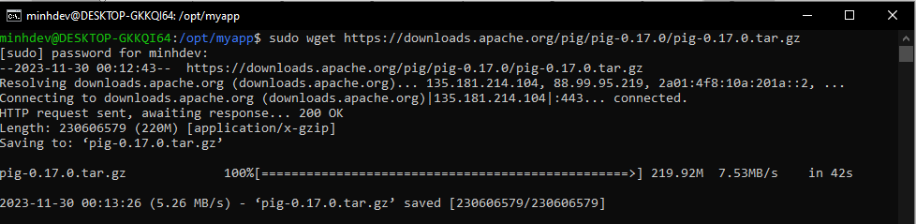

**Tar File Pig:**

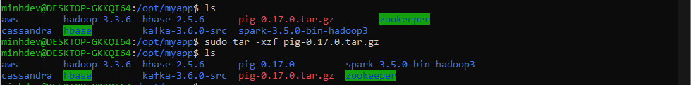

**Move File Pig:** sudo mv pig-0.17.0 /usr/local/pig

**Add Path:**

**export PIG_HOME=/usr/local/pig**

**export PATH=$PATH:$PIG_HOME/bin**

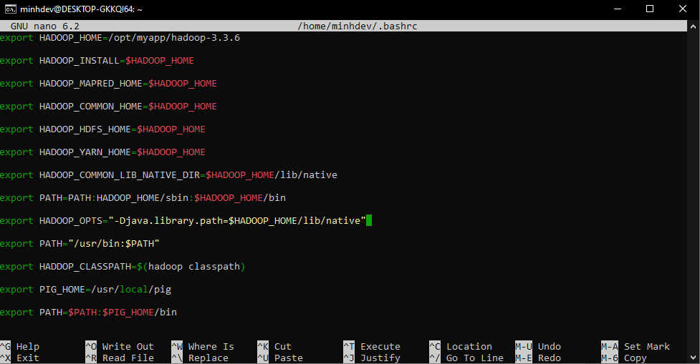

**Apply Changes: source ~/.bashrc**

**Test Apache Pig:**

