**Homework Assignment #4**

**(Uninformed Search –Depth First Search (DFS), Breadth First Search (BFS), Unified Cost Search (UCS))**

**CS 156 Fall 2020**

The objective of this homework assignment is to understand and visualize how different uninformed search algorithms work. Specifically, we will implement and compare the performance of three different uninformed search algorithms:

1. Depth First Search (DFS)
2. Breadth First Search (BFS)
3. Uniform Cost Search (UCS)

We will explore these algorithms in a gaming environment where the Spartan Sammy will try to collect medals in a maze in the shortest possible time.

These are the following files for this assignment:

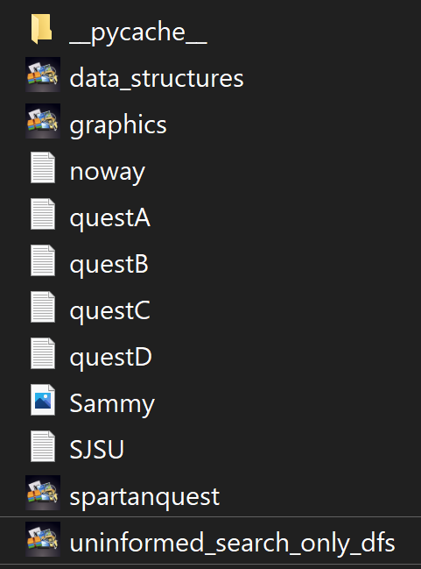

1. data_structures contains all the Class definitions for data structures to be used by the search algorithms
2. graphics contains Visualization of the maze and solution for the Spartan's quest
3. noway, questA, questB, questC, questD and SJSU are txt files containing the description of different mazes with walls, starting position of Sammy and the starting positions of the medals that will be collected by Sammy
4. Sammy is the Spartan (mascot).
5. Spartanquest has the Main program that guides Sammy the Spartan on a quest within a given maze. It is invoked using: spartanquest.py maze_file search_algoritm where

The maze_file is a text file such as SJSU.txt

The search_algorithm in homework 4 is:

dfs: for depth first search (coded for you)

bfs: for breadth first search

ucs for uniform cost search

Example: spartanquest.py SJSU.txt dfs

1. Uninformed_search_only_dfs has the implementation of the dfs algorithm and place holders for bfs and ucs algorithms that you have to write for this homework assignment.

**Summarize your observations in terms of:**

1. Which search algorithm performed the best ?
2. Did the performance of the algorithms vary with the type of the maze file?