



1. **Database Design**

**1. ERD Diagrams**

The entity relational diagram visually describes the database conceptual and logical design for the project’s specific requirements. Our ERD was drawn using draw.io and exported as a PNG file. Since the file’s drawing was quite large, therefore, zoom-in with a higher rate would be recommended. Each entity is marked with square brackets, attributes are marked with pill-shaped, and non-relational documents are marked using classes. Attributes with red color are primary keys and blue colors are foreign keys.

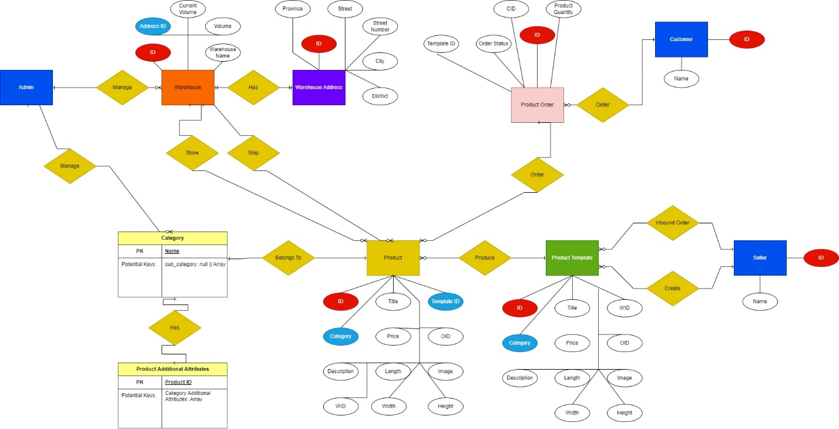

Explanation will be provided to elaborate the relationships between entities provided in the diagram above as follow from left to right and top to bottom:

* Each customer can make one or many orders
* Each product order can consume/order one or many products
* Each product belongs to one single category
* Each product can have additional attributes of the category it belongs to
* A warehouse can store one or many products, as long as its volume is sufficient
* A warehouse can ship one or many products
* A product template can produce one or many products based on the inbound order quantity of seller
* A seller can create one or many product templates
* A seller can make one or many inbound orders using created product template(s)
* An admin can manage warehouses with full CRUD support
* An admin can manage categories with full CRUD support

The above ERD can be translated into the following Relational Schema to better show the table structures:

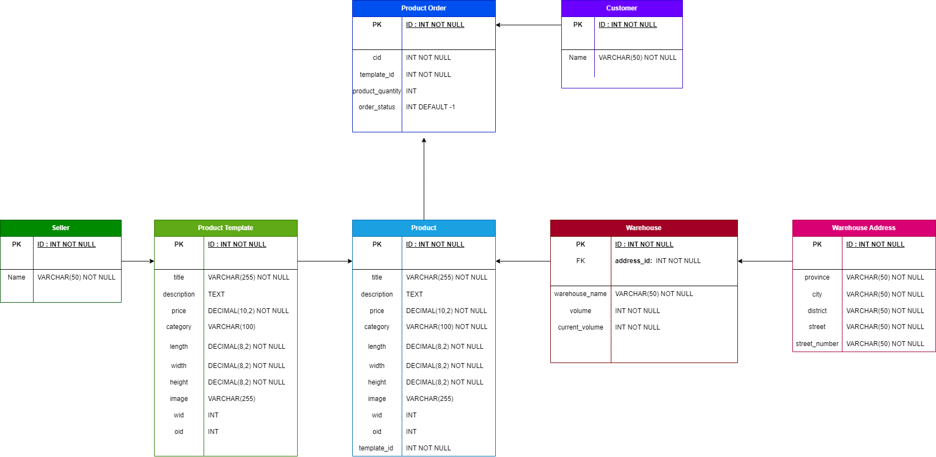

This section will further explain and clarify the data analysis and database design that our team has implemented in this project.

Since there is a special step when a seller can make an inbound order to order many products, we think it is much more appropriate to first let the user create their product template using the **product_template** table, so these templates can be supported with read, update, and delete operations. A template can be updated & deleted if and only if this template currently has no products left to keep product consistency in the database. This table will act as a prototype to create products. Created products will have a one-to-one relationship with the product_template, like one factory’s supply chain can create many products, before the supply chain’s prototype is changed.

When the seller wants to order products, they will specify the quantity, and the server will create the requested products. Each product will get similar information that can’t be updated by the seller later because in the real world, created products can’t change their physical structures. However, since they are real instances, they will have a distinctive **id** in the **product** table. Therefore, these products can be read and deleted, but not updated. We believe this would help product ordering and product management much easier.

Each created product will get stored to a warehouse that has the most available volume. When all warehouses are full, the extra product will have the warehouse ID set to null, and these products will be sent to admin, so admin can choose to move them to the warehouse when volumes are available later, or discard them (sending them back to the seller). We discussed discarding excess products in the first place by terminating them when volume exceeded, however, this approach would add an interesting feature to our application.

Each warehouse’s address will be vertically partitioned into another table **warehouse_address** (mySQL doesn’t support vertical partition) so the database is much more organized.

When a customer orders products, our team will use the **template_id** attribute of the **product** table to let the user order many items at the same time. For each template in the cart, there will be a new order added into the product table. For instance, in the cart, the customer may have 3 different templates, then there will be 3 orders made to fulfill the customer’s cart. Essentially, when these products are added to a customer cart, these products won’t be available to other customers. In the future development, these orders can have a set amount of time before expiration and returned to their original warehouses rather than waiting for the customer to accept/reject the whole cart order. One of the examples is duong sat viet nam (https://dsvn.vn) where they allow customers to reserve the train ticket for 500 seconds before the ticket is released and be available to other customers.

By having the attribute **oid** in the table product not constrained and nullable, we can simply make a many to one relationship between products and an order by setting **oid** of each product to the current order. When the customer accepts the order, then all these products with current order id will be removed from the warehouse. Otherwise, we just need to set those **oid** columns back to null.

**2. Constraint Relationships**

In this project, our team wanted to have flexibility on **product** table’s order tracking and warehouse tracking. Specifically, sellers can make as many inbound orders as they want, and the extra products that have not been stored in any warehouse due to insufficient storage will be sitting on a wait-list. This wait-list can be viewed by the admin and the admin can decide to either move these waiting products to any warehouse that has volume availability after, or decline the waiting product.

Therefore, there is one foreign key constraint only in the **warehouse** table where a warehouse must have an address id that references an id in the **warehouse_address** table.

Last but not least, all tables have a primary key constraint using the **id** column.

**3. Non-relational documents**

In this project, MongoDB was used as a non-relational database to store a **category** table/collection. Additionally, it also stores a **product_template** collection that purposefully stores created products with their additional attributes inherited from the **category** the product belongs to. Because the categories can have dynamic attributes and structures, therefore, a non-relational database is needed.

As described in the ERD above, each category will mainly have a **name** as primary key, with potential **sub_category** attribute if there are sub categories. Any additional attributes will have a key that represents their name, and the value can either be text or number, required or not required. The documentation follows the **BSON/JSON** format. An example for this would be:

{

“phone” : {

type: “text/number”,

require: true/false

}

}

Combining with the name primary key column, we can have a category structure as follow:

{

“name: “electronic”,

“phone” : {

type: “text/number”,

require: true/false

},

…,

sub_category: [

{

name: “phone”,

…

},

]

}

As illustrated, each category can be a top category, and each has a sub-category. We designed the format to only contain two levels of parent and child category because for CREATE, READ, and DELETE operations are very easy to handle. However, for UPDATE operation, it’s relatively very hard to handle for our team when the category loops go deeper into 3+ levels. Therefore, to support CRUD, our team would like to keep the data in a consistent state with only two levels.

1. **Performance Analysis**

**1. Indexes**

**In this section, our team would like to present the indexes we have created or not created for each table and elaborate why the indexes were created or not created on that particular table using the table below:**

|  |  |  |  |
| --- | --- | --- | --- |
| **Table Name** | **Possible index fields** | **Indexes** | **Rational** |
| **warehouse** | **volume** | **none** | The id field is the most accessed one to identify the warehouse. However, it’s already the primary key.  The address_id key is also accessed a lot. However, in real practice, a warehouse should only contain one address. Therefore, there is no usage making an index on this field.  The volume is an integer and can be sorted. However, in a warehouse, users are more interested and accessing the available volume field more than the maximum volume. Therefore, creating an index wouldn’t boost up query processes that much. SInce the available volume will be frequently updated, it is no use to create an index there as well. |
| **warehouse_address** | **N/A** | **None** | The id field is the most accessed one to identify the warehouse address. However, it’s already the primary key. |
| **product_template** | **N/A** | **None** | The id field is the most accessed one to identify the template. However, it’s already the primary key.  All the other columns are just placeholders to create products. Therefore, there are no usage creating indexes on them |
| **product** | **wid, oid, category** | **warehouse_index(wid)**  **order_index(oid)**  **category_index(category)** | All these columns are integers, frequently accessed to retrieve rows, and can be shared by many products |
| **product_order** | **cid, template_id** | **customer_product_order_index(cid),**  **product_order_template_index(template_id)** | These two fields are frequently visited to identify products within an order, as well as the customer. They can also be used for data analysis on products & customer behaviors.  Therefore, it’s very useful to create indexes on these two columns. |
| **customer** | **N/A** | **None** | The id field is the most accessed one to identify the customer. However, it’s already the primary key. |
| **seller** | **N/A** | **None** | The id field is the most accessed one to identify the seller. However, it’s already the primary key. |

**2. Partitions**

**In this section, our team would like to present the partitions we have created or not created for each table and elaborate why the partitions were created or not created on that particular table using the table below:**

|  |  |  |  |  |
| --- | --- | --- | --- | --- |
| **Table Name** | **Possible partition fields** | **Partition Types** | **Partition Column** | **Rational** |
| **warehouse** | **Volume** | **N/A** | **N/A** | There are constraints in the table, as well as the warehouse table isn’t expected to have lots of data. |
|
|
|
| **warehouse_address** | **province** | **N/A** | **N/A** | The warehouse table isn’t expected to have lots of data, therefore warehouse_address as well.  Unless the project can scale as large as The Gioi Di Dong or Dien May Xanh where there are branches across 68 provinces in Vietnam, we can make a partition using LIST.  However, since the input for warehouse addresses is very dynamic right now, we can’t define the exact number of partitions we want to make for this table. |
|
|
|
| **product_template** | **price, length, width, height** | **N/A** | **N/A** | We allow users to input decimal numbers such as 12.04, 14.08 and so on to calculate taxes in the future, therefore Range partition is not possible.  We can partition by hash on the price, however, it’s very unpredictable on the partitions and the appropriate partition’s number is still unknown for us. |
|
|
|
| **product** | **oid, wid, price, length, width, height, template_id** | **N/A** | **N/A** | Template_id, oid, and wid all have their own indexes already, using partitions won’t be a wise choice. These values can be a lot and they can also be null as well, therefore, indexes work better on these fields.  We allow users to input decimal numbers such as 12.04, 14.08 and so on to calculate taxes in the future, therefore Range partition is not possible.  We can partition by hash on the price, however, it’s very unpredictable on the partitions and the appropriate partition’s number is still unknown for us. |
|
|
|
| **product_order** | **order_status** | **LIST** | **order_status** | Since status has three forms:   * -1: Waiting customer * 0: Order Rejected * 1: Order Accepted   Therefore, we can partition this table into 3 using LIST partition. |
|
|
|
| **customer**  **& seller** | **None** | **RANGE** | **None** | These two tables only have id, and a name. ID is already a primary key. |
| **LIST** |
| **HASH** |
| **KEY** |

**3. Query Optimization**

In this project, aside from using partitions and indexes to optimize queries, all data is called and returned on O(1) complexity using stored procedures. Any loop mechanism is limited to O(n) with possible early termination.

Most of the looping is done by the frontend/NodeJS client code to make sure the server’s responsibility is returning appropriate and single data on each call. Matching search strings, sorting ascending, sorting descending, etc. are mostly done on the front-end side because sorting and finding rows using matching patterns with wildcards are very expensive in database management. Therefore, we make API calls to the server to get the whole data in one call, and process them on the front-end.

Moreover, all stored procedures only select certain variables/fields to return data rather than all columns (SELECT x,y,x rather than SELECT *).

By avoiding many to many relationships between tables, we can avoid the loops of joining table to perform complex queries. On table joins, we can also use INNER JOIN of primary keys and foreign keys rather than using WHERE condition.

**4. Concurrent Access**

Most of the transactions in this database uses **SERIALIZABLE** isolation level offered by mySQL to ensure data consistency, avoiding possible dirty reads and writes, non-repeatable reads, and phantom read phenomena.

Our team is aware that by applying this isolation level, the transactions' concurrency will be very minimal compared to **REPEATABLE-READS** isolation level. Nonetheless, when a customer places the orders in his/her cart, many products in the cart need to be updated, as well as the warehouse’s volume and the product order. Therefore, we need to sacrifice performance to lock related rows for updating and keeping data consistency.

1. **Data Consistency**

**1. Triggers**

In this project, we have built exactly one trigger in the whole application to satisfy this requirement: **“Use triggers (combined with stored procedures) to automate the inventory update once an order status is updated to Accept or Reject.”**.

The trigger is built to check whether there is an update made in the table **product_order.** Because an order is expected to be inserted once, updated once, and potentially be deleted after implementing business logic with stored procedures and transactions. On each update, the order is expected to be updating only the **order_status** field.

This trigger is called after the update on table **product_order** to ensure all orders are in their stable state. This trigger will then execute either **accept_order** or **reject_order** stored procedures based on the condition of the **order_status** on each row. if the status is 0 then **reject_order** is called and **accept_order** is called when status is 1, else nothing happens.

**2. Transaction Management**

In this project, we have built two transaction management which are **move_product()** and **order_product()**.

**move_product()** is used to lock a specific warehouse and the product rows that need to be updated. During this transaction, the server is updating the two warehouse’s available volumes, as well as the product that’s being moved, therefore, these rows are locked with exquisite locks using SERIALIZABLE isolation level. During this time, we don’t want any product’s inbound orders or product orders to happen. Any attempt to make dirty reads, writes, non-repeatable reads and phantom reads will be blocked to ensure the volume is consistent.

Similarly, **order_product()** is used to lock a specific product order and the product rows that need to be updated. During this transaction, the server doesn’t know which warehouse all products belong to since they are assigned randomly, as well as the server is potentially updating many warehouse available volumes at once if the customer accepts the order (when products are shipped, they return more space to warehouse’s available volume), therefore, these rows are locked with exquisite locks using SERIALIZABLE isolation level. Additionally, this also makes sure that stocks should be updated consistently as well if the product orders are rejected by the customer and the products are returned to their original warehouses. Any attempt to make dirty reads, writes, non-repeatable reads and phantom reads will be blocked to ensure the volume is consistent. This also makes sure any customer making the order first will be served first.

1. **Data Security**

**1. Database permissions**

In our database system, we have created several database accounts aside from root accounts to provide appropriate accessibility to the database system. The account along with their roles, permissions, and business usage will be discussed in the table below:

|  |  |  |  |
| --- | --- | --- | --- |
| User | Roles | Permissions | Business Logic |
| root | root user | - All privileges in the database management system | - Create by default |
| lazada_admin | admin | - Read/write the whole lazada database  - Grant other users with temporary privileges | - Since the root user can navigate through all databases, we think having an additional admin will provide another security layer to the database system when this account doesn’t modify anything on other databases, but it still has enough flexibility to perform everything in the lazada database. |
| lazada_seller | seller/tester | - SELECTtable product_order  - UPDATE, DELETE rows in table product and product_template to make inbound orders  - Additional privileges granted by lazada_admin on contract  - | - This account is used to stimulate seller actions for testing purpose, as well as it can be provided to potential clients for evaluating the database business logic |
| lazada_customer | customer/tester | - View table product  - UPDATE rows in table product to order products  - Additional privileges granted by lazada_admin on contract | - This account is used to stimulate customer actions for testing purpose |

**2. SQL Injection Prevention**

Since our group was using NodeJS mySQL client to drive the queries from frontend to the database, the client offers one of the SQL Injection Prevention methods on its own. The following image describes how SQL Injection Prevention is done using NodeJS:

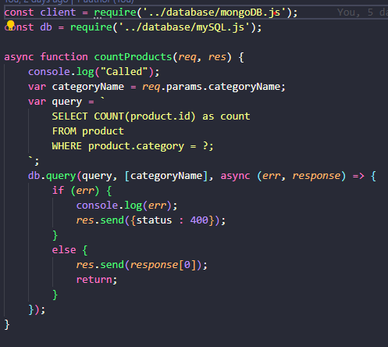

In this image, the query’s statement is prepared and computed first, then the dependencies are injected later using the appropriate passed in array values.

We have also implemented another SQL Injection Prevention method, which is using stored procedures. Each stored procedure only accepts certain types of IN parameters with predefined variable types such as INT.

**3. Password hashing**

By default, on each user creation, mySQL automatically hashes the user password using either MD5 or SHA-1/SHA-2 authentication plugins by default **Need Reference [1]**. These two hashing functions are relatively close to each other. As the picture below describes, when running the query on default, mySQL will automatically convert any password string in “IDENTIFIED BY” using declared hashing functions. We used SHA-256 in this case for consistency and to illustrate we have used a password hashing method in this project.

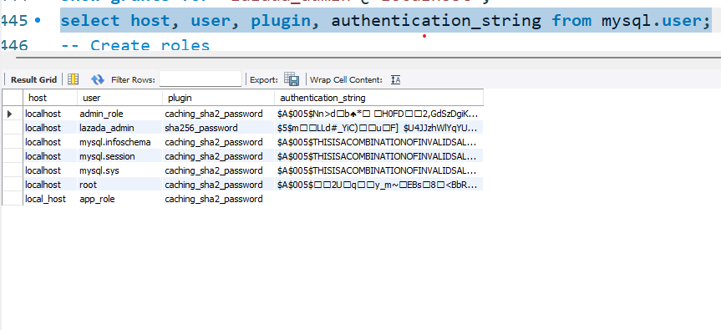

As illustrated, other accounts are created using the default plugin of mySQL, which is caching SHA2. However, our accounts are created using SHA256 hash functions to diversify the security layer. For further protection, a salt value can be used to create the hash password. However, we think this is a small application and it would be fine using this SHA256 hash function. It requires high computational power to brute force and to break into any system, the weakest link is the people who hold the high-privileged accounts that have access to the database.

**4. Additional security mechanisms**

1. **mySQL connections**

Connections to the database are made via mySQL connection pool using NodeJS dependencies. On each query to the database, the data is fetched using API and connection is released immediately and returned to the pool after receiving the response from the server. Short connections will ensure there won’t be potential breaches during the established section between frontend and backend.

1. **Other potential approaches**

These **application-layer** security approaches are potential practices that can be used for future projects to further enhance the application security. Even though we have not implemented these practices due to time constraint and human resources, it’s very worth to mention these for future students who can use these for their projects:

|  |  |
| --- | --- |
| **Method** | **Rationale** |
| Data Encryption | - This is an extra step that uses encryption to transform plain-text data into more secured data using asymmetric encryption such as RSA. |
| Real-time database monitoring [] | Databases should be scanned regularly for breaching attempts to come up with intermediate actions. |
| Regular Database Back-ups | Databases should be backed up regularly to protect and retrieve data when the server breaks down. |
| Multi-factor authentication | Add more security mechanisms to verify user access. |

References

[1] <https://dev.mysql.com/doc/mysql-secure-deployment-guide/5.7/en/secure-deployment-user-accounts.html>

[2]

<https://azure.microsoft.com/en-us/resources/cloud-computing-dictionary/what-is-database-security/#what-is-database-security>

https://www.tripwire.com/state-of-security/database-security-best-practices-you-should-know